Anne Arundel County

Baltimore City

Baltimore County

Mid Maryland

Susquehanna

with Baltimore Metropolitan Council

Regional workforce development plan

Maryland Central Region

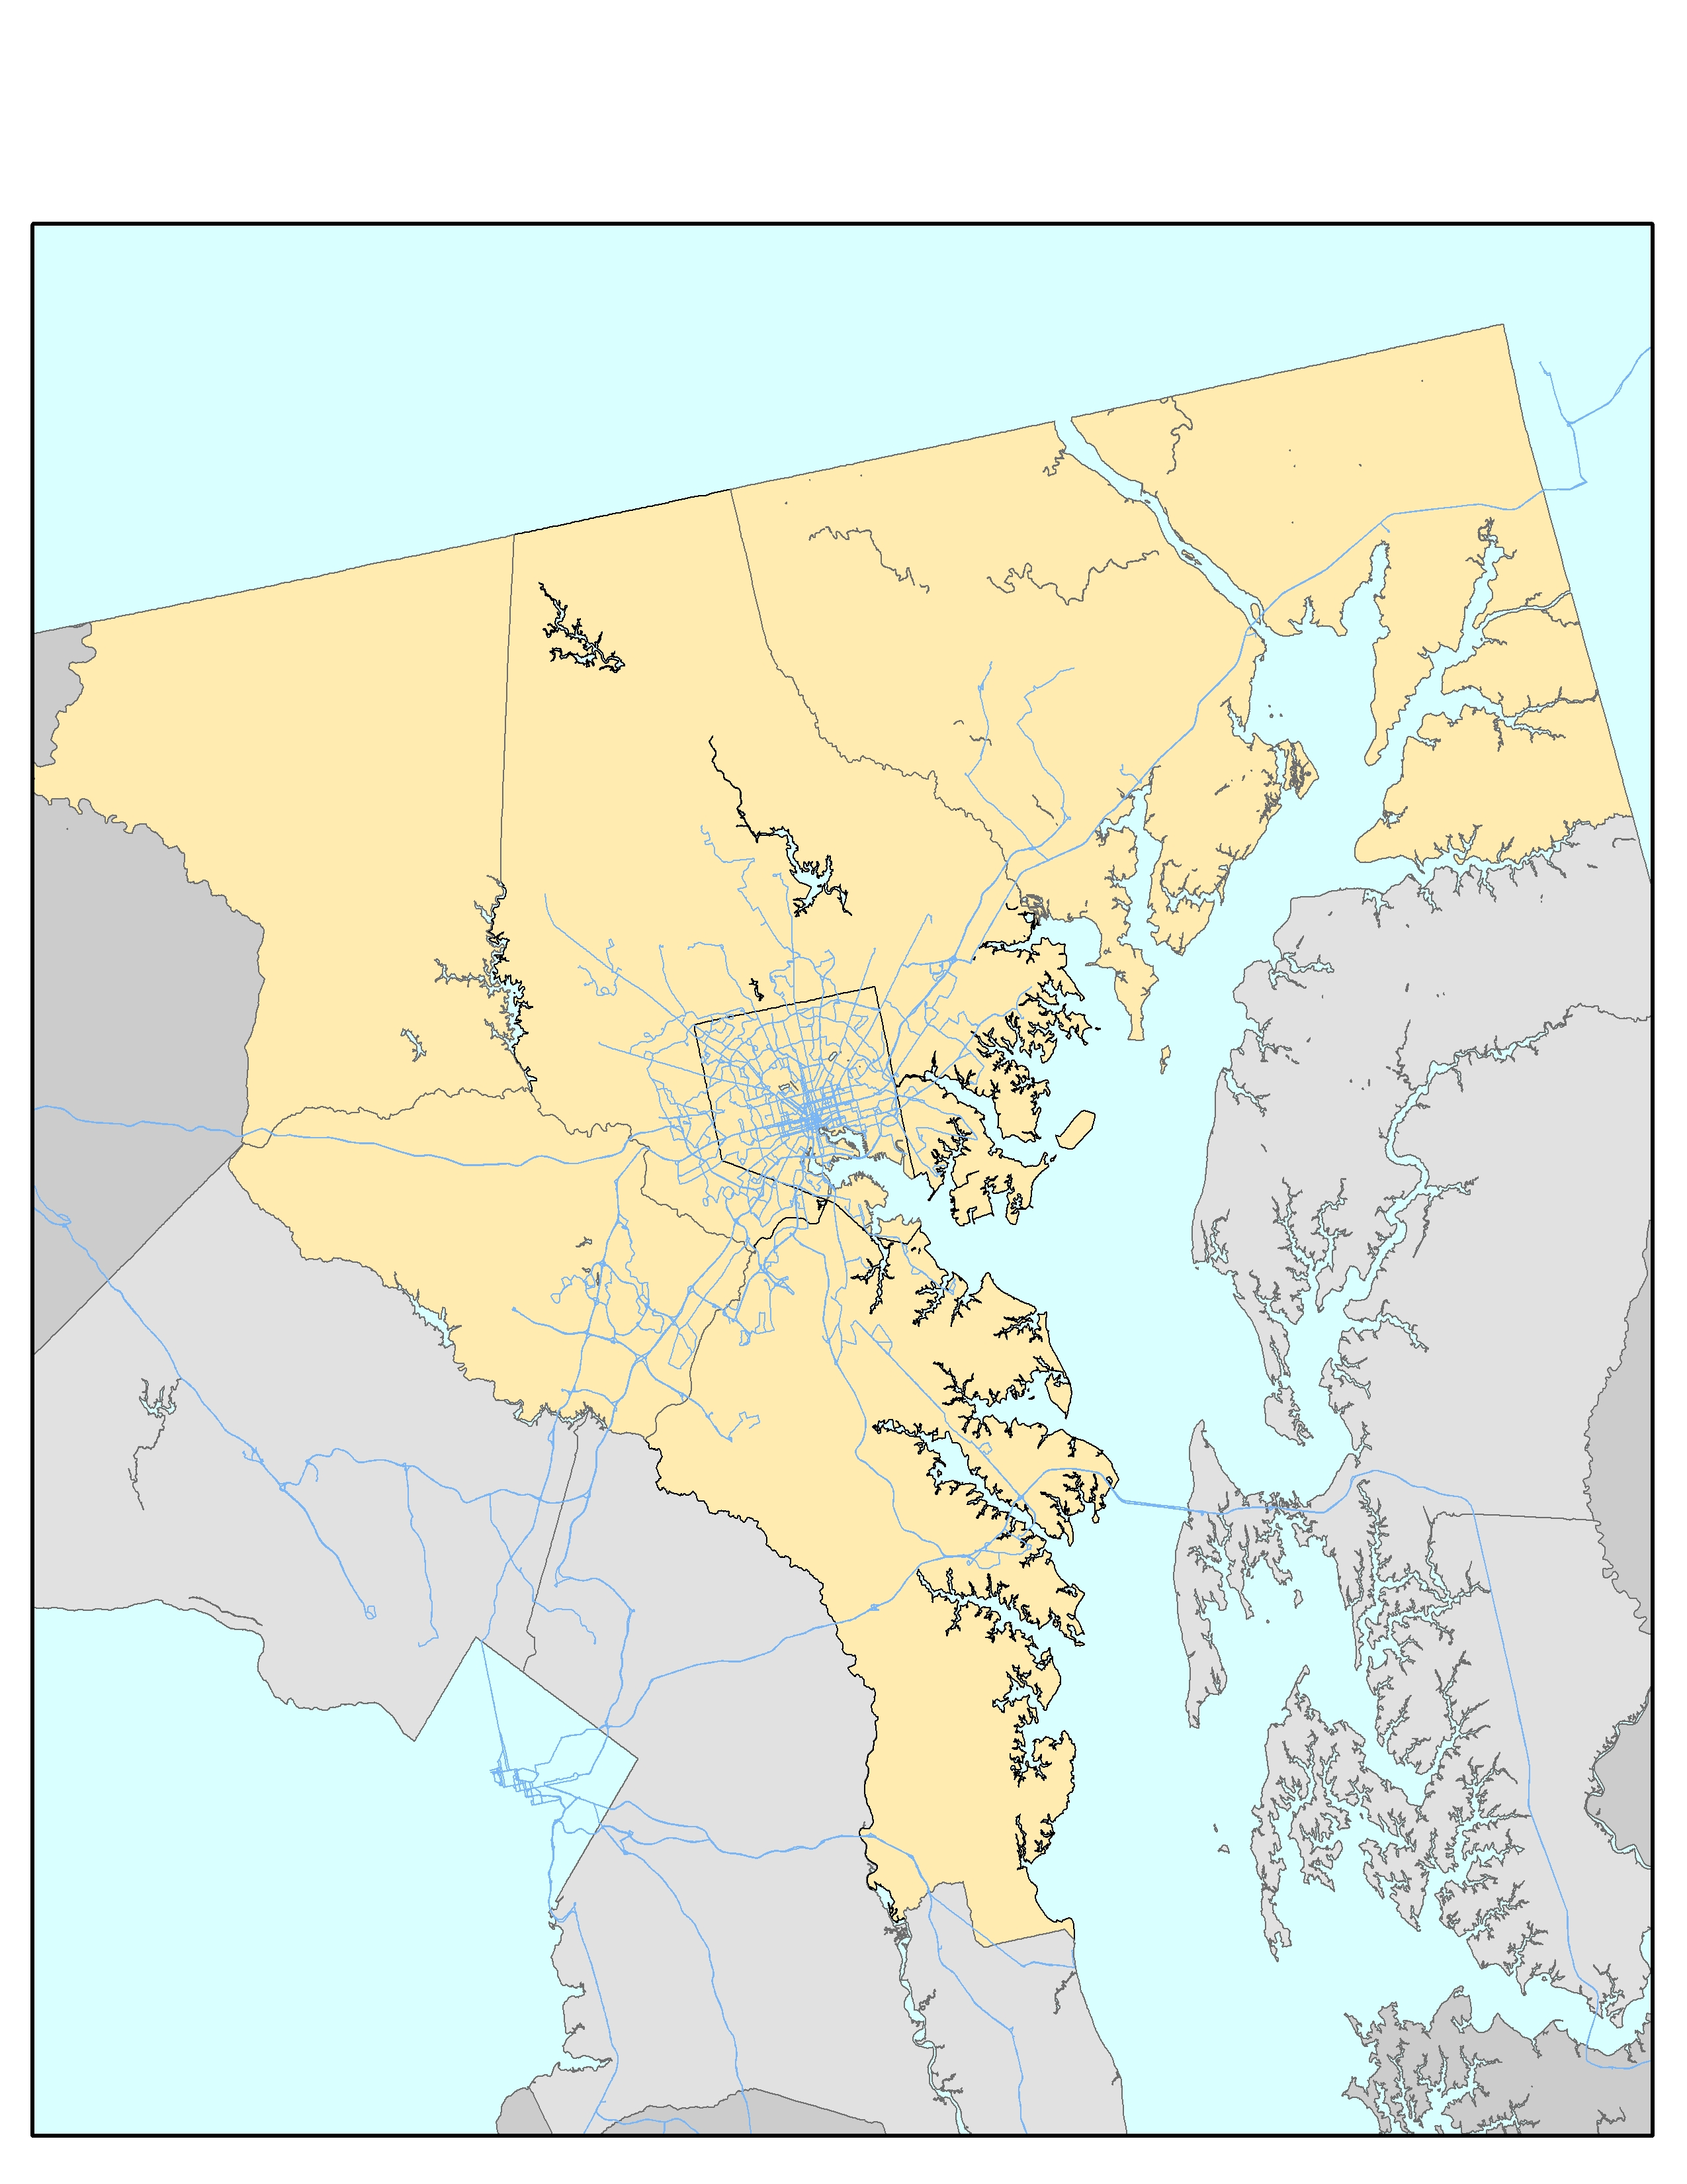

**Executive Summary**

Maryland Central Region is excited to submit its *Regional Workforce Development Plan* in accordance with Section 106 of WIOA which provides for the identification of Workforce Development Regions. This document is submitted by the Maryland Central Region (the Region) that consists of the following areas: Anne Arundel County, Baltimore City, Baltimore County, Susquehanna and Mid Maryland; and was prepared in collaboration with the Baltimore Metropolitan Council.

The Region believes that collaboration and coordination of efforts in all areas is a key to success in ensuring that workforce needs of businesses and job seekers in the State are met. A regional approach will allow for areas to address workforce challenges that industry sectors have in a more efficient way. The Region will collaborate to collect, analyze and use labor market information to make strategic decisions.

As a workforce development strategy, the regional approach enjoys a long history of success in the Central Region. This success is carried forward to the present day with cross-county initiatives currently underway, such as:

* The MTC initiative, which helps long-term unemployed individuals gain access to training and certifications that prepare them for employment in Bioscience and IT sectors;
* A variety of EARN initiatives designed to address industry specific workforce challenges through Industry Partnerships; and
* The MC3 initiative, which helps recently separated veterans and their spouses find employment.

The Region will create coordination, tracking and reporting mechanisms on a case by case basis when it comes to implementation of workforce initiatives. This would include coordination of service delivery, referrals, integration of supportive service providers, tracking and reporting mechanisms, cost sharing and distribution and performance monitoring.

The Baltimore Metropolitan Council will provide support in coordination economic development perspective entities and collection and analysis of labor market information.

**Section 1 – Regional Analysis**

1. **Existing and emerging in-demand industry sectors and occupations, and their employment needs.**

Over the long term, the total number of job opportunities in the region (total hiring activity) is expected to increase in several sectors. The sectors that are projected to experience the greatest hiring demand include healthcare (hiring demand of approximately 49,400 workers including turnover), business services (46,800 workers), hospitality and tourism (39,700 workers), retail trade (37,500 workers) and education (33,270 workers). In the retail and hospitality sectors, most hiring demand will be for replacement of lost workers, while new business growth will account for a larger portion of hiring demand in healthcare, business services and education. Hiring demand is projected to be more modest in other sectors ranging from a low of 1,500 workers in the utilities sector to a high of 17,250 workers in the construction sector.[1]

**Figure 1 Total Projected Hiring Demand by Sector in the Baltimore Region 2012-2020**

Source: RDA Global Baltimore Region Outlook 2012-2020

In descending order, the largest occupational employment needs in the five sectors projecting the most growth are:

|  |  |  |
| --- | --- | --- |
| HEALTHCARE |  |  |
| Minimal Educational  Requirement | Occupation | Total Hiring Requirement (2012-2020) |
|  |  |  |
| Associate’s Degree | Registered Nurses | 3,083 |
| HS Diploma or Equivalent | Receptionists & Information Clerks | 1,742 |
| Post Secondary Non-Award Degree | Nursing Aides, Orderlies & Attendants | 1,602 |
| HS Diploma or Equivalent | Office Clerks, General | 1,187 |
| Post Secondary Non-Award Degree | Licensed Practical & Licensed Vocational Nurses | 1,163 |

|  |  |  |
| --- | --- | --- |
| Business Services |  |  |
| Minimal Educational  Requirement | Occupation | Total Hiring Requirement (2012-2020) |
|  |  |  |
| Bachelor’s Degree | Accountants & Auditors | 1,447 |
| HS Diploma or Equivalent | Security Guards | 1,403 |
| Less than High School | Janitors and Cleaners | 1,379 |
| Associates Degree | General and Operations Managers | 1,267 |
| Bachelor’s Degree | Management Analysts | 1,244 |

|  |  |  |
| --- | --- | --- |
| Hospitality & Tourism |  |  |
| Minimal Educational  Requirement | Occupation | Total Hiring Requirement (2012-2020) |
|  |  |  |
| Less than High School | Waiters and Waitresses | 9,838 |
| Less than High School | Combined Food Prep and Service Workers | 4,766 |
| Less than High School | Counter Attendants, Cafeteria, Food Concession and Coffee Shop | 3,085 |
| Less than High School | Hosts and Hostesses, Restaurant, Lounge and Coffee Shop | 2,141 |
| Less than High School | Dishwashers | 1,836 |

|  |  |  |
| --- | --- | --- |
| Retail Trade |  |  |
| Minimal Educational  Requirement | Occupation | Total Hiring Requirement (2012-2020) |
|  |  |  |
| Less than High School | Cashiers | 10,442 |
| Less than High School | Retail Salespersons | 8,920 |
| Less than High School | Stock Clerks and Order-Fillers | 2,868 |
| HS Diploma or Equivalent | First-Line Supervisors of Retail Sales Workers | 2,320 |
| Less than High School | Laborers and Freight, Stock and Material Movers | 880 |

|  |  |  |
| --- | --- | --- |
| EDUCATION |  |  |
| Minimal Educational  Requirement | Occupation | Total Hiring Requirement (2012-2020) |
|  |  |  |
| Bachelor’s Degree | Secondary School Teachers, Except Special and Career/Tech Education | 3,139 |
| Bachelor’s Degree | Elementary School Teachers, Except Special Education | 2,958 |
| HS Diploma or Equivalent | Teacher Assistants | 2,002 |
| Bachelor’s Degree | Middle School Teachers, Except Special and Career/Tech Education | 1,971 |
| Bachelor’s Degree | Teachers and Instructors, All Other | 1,317 |

1. **Demographic characteristics of the workforce, including the educational and literacy levels with emphasis on youth, adults in transition and individuals with disabilities. Describe how the local area’s demographics are changing and the planning implications for the anticipated workforce in the future.**

The Baltimore region is home to a highly-educated workforce, with 63.5% of the population having at least some college education. Literacy rates in the region are relatively high, with most jurisdictions averaging only 6% - 7% of the population lacking basic prose and literacy skills. The outlier in this category is Baltimore City, where 16% of individuals 16 years of age or older lack basic prose and literacy skills.[2]

There are significant gaps between the educational attainment of the population with and without a disability. Nearly 12% of the MSA’s population has a disability, which represents a significant portion of the workforce. In the population aged 25+ who have disability, the percentage of the population with a Bachelor’s degree dips to 18%, while the percent of the population without even a high school diploma rises to 23.2%.

The Region has experienced significant population growth over the past thirty years. Since 1970, the total number of households in the Region has grown from roughly 600,000 to over 1,000,000. Total population in the region is now roughly 2.75 million. The Region’s net population growth is fueled by persons of color. The white population declined by 4% between 2000 and 2010, while the number of African Americans in the Region grew by 11.5 percent. While still a small share of the population, Asian and Hispanic residents have shown high levels of growth from 2000 to 2010; a 79 percent and 139 percent growth rate for Asians and Hispanics respectively in that decade.[3]

1. **Knowledge and skills needed to meet the employment needs of the employers in the region, including employment needs in in-demand industry sectors and occupations.**

Several workforce studies in the region have noted that there is a divergence of job opportunities available to the MD Central Region’s residents that include two broad groups of jobs: (1) low-skilled jobs that require little post-secondary education and do not offer family-supporting wages, and (2) high-skilled, high-paying jobs requiring education at the Bachelor’s degree level or higher.[4] At a macro-level, this study confirms this overall trend, underscoring the difficulty of creating regional Career Pathways[5] that are both aligned with industry workforce requirements and at the same time lead to family-supporting careers. Individual industry sectors, however, differ somewhat in their opportunities for jobs at the mid-skill level. Industry sectors such as bioscience, education, and information technology have historically been some of the best performing sectors in the region but many of the high-paying jobs in these sectors require a Bachelor’s degree or higher. By contrast, sectors such as retail trade and the tourism & hospitality sector require a large number of workers for comparatively low-wage jobs that require a high school education or lower.

**Figure 2 Share of Jobs by Minimum Required Education and by Industry Sector, 2012**

|  |  |  |  |  |
| --- | --- | --- | --- | --- |
| Sector | Less than High School | High School Diploma or Equivalent | Associates Degree, Post-Secondary Award, or Some College, less than a Bachelors Degree | Bachelors Degree or Higher |
| Bioscience | 2% | 25% | 13% | 60% |
| Business Services | 13% | 36% | 12% | 38% |
| Construction | 18% | 65% | 12% | 5% |
| Education | 4% | 28% | 5% | 63% |
| Finance & Insurance | 6% | 64% | 4% | 26% |
| Healthcare | 11% | 30% | 38% | 22% |
| Hospitality & Tourism | 76% | 20% | 2% | 2% |
| Information Technology | 2% | 28% | 13% | 57% |
| Manufacturing | 15% | 55% | 11% | 19% |
| Retail Trade | 62% | 31% | 3% | 3% |
| Transportation And Warehousing | 24% | 66% | 4% | 6% |
| Utilities | 4% | 63% | 11% | 22% |
| Wholesalers | 15% | 61% | 8% | 16% |

Sources: RDA Global Baltimore Employment Forecast 2012-2020, Quarterly Census of Employment and Wages, Occupational Employment Statistics, O*Net Database, Analysis by author.

Healthcare stands out as the single sector with a large portion (38%) of jobs in the mid-skill level (jobs requiring an Associate’s degree or other level of post-secondary education less than a Bachelor’s degree). After healthcare, other sectors with a significant number of jobs at this mid-skill level include bioscience (13%), business services (12%), construction (12%), and information technology (13%). While these percentages suggest good mid-skill job opportunities within these sectors, a detailed review of mid-skill occupations reveals that many jobs in these sectors are for supervisors, managers, or sales professionals, typically requiring either moderate to longer-term on the job training or multiple years of experience, restricting opportunities for workers with little relevant work experience.

1. **Analysis of the workforce in the region, including current labor force employment/unemployment data, labor market trends and the educational and skill levels of the workforce in the region, including individuals with barriers to employment**

Employment/unemployment trends have been positive since 2010, the height of the great recession in Maryland. The unemployment rate during that time has steadily dropped from 8.1% to 5.4%. During the same timeframe, the total number of residents participating in the labor force has risen by over 50,000 people.

These positive employment trends are not equally reflected among all populations. As previously stated, in addition to the disparities in education level among individuals with disabilities (see Section B), there are clear challenges faced by younger and less-educated members of the workforce. First, with regard to educational attainment, the recovery from the recession has increased the total number of jobs in our Region, but the quality of those jobs is less than it once was. The result of this shift is that many workers are now “over-educated” for their current positions, and some less-educated job seekers are struggling to find work. The chart below shows share of regional employment by educational attainment. Since 2011, the start of the recovery, only those with a Bachelor’s degree or more have seen an increase in their share of the labor market. Less educated workers have seen their share decline, with the most sever impacts being on those with less than a high school diploma.

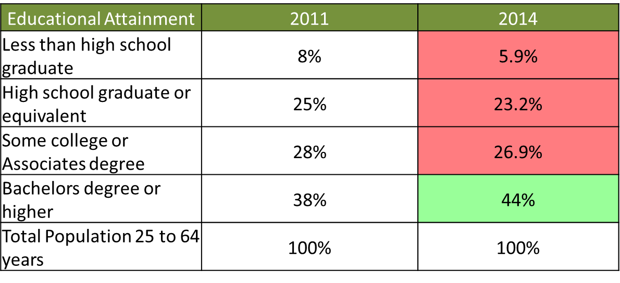

In a related set of statistics, younger workers are facing larger unemployment rates than their more seasoned colleagues. Workers ages 16-24 experience an unemployment rate of 12.7%, which is over three times that of workers age 45-54 and double the regional average of 5.8%. These struggles are likely to continue for the next decade as the baby boomer generation works longer than expected and workers in Generation X see fewer opportunities for advancement.

1. **Analysis of workforce development activities (including education and training) in the region, including an analysis of the strengths and weaknesses of such services, and the capacity to provide such services, to address the identified education and skill needs of the workforce and the employment needs of employers in the region.**

The Regional Talent Development Pipeline Study identified a total of 2,049 educational programs in the Maryland Central Region that reported enrollment during the 2011-2012 period. This included 1,778 college and university programs with combined enrollment of 184,844 students in 2012; 186 WIA-eligible[6] training programs with combined enrollment of 7,939 students; and 85 other programs (non-WIA eligible) with combined enrollment of 6,435 students. In total, these programs reported graduations of 46,250 students from all programs in the most recent year of reporting (2011-2012).

The business services sector benefits from over 767 programs in the Region that had a combined enrollment of 61,684 students in 2012. These programs are highly diverse, reflecting the range of sub-industries that comprise the business services sector, which include legal services, accounting, engineering, consulting services, computer systems, facilities support, security services, waste management, treatment and remediation, repair and maintenance services and other services included in the definition of the sector. The majority of these programs are at the Bachelor’s degree level or higher, but there are 56 WIA-eligible programs in the Region that are linked to the business services sector that had a combined enrollment of 1,000 students in 2012.

A large number of educational programs and occupational training programs are associated with careers in the healthcare sector. A total of 459 programs were identified which include programs for healthcare professionals and technicians, health support occupations, business occupations in healthcare, and other occupations that support healthcare operations (e.g. stationary power systems engineers who assure back-up power at hospitals). There were about 48,200 individuals enrolled in these programs in 2012. Healthcare also has the largest number of WIA-eligible programs (66) and these programs had a combined reported enrollment of 4,153 students in 2012.

**Figure 3 Educational Programs and Enrollment by Sector, 2011-2012**

|  |  |  |  |  |  |  |
| --- | --- | --- | --- | --- | --- | --- |
| Sector | Training and Education Capacity | | | | | |
| WIA-Eligible Training Programs | Enrollment in WIA-Eligible Training Programs | All Programs Less than a Bachelors Degree | Enrollment in Programs Less than a Bachelors Degree | Total Educational and Training Programs | Total Enrollment - All Programs |
| Bioscience | 7 | 119 | 115 | 6,072 | 384 | 28,869 |
| Business Services | 56 | 1,000 | 341 | 18,115 | 767 | 61,648 |
| Construction | 26 | 586 | 62 | 2,677 | 65 | 2,792 |
| Education | 2 | 338 | 142 | 40,329 | 413 | 64,015 |
| Finance & Insurance | 7 | 144 | 52 | 2,881 | 101 | 6,995 |
| Healthcare | 66 | 4,153 | 218 | 20,150 | 459 | 48,194 |
| Hospitality & Tourism | 7 | 244 | 39 | 2,212 | 115 | 7,485 |
| Information Technology | 28 | 176 | 151 | 5,490 | 271 | 15,117 |
| Manufacturing | 9 | 189 | 38 | 1,506 | 72 | 4,556 |
| Retail Trade | 4 | 99 | 9 | 649 | 15 | 888 |
| Transportation and Warehousing | 15 | 1,668 | 44 | 2,918 | 45 | 2,957 |
| Utilities | - | - | 10 | 486 | 17 | 1493 |
| Wholesale | 9 | 1,129 | 33 | 2,201 | 45 | 3656 |

Sources: Trends in Enrollments by Program, Maryland Higher Education Commission 1999-2012, Trends in Degrees and Certificates by Program, Maryland Higher Education Commission 1999-2012, WIA Occupation Training Programs, Online Database of WIA Service Providers by County, RDA Global Survey of Occupational Training Providers, MHEC online database of private career schools in Maryland. Linkages between educational training programs and occupations in high demand in each sector are based on the Bureau of Labor Statistics crosswalk for occupations and educational programs (http://www.bls.gov/soc/soccrosswalks.htm) and a subsequent qualitative review of each educational program was performed to associate programs with occupations and sectors. Caution is urged in interpreting the total programs, enrollment and graduations by sector because some judgment was applied in making associations.

Other sectors with a large number of training programs include the education sector (enrollment of approximately 61,650 students in 413 programs), the bioscience sector (384 programs), and the information technology sector (271 programs). There are comparatively fewer training programs for the construction, finance & insurance, hospitality & tourism, information technology, retail trade, manufacturing, transportation and warehousing, wholesale, and utilities sector. In 2012, there were just 15 WIA-eligible programs that trained approximately 1,668 students for careers in the transportation and warehousing sector. While few formal educational and training programs are linked to the construction sector, the apprenticeship training system serving the region is robust. There are at least 24 local unions and organizations for construction trades in the Baltimore Region offering apprenticeship training programs or similar services, typically through 3-year to 5-year programs that combine on-the-job training with classroom education.

**Section 2. Regional Sector Strategies.**

1. **Identify which in-demand industry sector(s) or occupation(s) the Local Boards in the region is/are serving and why.**



1. **Describe the current status of regional collaboration in support of the sector occupation and identify anticipated next steps and timelines for at least the first two years of plan implementation.**

Within the last few years, local areas collaborated on a few initiatives focusing on specific industries and/or occupations. Some of those initiatives are still under implementation. The following are several examples of such collaboration.

*Maryland Tech Connection.* The program focuses on providing training and employment services to long-term unemployed individuals who are seeking to pursue a career in Bio technology or IT industries. All local areas of this region are participating.

*Train-to-Hire.* The initiative provides on-the-job training opportunities for dislocated workers. All areas but Mid Maryland are participating.

*BRAC.* The program focused on helping individuals to prepare for the military bases relocations who coming to the area.

*RG Steel*. Reemployment initiative focused on servicing former employees of RG Steel.

*ACE.* Provided services to individuals in accordance with I-Best model. Baltimore City, Baltimore County, and Anne Arundel county participated.

*EARN.* Numerous projects that focus on addressing specific workforce needs of targeted industries.

*C3.* The program will serve transitioning and recently separated veterans and will provide them with an opportunity to go through a training and work and learn initiatives, which will help veterans to obtain gainful employment and career in a civilian world. Participating areas are Susquehanna, Anne Arundel County, Mid Maryland.

Within the next two year, the Region will work on implementing existing projects and identifying specific needs of common targeted industries. The results of this process will allow for development of strategies that address these needs and go after additional resources and funding.

**Section 3. Regional Service Strategies**

1. **Identify and describe which populations and/or service strategies and/or services will be developed on a regional basis.**

*NOTE: There is no expectation that all service strategies in multi-area regions will be regional, or that regions will have robust strategies in place at the start of the planning timeline. This plan provides the baseline. Local Board(s) are expected to make a good faith effort at exploring options to better integrate service delivery as it makes sense over time.*

The Central Region has demonstrated effectiveness serving populations identified in the state plan as evidenced in the Targeted Population Summary. Previously, the greatest number of barrier populations served as reported in the Maryland Workforce Exchange had been SNAP recipients, ex-offenders, low income individuals, under-employed, and individuals with disabilities. To broaden our efforts to serve individuals with other barriers we plan to coordinate and seek deployment of innovative outreach strategies. We are working to align partner programs that serve these populations with the intent to advance our ability to address the workforce demands of the business enterprises in the region. This alignment will foster the ability for individuals in the targeted populations to obtain employment leading to self-sufficiency by increasing access to services and programs that increase the acquisition of skills required to fill the demands of the business community. Conversely, we will partner to provide outplacement assistance for those companies that may be resizing their workforce and assist displaced employees.

Continuing our history of regional collaboration, we plan to advance our efforts in seeking regional grants, trainings, best practices, sector initiatives and other alliances that support the employment needs of the shared priority industries and common populations. Past examples include the regional partnership to develop a regional workforce plan through the Opportunity Collaborative; our collective contribution to the success of the BRAC and Cyber grants; and continued work on the MTC and MC3 grants. Regionally, we supported the workforce attraction efforts for Amazon and Maryland’s casino expansions, ACE and Train-to-Hire initiatives.

As a Region, we will support regional economic expansion projects and collaborate to fill the needs of regional industry sectors such as gaming, warehouse and distribution, manufacturing and the expansion of military installations (public and private sectors that support defense industry). Historically, we have worked regionally to assist with the workforce development needs of these industry sectors. We plan to advance our efforts with regional business activities and engagement to support workforce attraction, retention and development needs.

**Section 4 – Coordination with Regional Economic Development Organizations.**

At the local level, the models of coordination between workforce investment agencies and economic development agencies vary greatly from jurisdiction to jurisdiction. The most common model is to have two quasi-government agencies operating as separate non-profit corporations. In Baltimore County, the Office of Workforce and Economic Development serves as a combined agency sitting within county government. The same holds true for the Carroll County office in Mid-Maryland.

Regionally, two agencies, the Baltimore Metropolitan Council (BMC) and the Economic Alliance of Greater Baltimore (EAGB) help to coordinate the efforts of local workforce development and economic development agencies. BMC is a nonprofit organization that works with the region’s elected executives to identify mutual interests and develop collaborative strategies, plans and programs that will help improve the quality of life and economic vitality. A portion of BMC’s statutory charge is to assist in the coordination of regional workforce development efforts. EAGB is a not-for-profit economic development organization led by a partnership of regional business executives, elected government officials and leaders from higher education focused on fostering business retention and development, job creation, workforce development and new investment throughout the Greater Baltimore region.

In FY18, BMC and EAGB will release a comprehensive series of industry profiles, blending labor market analysis with economic development research. The local workforce and economic development agencies will be partners in this process, which is designed to provide a comprehensive and shared data set to relevant employers, trainers and government partners.

**Section 6. Regional Costs Arrangements, as Appropriate**

1. **Describe cost arrangements in the region for costs associated with items 1 through 5 above, which may include the pooling of administrative costs.**

On a project by project basis, the local areas in the region will determine the costs arrangements depending on requirements and nature of the projects, their goals and objectives, and funding streams. As an example, the arrangements could be made on the basis of proportion of participants served by each area, staff engagement, or the estimations of the common benefits received by each area or how the partners feel the costs distribution provides a common benefit. Cost sharing will also be utilized as a method of cost arrangements.

The Region could combine resources for procuring data systems and conducting an analysis of the regional LMI trends and determination of growth and emerging industries. This project will assist in identifying skills and credentials that are in demand in the Region and defining the skills gaps. Consequently, regional initiatives will be developed to address these gaps and assist job seekers in entering careers and obtaining jobs at a family sustaining wages.

Areas may combine resources for rapid response initiatives, and developing strategies to tackle challenges faced by targeted industries and priority populations. Regional collaboration will also allow for creation and implementation of innovative outreach strategies and recruitment.

Regional cooperation will enhance an alignment of partner programs and efficiently use tools in meeting common business needs within shared targeted industries.

**Section 7 – Regional performance negotiation**

**(A) Single area regions may describe the process used to negotiate performance. Describe how a region consisting of multiple workforce areas will collaboratively negotiate and reach agreement with the Governor on local levels of performance and report on performance accountability measures.**

*NOTE: There is no requirement that a region negotiate a single level of performance on any measures. The requirement is that the region agrees on how it will manage the negotiation with the Governor, which can include each Local Board negotiating separately.*

The Central Region is comprised of five local workforce areas with accomplished records of meeting or exceeding performance expectations of their funding organizations. Routinely, these workforce areas are focused on outcomes and manage performance of their various funding streams while providing high quality services to their job seeking customers and the business community. Therefore, the Local Boards comprising the Maryland Central Region plan to continue to negotiate WIOA performance with the Governor separately.

While negotiating WIOA performance separately, collectively the local workforce areas agree to continue their collaborative relationships sharing best practices in performance negotiation and management as well as innovations in programming. Additionally, as the identified regional planning and service strategies are deployed, mechanisms to track and report progress will be established to ensure regional success.

1. All data taken from the Baltimore Regional Talent Development Pipeline Study, Opportunity Collaborative/Baltimore Metropolitan Council, 2013. The study is based on an econometric forecast of the years 2012-2020. In FY18 the Baltimore Metropolitan Council will be updating this data to cover the years 2016-2020.
2. National Center for Education Statistics, Indirect estimate of percent lacking Basic prose literacy skills and corresponding credible intervals in Anne Arundel, Baltimore City, Baltimore, Carroll, Cecil, Harford and Howard Counties, Maryland 2003
3. Strong Communities; Strong Region: The Baltimore Regional Housing Plan & Fair Housing Equity Assessment, Baltimore Metropolitan Council, November 2014
4. See Investing in Baltimore’s Workforce, Job Opportunity Task Force; Creating Opportunity in Baltimore’s Next Economy, Brookings.
5. For an introduction to Career Pathways systems for workforce development, see The Promise of Career Pathways System Change, Last Accessed May 2013 at <http://www.jff.org/sites/default/files/CareerPathways_JFF_Paper_060112.pdf>
6. Programs for which students may be eligible to receive financial aid through the Workforce Investment Act.