NINETY-SEVENTH

ANNUAL REPORT

2016

STATE OF MARYLAND
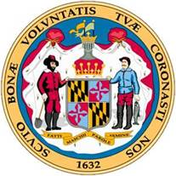

MARYLAND RACING COMMISSION

LARRY HOGAN
Governor of Maryland
BOYD K. RUTHERFORD
Lt. Governor of Maryland

KELLY M. SCHULZ
Secretary
Department of Labor


Maryland Racing Commission
300 E. Towsontown Blvd.
Baltimore, MD 21286

August 1, 2017

Kelly M. Schulz, Secretary
Department of Labor, Licensing and Regulation
500 N. Calvert Street
Baltimore, Maryland 21202

Dear Secretary Schulz:

The Maryland Racing Commission is pleased to present you with the annual report for calendar year 2016.

A review of this report will give you an overview of the horse racing industry in Maryland.

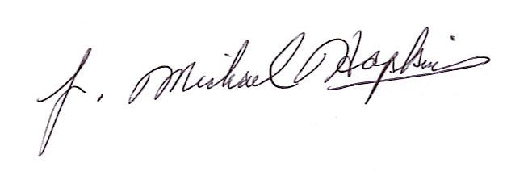
Sincerely,

J. Michael Hopkins
Executive Director

phone: 410-296-9682 - FAX: 410.-296-9687. TTY Users, Call via The Maryland Relay Service
internet: www.dllr.state.md.us . Email: racing @dllr.state.md.us
LARRY HOGAN, Governor . BOYD K. RUTHERFORD, Lt. Governor . KELLY M. SCHULZ, Secretary

TABLE OF CONTENTS

The Commission during the year 2016 1
Meeting and Hearing Statistics 2
2016 Highlights 3
2016 Legislation and Other Major Events 4
Racing Dates 5
Attendance 7
Wagering History 8
Amount Wagered 9
Satellite Simulcast Betting 10
Five Year Assessments 11
Method of Taxation 16
Revenue to the State: Thoroughbred 18
Revenue to the State: Harness 19
Summary of Licenses Issued 20
Uncashed Pari-Mutuel Tickets 22
Statement of Receipts 23
Statement of Actual Expenditures 25
Maryland Racing Commission Laboratory 26
The Maryland Jockey Injury Compensation Fund 27
Maryland-Bred Fund Report 28
Maryland Standardbred Fund Report 30

The Commission during the year 2016 consisted of:
Chairman……… John P. McDaniel

Members Mary Louise Preis
Charles G. Tildon III
David Hayden
Ernest R. Grecco
Tammy Lafferty
Tom Winebrener
Dr. Tom Bowman
Bruce Quade
The Commission Staff:
Executive Director J. Michael W. Hopkins
Admin. Program Manager. Doreen K. Munday
Fiscal Accts. Supvr. Ursula Suber
Fiscal Clerk II Aretha Jordan
Chief Investigator Joseph M. Poag

Stewards:
Administrative Steward Adam Campola
Associate Stewards Ross Pearce
Russell Derderian
Veterinarians:
Chief Veterinarian David G. Zipf
Veterinarians Thomas C. Jett
Kelly Walsh

MEETING STATISTICS - 2016

Commission Meetings

In 2016, the Commission met to conduct business on eleven (11) occasions.

2016 HIGHLIGHTS

REVENUE:

$ 2,806,536 was collected by the State in 2016. This amount represents an increase from the amount of revenue collected in 2015.

ATTENDANCE:

Attendance at Maryland tracks was 549,271 in 2016. Since attendance is not kept for patronage at Satellite Simulcast Betting Facilities and at remote tracks, recorded attendance alone is not a good measure of activity.

LEGISLATION and OTHER MAJOR EVENTS

HB 727– Increased The amount of time a notice of a public hearing would be held from 15 days to 30 days before the Racing Commission would be considering an application for a Satellite Simulcast Betting Facility and required notice of such meeting be posted on the Commission web site and have a sign posted in a conspicuous place also advertising the public hearing.

HB 815 – Allows Arabian races to be held at the Fair Hill Natural Resources Management area.

HB 965 – Provides for a bonus for a Maryland Bred or Maryland sired horse that participates in the Preakness; provides a grant of $500,000 for a Grade 1 race called the Maryland International; and provides for a grant to the Maryland Office of Sports Marketing and the Maryland Humanities Council. The legislation is effective through June 30, 2019.

2016 RACING DATES
(Continued)

HARNESS TRACKS:
Rosecroft | January 1 – December 31 | 54 | +
 | ITW | 306
 |  | 360 | Nights
Ocean Downs | January 1 – December 31 | 47 | +
 | ITW | 317
 |  | 364 | Nights
TOTAL LIVE: |  | 101 | NIGHTS
TOTAL SIMULCAST ONLY: |  | 623 | NIGHTS
HARNESS TOTAL: |  | 724 | NIGHTS
TOTAL LIVE RACING DAYS AND NIGHTS |  | 262
TOTAL SIMULCAST ONLY |  | 1,197
GRAND TOTAL |  | 1,459

RACE YEAR SUMMARY:

During the year 2016, there were 1,459 days and nights of licensed racing in the State, consisting of the following:

There were 735 days of licensed racing at the Mile Tracks - Pimlico 362 days and Laurel 362 days; 10 days at Timonium; and 1 day raced at Fair Hill. There were also 724 nights of licensed racing at the Harness Tracks - Rosecroft 360 nights and Ocean Downs 364 nights.

ATTENDANCE FOR CALENDAR YEARS 2014 – 2016

 | 2014 |  | 2015 |  | 2016
Laurel | 338,459 |  | 341,867 |  | 330,817
Pimlico | 263,782 |  | 228,919 |  | 149,544
Timonium | 16,278 |  | 15,948 |  | 14,465
TOTAL: | 618,519 |  | 586,734 |  | 494,826
Rosecroft ** | ** |  | ** |  | **
Not recorded
Ocean Downs | 41,349 |  | 39,552 |  | 39,339 | *
* Live Only
TOTAL: | 41,349 |  | 39,552 |  | 39,339
Fair Hill | 11,984 |  | 12,000 |  | 15,106
TOTAL ATTENDANCE - THOROUGHBRED AND HARNESS: | 671,852 |  | 638,286 |  | 549,271

** No record of attendance

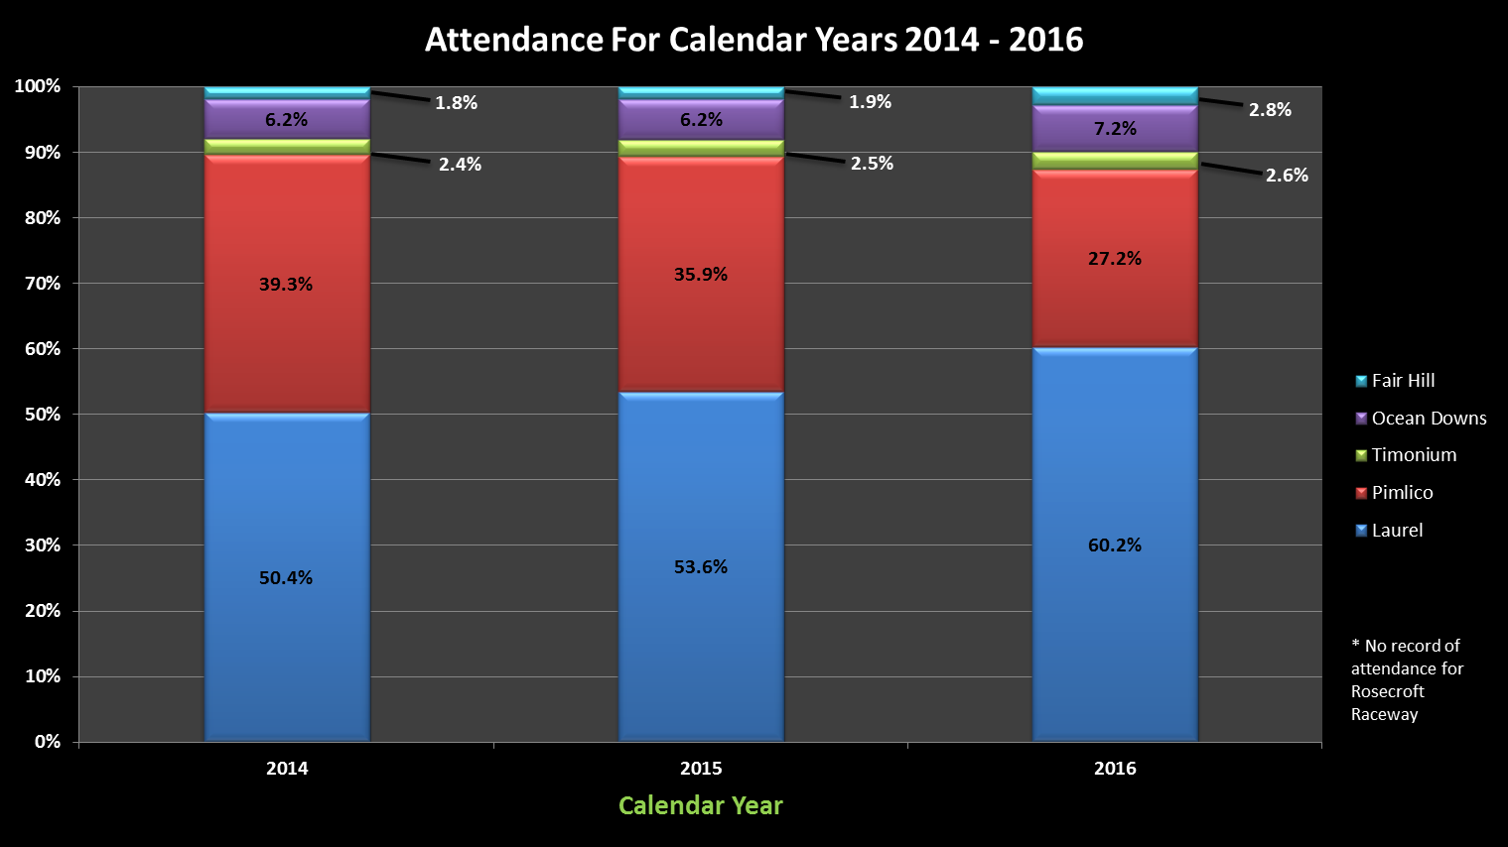
WAGERING HISTORY IN MARYLAND
Of
THOROUGHBRED AND HARNESS RACING

THOROUGHBRED STATISTICS: HARNESS STATISTICS:
YEAR | LICENSED  DAYS | AMOUNT  WAGERED | YEAR | LICENSED  DAYS | AMOUNT  WAGERED
2001 | 348 | 337,652,117 | 2001 | 705 | 156,777,856
2002 | 344 | 329,705,940 | 2002 | 749 | 155,892,827
2003 | 346 | 306,261,175 | 2003 | 742 | 144,598,813
2004 | 312 | 293,795,752 | 2004 | 749 | 131,111,243
2005 | 303 | 298,722,053 | 2005 | 721 | 140,789,276
2006 | 297 | 279,978,363 | 2006 | 724 | 130,058,639
2007 | 301 | 259,549,867 | 2007 | 721 | 117,815,100
2008 | 303 | 225,189,800 | 2008 | 727 | 100,559,207
2009 | 291 | 195,908,615 | 2009 | 738 | 65,631,105
2010 | 290 | 190,800,402 | 2010 | 823 | 22,753,567
2011 | 267 | 182,980,868 | 2011 | 490 | 20,810,252
2012 | 336 | 158,031,769 | 2013 | 717 | 34,180,137
2013 | 363 | 134,515,395 | 2013 | 723 | 47,922,650
2014 | 362 | 122,668,323 | 2014 | 724 | 46,070,856
2015 3 | 361 11 | 129,139,471 | 2015 | 719 | 40,915,568
2016 | 362 | 102,388,036 | 2016 | 724 | 46,168,043

SSB FACILITIES STATISTICS: COMBINED TOTALS:
YEAR | AMOUNT  WAGERED | YEAR | LICENSED  DAYS | AMOUNT  WAGERED
2001 | 64,393,587 | 2001 | 1,053 | 558,823,560
2002 | 65,580,391 | 2002 | 1,093 | 555,179,158
2003 | 68,972,477 | 2003 | 1,088 | 519,832,465
2004 | 67,351,515 | 2004 | 1,061 | 492,258,510
2005 | 65,745,234 | 2005 | 1,024 | 505,256,563
2006 | 64,961,268 | 2006 | 1,021 | 474,998,270
2007 | 69,206,967 | 2007 | 1,022 | 446,571,934
2008 | 52,507,771 | 2008 | 1,030 | 378,256,778
2009 | 41,360,026 | 2009 | 1,029 | 302,899,746
2010 | 38,137,636 | 2010 | 1,113 | 251,691,605
2011 | 30,812,484 | 2011 | 757 | 234,603,604
2012 | 14,288,365 | 2012 | 1,053 | 206,500,271
2013 | 10,212,577 | 2013 | 1,086 | 192,286,622
2014 | 5,140,478 | 2014 | 1,086 | 173,879,657
2015 | 13,857,614 | 2015 | 1,080 | 183,912,653
2016 | 20,449,226 | 2016 | 1,086 | 169,005,305
AMOUNT WAGERED

 | 2015 |  | 2016
MILE TRACKS:
Laurel | $84,825,256 |  | 72,468,771
Pimlico | $42,883,334 |  | 28,400,918
 |  |  | ____________
TOTAL | $127,708,590 |  | 100,869,689
COUNTY FAIR TRACKS:
Timonium | $1,268,467 |  | 1,385,829
TOTAL | $1,268,467 |  | 1,385,829
HARNESS TRACKS:
Rosecroft | $32,407,544 |  | 34,581,856
Ocean Downs | $8,508,024 |  | 11,586,187
 |  |  | ____________
TOTAL | $40,915,568 |  | 46,168,043
STEEPLECHASE:
Fair Hill | $162,414 |  | 132,518
TOTAL | $162,414 |  | 132,518
SSB FACILITIES | $13,857,614 |  | 20,449,226
SUMMARY
Mile Tracks | $127,708,590 |  | 100,869,689
County Fair Tracks | $1,268,467 |  | 1,385,829
Harness Tracks | $40,915,568 |  | 46,168,043
Steeplechase | $162,414 |  | 132,518
SSB Facilities | $13,857,614 |  | 20,449,226
TOTAL | $183,912,653 |  | 169,005,305

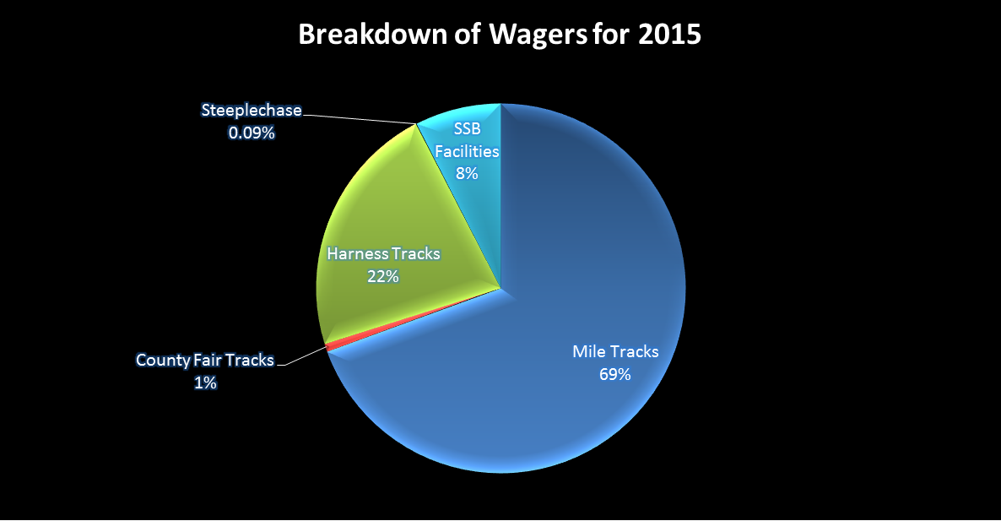
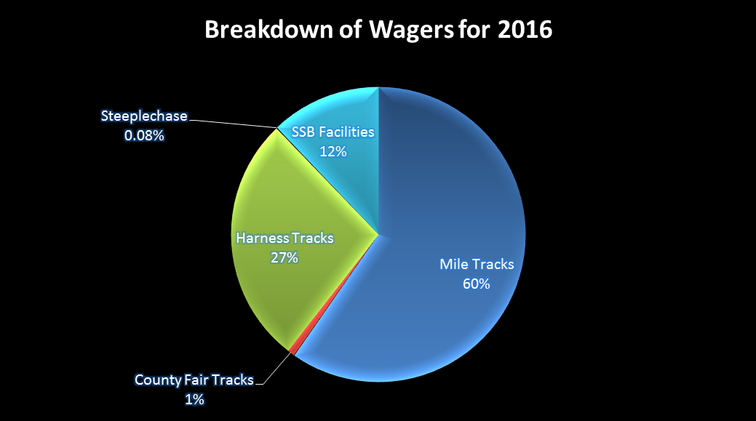
SATELLITE SIMULCAST BETTING

The amounts bet at the Satellite Simulcast Betting Facilities in calendar year 2016 are reflected in the following table.

Maryland Satellite Simulcast Betting Facilities

Bet At: | Riverboat | Horseshoe | Timonium | Boonsboro | Perryville
Bets on:
MD Thoroughbred Races | 532,761 | 1,050,614 | 1,463,503 | 569,152 | 61,181
MD Harness Races | 1,345 | 67,308 | 6,045 | 1,285 | 1,225
Out - of -State Races | 6,617,476 | 12,179,722 | 9,161,506 | 2,288,911 | 637,323
TOTAL | 7,151,582 | 13,297,644 | 10,631,054 | 2,859,348 | 699,729

In 2016, SSB facilities met the prescribed food and service standards and provide a convenience to the horse racing public.

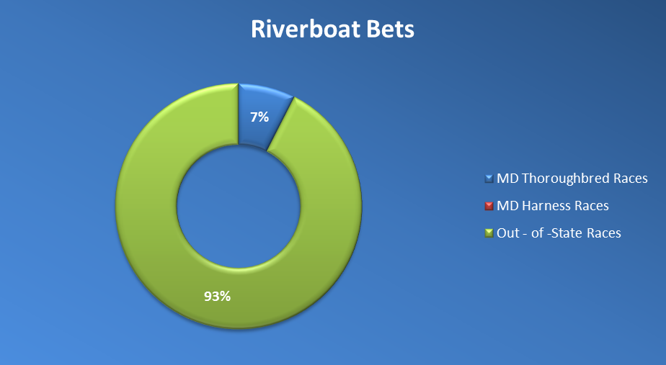
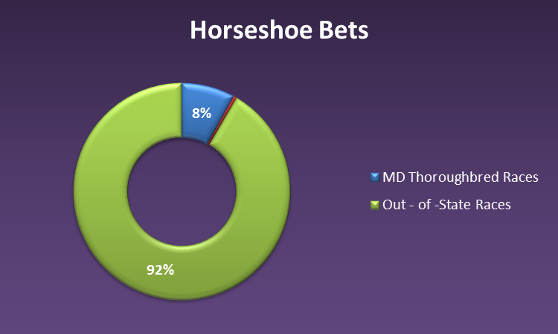

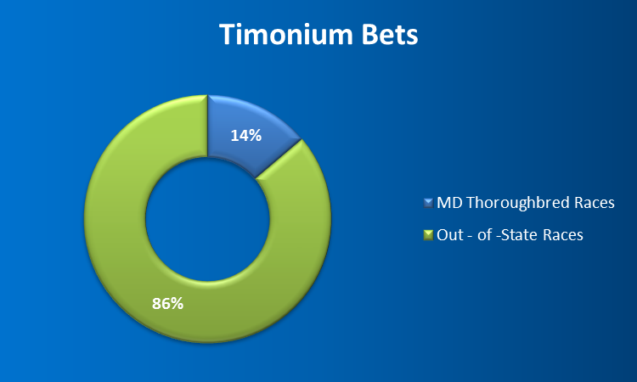

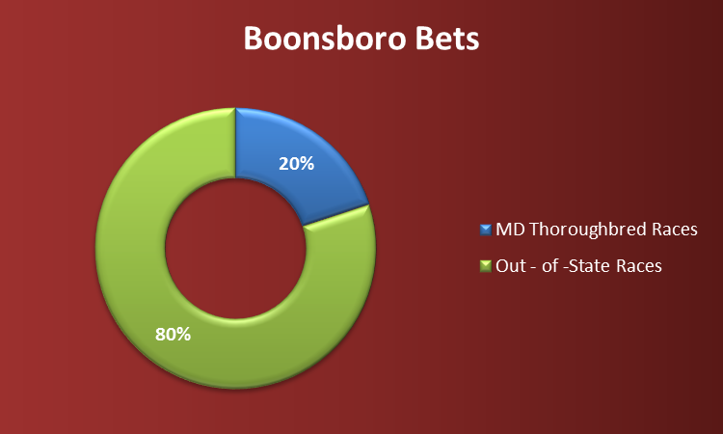

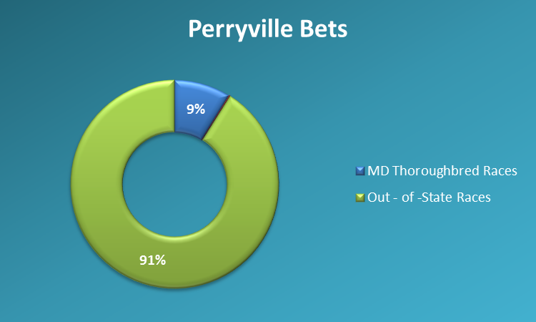

FIVE YEAR ASSESSMENT OF LAUREL

 | 2016 | 2015 | 2014 | 2013 | 2012
Attendance | 330,817 | 341,867 | 327,690 | 365,551 | 429,114
Purses | 33,959,365 | 27,661,465 | 29,106,690 | 27,815,060 | 26,589,170
Number of days of live racing | 125 | 103 | 107 | 109 | 117
Betting on its live racing at:
Laurel | 12,164,916 | 10,027,397 | 8,772,235 | 9,354,955 | 10,877,867
Other MD tracks | 3,436,710 | 3,587,975 | 3,541,793 | 3,265,292 | 2,601,664
Satellite Simulcast Facilities | 2,480,279 | 678,328 | 180,372 | 418,788 | 505,181
Out-of-state | 256,578,508 | 175,672,864 | 142,507,116 | 161,430,230 | 156,578,967
Betting on other in-State races | 2,219,172 | 2,914,564 | 2,551,364 | 2,560,813 | 2,972,084
Betting on out-of-State races | 58,084,683 | 61,855,898 | 60,516,114 | 66,662,588 | 85,446,848
Total betting at this location on all racing | 72,468,771 | 74,797,859 | 71,839,713 | 78,578,356 | 99,296,799

FIVE YEAR ASSESSMENT OF PIMLICO

 | 2016 | 2015 | 2014 | 2013 | 2012
Attendance | 149,544 | 228,919 | 256,725 | 287,140 | 300,056
Purses | 8,952,825 | 12,395,050 | 12,892,690 | 12,581,995 | 8,603,875
Number of days of live racing | 28 | 37 | 35 | 36 | 29
Betting on its live racing at:
Pimlico | 7,844,833 | 9,651,661 | 9,672,078 | 10,115,032 | 9,862,787
Other MD tracks | 2,905,243 | 3,512,330 | 3,416,557 | 2,946,910 | 2,813,071
Satellite Simulcast Facilities in MD | 1,152,775 | 344,698 | 175,696 | 411,630 | 406,178
Out-of-state | 160,625,703 | 171,301,182 | 146,829,060 | 143,766,884 | 128,842,396
Betting on other in-State races | 1,643,715 | 2,198,420 | 2,171,348 | 2,505,917 | 2,680,782
Betting on out-of-State races | 18,912,370 | 31,033,253 | 37,505,388 | 41,224,274 | 44,712,293
Total betting at this location on all racing | 28,400,918 | 42,883,334 | 49,348,814 | 53,845,223 | 57,255,862

FIVE YEAR ASSESSMENT OF TIMONIUM

 | 2016 | 2015 | 2014 | 2013 | 2012
Attendance | 14,465 | 15,948 | 16,278 | 2,760 | 18,118
Purses | 1,126,275 | 1,071,240 | 11,843 | 1,484,290 | 886,905
Number of days of live racing | 7 | 7 | 7 | 10 | 7
Betting on its live racing at:
Timonium | 697,034 | 762,714 | 790,176 | 962,966 | 842,211
Other MD tracks | 248,940 | 191,647 | 234,163 | 272,967 | 238,131
Satellite Simulcast Facilities in MD | 44,157 | 30,361 | 8,517 | 22,319 | 21,061
Out-of-state | 2,595,868 | 2,188,761 | 1,555,991 | 2,404,431 | 1,611,380
Betting on other in-State races | 151 | 0 | 0 | 0 | 0
Betting on out-of-State races | 688,644 | 505,753 | 514,027 | 593,183 | 487,132
Total betting at this location on all racing | 1,385,829 | 1,268,467 | 1,304,203 | 1,556,149 | 1,329,343

FIVE YEAR ASSESSMENT OF ROSECROFT

 | 2016 | 2015 | 2014 | 2013 | 2012
Attendance | *0 | *0 | *0 | *0 | *0
*Attendance not recorded
Purses | 6,016,904 | 4,760,147 | 4,249,537 | 3,336,615 | 1,823,332
Includes
**Purses pd. By MD. Stndbred.Race Fund
Number of days of live racing | 54 | 54 | 54 | 54 | 54
Betting on its live racing at:
Rosecroft | 1,007,007 | 851,600 | 812,441 | 815,926 | 878,840
Other MD tracks | 100,827 | 71,452 | 57,530 | 39,820 | 0
Satellite Simulcast Facilities in MD | 51,995 | 22,306 | 4 | 4,180 | 13,231
Out-of-state | 5,947,155 | 4,221,548 | 2,804,119 | 2,820,681 | 2,707,644
Betting on other in-State races | 2,252,743 | 2,410,434 | 2,126,834 | 1,559,380 | 0
Betting on out-of-State races | 31,284,981 | 29,145,510 | 34,407,539 | 36,077,069 | 18,789,664
Total betting at this location on all racing | 34,544,731 | 32,407,544 | 37,346,814 | 38,452,375 | 19,668,504

FIVE YEAR ASSESSMENT OF OCEAN DOWNS

 | 2016 | 2015 | 2014 | 2013 | 2012
Attendance | 39,339 | 39,552 | 41,349 | 45,438 | 46,843
Purses | 4,236,917 | 2,610,769 | 3,345,941 | 3,367,612 | 2,485,829
Number of days of live racing | 47 | 48 | 48 | 46 | 44
Betting on its live racing at:
Ocean Downs | 983,450 | 1,103,909 | 981,404 | 1,057,601 | 1,080,260
Other MD tracks | 204,134 | 125,437 | 85,510 | 10,121 | 75,647
MD Satellite Simulcast Facilities | 25,213 | 22,260 | 102 | 4,435 | 35,258
Out-of-state | 3,250,006 | 3,318,642 | 2,389,676 | 2,973,522 | 2,605,837
Betting on other in-State races | 646,568 | 504,537 | 485,974 | 307,939 | 557,658
Betting on out-of-State races | 7,148,597 | 6,899,578 | 7,256,664 | 8,104,735 | 8,648,920
Total betting at this location on all racing | 8,778,615 | 8,508,024 | 8,724,042 | 9,470,275 | 10,286,838

METHOD OF TAXATION

TAKEOUT AT MARYLAND THOROUGHBRED RACETRACKS

Effective July 1, 2005

 |  |  |  |  | 3-Horse
 | Regular |  | 2-Horse |  | Multiple
 | Pool% |  | Multiple |  | 1st Race
State Tax | .32 |  | .32 |  | .32
Purses | 7.88 | (1) | 8.88 | (1) | 11.88 | (1)
Track | 7.70 | (2) | 8.70 | (2) | 11.70 | (2)
Maryland Million | 1.00 |  | 2.0 |  | .75
Bred Fund | 1.10 |  | 1.10 |  | 1.10
Total Takeout | 18.00 |  | 21.00 |  | 25.75
Returned to Public | 82.00 |  | 79.00 |  | 74.25
Total Handle | 100.00 | % | 100.00 | % | 100.00 | %
Timonium
State Tax | 0 | (3) | 0 | (3) | 0 | (3)
Purses | 5.00 |  | 7.00 |  | 13.00
Track | 10.50 | (2) | 10.50 | (2) | 10.50 | (2)
Bred Fund | 1.50 |  | 1.50 |  | 1.50
Total Takeout | 17.00 |  | 19.00 |  | 25.00
Returned to Public | 83.00 |  | 81.00 |  | 75.00
Total Handle | 100.00 | % | 100.00 | % | 100.00 | %
Fair Hill
State Tax (Fair Hill
Improvement Fund) | 9.00
Track | 16.00
Total Takeout | 25.00
Returned to Public | 75.00
Total Handle | 100.00 | %

(1) Includes .18 for purses.
(2) Includes .25 for Pension Fund.
(3) No State tax paid during the State Fair.
METHOD OF TAXATION
(Continued)

TAKEOUT AT MARYLAND HARNESS RACETRACKS

 | 1-Horse |  | 2-Horse |  | Over 2-Horse
 | Pool % |  | Pool % |  | Pool %
State Tax | .32 |  | .32 |  | .32
Purses | .18 |  | .18 |  | .18
Track | 18.00 |  | 20.00 |  | 26.00
Standardbred Fund |  | (4) |  | (4) |  | (4)
Track Pensions |  | (5) |  | (5) |  | (5)
Total Takeout | 18.75 |  | 20.75 |  | 26.75
Returned to Public | 81.25 |  | 79.25 |  | 73.25
Total Handle | 100.00 | % | 100.00 | % | 100.00 | %

(4) The amount deducted is .5 and 1.00 respectively of the first $125,000 daily average. The amount deducted for amounts in excess of $125,000 are 1.00, 1.00 and 1.50 of the track share of the takeout.
(5) If daily average for the year exceeds $125,000, .25% of the handle is deducted from all pools for track employee pensions.

REVENUE TO THE STATE: THOROUGHBRED
TOTAL FOR ALL MEETS
 |  | 2015 |  | 2016
LAUREL
Race Days |  | 361 |  | 362
Tax to the State |  | 406,935 |  | 400,876
License Fee |  | 9,025 |  | 9,050
 |  | 415,960 |  | 409,926
PIMLICO
Race Days |  | 361 |  | 362
Tax to the State |  | 273,767 |  | 264,338
License Fee |  | 9,025 |  | 9,050
 |  | 282,792 |  | 273,388
TOTAL THOROUGHBRED |  | 698,752 |  | 683,314
COUNTY FAIR: TIMONIUM
Race Days |  | 10 |  | 10
Tax to the State |  | -0- |  | 0
License Fee |  | -0- |  | 0
 |  | -0- |  | 0
TOTAL COUNTY FAIR |  | -0- |  | 0
STEEPLECHASE: FAIR HILL
Race Days |  | 1 |  | 1
Tax to the State |  | 14,617 |  | 11,927
TOTAL STEEPLECHASE |  | 14,617 |  | 11,927

REVENUE TO THE STATE: HARNESS

 |  | 2015 |  | 2016
ROSECROFT
Race Days |  | 361 |  | 360
Tax to the State |  | 128,626 |  | 127,351
License Fee |  | 9,025 |  | 9,000
 |  | 137,651 |  | 136,351
OCEAN DOWNS
Race Days |  | 361 |  | 364
Tax to the State |  | 3,535 |  | 3,147
License Fee |  | 9,025 |  | 9,100
 |  | 12,560 |  | 12,247
TOTAL HARNESS |  | 150,211 |  | 148,598

(Race days include live and simulcast only days)

SUMMARY OF LICENSES & REGISTRATIONS ISSUED

2016

SUMMARY OF LICENSES & REGISTRATIONS ISSUED
(Continued)

UNCASHED PARI-MUTUEL TICKETS

If any winning ticket is not redeemed for a period of one (1) year from the date of issue, the amount necessary to redeem the ticket shall be paid to a special fund of the State. The following receipts are from race meetings conducted in the year prior to that indicated by the columnar heading.

 | 2015 |  | 2016
Mile Tracks | $369,116 |  | $666,303
Harness Tracks | 210,394 |  | 210,793
County Fair Track | 0* |  | 0*
Steeplechase | 4,184 |  | 3,650
TOTAL UNCASHED PARI-MUTUEL TICKETS | $583,694 |  | $880,746

*County Fair uncashed monies included with mile tracks.

STATEMENT OF RECEIPTS
DISBURSED TO THE STATE COMPTROLLER

 |  | 2015 |  | 2016
MILE TRACKS:
 | Track License Fees | $18,050 |  | $18,100
 | Tax on Betting | 680,702 |  | 665,214
 | Licensing Fees | 159,270 |  | 155,495
 | Registration Fees | 93,215 |  | 97,815
 | Uncashed Pari-Mutuels | 369,116 |  | 666,303
TOTAL DISBURSEMENTS MILE TRACKS |  | $1,320,353 |  | $1,602,927
COUNTY FAIR TRACKS:
 | Tax on Betting (6) | -0- |  | -0-
 | Uncashed Pari-Mutuels | * |  | *
TOTAL DISBURSEMENTS COUNTY FAIR TRACKS |  | 0 |  | 0
HARNESS TRACKS:
 | Track License Fees | $18,050 |  | $18,100
 | Tax on Betting | 132,162 |  | 130,498
 | Licensing Fees | 43,560 |  | 38,475
 | Registration Fees | 7,050 |  | 7,275
 | Uncashed Pari-Mutuels | 210,395 |  | 210,793
TOTAL DISBURSEMENTS HARNESS TRACKS |  | $411,217 |  | $405,141
STEEPLECHASE:
 | Tax on Betting | $14,617 |  | $11,927
 | Uncashed Pari-Mutuels | 4,184 |  | 3,650
TOTAL DISBURSEMENTS STEEPLECHASE |  | $18,801 |  | $15,577
OTB’S:
 | Permit Fee | $1,500 |  | $2,500
TOTAL DISBURSEMENTS O.T.B. |  | $1,500 |  | $2,500
TOTAL ALL DISBURSEMENTS |  | $1,751,871 |  | $2,026,145
(6) No State tax is payable when racing is conducted during the State Fair.
*County Fair uncashed monies included with mile tracks.

STATEMENT OF RECEIPTS

DISBURSED TO THE STATE COMPTROLLER
(Continued)

DIRECT DISBURSEMENTS TO STATE COMPTROLLER:

 | 2015 |  | 2016
Tax on Admissions | $408,670 |  | 400,906
Sales Tax on Horses Claimed | 337,695 |  | 379,485
TOTAL DIRECT DISBURSEMENTS TO STATE | $746,365 |  | 780,391
TOTAL ALL DISBURSEMENTS TO STATE COMPTROLLER | $2,498,236 |  | $2,806,536

STATEMENT OF ACTUAL EXPENDITURES

Fiscal Year ‘15’ July 1, 2014 TO June 30, 2015

(7) Does not include salaries of Stewards and Judges, nor salaries of personnel and expenses reimbursed by the associations.
MARYLAND RACING COMMISSION 2016
EQUINE SPECIMEN TESTING

Truesdail Laboratories located in Tustin, California was one of two laboratories that responded to a “Request For Proposal” (RFP) issued by the Department late in 2013. Consequently Truesdail was awarded the five year contract and provided the urine and blood specimen analysis during 2016 and continues to do so. Below are the statistics regarding the analysis of these samples.

NUMBER OF OFFICIAL SAMPLES ANALYZED

THE MARYLAND JOCKEY INJURY COMPENSATION FUND

The Maryland Jockey Injury Compensation Fund, Inc. was established by legislative action during the 1985 session of the General Assembly and became effective January 1, 1986.

The purpose of this fund is to purchase a blanket workmen's compensation insurance policy for all jockeys licensed by the Maryland Racing Commission and participating at the Maryland race tracks.

POLICY COST

1997 |  | $ 318,181.00
1998 |  | $ 312,093.00
1999 |  | $ 346,367.00
2000 |  | $ 355,966.00
2001 |  | $ 378,578.00
2002 |  | $ 388,877.00
2003 |  | $ 586,640.00
2004 |  | $ 611,533.00
2005 |  | $ 655,311.00
2006 |  | $ 741,868.00
2007 |  | $ 977,423.00
2008 |  | $ 723,852.00
2009 |  | $ 476,211.00
2010 |  | $ 404,954.00
2011 |  | $ 508,182.00
2012 |  | $ 1,675,611.00
2013 |  | $ 1,648,613.00
2014 |  | $ 1,223,005.00
2015 $ 808,553.00
2016 $ 882,763.00
The above costs were funded by an assessment on all licensed owners and trainers levied and collected by the Maryland Racing Commission at the time of licensure. The assessment per licensee for 2016 was $100.00

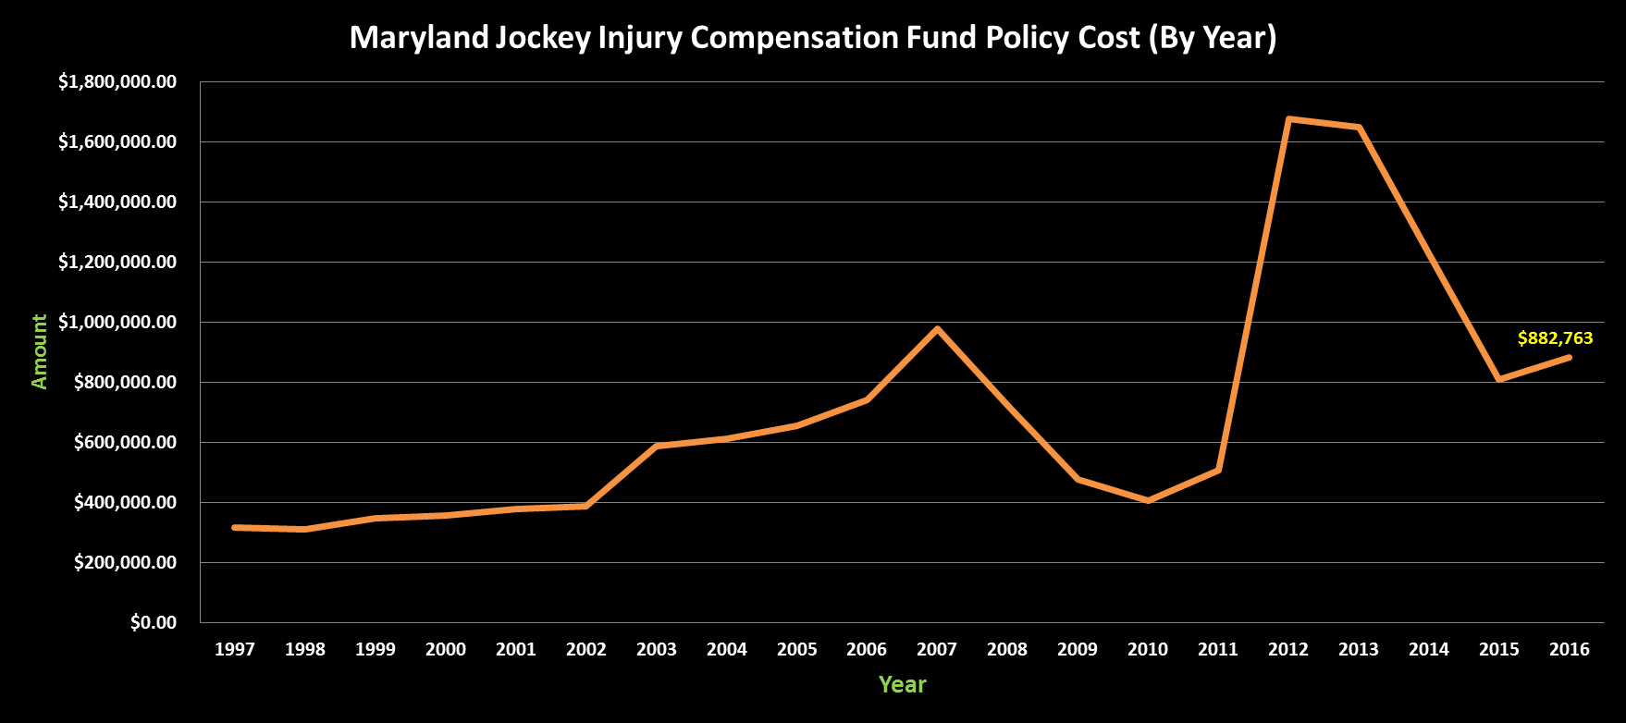
MARYLAND-BRED FUND REPORT

MARYLAND-BRED FUND DISTRIBUTION IS EXPLAINED

The Maryland Fund was created by the General Assembly in 1962. Maryland was the first state to develop a legislated incentive program to encourage the improvement of Thoroughbred breeding and racing. Since that time, more than 30 other states have instituted incentive programs largely based on this model.

In Maryland, there are six categories through which monies from the fund are made available: 1) purse money for stakes races for registered Maryland-breds; 2) awards for owners of registered Maryland-breds finishing first, second or third; 3) awards for breeders of registered Maryland-breds finishing first, second or third; 4) awards for owners of stallions which are duly registered with the Maryland Horse Breeders Association (MHBA); 5) yearling show bonus awards for the four highest-earning 2 and 3-year-olds shown at the annual MHBA yearling show (based on North American earnings); and 6) Maryland-sired allocation for purses and awards for horses conceived in Maryland by a registered/nominated Maryland stallion.

The Maryland-Bred Fund receives slightly less than 1 percent of the total mutuel handle and breakage from Laurel and Pimlico (the State’s two mile tracks), and receives approximately 1.5 percent of the mutuel handle and 5.0 percent of the breakage at Timonium (the State’s half mile track).

In 2016, revenue for the Maryland Bred Fund totaled over $6.5 million (includes approximately $1.2 million from pari-mutuel wagering funds and $5.3 million from other sources).
After eligible deductions a portion of this money is allocated to purses and owner awards. The remaining percentage is distributed in the form of breeder awards and stallion awards. In 2016 nearly $1,000,000 was paid in purses owner awards were paid with purses and $ 3.6 million was disbursed as breeder and stallion awards.

In 2016, breeder and stallion awards were paid for the registered Maryland-bred who finished first through third in any race in Maryland. The breeder awards were 30% percent and the stallion bonuses were 10 percent of the winner’s share of the purse. In stakes races the award is based on the first $100,000 of the gross purse. The Maryland-bred stakes program is typically planned on a meet by meet basis, and is based on projected revenues for the coming year.

In order to earn a breeder award, the horse must be registered as a Maryland-bred. In order to earn a stallion award, the horse must be registered as a Maryland-bred, and the sire must be registered with the MHBA, in addition to having been standing in Maryland at the time the horse was conceived.

The Maryland-Bred Fund program is administered by the Maryland Racing Commission with the assistance and advice of the Maryland Fund Advisory Committee chaired by David Hayden, a member of the Maryland Racing Commission. Other members of the Maryland Fund Advisory Committee are Georganne Hale (representing mile tracks); Andy Cashman (half-mile track) and Willie White and Larry Johnson (MHBA). Under the direction of the Commission, the actual implementation of the fund, including maintaining the Maryland-bred registry and computing and distributing all bonus awards, is performed by the MHBA for which it receives up to 10 percent of the total receipts of the Fund, subject to the approval of the Maryland Racing Commission.

Breeder and stallion award percentages are determined on a bi-annual basis on the advice of the Maryland Fund Advisory Committee. Owner award percentages are determined by a separate agreement. (For Maryland Million Day, breeder and stallion award percentages are determined annually). Awards are distributed as soon as is practical. The quality of Maryland-breds has improved since the Maryland-Bred Fund was initiated over 50 years ago and the program is evaluated bi-annually to ensure the most effective use of the money.

MARYLAND STANDARDBRED RACE FUND

Total purses for the year were $1,711,025 an increase from 2015 purses. The Maryland Sire Stakes (MSS) and Maryland Standardbred Fund (MSF) combined totals for the program in each year from 1997 through 2016 are shown below:

YEAR |  | MSS |  | MSF |  | TOTAL
1997 |  | $1,209,660 |  | $793,775 |  | $2,003,435
1998 |  | $1,152,040 |  | $909,190 |  | $2,061,230
1999 |  | $1,171,750 |  | $967,620 |  | $2,139,370
2000 |  | $1,215,690 |  | $1,132,700 |  | $2,348,390
2001 |  | $1,142,780 |  | $1,039,960 |  | $2,182,740
2002 |  | $970,360 |  | $900,690 |  | $1,871,050
2003 |  | $947,550 |  | $833,250 |  | $1,780,800
2004 |  | $784,000 |  | $537,127 |  | $1,321,127
2005 |  | $779,104 |  | $627,761 |  | $1,406,865
2006 |  | $859,650 |  | $687,860 |  | $1,547,510
2007 |  | $816,750 |  | $620,200 |  | $1,436,950
2008 |  | $720,000 |  | $494,550 |  | $1,214,550
2009 |  | $445,000 |  | $315,550 |  | $760,550
2010 |  | $311,500 |  | $241,475 |  | $552,975
2011 |  | $447,500 |  | $260,250 |  | $707,750
2012 |  | $798,600 |  | $172,250 |  | $970,850
2013 |  | $825,997 |  | $529,475 |  | $1,355,472
2014 |  | $1,406,377 |  | $501,835 |  | $1,908,212
2015 |  | $1,210,700 |  | $472,585 |  | $1,683,285
2016 |  | 1,239,250 |  | 471,775 |  | 1,711,025

