What is WIOA?
WIOA stands for Workforce Investment Opportunity Act and was signed into law on July 22, 2014. The purpose of WIOA is to bring the Departments of Labor and Education together to provide job seekers access to a) employment and training services, b) adult education, literacy, and c) Vocational Rehabilitation programs. WIOA replaced the Workforce Investment Act (WIA) of 1998.

The WIOA performance measures for Adult Education went into effect on July 1, 2016, and represent a change in the way data is collected in LACES and reported to OCTAE (Office of Career, Technical, and Adult Education). Data will be reported with the new WIOA performance measures beginning in the 2016-2017 program year using:
- Updated NRS Tables
- New Statewide and Local Performance Report
It is important that all LACES users familiarize themselves with the NRS guidelines as they pertain to WIOA. LACES is OCTAE and NRS compliant, and is designed to report data based on the guidelines of those organizations. Additional information regarding WIOA and how it affects NRS reporting can be found at the NRS WIOA website.

IMPORTANT NOTE: LiteracyPro has been making changes to LACES as the information from OCTAE and the NRS becomes available. Please be aware that the rules regarding WIOA performance accountability requirements for adult education are still evolving. LACES will be updated accordingly as the rules continue to be finalized.

Important Information About 16/17 Reporting
- NRS Table 5 reporting is not required for the 16/17 FY.
- Cohorts are no longer in effect. Cohort follow up conducted during the 16/17 FY is not reportable.
- 'Include in Survey' and 'Responded to Survey' have been discontinued for NRS reporting purposes.
- Students are now reported based on Periods of Participation (PoP).
- NRS Tables 1, 2, 3, 4, 4b, 4c, 5, 5a, 6, 8, 9 and 10 have changed.
- 'Barriers to Employment' are reported on the WIOA Statewide and Local Performance Report. Barriers to Employment are not reported on NRS tables.
- The OCTAE/NRS reporting due date is now October 15.
- Follow up quarters for NRS Table 5 have changed.

IMPORTANT NOTE: Students will not count on the new NRS Table 4 until their FY summaries are updated. Fiscal Year summaries may be run manually. Fiscal year summaries are also updated automatically. Check your user news page for your state's schedule.

What Changed in LACES?
LiteracyPro began making changes in LACES to accommodate the WIOA changes beginning with Release 2016.11.0. Additional changes were implemented in Release 2017.1.0, Release 2017.2.0 and Release 2017.3.0. Those releases included:

Release 2017.3.0
- The left date rules were changed.
- A checkbox field for 'Data Sharing Agreed' was added to the student intake page and the student key info page.
- A 'PoP Summary/Measurable Outcomes' panel was added to the student Outcomes tab.
- The 16/17 NRS Tables 4 and 4c were updated to report based on PoPs.
- Column E was removed on NRS Table 4b, and the row for ABE Level 6 was removed on Table 4b. (Table 4b does not report on PoPs).
- The concept of Periods of Participation was added (PoP), which includes assessments, enrollments, hours, scheduled services. If your state is NEDP accredited, click the 'NEDP Information' link on your User News page to learn how the NEDP cycle may be affected by PoPs.
- Additional PoP Pre/Post columns were added to the assessment grid.
- A 'Postsecondary Education or Training' panel was added to the student Education tab.
- Student FY summary record was updated to display PoP specific rows.

Release 2017.2.0
- NRS Table 6 was updated.
- A 'Barriers to Employment History' panel was added at the student History tab.
- Barriers to Employment were changed to read only format at the Demographics tab/Demographics panel.

Release 2017.1.0
- NRS Tables 1, 2, and 3 were updated.
- The 16/17 NRS tables were added as drill down searches. The updated 16/17 reports are NOT available at the Report Manager.

Release 2016.11.0
- The 'Secondary Program' field was added to the student intake form and the student Education tab/Education panel.
- Assessed levels were changed to display as levels (ABE L1, ABE, L2, etc.)
- 'Employed With Separation Notice' was added as a choice on the Employment Status drop down list.
- 'Secondary School Equivalent,' 'Some Postsecondary education, no degree,' and 'Postsecondary or professional degree' were added as choices on the Highest Ed Level Compl on Entry drop down list.
- The IEPT checkbox was added to the student and class enrollment record.
- Barriers to Employment were added to the student intake page and Demograpics tab/Demographics panel.

Are all the WIOA changes in LACES?

Not yet!

As mentioned above, the rules are evolving. At this time we plan to implement the changes related to Tables 5, 5a, 8, 9 and 10 by late April or early May 2017. The remaining updates related to searches, outcome imports, and the Statewide and Local Performance Report will be implemented prior to the end of the fiscal year.

How is my program affected by these changes?
LiteracyPro's goal for release 2017.3.0 was to implement the WIOA changes so your day-to-day data entry would not be greatly impacted. The changes were released to ALL LACES client databases, which includes ABE state clients and independent literacy agencies. While most independent literacy agencies may not report to the NRS, the only obvious changes independent literacy agencies will see are additional fields and panels, and the new rules regarding the population of the student Left Date field.

All you need to do is continue entering your data as normal and let the LACES rules do the rest. For example, continue to add assessments, enrollments, and hours as you normally do. The data will be placed in the appropriate Period of Participation (PoP) based on the record dates. When a student earns a High School Equivalency diploma, either enter the scores at the assessment grid, or enter a record at the Education tab/Diplomas/Credential panel. When a student enters postsecondary education or training, enter a record at the Education tab/Postsecondary Education or Training panel. If the information meets the requirements to be a PoP, look at the student Outcomes tab/PoP Summary/Measurable Outcomes panel for the PoP record.

If your state data matches High School Equivalency, Postsecondary, or Employment, you do not need to manually enter those records. If you are unsure, please check with your agency director or state department of education. (Maryland data matches High School Equivalency and Employment. Maryland no longer data matches with the National Student Clearinghouse for Postsecondary.)

As always, it is important to enter data on the schedule set by your agency or state. Because NRS reports are now due in October, it is especially important that you stay up-to-date with your data entry.

As a reminder, cohorts are no longer in effect! Unless directed by your state to do so, you do not need to follow up cohort data. Cohorts will not be used for 16/17 NRS reporting.

Acronyms and Definitions
Acronym/Abbreviation | Definition
EFL | Educational Functioning Level
HSE | High School Equivalency
IELCE | Integrated English Literacy and Civics Education
IEPT | Integrated Education and Training Program
MSG | Measurable Skill Gain
NRS | National Reporting System
OCTAE | Office of Career, Technical, and Adult Education
PoP | Period of Participation
SPL/GLE | Student Performance Level/Grade Level Equivalency
SSD | Secondary School Diploma
WIOA | Workforce Investment Opportunity Act

New Left Date Rules
How a student's left date is calculated has not changed. The left date calculates and displays in the student record header in the Left Date field based on:
- Student's last instruction hours date, including unlinked instruction hours. (Records with 0 hours do not count.)
- Student's last class or group start date, or pair match date if the student was enrolled or matched in a pair, but no instruction hours were entered.
- Student's intake date if there are no enrollments or hours.
When a student's left date displays has changed.

When | Change?
After 90+ days with no instructional hours, even if the student overall status is Active or Enrolled | No.
After 90+ days with no enrollments or hours, even if student overall status is prospective. | No.
After the student is marked completed or left from all enrollments, and all pairs are dissolved. The student overall status is then Left or On Hold. | Yes. Now the student left date will not display in the student header 'Left Date' field until 90+ days after the last activity in a Period of Participation, even if the student in no longer enrolled and the overall status is Left or On Hold.

Q: How can I tell what a 'Left' or 'On hold' student's left date is if the left date won't display until 90 or more days have passed?
A: Even though the actual left date is be based on either the student's last instructional hours date, last enrollment date, or intake date (depending on the student's activities), it is most likely that the student's left date will be based on instructional hours. The field 'Last Instr Hours Date' has been added to the Student List view to allow you to quickly see the last hours date. You can also create a student view that includes 'Overall Status,' 'Last Instr Hours Date' and 'Left Date.' This will help you to see what a student's potential left date will be.

In the screenshot below:
- Bob is still enrolled but 90+ days have passed since his last hours date (assuming today's date is 3/24/2017). His left date is the same date as his last instructional hours.
- Jimmy has completed all of his enrollments and his overall status is Left, but it has not been 90+ days since his last instructional hours date (assuming today's date is 3/24/2017). After 90+ days his left date will be 3/11/2017.
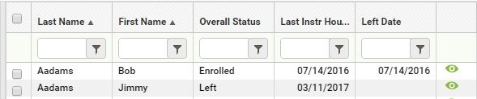
Tip: The 'Last Instr Hours Date' field is also on the student Education tab/Education panel.

Period of Participation (PoP)
Under the new WIOA rules, students are now reported on NRS tables 4, 4c, 5, 5a, 8, and 10 based on Periods of Participation (PoP). This represents a significant change in how student activity is reported but only minor changes in your data entry processes. If your data is entered in a consistent and accurate manner, the LACES business rules will ensure that the data is reported correctly on the NRS tables for each period of participation.

What is a Period of Participation?

A Period of Participation (PoP) begins when a student enters your program and has activity, and ends when the student leaves, or does not have additional activity 90+ days after the last activity date. It is considered a new entry if the student returns in the current program year after a gap of 90+ days since the last activity. At that time a new PoP will begin. While it is possible for a student to have up to four PoPs within a fiscal year, most students will have one or two.

A read only PoP summary record will populate at the Outcomes tab/PoP Summary/Measurable Outcomes panel once a level defining pretest AND 12 instruction hours have been entered in the student record. Students do not count on NRS Table 4 until they have at least one PoP. (Please refer to the Table 4 instructions)
All student data has been synced to a PoP. This means that students who meet the requirements to be in a PoP will display a record(s) at the student Outcomes tab/PoP Summary/Measurable Outcomes panel.
Each PoP summary record will display:
- A start date
- An end date
- Total number of instruction hours in the PoP
- Subject area
- Entry level
- Exit level
- Completed Level
- Obtained Secondary Credential (based on an assessment record or a diploma info record)
- Entered Postsecondary Education (based on a Postsecondary Education or Training record)
- Left Date

IMPORTANT NOTE: Employment information will be included in the PoP summary record in a future release.
How PoP Data is calculated

PoP Start Date | First activity in a PoP:  - First assessment date, whether a level defining assessment or not  - First hours date, regardless of hours type  - The student start date in a class, group, or workshop, or pair match date  - Diploma/Credential record date earned  For NEDP states ONLY:  - NEDP Diagnostic Phase Entry Date  - NEPD Assessment Phase Entry Date
PoP End Date | Last activity in a PoP:  - Most recent assessment date, whether level defining assessment or not  - Last hours, regardless of hours type  - Most recent start date in a class, group, or workshop, or pair match date if there are not hours entered after that date within 90+ days  For NEDP states ONLY:  - NEDP Diagnostic Phase Entry Date  - NEPD Assessment Phase Entry Date
Instruct Hours | - The total number of instructional hours between the PoP start and end date. (Remember that an hours date may also be used to calculate the PoP start or end date.)
Subject Area | - The subject area of the assessment in effect between the Pop start and end date. (Remember that an assessment date may also be used to calculate the PoP start or end date.)
Entry Level | - The entry level based on the level defining assessment identified as the pretest in the PoP.
Exit Level | - The exit level based on the assessment identified as the post test in the PoP, or the level of the assessment identified as the pretest if no post test has been entered.
Completed Level | - Displays 'yes' if level is completed from a post test.  - Displays 'yes' if entry level is ABE L6 and the student earns a secondary school diploma.  - Displays 'yes' if the student entered Postsecondary education or training after PoP exit date but before the last day of the fiscal year. NOTE: Entered Postsecondary after exit now counts as an EFL gain on Table 4.
Obtained Secondary Credential | - Displays 'yes' if the student earned a secondary credential.
Left Date | - Left date in the PoP. This date will not display until 90 days after the last activity in a PoP, but will be based on the left date rules.
Entered Postsecondary Education | - Displays 'yes' if the student entered postsecondary education after the exit date in the PoP and the PoP left date displays. Entered Postsecondary Education and Training records are entered in the student record at the Education tab/Postsecondary Education or Training panel.

In the screenshot below:
- The student's first enrollment was on 7/5/2016, which set the PoP start date.
- The last instruction hours were on 7/14/2016, which set the PoP end date.
- There was a total of 14 instructional hours in the PoP.
- The student's assessment subject was Read.
- The assessed entry level was ABE L5.
- The student did not have a post test, so the exit level was also ABE L5.
- Completed Level is 'yes' because the student Entered Postsecondary Education after the PoP exit date but before the end of the fiscal year. Entering Postsecondary after PoP exit may now count as an EFL gain on Table 4.
- Obtained Secondary Credential is 'yes' because the student earned a GED.
- Left Date is 7/14/2016, which is the date of the last instruction hours.
- Entered Postsecondary Education is 'yes' because the student has a Postsecondary Education record entered after the end date of the PoP but before the last day of the fiscal year.

REMEMBER: A new PoP will not begin until there is activity 90+ days after the previous PoP end date. A PoP summary record will not populate until an assessment and 12+ instruction hours have been entered.

Q: A student in my program has had an assessment, is enrolled in a class, and has hours, but doesn't have a PoP Summary/Measurable Outcome record. Why not?
A: In order for a PoP Summary/Measurable Outcomes record to populate, the student must have at least 12 instructional hours without a gap. For example, look at the screenshot below.

Even though this student has been assessed and is enrolled, the student did not earn at least 12 hours before a 90 day gap in activity. The student earned 4.75 hours between 8/31/2016 and 11/11/2016. There is a 90+ day gap between the hours on 11/11/2016 and 2/24/2017. The student still has not earned at least 12 instructional hours after the gap, so will not have a PoP record until at least 2 more instructional hours are earned within 90 days of 3/3/2017.

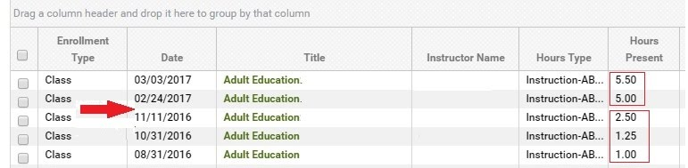

Assessments in PoPs
You will notice additional columns on the Student Assessments grid at the Pre/Post default view.

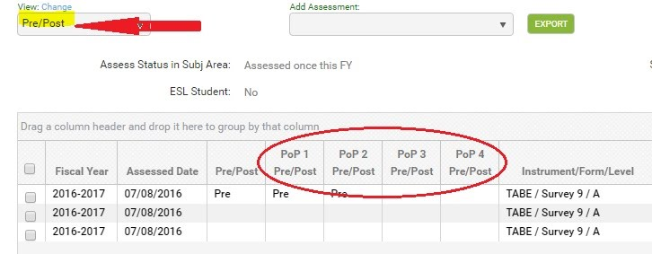

The additional columns allow you to see the assessments being used as the pre and post tests within a PoP.

There are four PoP Pre/Post columns because it is possible for a student to enter your program 4 times within the program year with 90+ day gaps.

It is important to understand what displays on the assessment grid and how the information pertains to the student's assessment activities.

Pre/Post Column | The Pre/Post column identifies the assessments being used as the pre and post tests for the entire program year. The assessments in this column populate the student header 'Subject Area', 'Entry Level', and 'Current Level' fields. This is exactly what LACES has always done, so there is NO CHANGE to this functionality.  This column and functionality was not changed since many independent literacy agencies who also use LACES do not report to the NRS, and their additional reporting needs may not include PoPs.  Important: Depending on whether or not a subject area override has been indicated, an assessment that shows as the pretest in this column may not be the pretest for the first PoP. This is explained in further detail below for Assessment Rule 1.
Pop 1, PoP 2, PoP 3, PoP 4 Pre/Post Columns | These columns identify the assessments being used as the pre and post tests for each student program entry that starts a new PoP.  There are specific rules that are used to identify existing assessments as the pre or post test in a PoP, or to determine the pretest or subject area in a PoP when a new assessment is entered. See the rules below.

Assessment Rules
- The most recent assessment in the subject area is carried forward as the pretest for the next PoP after a 90+ day gap in activity, regardless of scaled score or SPL/GLE.
- The user may override the carried forward assessment by selecting a different subject area in the previous PoP. The most recent assessment in the subject area, however, will be used as the pretest in the new PoP.
- A level defining assessment, regardless of subject area, entered before the first hours date after the start of a PoP will override the automatically carried forward assessment.
- An assessment in the subject area entered AFTER the first hours date in a PoP will be considered to be the post test when there is a carried forward pretest.
- Any assessment in a different subject area entered AFTER the first hours date in the PoP can be set as the subject area in the PoP, overriding the default subject area.

How do these rules work?
Assessment Rule 1:
The most recent assessment in the subject area is carried forward as the pretest for the next PoP after a 90+ day gap in activity, regardless of scaled score or SPL/GLE.
Look at the screenshot below.
- You can tell from the assessment grid that the student had two TABE assessments on 7/8/2016. The Reading assessment had a lower score and a lower assessed level than the Math assessment. The subject area defaulted to Read, and the Reading assessment defaulted to Pre in both the Pre/Post and PoP1 columns.
- The student then had Reading and Math post tests on 8/15/2016. Because the scores went down, there is no post test indicated.
- The student went 90+ days without activity.
- The student returned and earned 12 instructional hours. A second PoP began.
- The most recent assessment in the subject area was the Reading assessment on 8/15/2016. That assessment now is the pretest for PoP2 - NOT the Reading assessment on 7/8/2016..
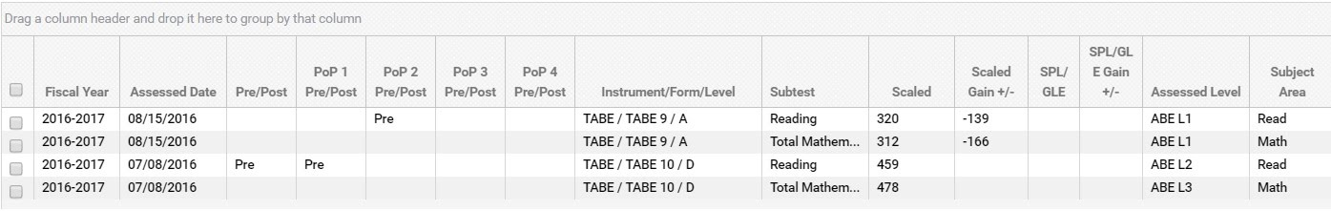
Q: Which assessment is the pretest if there are multiple pretests on different dates?
A: The assessment dates are important. In the screenshot below, the student has only been pretested. The student's lowest scaled score is in Language. However, since this assessment was entered on a date after the Reading and Math assessments, Language is not the subject area. Read is the subject area, so the Reading assessment will carry over to the next PoP. To change the subject area to Language for PoP 1, you would click the Move Forward button on the Language assessment record and select 'Use as Subject Area for PoP 1.' This would then carry over Language as the subject area for PoP 2. See Assessment Rule 2.

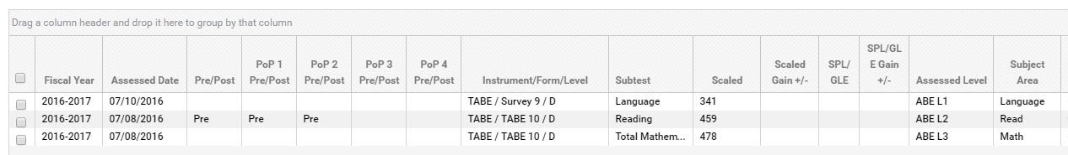

Assessment Rule 2:
The user may override the carried forward assessment by selecting a different subject area in the previous PoP. The most recent assessment in the subject area, however, will be used as the pretest in the new PoP. See Assessment Rule 1.
Look at this screenshot below.
- The student is currently being tracked in Reading. Since the student did not have a post test, the Reading assessment will automatically be used as the pretest for PoPs 1 and 2.
- However, the user wants to track the student in Language instead.

3. To track the student in Language, click the move forward button on the Language assessment record.
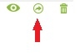
4. You will now see a new window. The window displays the options that are appropriate for this particular assessment. The assessment may be used to set the subject area for PoP 1 or PoP 2.

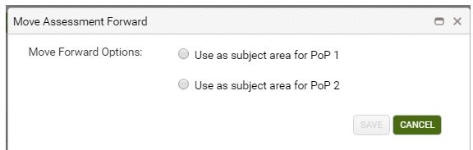

5. If 'Use as subject area for PoP 1' is selected, the subject area will change in the PoP 1 and PoP 2 Pre/Post columns, but not the Pre/Post column.
- Read is still the subject area for the overall fiscal year since it was a) entered prior to the Language assessment, and b) was the lower scaled score.
- Clicking the Move Forward button on the Language assessment and selecting 'Use as subject area for PoP 1' only affects the subject area for PoP 1.
- Selecting 'Use as subject area only for PoP 1, will, by default, carry this subject area forward to PoP 2.
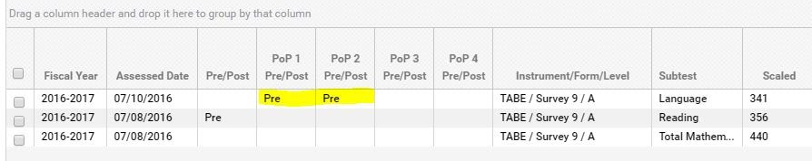

6. If 'Use as subject area for PoP 2' is selected, the subject area will change in the PoP 2 Pre/Post column, but not the Pre/Post or PoP 1 Pre/Post columns.
- Clicking the Move Forward button on the Language assessment and selecting 'Use as subject area for PoP 2' only affects the subject area for PoP 2.
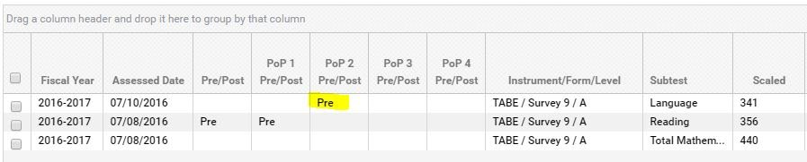

Using Select Subject checkbox vs. Move Forward icon
Q: When I need to track a student in a different subject area, I typically check the 'Select Subject' box on the assessment card. Should I still do that?
A: Assessments that had 'Select Subject' checked prior to the WIOA changes released on 3/24/2017 will remain the pretest and subject area, and will be used to set the pretest and subject area in the PoPs. This overrides an assessment with a lower score for setting the subject area.

Going forward, we recommend:
- All ABE clients should only use the Move Forward icon on the assessment grid to change the subject area. Because PoPs are now important for NRS reporting, this represents a new way of entering and managing your assessment data.
- Independent literacy clients who do not report to the NRS and do not report based on PoPs may continue to use the 'Select Subject' checkbox on the assessment record. However, independent literacy agencies may also use the Move Forward icon, if they wish. The checkbox was not removed from the assessment card to allow independent literacy agencies to continue using their existing data entry processes.

IMPORTANT NOTE: There is currently no indicator on the assessment record that shows you which assessments have a subject area override as the result of using the Move Forward icon. This will be added in a future release.
To see assessments that have the 'Select Subject' box checked in the assessment record, use the All view at the Assessments tab, or go to the All Assessments area and add the field 'Select Subject' to the view.
Q: I've only used the move forward button to move an assessment to the next fiscal year. How do I do that now?
A: You still use the same button, but you will only see 'Move forward to next fiscal year' on the message if that is an applicable option. The functionality to move an assessment forward to the next fiscal year has not changed. For example, if your agency setting for Max Days to Move Assessments Forward is set for 120 days, assessment dates that do not fall within that range from the last day of the FY cannot be moved forward; the option to do so will not display on the message. Once the assessment is within range, the option will display on the message. (Ex: if the setting is 120 days, only assessments entered with a date from 3/2 to 6/30 may be moved forward to the next FY.)

To see the Max Days to Move Assessments Forward setting in your agency, go to:
- Profile menu
- Agency Settings
- Agency Data tab/Detail panel
NOTE: Some agencies may not see this information, depending on the configuration of the client.

Assessment Rule 3:
A level defining assessment, regardless of subject area, entered before the first hours date after the start of a PoP, will override the automatically carried forward assessment.

NOTE: Some states have a policy requiring students who return after a 90+ day gap in activity be retested when they return. If this is a policy in your state, the assessment should be entered as the first activity. (Maryland’s policy is that if a person is separated from a program for 120 or more days he or she will need to be administered a new assessment.)

Look at the screenshot below:
- The student has only been pretested and is in two PoPs.
- The first hours date in the second PoP was 2/3/2017. The pretest from PoP 1 carried forward to PoP 2.
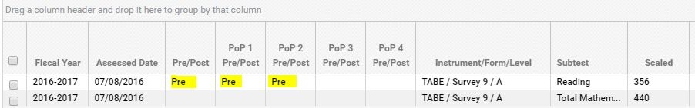

3. A reading assessment was then entered on 1/30/2017. Because the assessment is in the subject area and the scaled score is higher than the pretest, this assessment is a post test for the overall fiscal year. It is NOT a post test for PoP 1 because it is not within the PoP 1 range.

4. However, since the assessment on 1/30/2017 is within the second PoP, and the date is prior to the first hours date in PoP 2, this assessment is now the pretest for PoP 2.

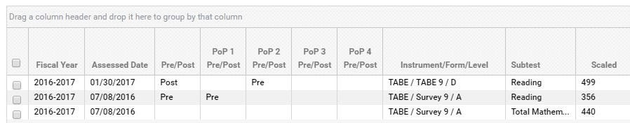

Q: Can the student be tracked in a different subject area in PoP 2?
A: Yes. When the assessment for a new PoP is entered as the first activity, the assessment subject for that assessment will override the automatically carried forward assessment. While the subject area field in the student header will not change, the new subject area will display in the PoP Summary/Measurable Outcomes record.
In the screenshot below, the subject area for PoP 2 is Math because the Math assessment was entered as the first activity in PoP 2.

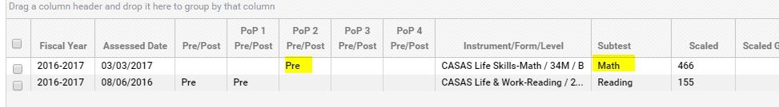
Assessment Rule 4:
Assessment in the subject area entered after the first hours date in a PoP will be considered the post test when there is a carried forward pretest.
Assessment Rule 4 is the reverse of Assessment Rule 3.
Look at the screenshot below.
- In this example, the student's first activity in PoP 2 was hours on 1/25/2017.
- The reading assessment on 7/8/2016 carried forward as the pretest for PoP 2.
- A new reading assessment was entered on 2/1/2017, which is after the first hours date in PoP 2.
- This assessment is now the post test for the overall fiscal year, and is the post test for PoP 2.
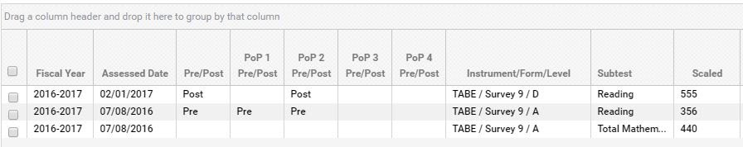
Assessment Rule 5:
Any assessment in a different subject area entered after the first hours date in the PoP can be set as the subject area in the PoP, overriding the default subject area.

Look at the screenshot below.
- The student has hours on 2/2/2017, which began PoP 2.
- A CASAS Math assessment was entered on 2/25/2017.
- Because the assessment was entered after the first hours date in PoP 2, it is not considered a pretest for PoP 2.
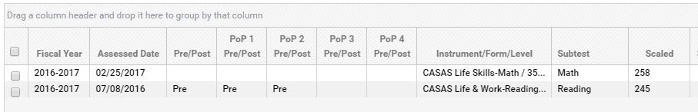

3. To set the CASAS Math assessment as the subject area for PoP 2, click the Move Forward icon on the assessment record.
4. Select 'Use as subject are for PoP 2.'

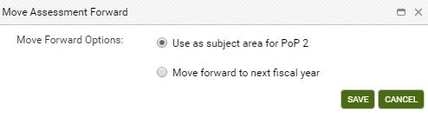

5. The assessment grid now displays:

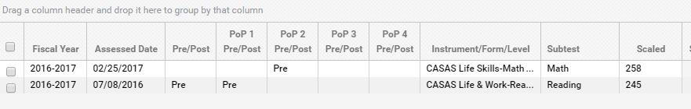

Obtain Secondary Credential
A secondary credential is a GED, HiSET, TASC, Secondary Diploma/Credential, High School Diploma, State High School Equivalency Diploma, or NEDP Diploma. Each of these may be entered as a record at the student Education tab/Diplomas/Credentials panel with the Diploma/Credential Type selected, and the Date Earned entered. GED, HiSET, and TASC may also be entered at the Assessment tab.

There are three changes in the way secondary credentials are reported on NRS Table 4.
- Obtaining a secondary credential is not counted as a completed level when the student's entry level is ABE L6, as it was previously on Table 4. Now, obtaining a secondary credential counts on the new Table 4 in column E (Attaining a secondary school diploma or its equivalent.)
- Students do not have to enter at ABE L6 in order to count on Table 4 as attaining a secondary credential.
- Table 4b no longer has a row for ABE L6 to show completed level when a student attains a secondary credential.
Entered Postsecondary Education
An important change to NRS Table 4 is that students entering Postsecondary Education or Training after exit can now count as making an EFL gain, even if the student was not post-tested. In order to show this, the Postsecondary Education or Training panel has been added for all clients at the student Education tab. A record must be entered to show that the student entered postsecondary.
Agencies will now need to use this Postsecondary Education or Training panel to capture this data moving forward or students will not be able to be included on either Table 4 or 5 for the postsecondary outcomes. Previously, DLLR captured this data via two ways: 1. A data match with the National Student Clearinghouse and 2. Pulling the Goals Met for the following two goals: ‘enrolled in a postsecondary institution’ and ‘enrolled in occupational training’. Since DLLR is no longer using either of these two methods to collect this entered postsecondary data, it is important that agencies use this Postsecondary Education or Training panel to capture this data moving forward.
Look at the screenshot below.

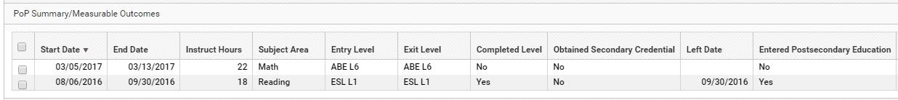
- The student is in two PoPs, but only the first PoP displays a left date since 90+ days have passed since the PoP end date.
- PoP 2 does not have a left date yet.
- A Postsecondary Education or Training record was entered in the student record with the date 3/20/2017.
- Since a record for entered Postsecondary Education or Training was entered after the PoP 1 Left Date, the columns Completed Level and Entered Postsecondary Education are both 'yes' for PoP 1.
- These columns will also display 'yes' for PoP 2 after a left date populates for PoP 2.

Q:: Why will these columns display 'yes' for both PoPs?
A: Because the student entered postsecondary after exiting, the student gets credit for making a MSG in both PoPs. But again, remember that the Entered Postsecondary column will only display 'yes' after 90 days have passed and a left date displays for the PoP.

Scheduled Services
One of the major WOIA changes is the concept of Periods of Participation (PoP). While the student is enrolled and earning instructional hours without a 90+ day gap in activity, the student is in a PoP. Once the student completes all enrollments and leaves the program, or stops attending and is gone for 90+ days, the student begins a new PoP when they return.

However, a scheduled service by enrollment date or scheduled service start date overrides the 90+ day left rule.

The NRS states:
- Program exit occurs when the participant has not received services for the past 90 days and has no additional services scheduled. The date of exit is the last date on which the participant receives services.

How this works in LACES:

Scheduled Service | Rules | When to use
Class, group, or workshop enrollment that is scheduled during a student’s PoP but starts on a future date. The enroll date will be within the PoP but the enrollment start date will be in the future. Pairs are NOT scheduled services. | The scheduled service is based on the student enroll date in a class, group, or workshop - not the class or group start date.  The scheduled service is in effect until 90 days after the class or group start date if the student did not earn instructional hours. The student will then be 'left' in the appropriate PoP. A future class or group enrollment may cross the fiscal year boundary. | Use if your agency creates future classes, groups or workshops, and you are allowed to enroll the students in advance of the class, group, or workshop start date. For example:  - A student was in a PoP between 7/1 and 9/25 but is not currently enrolled.  - The student plans to return after the first of the year.  - Classes, groups, and workshops that do not begin until the new year are created with a start date in January.  - The student is then enrolled into these classes, groups, or workshops.  - The student must have an enroll date that falls within 90 days of the last PoP activity date, but the enrollment start date will be in January.  - The student will not be left if there is a gap of 90+ days without activity. However, the student must earn instructional hours within 90 days of the enrollment start date.  This is a scheduled service.  Pro: Staff/tutors assigned to teach these classes or groups can plan accordingly, since they know how many students will be attending. Con: Students may not return even though they are scheduled, and must either be deleted from the class or group, or the enroll status changed to Never Attended. This creates additional data entry and may affect student measurable outcomes follow up quarters.
Indicated by a 'Scheduled Service Start Date' entered in the student record at the Education tab/Education panel. This is the date a student is planning to begin a future service. | The scheduled service ‘expires’ 90+ days after that date if there has been no enrollment during that time, and the student will then be 'left' in the appropriate PoP. A Scheduled Service Start Date may cross fiscal year boundaries. | Use if your agency creates future classes or groups, but students are not allowed to be future enrolled. Or: If your agency does not create future classes or groups but needs a way to show that a student plans to return after a gap in activity. OR: If your agency creates future classes or groups, but students are not allowed to be future enrolled because of customized assessment rules. You want to indicate that a student will return but the student cannot be enrolled in a future class or group without a new assessment. (NOTE: check the User News at the '<ST> Customizations' link to see if your state or agency has customized assessment rules.) Pro: Allows you to indicate that a student plans to return but is not yet enrolled in a class or group, which prevents the student from being considered left. Con: The student may not return to be enrolled. If the student is not enrolled but is not considered left, you must remember to check the Scheduled Service Start Date field. The date can be deleted, but this may create additional data entry may affect student measurable outcomes follow up quarters. Also, when this date is entered, the student overall status may be left, and a Left Date displays in the student header field, but the PoP summary record will NOT display a left date.

Scheduled Service Start Date
- This student entered the program on 9/12/2016 and his last hours date was 9/28/2016. That was the student's last activity in the PoP. It has been more than 90 days since 9/28/2016, so the student is left. Notice that the Left Date in the student header and the Left Date in the PoP summary record are the same.
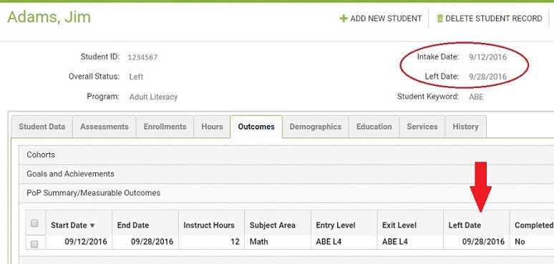

Now, assume that today's date is 3/24/2017. The student plans to return on 5/1/2017 but is not enrolled in a class or group. The date of 5/1/2017 is entered in the Scheduled Service Start Date field.
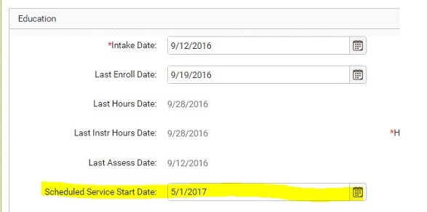

The student is no longer considered left because he has a scheduled service. However, notice that his overall status is still Left and the Left Date of 9/28/2016 still displays in the student header, but his PoP summary record does NOT display a left date.

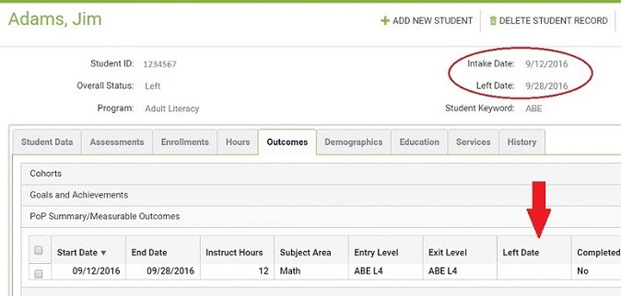

Q:: When will Jim be considered left in the PoP?
A:: If Jim does not enroll in a class or group within 90 days of 5/1/2017 (approximately 8/1/2017) , his original left date of 9/28/2016 will re-populate in the PoP summary record. This may affect follow up for his outcome measures.

If the date is deleted from the field, the left date will re-populate in the PoP summary record.

Scheduled Enrollment
- Using the same student from the example above, the last activity in his first PoP was 9/28/2016. There is no date in the Scheduled Service Start Date field.
- The student was, however, enrolled in a class that is scheduled to begin on 5/1/2017.
- If the student's enrollment date in the class is within 90 days of 9/28/2017, he will not be considered left. In this example, his enrollment date was 10/15/2016, which is within 90 days of his left date of 9/28/2016.
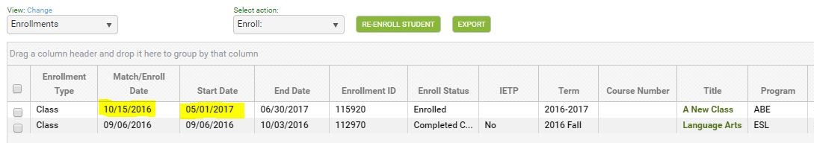

Q:: When will Jim be considered left in the PoP?
A:: If Jim does not earn instructional hours within 90 days of the class start date, his original left date of 9/28/2016 will re-populate in the PoP summary record. This may affect follow up for his outcome measures.
You may delete Jim's enrollment record in the class if he does not return. When the enrollment is deleted, the left date will repopulate in the PoP summary record.

It is important to utilize Scheduled Services only as directed by your state policy. When a student has a scheduled service, they are not left unless the scheduled services requirements have not been met. This is important for employment, obtain secondary credential, and entered postsecondary follow up. Make sure you are following your state policy in regards to scheduled services.

NRS Table Changes/Updates for WIOA Reporting

Tables 1, 2, 3
The following tables were updated in Release 2017.1.0.

Table | What changed | Additional Info
Table 1 | The Entering Educational Functioning Levels in column A have been updated to reflect the new levels. | The Educational Functioning Level labels were updated in 2016.11.0 release.
Table 2 | The age ranges have been updated. | Beginning in fiscal year 2016-2017, the age ranges for NRS reporting have changed. Prior fiscal year reports will still report on the age range for that year.  Age ranges for 2016-2017:  16-18  19-24  25-44  45-54  55-59  60+
Table 3 | The program 'Integrated English Literacy and Civics Education (Sec. 243)' has been added.  Rows for Integrated Education and Training Program has been added as a subset under each program row.. | Students populate on the rows for Adult Basic Education, Adult Secondary Education, and English Language Acquisition based on pre-test entry level. This has not changed from the way students have populated NRS Table 3 in prior fiscal years.  'Integrated English Literacy and Civics Education (Sec. 243)' is NOT based on a pre-test entry level, but is based on the secondary program IELCE. The secondary program field is located on the student intake page and the student Education tab/Education panel. When IELCE is selected at the secondary program field, the student will count on this row - regardless of their entry level.  Students will populate the rows under each program if the student has the IETP field checked in the enrollment record of at least one current fiscal year class enrollment.  For example:  Bob - pretest entry level is ABE L5. He does NOT have an IETP enrollment. Bob has 12+ instruction hours. Bob counts on Table 3 on the Adult Secondary Education row.  Mary - pretest entry level is ABE L2. She has an ITEP enrollment. Mary has 12+ instruction hours. Mary counts on Table 3 on the Adult Basic Education row, and on the Integrated Education and Training Program row. Integrated Education and Training Program is a subset of students who count on the Adult Basic Education row.  Joe - pretest level is ESL L4. IELCE has been selected in the secondary program field in his record. Joe has 12+ instruction hours. Joe counts on the Integrated English Literacy and Civics Education (Sec. 243) row. Joe will not count on the English Language Acquisition row even though his entry level is ESL because IELCE has been selected in the Secondary Program field.  Susan - pretest level is ESL L3. IELCE has been selected in the secondary program field in her record. She has an ITEP enrollment. Susan has 12+ instruction hours. Susan counts on the Integrated English Literacy and Civics Education (Sec. 243) row, and on the Integrated Education and Training Program row. Integrated Education and Training Program is a subset of students who count on the Integrated English Literacy and Civics Education (Sec. 243) row. Susan will not count on the English Language Acquisition row even though her entry level is ESL because IELCE has been selected in the Secondary Program field.

Table 6
The following table was updated in Release 2017.2.0.
Table | What changed | Additional Info
Table 6 | New employment row added | 'Employed, but Received Notice of Termination of Employment or Military Separation is pending' displays as a row on Table 6.  This populates from the employment option 'Employed with Separation Notice.' This option was added to the student record Employment Status field drop down list in Release 2016.11.0.
 | Disabled, On Public Assistance, and Living in rural areas rows have been removed. | The field 'Residence Area' was used to populate the row for 'Living in Rural Area' on Table 6 in prior fiscal years. The requirement for this field was removed in Release 2016.10.0.
 | Homeless and Work-based Project Learner rows have been removed.
The section for optional 'Secondary Status Measures' has been removed. This section included:
Low Income
Displaced Homemaker
Single Parent
Dislocated Worker
Learning Disabled Adults
 | The 'Highest Degree Level of School Completed' rows have been updated to include the new options. | The field 'Highest Education Level Completed on Entry' list was updated in Release 2013.00.0

Table 4
- The basic requirements to count on NRS Table 4 have not changed. Students must have at least one level-defining assessment and have at least 12 instructional hours.
- However, NRS Table 4 has been renamed to Measurable Skill Gains by Entry Level and major changes have been made regarding how information is reported in each column.
- Because the new 16/17 Table 4 is PoP based, students will not count until their FY summaries are updated. Fiscal Year summaries may be run manually. Fiscal year summaries are also updated automatically. Check your user news page for your state's schedule.
Column | Column Label | Description: who and what is counting
Column A | Entering Educational Functioning Level | Educational Functioning Levels.
Column B | Total Number Enrolled | Column B tracks the total number of students based on the entry EFL for the first period of participation only.
Column C | Total Attendance Hours for All Participants | Column C reports ALL instructional hours earned by students in the fiscal year who have at least one PoP.
Column D | Number Who Achieved at Least One Educational Functioning Level Gain | Column D tracks students reported in column B who made an EFL gain in the first period of participation only.  EFL is measured by the achievement of one of the following within the first period of participation only:  - A level gain from a post test with a level defining assessment.  - Enrollment in postsecondary education and training after exit but prior to 6/30. A Postsecondary Education or Training record must be entered on a date that is after the exit date of the PoP, but prior to 6/30.
Column E | Number Who Attained a Secondary School Diploma or Its Equivalent | Column E tracks the achievement of a secondary school diploma in the first period of participation only.  - A student cannot count in both Column D and Column E. If a student makes a level gain AND gets a secondary school diploma in the first period of participation, only the latest by date will be counted in one of these columns.  - If a student had multiple periods of participation, and achieved a secondary credential by the end of the fiscal year, then this MSG may be credited to each period of participation.  - If the student makes a level gain with a post test in the first period of participation, then earns a secondary school diploma by the end of the fiscal year, the secondary school diploma counts in column E, and the EFL gain is reported in column J.  The completion of a secondary school diploma is indicated by:  - GED, HiSET, or TASC assessment record with a passing score, or  - GED, HiSET, TASC, or other equivalency diploma record entered at the Diploma/Credential panel with date earned.
Column F | Number Separated Before Achieving Measurable Skill Gains | Column F tracks students who exited but did not make a MSG in the first period of participation only.
Column G | Number Remaining in Program Without Measurable Skill Gains | Column G tracks students who did not exit and did not achieve a MSG in the first period of participation only.
Column H | Percentage Achieving Measurable Skill Gains | Column H = D+E/B
Column I | Total Number of Periods of Participation | Column I is the total number of periods of participation for each participant from Column B.
Column J | Total Number of Periods of Participation with Measurable Skill Gains | Column J is the number of periods of participation for each student in Column B in which the student had any MSG. A maximum of one gain per period (most current) can be reported in Column J. This is based on the requirements for columns D and E.
Column K | Percentage of Periods of Participation with Measurable Skill Gains | Column J/Column I

Running the New NRS Tables
The new NRS tables for fiscal year 2016-2017 are not on the report manager but instead are located on the student NRS table searches. The searches for 2016-2017 tables have been updated to include the total rows and NRS instructions for completing the new tables. This change was introduced in Release 2017.1.0.

1. Click the <Searches link at the student area.
2. Expand the NRS category.
3. Select one of the new tables - NRS tables 1, 2, 3, or 6.
4. Select NRS FY 16-17 on the drop down list at the the 'Select Reporting System' field.
5. The new report will display. From here, you may print the report by clicking the Print icon at the top right.
6. Click any of the cells to drill down to the list of students populating the cell.

The correct table format will display once you select the Reporting System. For example, if you select NRS FY 15-16, the table format appropriate for that reporting year will display. If you select NRS FY 16-17, the new table for that reporting year will display.

Q: How do I save the new table?
A: Most browsers have a built-in PDF printer that allows you to 'print' and save any file to PDF.

To print an NRS table to PDF:

1. First, follow the steps above to display an NRS table using the <Searches link.
2. Click the printer icon on the window.
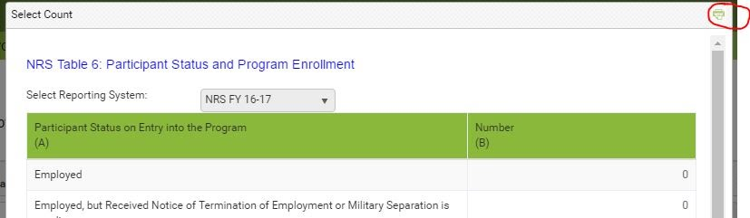

3. The 'PrintFriendly' window will display.
4. Click the Print button at the bottom of the window.
5. The printer dialog window will display. Depending on your browser and/or printer, you will see:

Chrome: Destination/Change
Firefox: Name field with a drop down list
IE: 'Select Printer' area

6. Depending on your browser/printer, you will then:
Chrome: Click the Change button and select 'Save as PDF'
Firefox: Select 'Microsoft Print to PDF.'
IE: Select 'Microsoft Print to PDF.

7. Depending on your browser and/or printer, you will then:
Chrome: Click the Save button
Firefox: Click the OK button
IE: Click the Print button

8. Select a location on your computer drive, enter a name for the file, and click Save.
9. The table is now saved as a file on your computer. You can locate the file, open, then print.

IMPORTANT NOTE: Be sure to look at the print dialog box the next time you print a file. You may have to change the destination or printer, back to your default printer name.

