STATE OF MARYLAND
BOARD OF PUBLIC ACCOUNTANCY
December 2, 2014

LOCATION: 500 North Calvert Street
Baltimore, Maryland 21202
Third Floor Conference Room
MEMBERS
IN ATTENDANCE: Elizabeth Gantnier
Mac Claxton
Ross Ehudin
Arthur Flach
Phillip J. Korb
Clifton B. Jeter
Naomi Powell

MEMBERS ABSENT:

DLLR OFFICIALS/STAFF: Dennis L. Gring, Executive Director
Linda L. Rhew, Administrative Officer
Matthew Lawrence, Counsel
Shontae Moore, Office Secretary
Douglas Blackstone, Director of Individual Tax Preparers
Janet Morgan, Outreach Coordinator
Michael Vorgetts, Acting Commissioner

OTHERS PRESENT: Mary Beth Halpern, MACPA
Shirley Buchanan, MSATP

The December 2, 2014 meeting of the Maryland Board of Public Accountancy was called to order at 9:08 AM by Elizabeth Gantnier, Chair.

Upon a motion (I) by Mr. Flach, and seconded by Mr. Ehudin, the minutes of the November 7, 2014 meeting were approved, with corrections.

Chairman’s Report

Ms. Gantnier reported on the MACPA swearing-in event which was held on November 10, 2014. The event was well-attended and she thanked everyone on the Board who were able to attend.

Executive Director’s Report

Mr. Gring presented the following report:

- CE Regulations, Policies and Reporting.
- The proposed modifications to the Continuing Education regulations will be published in the December 12, 2014 issue of the Maryland Register. The public will have until January 11, 2015 to comment. The Board can take final action on the proposed regulations at the February 3, 2015 meeting, with an effective date of no later than March 3, 3015.

- CPE Tracking –The Executive Director and staff will be working with NASBA, MACPA and MSATP, and to complete the testing of the system, determine data migration protocols from the MACPA and MSTAP to NASBA and from NASBA to the Board. A meeting with MACPA and MSATP is scheduled for early January.

- DOL-ERISA Financial Statement Project.
The Board is beginning to receive responses to inquiry letters to out of state firms that have been identified by the US Department of Labor as performing ERISA audits for employee benefit plans located in Maryland. Ninety-six (96) Maryland Employee Benefit
plan audits were identified by the DOL as being prepared by firms that did not have a
Maryland permit, including firms located in Maryland which either never have a permit or previously held a permit but let the permit expire. The deadline for responses is the week of December 15-19, 2014.

- CPA Application and Licensing Fees.
As was discussed last year, an analysis of the long term stability of the CPA Board Fund is dependent upon a series of adjustments to license application and license/permit fees over a period of fiscal years. These adjustments are necessary to sustain the Board’s ability to pay for its direct and indirect operating expenses as well as implement information technology initiatives and maintenance. The initial adjustment in fees was implemented in May 2014.

Acting Commissioner Michael Vorgetts recommended that the Board should defer any formal action for an additional adjustment for FY 2016 until the administration of Governor-elect Larry Hogan takes office and a new Secretary of DLLR has an opportunity to review any proposed adjustment.

- The Future of CPA License Population in Maryland

The age distribution of the Board’s current license population was evaluated as part of the long term analysis of the CPA Board Fund and its sustainability for the next ten years. A chart of the age distribution of the current CPA age distribution suggests a potential drop in the number of licensed CPAs as the baby boom generation continues to retire. A significant drop in the number of active licensees will impact revenue collected by the Board in the future. Further analysis is required to determine how significant the aging of the CPA population will have on future licensing projections. See chart below:

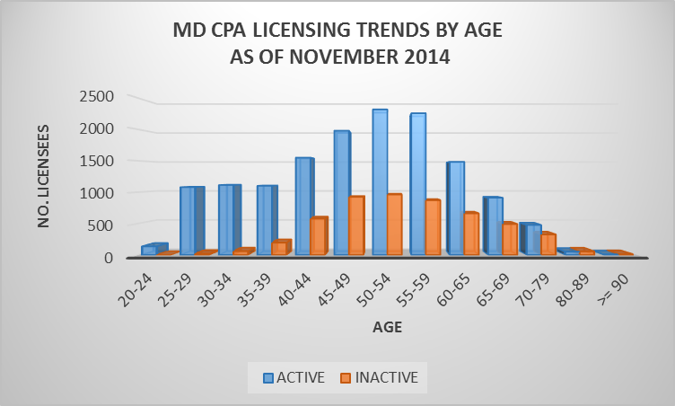
Exam Appeals

The Board did not consider any CPA Examination denial Appeals.

Education Report

Mr. Korb presented the Education Report. There were zero (0) Transfer of Grades application approvals during the period November 7, 2014, through December 2, 2014. There was one (1) Transfer of Grades application denials.

Upon a motion (II), by Mr. Ehudin, and seconded by Mr. Jeter, the Board unanimously approved the Education Report.

Experience Report

Ms. Powell presented the Experience Report. There were 5 Reciprocal and 17 Maryland Candidate license application approvals during the period November 7, 2014, through December 2, 2014.

Upon a motion (III), by Mr. Flach and seconded by Mr. Ehudin, the Board unanimously approved the Experience Report.

Firm Permit Report

Mr. Claxton presented the Firm Permit Report. Four (4) firm permit applications were approved during the period November 7, 2014, through December 2, 2014. There were three (3) firm application denials.

Upon a motion (IV), by Mr. Flach, and seconded by Mr. Korb, the Board unanimously approved the Firm Permit Report.

Peer Review Oversight Committee Report

Mr. Flach presented the Peer Review Oversight Committee Report.

- On November 14, 2014, the Board was contacted by the Kansas State Board of Public Accountancy inquiring about a Maryland CPA firm doing attest work in the state of Kansas on a DOL engagement. We contacted the Peer Review committee who indicated this firm had a peer review issued on June 18, 2014. This information was conveyed to the Kansas Board and the matter was concluded.

- The PROC met with the Peer Review committee on November 13, 2014 and the following status information was received:
  - 18 Firms were identified
  - 7 Firms had matters closed
  - 6 Firms were still in process

- A summary description of the status for each of the reviews revealed:

Five (5) firms were required to take corrective action;
Five (5) firm peer reviews were reviewed and closed;
One (1) firm merged with another
Three (3) firms received an accelerated review and were closed
One (1) firm provided information that made a recall review unnecessary
Three (3) firms were reviews were accepted and closed;
Two (2) firm reviews were accelerated and closed
One (1) Firm was determined by team captain not to need further review
One (1) firm was terminated from program for failure to comply;
Two (2) firm reviews were recalled;
Two (2) firm reviews were performed for year ending 12/31/2013 and plans were on schedule.

Upon a motion (V), by Mr. Ehudin, and seconded by Mr. Korb, the Board unanimously approved the Peer Review Oversight Committee Report.

Old Business

The Board agreed that if the Dean of MAALOT Baltimore would provide a letter signed by her stating that the classes where taken in Baltimore it would be sufficient. In the near future transcripts will read MAALOT Baltimore and not Jerusalem, Israel.

New Business

There was no new business.

Executive Session

Upon a motion (VI), by Mr. Ehudin, and seconded by Mr. Flach, the Board went into Executive Session in the 3rd Floor Conference Room, 500 N. Calvert Street, Baltimore, Maryland 21202 at 10:22 AM. The purpose of this session was to consult with counsel. This session is permitted to be closed pursuant to State Government Title Section 10-508(a), (7). It returned to the regular business meeting at 10:43 AM upon a motion (VII), by Ms. Powell and seconded by Mr. Claxton.

Complaint Committee Report

Mr. Jeter presented the Complaint Committee Report. Mr. Jeter reported that the Board opened two (2) consumer complaints during the period November 7, 2014 through December 2, 2014. Two consumer complaints were closed as follows: CPAS 14-0036 and CPAS 15-0026.

Upon a motion (VIII), by Mr. Flach, and seconded by Mr. Korb, the Board approved the Complaint Committee Report.

In EX-A1214 – Upon a motion (IX), by Mr. Korb, and seconded by Mr. Flach, the Board approved accommodations under the American with Disabilities Act for a CPA Examination candidate.

In EX-B-1214 - Upon a motion (X), by Mr. Claxton, and seconded by Mr. Korb, the Board approved the exam candidate application of an individual who needed her notice to schedule to be extended thru March 31, 2015.

Upon a motion (XI), by Mr. Claxton, and seconded by Ms. Powell, the Board adjourned at 10:50 AM.

NEXT MEETING

Tuesday, January 6, 2015, 500 North Calvert Street, Third Floor, 9:00 AM

__ ___ With corrections ____ Without corrections

_______________________________________ ____________________
Chairman Date

