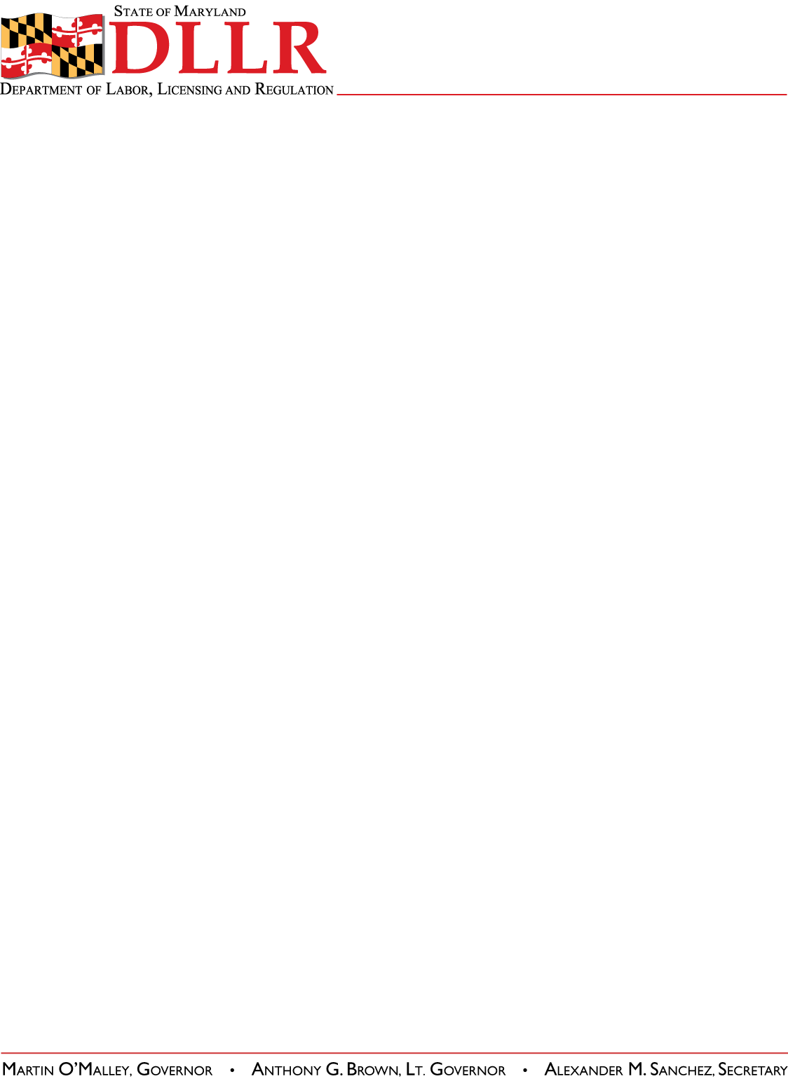
DIVISION OF LABOR AND INDUSTRY
J. RONALD DEJULIIS, COMMISSIONER
MARYLAND OCCUPATIONAL SAFETY AND HEALTH
ERIC M. UTTENREITHER, ASST. COMMISSIONER
10946 GOLDEN WEST DRIVE, SUITE 160
HUNT VALLEY, MD 21031-8212

MOSH STANDARDS NOTICE
MOSH STANDARDS NOTICE: 14-1 | EFFECTIVE DATE: September 2, 2013
SUBJECT: Globally Harmonized System – Hazard Communication | ISSUANCE DATE: October 1, 2013
CANCELLATION: None | EXPIRATION: Effective until replaced by a new Notice.

Purpose: The purpose of this action is to amend OSHA’s Hazard Communication Standard (HCS) to conform to the United Nations Globally Harmonized System of Classification and Labeling of Chemicals (GHS). The modifications include revised criteria for classification of chemical hazards; revised labeling provisions that include requirements for use of standardized signal words, pictograms, hazard statements, and precautionary statements; a specified format for safety data sheets; and related revisions to definitions of terms used in the standard, and requirements for employee training on labels and safety data sheets. OSHA is also modifying provisions of other standards to include standards for flammable and combustible liquids, process safety management, and most substance-specific health standards, to ensure consistency with the modified HCS requirements.

Scope: MOSH-wide

Contact: Chief of MOSH Compliance Services
See MOSH Website for Current Information: http://www.dllr.maryland.gov/labor/mosh.html

Background:

On August 14, 2013, the Commissioner of Labor and Industry adopted, through incorporation by reference under COMAR 09.12.31 Maryland Occupational Safety and Health Act – Incorporation by Reference of Federal Standards, amendments and revisions relating to Hazard Communication, 29 CFR Parts 1910 and 1926, excluding Part 1915 and 29 CFR §1910.1200(b)(6)(iv), published in 77 FR 17574 – 17896 (March 26, 2012), as amended. This action, which was proposed for adoption in 40:13 Md. R. 1082 – 1084 (June 28, 2013), has been adopted.

Action:

- Supervisors shall ensure that this notice is reviewed with all compliance officers and consultants.
- MOSH compliance and consultation personnel shall become familiar with and abide by all changes.

By and Under the Authority of

_________________________________________
Eric M. Uttenreither, Assistant Commissioner

cc: J. Ronald DeJuliis, Commissioner, Division of Labor and Industry
Jonathan Krasnoff, Assistant Attorney General
Office of Administrative Hearings

