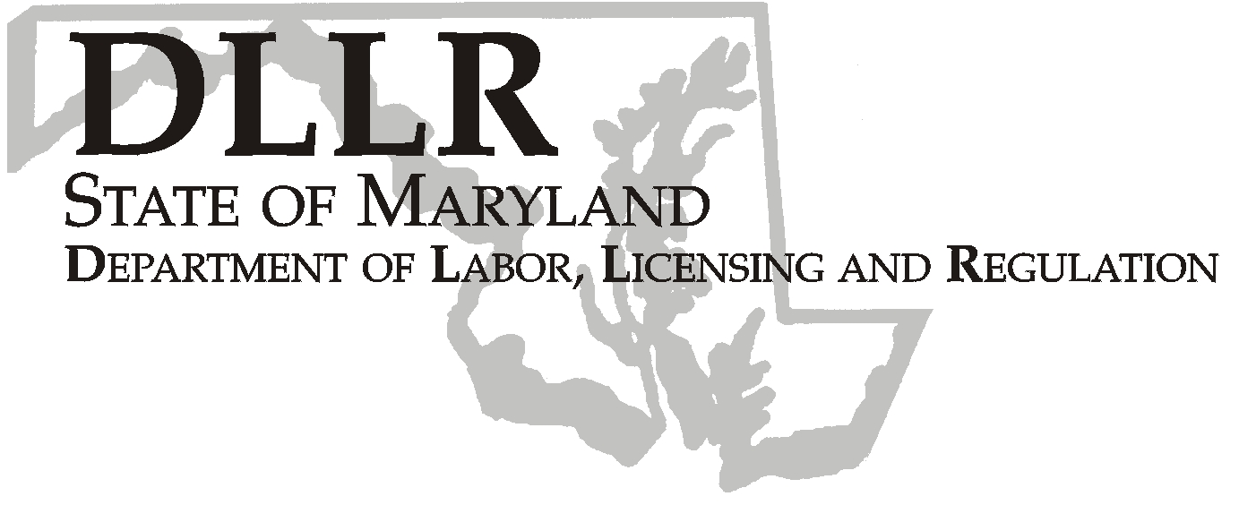
MARTIN O’MALLEY, Governor
ANTHONY G. BROWN, Lt. Governor
THOMAS E. PEREZ, Secretary

Division of Labor and Industry

J. Ronald DeJuliis, Commissioner

DLLR Home Page • http://www.dllr.state.md.us
DLLR E-mail • dli@dllr.state.md.us

MOSH STANDARDS NOTICE 06-2

TO: All MOSH Personnel

FROM: Roger Campbell
Assistant Commissioner

SUBJECT: Amendments to Regulation .05 under COMAR 09.12.20 Occupational Safety and Health.

PURPOSE: To clarify Maryland’s regulations with regard to prohibiting discrimination against employees exercising their rights under the Occupational Safety and Health Act so that State regulations are consistent with corresponding federal regulations. The action will clarify for employers and employees alike that occupational safety and health complaints to employers and other agencies are included in the actions for which an employer may not discriminate against an employee.

Effective Date: July 17, 2006

Issuance Date: February 20, 2008

- Background

- On June 27, 2006, the Commissioner of Labor and Industry adopted Amendments to Regulation .05 under COMAR 09.12.20 Occupational Safety and Health. This action, which was proposed for adoption in 33:10 Md. R. 894 – 895 (May 12, 2006), has been adopted as proposed. This action was recommended to the Commissioner of Labor and Industry by the Maryland Occupational Safety and Health Advisory Board pursuant to meeting held on January 4, 2006, notice of which was given in accordance with State Government Article, §10-506(c), Annotated Code of Maryland.

- Action

1. MOSH Compliance and Consultation Supervisors shall ensure that all Compliance Officers are trained on the
contents of this notice.

.05 Protection of Employees under §5-604 of the Act.

A. – C. (text unchanged)

D. Complaints. With regard to §5-604 of the Act, a “complaint under or related to this title” includes but is not
limited to:

  - A request for inspection under §5-209;

TEL: 410-767-2215 ⋅ FAX: 410-767-2003
TTY USERS, CALL VIA THE MARYLAND RELAY SERVICE
1100 N. EUTAW STREET
BALTIMORE, MD 21201

Keeping Maryland Working and Safe

  - Complaints regarding conditions at the workplace registered with the Commissioner, with a federal, State, a local agency with the authority regarding occupational safety and health conditions, or with such an agency that the employee, in good faith, believes has authority regarding occupational safety and health conditions; and

  - Complaints regarding conditions at the workplace made in good faith to an employer, management supervisor, or other employee serving in a supervisory capacity.

________________________________________ ________
Roger Campbell, Assistant Commissioner MOSH Date

cc: J. Ronald DeJuliis, Commissioner, Division of Labor and Industry
Craig D. Lowry, Deputy Commissioner, Division of Labor and Industry
General Jon Krasnoff, Assistant Attorney
Office of Administrative Hearings

