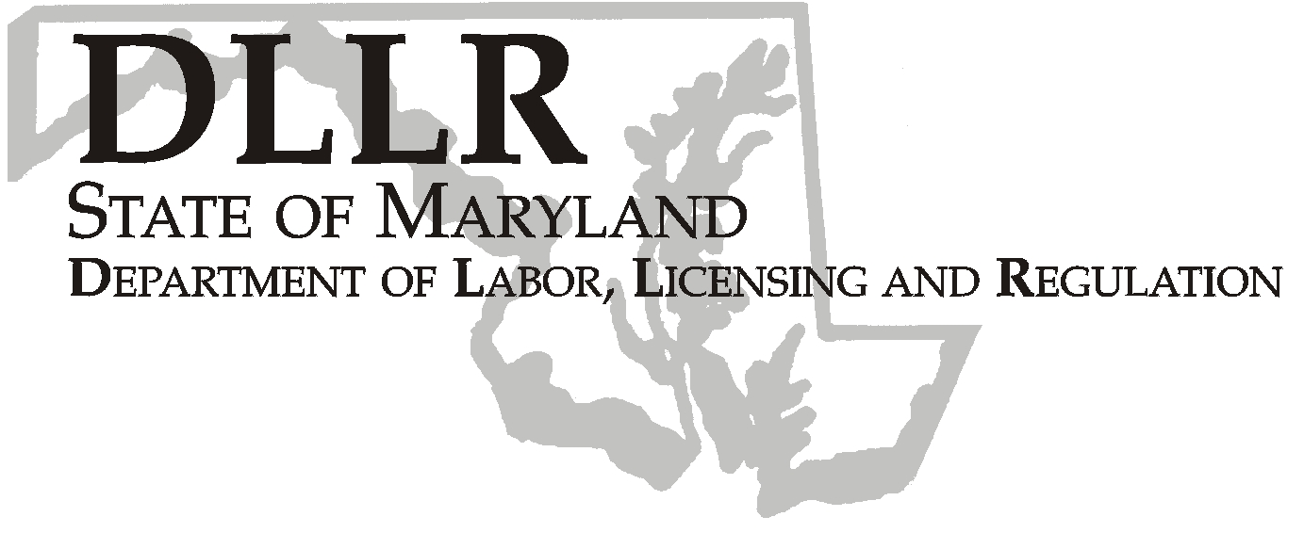
MARTIN O’MALLEY, Governor
ANTHONY G. BROWN, Lt. Governor
THOMAS E. PEREZ, Secretary

Division of Labor and Industry

J. Ronald DeJuliis, Commissioner

DLLR Home Page • http://www.dllr.state.md.us
DLLR E-mail • dli@dllr.state.md.us

MOSH STANDARDS NOTICE 05-4

TO: All MOSH Personnel

FROM: Roger Campbell
Assistant Commissioner

SUBJECT: Amendments and revisions to Standards Improvement Project – Phase II,
29 CFR Parts 1910 and 1926, excluding Part 1915.

PURPOSE: To remove and revise provisions in the standards for general industry and construction that are outdated, duplicative, unnecessary, or inconsistent, or that can be clarified or simplified by being written in plain language. These include amending provisions addressing notification of use, frequency of exposure monitoring, and medical surveillance.

Effective Date: September 12, 2005

Issuance Date: February 20, 2008

- Background

- On August 23, 2005, the Commissioner of Labor and Industry adopted through incorporation by reference under COMAR 09.12.31 Maryland Occupational Safety and Health Act – Incorporation by Reference of Federal Standards, the amendments and revisions relating to Standards Improvement Project – Phase II, 29 CFR Parts 1910 and 1926, excluding Part 1915, published in 70 FR 1112 – 1144 (January 5, 2005). This action, which was proposed for adoption in 32:14 Md. R. 1281-- 1282 (July 8, 2004), has been adopted as proposed. This action was recommended to the Commissioner of Labor and Industry by the Maryland Occupational Safety and Health Advisory Board pursuant to meeting held on April 6, 2005, notice of which was given in accordance with State Government Article, §10-506(c), Annotated Code of Maryland.
- In 1988, OSHA published the final rule, Phase I of the Standards Improvement Project. That final rule similarly set forth changes to a number of provisions in OSHA regulations and standards that were outdated, duplicative, unnecessary, or inconsistent, or that can be clarified or simplified by being written in plain language. As a result of the Phase I Standards Improvement Project rulemaking, OSHA identified other regulatory provisions that could also be addressed to reduce regulatory burdens by publishing Phase II of the Standards Improvement Project.

B. Action

- MOSH Compliance Supervisors and Consultation Supervisors shall ensure that all Compliance Officers are provided training on the contents of this notice.

________________________________________ ________
Roger Campbell, Assistant Commissioner MOSH Date

Attachment

cc: J. Ronald DeJuliis, Commissioner, Division of Labor and Industry
Craig D. Lowry, Deputy Commissioner, Division of Labor and Industry
General Jon Krasnoff, Assistant Attorney
Office of Administrative Hearings

TEL: 410-767-2215 ⋅ FAX: 410-767-2003
TTY USERS, CALL VIA THE MARYLAND RELAY SERVICE
1100 N. EUTAW STREET
BALTIMORE, MD 21201
Keeping Maryland Working and Safe

