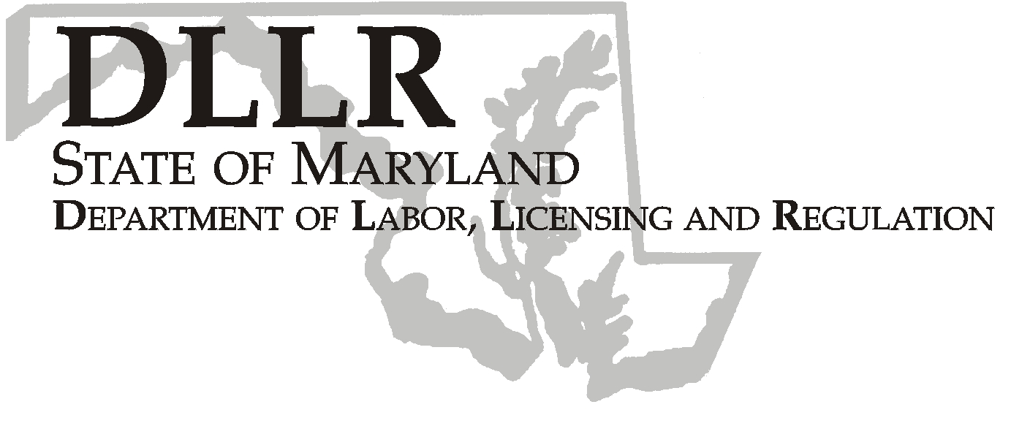
MARTIN O’MALLEY, Governor
ANTHONY G. BROWN, Lt. Governor
THOMAS E. PEREZ, Secretary

Division of Labor and Industry

J. Ronald DeJuliis, Commissioner

DLLR Home Page • http://www.dllr.state.md.us
DLLR E-mail • dli@dllr.state.md.us

MOSH STANDARDS NOTICE 05-2

TO: All MOSH Personnel

FROM: Roger Campbell
Assistant Commissioner

SUBJECT: Amendments and revisions under 29 CFR §1910.134 relating to Controlled Negative Pressure REDON Fit Testing Protocol.

PURPOSE: To incorporate by reference an additional OSHA-approved quantitative fit testing protocol, the controlled negative pressure (CNP) REDON fit testing protocol, for inclusion in Appendix A of the Respiratory Protection Standard, and to make several editorial and nonsubstantive technical revisions to the standard associated with the CNP REDON protocol and the previously approved CNP protocol.

Effective Date: February 14, 2005

Issuance Date: February 20, 2008

- Background

- On January 25, 2005, the Commissioner of Labor and Industry adopted through incorporation by reference under COMAR 09.12.31 Maryland Occupational Safety and Health Act – Incorporation by Reference of Federal Standards, the amendments and revisions under 29 CFR §1910.134 relating to Controlled Negative Pressure REDON Fit Testing Protocol published in 69 FR 46986 – 46994 (August 4, 2004). This action, which was proposed for adoption in 31:25 Md. R. 1797 (December 10, 2004), has been adopted as proposed. This action was recommended to the Commissioner of Labor and Industry by the Maryland Occupational Safety and Health Advisory Board pursuant to a meeting held on August 25, 2004, notice of which was given in accordance with State Government Article, §10-506(c), Annotated Code of Maryland.

- This protocol was adopted under the provisions contained in the Respiratory Protection Standard that allow individuals to submit evidence for including additional fit testing protocols in the standard. The CNP REDON protocol requires the performance of three different test exercises followed by two redonnings of the respirator, while the CNP protocol previously approved by OSHA specifies eight test exercises, including one redonning of the respirator.

- Action

  - MOSH Compliance and Consultation Supervisors shall ensure that Compliance Officers are provided training on the contents of this notice.

________________________________________ __________
Roger Campbell, Assistant Commissioner MOSH Date

Attachment

cc: J. Ronald DeJuliis, Commissioner, Division of Labor and Industry
Craig D. Lowry, Deputy Commissioner, Division of Labor and Industry
General Jon Krasnoff, Assistant Attorney
Office of Administrative Hearings
Keeping Maryland Working and Safe
TEL: 410-767-2215 ⋅ FAX: 410-767-2003
TTY USERS, CALL VIA THE MARYLAND RELAY SERVICE
1100 N. EUTAW STREET
BALTIMORE, MD 21201

