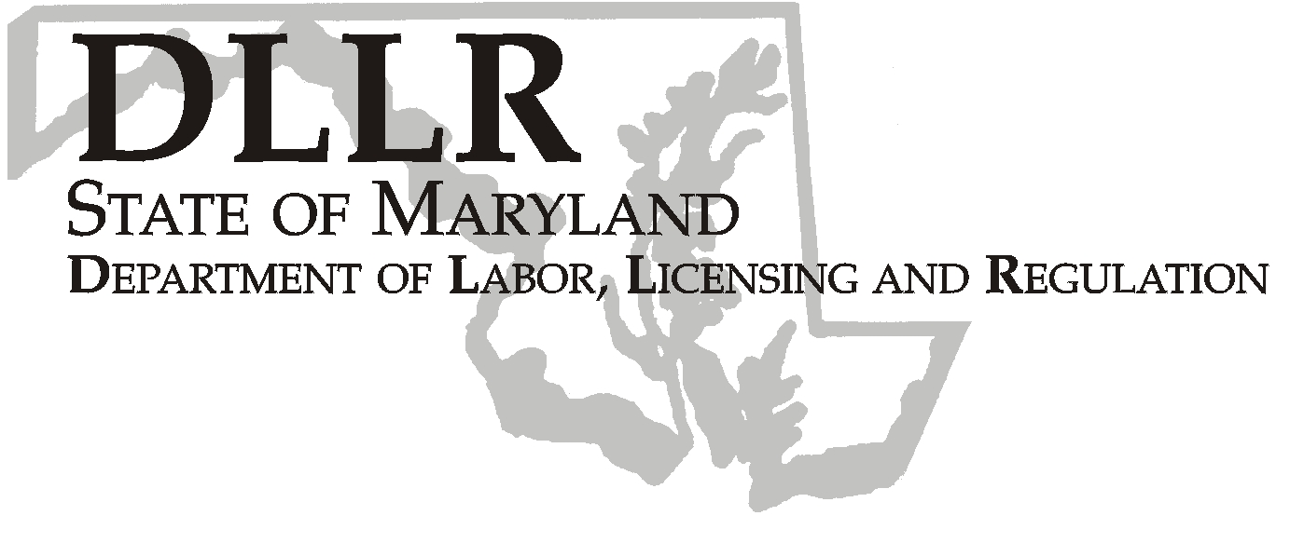
MARTIN O’MALLEY, Governor
ANTHONY G. BROWN, Lt. Governor
THOMAS E. PEREZ, Secretary

Division of Labor and Industry

J. Ronald DeJuliis, Commissioner

DLLR Home Page • http://www.dllr.state.md.us
DLLR E-mail • dli@dllr.state.md.us

MOSH STANDARDS NOTICE 05-1

TO: All MOSH Personnel

FROM: Roger Campbell
Assistant Commissioner

SUBJECT: Adoption and enforcement of the technical amendments under 29 CFR §1910.103, 29 CFR §1910.217, 29 CFR §1910.219, 29 CFR §1910.268, and 29 CFR §1910.307.

PURPOSE: To incorporate by reference recent corrections of errors in four OSHA standards. The first correction deletes two references to a nonexistent table in the Mechanical Power – Transmission Apparatus Standard. The second is a correction of typographical errors in the Mechanical Power presses Standard. The third correction is to a cross-reference in the Telecommunications standard. The fourth correction is to a reference to a table contained in the Hazardous materials standard for Hydrogen.

Effective Date: February 14, 2005

Issuance Date: February 20, 2008

- Background

- On January 25, 2005, the Commissioner of Labor and Industry adopted through incorporation by reference under COMAR 09.12.31 Maryland Occupational Safety and Health Act – Incorporation by Reference of Federal Standards, the technical amendments under 29 CFR §1910.103, 29 CFR §1910.217, 29 CFR §1910.219, 29 CFR §1910.268, and 29 CFR §1910.307 relating to Mechanical Power – Transmission Apparatus; Mechanical Power Presses; Telecommunications; and Hydrogen Published in 69 FR 31880 – 31882 (June 8, 2004). This action, which was proposed for adoption in 31:25 Md. R. 1797 – 1798 (December 10, 2004), has been adopted as proposed. This action was recommended to the Commissioner of Labor and Industry by the Maryland Occupational Safety and Health Advisory Board pursuant to a meeting held on August 25, 2004, notice of which was given in accordance with State Government Article §10-506(c), Annotated Code of Maryland.

B. Action

  - MOSH Compliance and Consultation Supervisors shall ensure that Compliance Officers are provided training on the contents of this notice.

________________________________________ __________
Roger Campbell, Assistant Commissioner MOSH Date

Attachment

cc: J. Ronald DeJuliis, Commissioner, Division of Labor and Industry
Craig D. Lowry, Deputy Commissioner, Division of Labor and Industry
General Jon Krasnoff, Assistant Attorney
Office of Administrative Hearings

TEL: 410-767-2215 ⋅ FAX: 410-767-2003
TTY USERS, CALL VIA THE MARYLAND RELAY SERVICE
1100 N. EUTAW STREET
BALTIMORE, MD 21201
Keeping Maryland Working and Safe

