Fatal Occupational Injuries In Maryland – 2019

Fatal work injuries totaled 78 in 2019 for Maryland, the U.S. Bureau of Labor Statistics reported today, down from 97 in the previous year. Since 1992, fatal occupational injuries in Maryland have ranged from a high of 106, reported in 2006, to a low of 60, reported in 2008 (See chart 1).

Nationwide, a total of 5,333 fatal work injuries were recorded in 2019, up from the 5,250 fatal injuries in 2018, according to the results from the Census of Fatal Occupational Injuries (CFOI) program.

Source: Maryland Division of Labor and Industry in cooperation with the U.S. Bureau of Labor Statistics, CFOI Program, December 2020.

Type of incident

In Maryland, transportation incidents resulted in 25 fatal work injuries and falls, slips and trips accounted for 17 fatalities. These two major categories accounted for 54 percent of all workplace fatalities in the state. (See table 1.) The number of worker deaths from transportation incidents dropped slightly from 24 in 2018, and worker fatalities due to falls, slips and trips increased from 11. Twelve of the incidents in the falls, slips and trips category were falls to a lower level.

Violence and other injuries by persons or animals was the third-most frequent fatal work event in the state with 14 fatalities and exposure to harmful substances or environments was fourth with 11 fatalities. Fatalities due to violence and other injuries by persons or animals decreased over the year from 22, while fatalities due to exposure to harmful substances or environments decreased from 24.

Unintentional overdoses due to nonmedical use of drugs or alcohol while at work accounted for 8 of the 11 worker deaths among exposure to harmful substances and environments.

Nationally, transportation incidents was the most frequent fatal workplace event in 2019, accounting for 40 percent of fatal work injuries. (See chart 2.) Falls, slips and trips was the second-most common fatal event (17 percent), followed by violence and other injuries by persons or animals (16 percent), and contact with objects and equipment (14 percent).

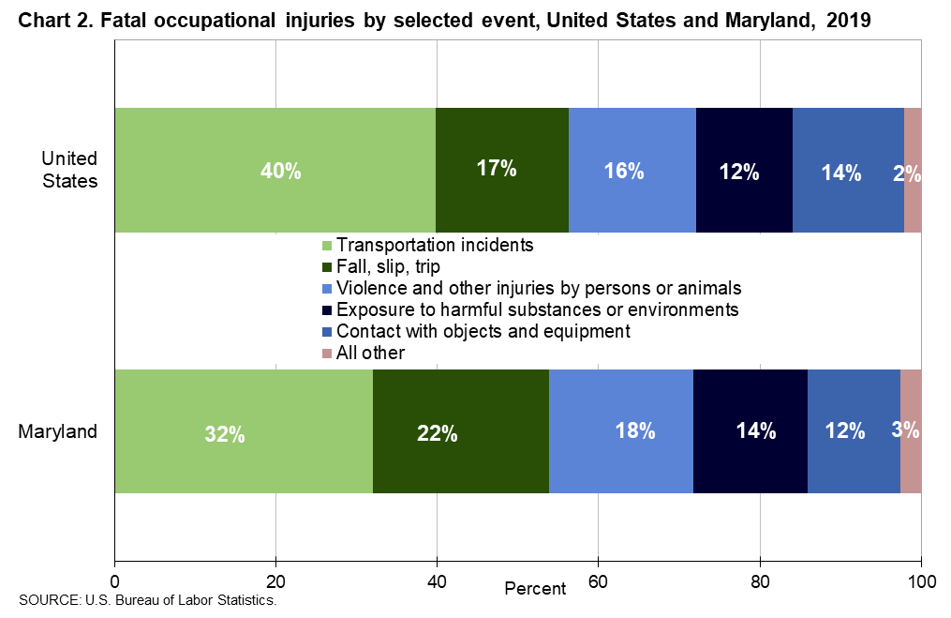

Industry
The construction industry had the largest numbers of fatalities in Maryland in 2019 with 15, followed by the government sector with 13 fatalities in 2019. (See table 2.) Transportation and warehousing accounted for 12 worker fatalities while administrative and support and waste management and remediation services accounted for 10. Construction industry fatalities were down from 22 in 2018, while those in the government sector increased slightly over the previous year. Transportation and warehousing was down from 14 in 2018 while administrative and support and waste management and remediation fatalities decreased slightly from 2018.

Occupation

Transportation and moving material moving occupations had the highest number of fatalities with 23, then construction and extraction occupations were second with 13. (See table 3.) The majority of the fatalities within the transportation and material moving group were heavy and tractor-trailer truck drivers, accounting for 10 out of the 23 fatalities. More than half of the workplace deaths in construction and extraction occupations were to construction laborers.

Additional highlights
- Men accounted for 87 percent of the work-related fatalities in Maryland, lower than the 92-percent national share. (See table 4.) The most frequent fatal event for men was transportation incidents with 25 fatalities.
- White, non-Hispanic workers accounted for 47 percent of those who died from a workplace injury in the state while black, non-Hispanic workers accounted for 36 percent. Nationwide, these groups accounted for 62 percent and 12 percent of work-related deaths respectively.
- Workers 25-54 years old accounted for 60 percent of the state’s work-related fatalities in 2019, higher than the 55 percent of on-the-job fatalities nationally.
- Of the 78 fatally-injured workers in Maryland, 81 percent worked for wages and salaries; the remainder were self-employed.

Scope and Program Technical Notes

The Maryland Census of Fatal Occupational Injuries (CFOI) program collects and publishes statistics on all fatal work injures occurring in the State of Maryland. Maryland CFOI is conducted within the Maryland Department of Labor, Licensing and Regulation, Division of Labor and Industry in cooperation with the U.S Department of Labor, Bureau of Labor Statistics. CFOI’s published results are the U.S. government’s official tally of workplace fatalities for the nation. Maryland has participated in the CFOI program every year since the program’s inception in 1992.

CFOI provides for a complete accounting of all fatal work injuries that occur in Maryland each year. The program uses diverse data sources from a variety of federal, state, and local government administrative records, as well as the media, in order to substantiate and profile fatal work injuries. CFOI includes data for all workplace fatalities regardless of whether the fatality was under the regulatory authority of the Maryland Occupational Safety and Health agency or other federal and state agencies. Any comparisons, therefore, between the CFOI program’s counts and those released by other agencies or sources should take into account the different coverage requirements and definitions being used.

For a fatality to be included in this census, the decedent must have been employed (defined as working for pay, compensation, or profit) at the time of the event, engaged in a legal work activity, or present at the site of the incident as a requirement of his or her job. Fatalities to volunteers and unpaid family workers who perform the same duties and functions as paid workers are also included in the count. These criteria are generally broader than those used by state and federal agencies administering specific laws and regulations. (Fatalities that occur during a person’s normal commute to and from work are excluded from the census counts.)

Data presented in this release include deaths occurring in 2019 that resulted from traumatic occupational injuries. An injury is defined as any wound or damage to the body resulting from acute exposure to energy, such as heat, electricity, or impact from a crash or fall, or from the absence of such essentials as heat or oxygen, caused by a specific event or incident within a single workday or shift. Fatal injuries included in the fatality census are open wounds; intracranial and internal injuries; heatstroke; hypothermia; asphyxiation; acute poisonings, resulting from short-term exposures limited to the worker’s shift; suicides and homicides; and work injuries listed as underlying or contributory causes of death.

