The Maryland Census of Fatal Occupational Injuries (CFOI) Program

The Maryland Census of Fatal Occupational Injuries (CFOI) program collects and publishes statistics on all fatal occupationally related injuries that occur in the State of Maryland. Maryland CFOI is conducted within the Maryland Department of Labor, Licensing and Regulation, Division of Labor and Industry in cooperation with the U.S Department of Labor, Bureau of Labor Statistics. CFOI’s results are the U.S. government’s official tally of workplace fatalities for the nation. Maryland has participated in the CFOI program every year since the program’s inception in 1992.

Preliminary results from the Maryland CFOI program for 2014

Fatal workplace injuries in Maryland totaled 73, according to preliminary results released for calendar year 2014. This count represented an 8 percent decrease from 2013’s final tally of 79. A number of these fatal events, however, including cases of workplace homicide, suicide, roadway incidents involving motorized land vehicles crashes and fatalities to the self-employed are not covered under MOSH’s investigative oversight. Since 1992, fatal occupational injuries in Maryland have ranged from a high of 106 cases reported in 2006 to a low of 60 cases reported in 2008. 2014’s preliminary count for the nation was 4,679 fatalities. This count represented a two-percent increase over 2013’s revised figure of 4,585. Final 2014 fatality numbers for Maryland, as well as the nation, will be released in April 2016.

Highlights from the Maryland Census of Fatal Occupational Injuries, 2014

- Violence and other injuries by persons or animals was the number one manner in which a worker was killed in Maryland during 2014. There were 24 reported cases. Deaths due to violence accounted for one-third of all fatalities in the State. There were 17 fatality cases associated with violence reported in 2013.

- With 21 fatalities, representing 29 percent of the total count, transportation incidents was the second leading cause of death to workers in the State of Maryland during 2014. Transportation events include workers killed in air, rail, and water craft accidents; in construction work zones; and motor vehicle highway crashes. Nine of the transportation incidents involved highway crashes. Four involved pedestrian vehicular accidents with 3 of these workers killed in construction work-zones.

- Falls, slips, and trips was the third leading fatality event in Maryland with 12 cases. Eleven of these involved falls to a lower level. One-third of the decedents fell through a surface or existing opening to a lower level. All but two of the fatalities worked for wages or salaries. Half occurred in the construction trades. Deaths due to falls, however, declined by 29 percent in Maryland when compared to 2013’s total of 17 cases, while nationally, fatal falls saw an increase of 10 percent, up to 793 reported cases from 724 in the previous year.

- Contact with objects and equipment was the fourth leading event in the State with 11 reported cases. Nine of these involved the worker being struck by an object or equipment with 5 involving being struck by a falling object or piece of equipment.

- Sixty-nine cases, representing 95 percent of the total, occurred to workers in the private sector with 71 percent in service providing industries while the remaining 29 percent were engaged in goods producing activities. Based on Maryland DLLR employment data, goods producing industries accounted for roughly 13 percent of the State’s private sector employment in 2014.

- Most (63 cases) of the decedents worked for salaries and wages; however; 14 percent of those killed in Maryland were self-employed. With 1,047 deaths reported, the self-employed accounted for 22 percent of the nation’s count.

- The public sector, which includes federal, State, and local government showed a significant decline from 19 reported cases in 2013 down to 4 in 2014. Two of the fatalities involved federal workers and 2 worked in local government. There were no fatalities in State government during 2014.

- The construction sector (NAICS 23) had the highest fatality count in Maryland’s private sector with 16 cases. The majority (88 percent) occurred among the specialty trade contractors; the remaining 2 workers were in heavy and civil engineering construction. The most frequently occurring event in construction was a fall to a lower level with 6 reported cases. With approximately 149,500 employees, construction represented 7 percent of private sector employment in 2014.

- Men accounted for all 16 of construction’s fatalities. Thirteen, worked for wages and salaries while 3 were self-employed. Ten of the decedents were White non-Hispanic; four were of Hispanic or Latino origin.

- The retail trade sector (NAICS 44-45) experienced a three-fold increase over the previous year’s count of 4 fatalities reported in 2013 to 12 cases in 2014.Three-quarters of the deaths in retail trade in Maryland were due to violence and other injuries by persons or animals. Nationally, deaths to violence accounted for 54 percent of the 267 deaths in retail trade.

- With 41 recorded cases, white, non-Hispanic workers accounted for 56 percent of all fatalities in Maryland, while nationally whites accounted for 68 percent; black, non-Hispanic workers accounted for 26 percent of the deaths in the State, while this group accounted for 10 percent of the national total. Hispanic or Latino workers accounted for 11 percent of the fatalities in Maryland and 17 percent for the nation.

- Fatalities in the transportation and warehousing sector (NAICS 48-49) increased from 5 cases in 2013 to 9 in 2014. Four of these fatalities were the result of violence and other injuries by persons or animals. Ten percent of the nation’s 735 fatalities in transportation and warehousing were due to violence.

Chart 3, Fatalities by event or exposure, all ownerships, Maryland, 2014

- The transportation and material moving occupations experienced the highest number of workplace fatalities in Maryland with 19. More detailed occupations within this major occupational grouping include airplane pilots, bus, truck, taxi, and ambulance drivers; subway operators; railroad conductors; parking lot attendants; crane and tower operators; and stock and material movers. Eleven truck drivers and 4 taxi drivers were killed in the Maryland during 2014.

- Workers in the construction and extraction occupations had the second highest fatality count with 12 cases. This major group includes diverse trades within the construction sector including carpenters; cement masons; construction laborers; drywall installers; electricians; glaziers; steamfitters, roofers, and more. Half of these workers died from falls.

- Following occupations in the construction trades were the building and grounds cleaning and maintenance occupations and sales and related occupations; both of these major groups experienced 9 fatalities each. Detailed occupations in the building and grounds maintenance occupations include cleaning and janitorial workers; house maids; pest exterminators; grounds maintenance and landscaping workers.

- Sales and related occupations include all manner of retail and whole trade workers; insurance agents, securities and commodities brokers, financial services agents; manufacturing reps.; and real estate agents. Over half (5 cases) of the workers in this occupation group died from violence and other injuries by persons or animals.

Chart 4, Fatal work injuries in selected industries, all ownerships, Maryland, 2014

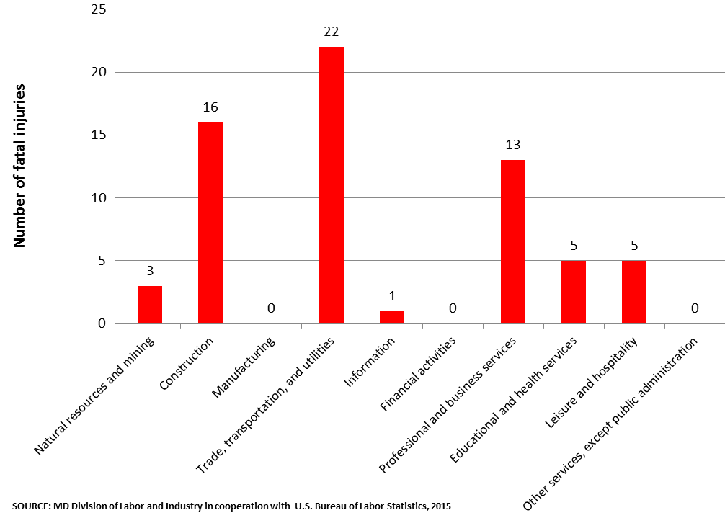

Chart 5, Occupations with the largest number of fatalities, all ownerships, Maryland, 2014
Scope and Program Technical Notes

The Maryland CFOI program compiles a complete accounting of all fatal work injures occurring in Maryland during the calendar year. The program uses diverse data sources from a variety of federal, state and local government administrative records and other independent data sources in order to substantiate and profile fatal work injuries. CFOI includes data for all workplace fatalities regardless of whether the fatality was under the regulatory authority of the Maryland Occupational Safety and Health agency or other federal and state agencies. Any comparisons, therefore, between the CFOI program’s census counts and those released by other agencies or sources should take into account the different scopes of coverage and definitions being used.

For a fatality to be included in this census, the decedent must have been employed (defined as working for pay, compensation, or profit) at the time of the event, engaged in a legal work activity, or present at the site of the incident as a requirement of his or her job. Fatalities to volunteers and unpaid family workers who perform the same duties and functions as paid workers are also included in the count. These criteria are generally broader than those used by State and federal agencies administering specific laws and regulations. (Fatalities that occur during a person’s normal commute to and from work are excluded from the census counts.)

Data presented in this release include deaths occurring in 2014 that resulted from traumatic occupational injuries. An injury is defined as any wound or damage to the body resulting from acute exposure to energy, such as heat, electricity, or impact from a crash or fall, or from the absence of such essentials as heat or oxygen, caused by a specific event or incident within a single workday or shift. Included are open wounds, intracranial and internal injuries, heatstroke, hypothermia, asphyxiation, acute poisonings resulting from short-term exposures limited to the worker’s shift, suicides and homicides, and work injuries listed as underlying or contributory causes of death.

For more information please contact:

Stephen C. Bisson
Administrator
MOSH Research and Statistics Unit
Maryland Occupational Safety and Health
10946 Golden West Drive, Suite 160
Hunt Valley, Maryland 21031
410-527-4463

