Bureau of Labor Statistics’ Census of Fatal Occupational Injuries (CFOI) Program

In cooperation with the U.S Department of Labor, Bureau of Labor Statistics, the Maryland Department of Labor, Licensing and Regulation, Division of Labor and Industry conducts the Census of Fatal Occupational Injuries (CFOI) program.

Preliminary results for the CFOI program, Maryland, 2012

In 2012, fatal work injuries in Maryland totaled 70 according to the preliminary results from the Maryland Census of Fatal Occupational Injuries (CFOI) program -- the majority of the cases were not under MOSH’s jurisdiction. The preliminary fatality numbers are down slightly from 2011’s final count of 71. Final fatality counts for Maryland and the nation will be released in April 2014.

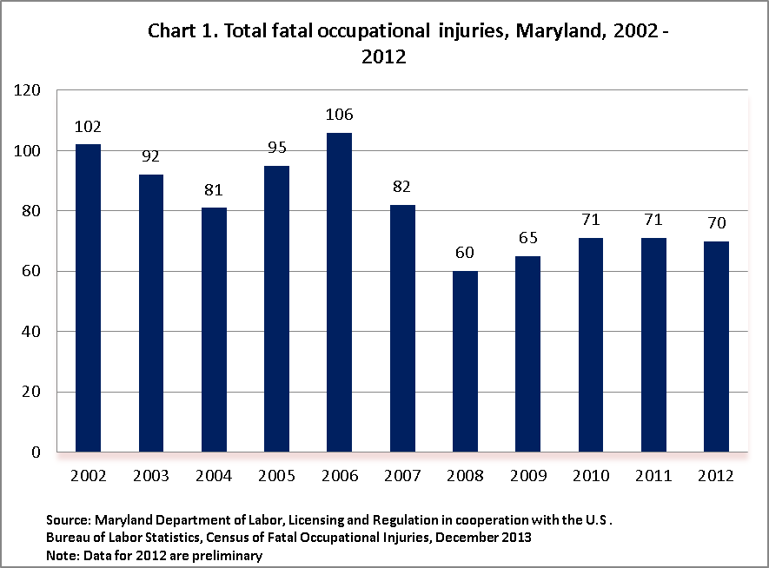

Scope of the Maryland CFOI program

The Maryland CFOI program compiles a complete accounting of all fatal work injures occurring in Maryland during the calendar year. The program uses diverse data sources from a variety of federal, state and local government administrative records in order to substantiate and then profile fatal work injuries. CFOI includes data for all workplace fatalities regardless of whether the fatality was under the regulatory authority of the Maryland Occupational Safety and Health agency or other federal and state agencies. Therefore, any comparison between the CFOI program’s census counts and those released by other agencies or sources should take into account the different scopes of coverage and definitions being used.

Highlights from the Maryland Census of Fatal Occupational Injuries, 2012

- Private sector construction experienced the largest number of fatalities in the State in 2012 with 15. The count was up from 13 cases reported the previous year. Specialty trade contractors (NAICS 238) accounted for 8 of these deaths while residential building construction (NAICS 23611) accounted for 5 deaths.

- Transportation and warehousing (NAICS 48-49) experienced 12 fatalities with 7 of the cases occurring in the trucking industry (NAICS 484). This represents the third consecutive year for fatality increases in transportation and warehousing. This sector reported 9 deaths in 2010 and 11 in 2011.

- Administrative and support services (NAICS 561) reported 7 cases, down from 8 in 2011. Six of the deaths occurred in landscaping services (NAICS 56173).

- Local government recorded 5 deaths in 2012, down by one from the previous year. Three cases were in police protection (NAICS 92212) and the other 2 in education (NAICS 61111).

- Men accounted for 91 percent or 64 of the State’s cases. Their proportion to the total was slightly less than the 92 percent reported for the U.S. based on gender.

- In Maryland, 53 percent of those who died while working on the job were white, non-Hispanic. Whites accounted for 68 percent of the nationwide count. Twenty-six percent (18 cases) were African-American, non-Hispanic. Their numbers were down for the previous year’s count of 27. African-American, non-Hispanic workers accounted for 10 percent of the 2012 U.S total. Hispanic or Latino fatalities increased in Maryland by 5 cases from the previous year’s total to 13 deaths. Additionally, Hispanic or Latino workers accounted for 19 percent of Maryland’s total count and 16 percent of the nation’s count.

- Of the 70 cases reported for Maryland, 71 percent (50 cases) worked for wages and salaries while the remaining 20 workers were self-employed. As was the case in 2011, the most frequent manner in which a wage and salary worker was killed while on the job was a transportation incident; whereas, the most frequent event for the self-employed worker was some type of violence or other injury by a person or animal.

- With 23 fatalities, transportation events were the leading cause of death to workers in Maryland in 2012, though this event’s numbers declined by 6 cases when compared to 2011.

- The total number of deaths due to violence and other injuries by persons or animals also declined in 2012 to 14 cases, down from 17 reported in 2011. Within this category, homicides were down from 2011 with 5 reported cases; however, suicides increased from 5 to 7 reported cases.

- Fatalities due to falls, slips, and trips rose from 8 cases reported in 2011 to 14 in 2012.

- Eight workers succumbed from exposures to harmful substances or environments such as death by electrocution or drowning.

Program Technical Notes

For a fatality to be included in the census, the decedent must have been employed (that is working for pay, compensation, or profit) at the time of the event, engaged in a legal work activity, or present at the site of the incident as a requirement of his or her job. Fatalities to volunteers and unpaid family workers who perform the same duties and functions as paid workers are also included in the count. These criteria are generally broader than those used by State and federal agencies administering specific laws and regulations. (Fatalities that occur during a person’s normal commute to or from work are excluded from the census counts.)
Data presented in this release include deaths occurring in 2012 that resulted from traumatic occupational injuries. An injury is defined as any wound or damage to the body resulting from acute exposure to energy, such as heat, electricity, or impact from a crash or fall, or from the absence of such essentials as heat or oxygen, caused by a specific event or incident within a single workday or shift. Included are open wounds, intracranial and internal injuries, heatstroke, hypothermia, asphyxiation, acute poisonings resulting from short-term exposures limited to the worker’s shift, suicides and homicides, and work injuries listed as underlying or contributory causes of death.

Table 1. Fatal occupational injuries by selected event or exposure, Maryland, 2011 - 2012

Table 2. Fatal occupational injuries by selected industry, Maryland 2011 – 2012

2011²
Number
Number
Percent
Total
71
70
100
Private industry
63
62
89
Natural resources and mining
4
5
7
Agriculture, forestry, fishing and hunting
4
5
7
Crop production
-
1
1
Support activities for agriculture and forestry
-
3
4
Construction
13
15
21
Construction of buildings
-
5
7
Specialty trade contractors
11
8
11
Manufacturing
3
5
7
Printing and related support activities
-
1
1
Nonmetallic mineral product manufacturing
-
1
1
Computer and electronic product manufacturing
-
1
1
Trade, transportation, and utilities
21
18
26
Retail trade
4
4
6
General merchandise stores
-
1
1
Transportation and warehousing
11
12
17
Air transportation
-
1
1
Truck transportation
7
7
10
Warehousing and storage
-
1
1
Financial activities
-
2
3
Finance and insurance
-
1
1
Credit intermediation and related activities
-
1
1
Real estate and rental and leasing
-
1
1
Real estate
-
1
1
Professional and business services
12
9
13
Administrative and waste services
10
8
11
Administrative and support services
8
7
10
Waste management and remediation services
-
1
1
Educational and health services
3
-
-
Educational services
1
1
1
Educational services
1
1
1
Leisure and hospitality
5
4
6
Accommodation and food services
5
3
4
Food services and drinking places
4
3
4
Other services, except public administration
-
2
3
Religious, grant making, civic, professional, and similar organizations
-
2
3
Government
3
8
8
11
Local government
6
5
7
2012
p
Industry
¹
1
Industry data are based on the North American Industry Classification System, 2007. Total may include other industries not shown.
NOTE: Totals for major categories may include subcategories not shown separately. Percentages may not add to totals because of rounding. Dashes
indicate no data reported or data that do not meet publication criteria. CFOI fatality counts exclude illness-related deaths unless precipitated by an injury.
3
Includes fatal injuries to workers employed by governmental organizations regardless of industry.
p
Data are preliminary. Revised and final 2012 data are scheduled to be released in Spring 2014.

2
Data for 2011 are revised and final.

2011
²
Number
Number
Percent
Total
71
70
100
Management occupations
3
6
9
Other management occupations
-
6
9
Farmers, ranchers, and other agricultural managers
-
2
3
Food service managers
-
1
1
Business and financial operations occupations
-
1
1
Business operations specialists
-
1
1
Compliance officers
-
1
1
Community and social services occupations
-
1
1
Religious workers
-
1
1
Clergy
-
1
1
Education, training, and library occupations
1
1
1
Preschool, primary, secondary, and special education school teachers
1
1
1
Elementary and middle school teachers
-
1
1
Protective service occupations
6
4
6
Law enforcement workers
2
3
4
Police officers
2
3
4
Other protective service workers
3
1
1
Security guards and gaming surveillance officers
3
1
1
Food preparation and serving related occupations
1
1
1
Food and beverage serving workers
-
1
1
Fast food and counter workers
-
1
1
Building and grounds cleaning and maintenance occupations
7
10
14
Supervisors of building and grounds cleaning and maintenance workers
-
2
3
First-line supervisors of building and grounds cleaning and maintenance
workers
-
2
3
Grounds maintenance workers
6
8
11
Sales and related occupations
6
-
-
Sales representatives, wholesale and manufacturing
-
1
1
Office and administrative support occupations
-
4
6
Material recording, scheduling, dispatching, and distributing workers
-
3
4
Stock clerks and order fillers
-
1
1
Secretaries and administrative assistants
-
1
1
Farming, fishing, and forestry occupations
3
-
-
Agricultural workers
-
2
3
Miscellaneous agricultural workers
-
2
3
Construction and extraction occupations
11
13
19
Construction trades workers
7
11
16
Construction laborers
3
4
6
Electricians
-
2
3
Roofers
-
2
3
Installation, maintenance, and repair occupations
5
5
7
Other installation, maintenance, and repair occupations
3
4
6
Heating, air conditioning, and refrigeration mechanics and installers
-
1
1
Transportation and material moving occupations
20
15
21
Motor vehicle operators
16
8
11
Driver/sales workers and truck drivers
15
6
9
Material moving workers
3
4
6
Laborers and material movers, hand
-
3
4
Data for 2012 are preliminary. Revised and final 2012 data are scheduled to be released in Spring 2014.
NOTE: Totals for major categories may include subcategories not shown separately. Percentages may not add to totals because of rounding. Dashes
indicate no data reported or data that do not meet publication criteria. CFOI fatality counts exclude illness-related deaths unless precipitated by an event.
2012
p
Occupation
¹
1
Occupation data for 2011 and 2012 are based on the Standard Occupational Classification system, 2010. Total may include occupations not shown.
2

p
Data for 2011 are revised and final.
Table 4. Fatal occupational injuries by selected worker characteristics, Maryland, 2011 – 2012

