Nonfatal Workplace Injuries and Illnesses in Maryland for 2013

Sixty-seven thousand nonfatal work-related injuries and illnesses were reported by Maryland’s public and private sector employers in 2013 according to the latest results of the Bureau of Labor Statistics’ Survey of Occupational Injuries and Illnesses (SOII) program. In 2013 there were approximately 2.3 million workers in the State under the Maryland Occupational Safety and Health agency’s regulatory oversight, based on data derived from the Maryland Department of Labor, Licensing and Regulation’s Quarterly Census of Employment and Wages program. The total number of injuries and illnesses reported represented a decrease of 1,400 cases when compared to the 2012 survey results. The number of injuries and illnesses converts to a total recordable case (TRC) incidence rate of 3.4 injuries and illnesses per 100 equivalent full-time workers. For 2013, Maryland’s TRC rate for all industries, including State and local government was 3 percent below the 2013 national average of 3.5.

Occupational Injury and Illness Summary Results for Maryland’s Private Sector, 2013

Occupational injuries and illnesses among Maryland’s private sector employers occurred at a rate of 3.0 cases per 100 equivalent full-time workers. The private sector's TRC incidence rate represented a slight decline from the previous year’s rate of 3.1.

Ninety-six percent of the total 51,500 cases reported by private industry were injuries with the remaining 1,900, cases of occupational illness. The rate for cases of a more serious nature involving days away from work, job transfers, or restrictions, commonly referred to as the DART rate, declined slightly from the previous year to 1.5 injuries and illnesses per 100 full-time equivalent workers. Maryland’s private sector injury and illness estimates cover 2 million workers.

Occupational Injury and Illness Summary Results for Maryland’s Public Sector, 2013

Public sector injury and illness estimates for State and local government have been published in Maryland every year since 1979. Representing some 342,000 employees, State and local government employers reported 15,500 injuries and illnesses in 2013; one thousand fewer cases than 2012. The total recordable case incidence rate for all injuries and illnesses was 5.9 cases per 100 full-time equivalent employees. This represented a 6-percent decline over 2012.
However, for the sixth consecutive year, Maryland State and local government’s TRC incidence rate has remained above the national average of 5.2 injuries and illnesses for all public sector employees and for a second year, Maryland’s Public Sector TRC rate remained at 13 percent above the U.S. average.

Maryland State Government

With 4,800 reported cases converting to a TRC incidence rate of 5.1 injuries and illnesses per 100 full-time equivalent workers, Maryland State government’s incidence rate increased by 4 percent from the previous year. Of the total cases reported, 2,100 were severe enough to require the injured or ill worker to take at least one day off from work to recuperate.

Maryland Local Government

An estimated 10,700 new injury and illness cases were reported by Maryland’s county governments and local municipalities. Collectively local government experienced a 10-percent decline from the previous year’s recorded rate of 7.1 cases per 100 equivalent fulltime workers to a current rate of 6.4. For 2013, local government’s rate remained above the national average by 12-percent. Local government’s rate has been above the national average every year since 2009. Of the total cases reported, 4,700 were severe enough to require the injured or ill worker to take either days away from work for recuperation, a job transfer, or be assigned some type of work restriction. In 2013, approximately 242,000 workers were employed by the State’s county governments and local municipalities.

Key Findings for the Maryland Survey of Occupational Injuries and Illnesses, 2013

Private Industry Estimates

- Reporting 3.0 workplace injuries and illnesses per 100 equivalent full-time workers in 2013, Maryland’s private sector TRC incidence rate has shown a dramatic decline (by 72 percent) since the inception of the Annual Survey of Occupational Injuries and Illnesses in 1972.

- Private construction’s TRC incidence rate remained unchanged from 2012’s rate of 3.6 and is currently 5 percent below the national average for this industry sector.

- At a rate of 3.0 injuries and illnesses per 100 full-time equivalent workers, manufacturing's TRC rate remained unchanged from the previous year and was almost half the rate it was in the State in 2004. Maryland manufacturing’s rate continues to remain well below the national average. For 2013, Maryland manufacturing was 25-percent below the U.S average.

- With 8,500 reported cases, goods-producing industries accounted for 17 percent of the total injury and illness cases reported by Maryland’s private sector employers. Based on employment data from the Maryland Department of Labor, Licensing and Regulation, this sector accounted for slightly more than 259,000 workers or 13 percent of private sector employment. With a TRC rate of 3.4, this sector’s rate remained unchanged from 2012. Maryland’s good-producing sector remains well below the national average by 13 percent.

State Government Estimates

Certain industry rates within State government remained high. Some notable examples:

- Although the TRC rate for State hospitals’ was 14.4 (representing a 7 percent increase over 2012), the industry’s rate remained well below 17.8, reported in 2011.

- Though State government’s rate for correctional institutions declined by 14 percent from the previous year, at 12.2 injuries and illnesses per 100 full-tie equivalent workers the industries’ rate remains 61 percent above the national average of 7.6

- At 20.1 injuries and illnesses per 100 full-time equivalent workers, State government’s nursing and residential care facilities’ recorded the highest rate for any industry in the State. This industry has reported the highest TRC incidence rate in Maryland for every year since 2009.

Local Government Estimates
- After four years of rate increases, local government’s public elementary and secondary schools’ TRC rate decreased by 15 percent to 5.0 from 5.9. Nationally, public elementary and secondary schools’ reported rate was 4.7.

- Local government’s water, sewage and other systems (NAICS 2213) reported a TRC rate increase from 8.2 cases in 2011, to 10.0 cases in 2012, and has increased again to 10.4 for 2013.

Background of the Survey

The Survey of Occupational Injuries and Illnesses (SOII) is a cooperative program between the State of Maryland’s Department of Labor, Licensing and Regulation, Division of Labor and Industry and the U.S. Department of Labor, Bureau of Labor Statistics. SOII provides estimates of the number and frequency (incidence rates) of nonfatal occupational injuries and illnesses by industry code as defined by the 2007 North American Industry Classification System (NAICS) manual. The SOII program also provides details on the circumstances and characteristics of the more seriously injured and ill workers. These injury and illness estimates are based on safety and health logs that, by law, employers are required to keep. Occupational injury and illness statistics have been published for Maryland’s private sector every year since 1972 and for State and local government from 1979 forward.
The SOII program utilizes an employer-based questionnaire to collect occupational injury and illness data. Questionnaires are mailed to a scientifically selected random sampling of businesses in Maryland. The responses are compiled, tabulated and published annually.

Statistical sampling techniques are used to produce the estimates. Because the results are based on a random sampling of establishments in the universe file (the universe is all operating in-scope establishments in Maryland’s unemployment insurance tax file), the estimates probably differ from the figures that would be obtained if every establishment in the State had participated. To determine the precision of each data estimate, a standard error is calculated. The standard error defines a range (confidence interval) around each estimate. Relative standard errors are calculated for every SOII estimate produced.

The quality of the data is dependent on the employer’s understanding of which cases are recordable under the Occupational Safety and Health Administration’s recordkeeping regulation. Maryland State agencies and all local government municipalities and jurisdictions are required by law to keep records of occupational injuries and illnesses. Additionally, many private sector establishments are required to keep injury and illness records. In order to have a complete picture of the occupational injury and illness experience for the economy, many establishments normally exempt from OSHA’s recordkeeping requirements are included in the survey. The OSHA recordkeeping system is designed to measure the incidence, rather than the prevalence, of occupational injury and illness. Prevalence measures capture all injuries and illnesses that occur in a given year including ongoing or unresolved cases from previous years. The intent of the OSHA recordkeeping system is to measure each occupational injury and illness only once. The SOII, therefore, provides estimates of the number and rate of only new injuries and illnesses in a given year.

Excluded from the SOII are the self-employed, farming operations with fewer than 11 employees, private households and federal government agencies. Occupational injury and illness data for coal, metal and nonmetal mining, and for railroad activities were provided by the U.S. Department of Labor’s Mine Safety and Health Administration and the U.S. Department of Transportation’s Federal Railroad Administration, respectively.

Collecting occupational illness statistics remains a challenge with the true number and rate difficult to measure. Unlike injuries, which result from sudden, acute events that are easily observed, reported and documented, many types of occupational disease are not diagnosed until long after the initial exposure to workplace carcinogens and other toxins have taken place. It may be years before the cumulative effects of these exposures present as occupational disease and the ill employee may no longer be in the workforce. Because of this, it is believed the incidence of certain long-term, latent forms of occupational disease is understated by the SOII. The overwhelming majority of the reported illness cases are those that are easier to directly relate to the workplace such as contact dermatitis or carpal tunnel syndrome.
The Bureau of Labor Statistics’ Survey of Occupational Injuries and Illnesses is the U.S government’s primary source for charting the nature and magnitude of the occupational injury and illness problem across the country.

Maryland Nonfatal Incidence Rates
Survey of Occupational Injuries and Illnesses, 2002-2013
 | Total Recordable Cases (TRC) | Cases with Days  Away, Restriction, or Transfer (DART) | Other Recordable Cases (ORC)
Private industry
2013  2012 | 3.0  3.1 | 1.5  1.6 | 1.5  1.5
2011 | 3.0 | 1.6 | 1.4
2010 | 3.6 | 1.9 | 1.7
2009 | 3.3 | 1.7 | 1.6
2008 | 3.3 | 1.7 | 1.6
2007 | 3.7 | 1.9 | 1.8
2006 | 3.8 | 2.0 | 1.8
2005 | 4.2 | 2.2 | 2.0
2004 | 4.2 | 2.3 | 1.9
2003 | 4.1 | 2.3 | 1.8
2002 | 4.3 | 2.4 | 1.9
State and local govt.
2013  2012 | 5.9  6.3 | 2.8  2.8 | 3.1  3.6
2011 | 5.8 | 2.9 | 3.0
2010 | 5.8 | 3.1 | 2.7
2009 | 5.9 | 3.0 | 2.9
2008 | 6.6 | 3.3 | 3.3
2007 | 7.1 | 3.5 | 3.6
2006* | - | - | -
2005 | 6.5 | 2.9 | 3.6
2004 | 6.0 | 3.2 | 2.9
2003 | 6.9 | 3.9 | 3.0
2002 | 6.2 | 3.6 | 2.6
All industries including State & local govt.
2013  2012 | 3.4  3.5 | 1.7  1.7 | 1.7  1.8
2011 | 3.4 | 1.8 | 1.6
2010 | 3.9 | 2.1 | 1.8
2009 | 3.7 | 1.9 | 1.8
2008 | 3.7 | 1.9 | 1.8
2007 | 4.1 | 2.1 | 2.1
2006* | - | - | -
2005 | 4.5 | 2.3 | 2.2
2004 | 4.5 | 2.4 | 2.1
2003 | 4.5 | 2.5 | 1.9
2002 | 4.6 | 2.6 | 2.0
SOURCE: Maryland Department of Labor, Licensing and Regulation, Division of Labor and Industry in cooperation with the U.S. Department of Labor, Bureau of Labor Statistics, Survey of Occupational Injuries and Illnesses, 2013. Incidence rates represent the number of injuries and illnesses per 100 full-time workers.
*2006 occupational injury and Illness data for State and local government did not meet publication criteria.

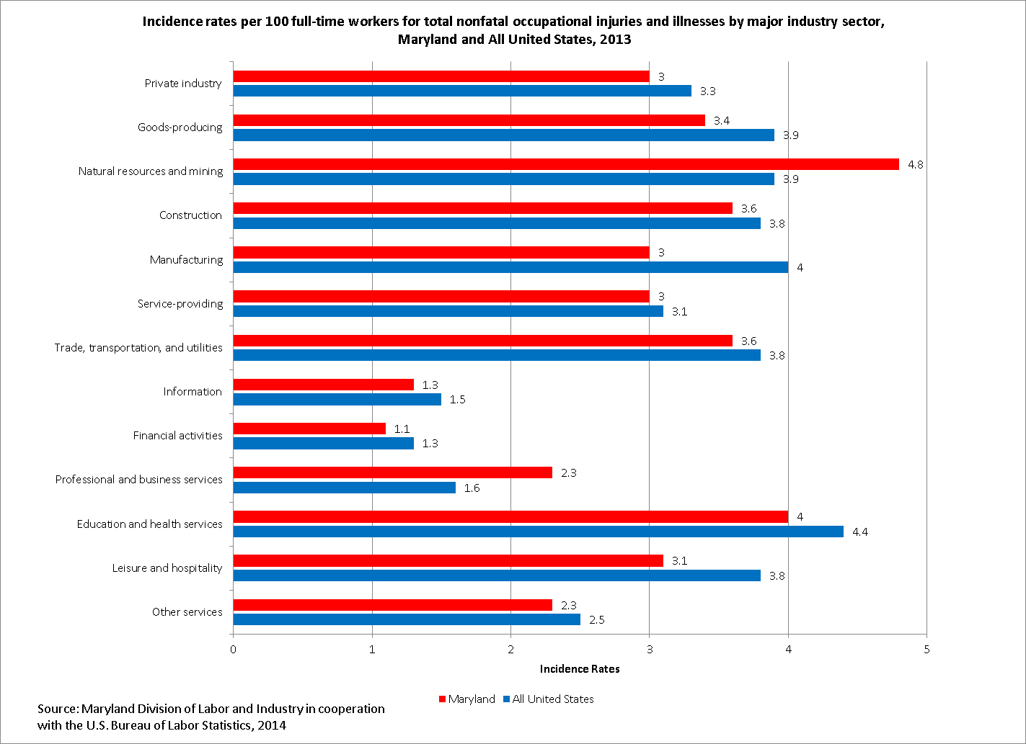
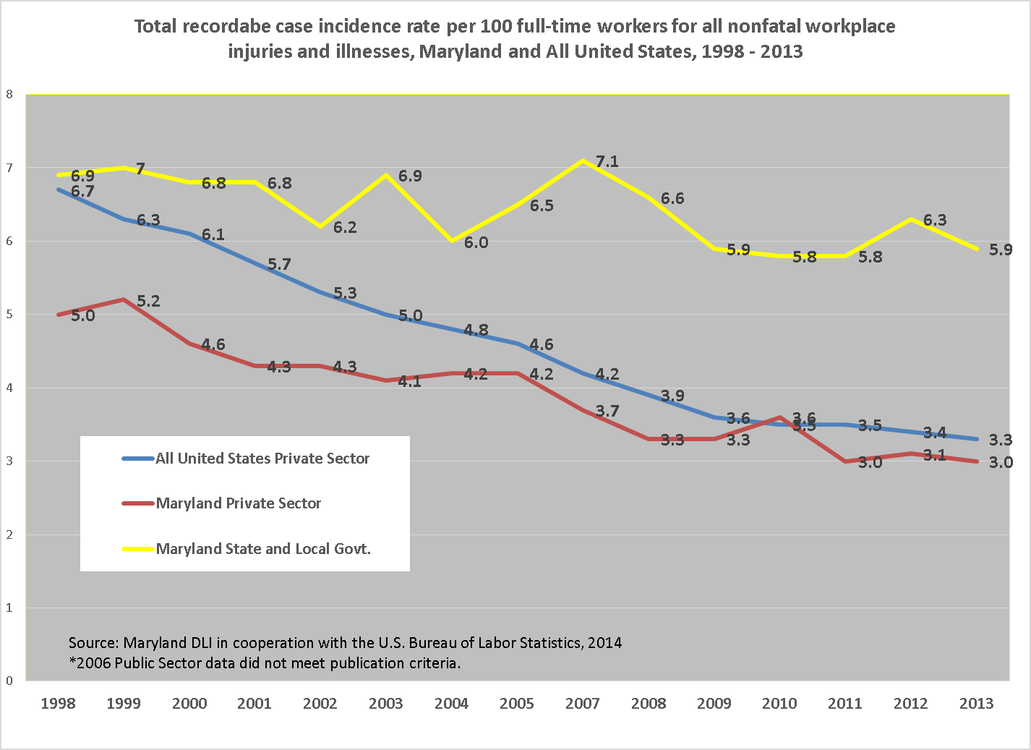

All employment data derived from the Maryland Department of Labor, Licensing and Regulation, Office of Workforce Information and Performance, Employment and Payrolls, Industry Series, 2013.
Incidence rates represent the number of injuries and illnesses per 100 full-time workers and are calculated as: (N/EH) x 200,000 where N = number of injuries and illnesses EH = total hours worked by all employees during the calendar year 200,000 = base for 100 equivalent full-time workers.

