State of Maryland
Occupational Safety and Health
Compliance Annual Report for Fiscal Year 2014

January 2015

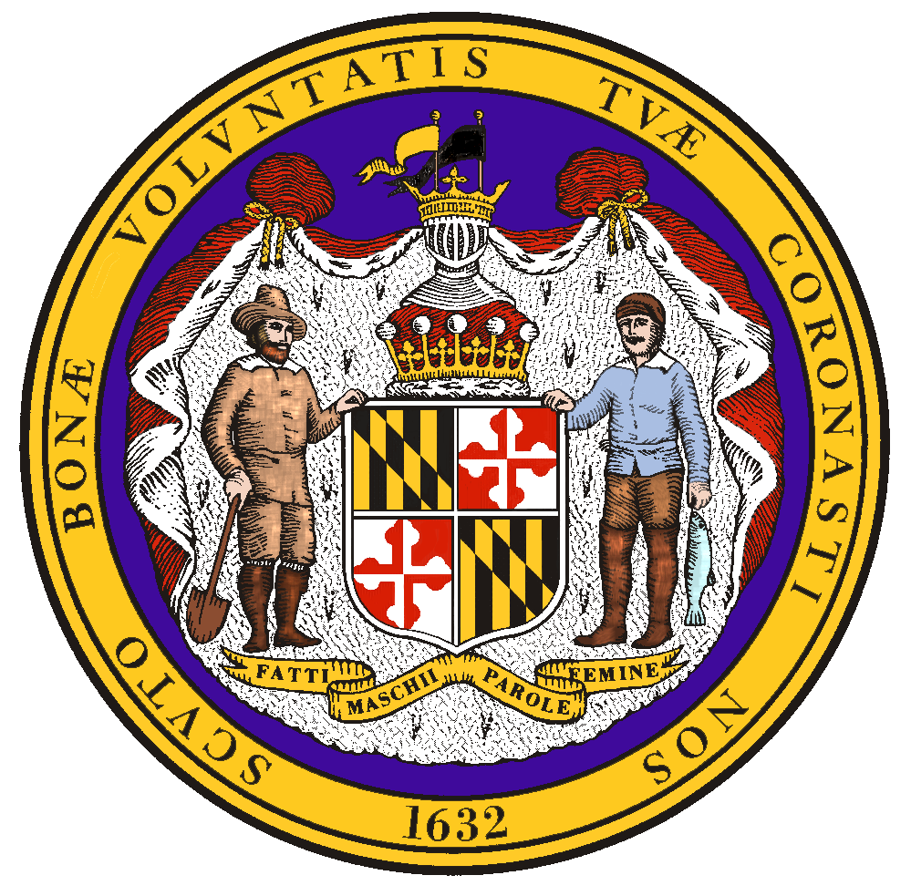

Larry J. Hogan, Jr., Governor
Kelly M. Schulz, Secretary
Eric M. Uttenreither, Assistant Commissioner

Table of Contents
Page
Section 1: Overview of MOSH News _______1-3
New Regulations ______ 2
Staff Training _2
Organizational Changes _______3
Funding and Furloughs _______3
Federal Audit _______3

Section 2: Explanation of each unit’s progress in FY14 ______ _4-9

Summary of Annual Performance Plan Goals for MOSH FY14 ______ Appendix A
Performance and Activity Results_____________________________________________ Appendix B
Research and Statistics Annual Report _________________________________________Appendix C

Section 1
Year in Review

Fiscal year 2014 (FY14) was a very busy and successful year for Maryland Occupational Safety and Health (MOSH). Progress towards our Five Year Strategic Plan was on track, despite continued reduced work days and implementation of the completely new federal operating system. Even with these difficulties, our staff pulled together and nearly all Annual Plan goals were met or exceeded.

After many months of preparation and last minute meetings the OSHA Information System (OIS) was successfully launched in August. The transition began in July with our Easton office. MOSH worked closely with the federal contractors and the OIS team to minimize the enormous amount of time and effort to switch systems. The dedication and teamwork of all parties involved resulted in a cooperative environment that fueled an unexpectedly smooth transition with no interruption of service to the public. By the end of the fiscal year all staff were successfully utilizing the OIS.

Effective October 1, 2014 MOSH no longer requires employers to maintain a chemical information list with Maryland specific requirements. The Maryland General Assembly passed House Bill 189 which repealed Labor and Employment Sections 5-405, 5-406, 5-407, and 5-408. The remaining requirement is for employers who “cease to operate or formulate, handle, manufacture, package, process, react, repackage, store, or transfer hazardous chemicals” to submit their latest chemical inventory to the Department of Labor, Licensing, and Regulation.

MOSH has begun to utilize social media to keep employers and employees throughout the state up-to-date on the latest activities and offerings from MOSH. The agency created a Facebook page to post upcoming educational seminars, latest news from OSHA, and seasonal safety tips. The page can be found at https://www.facebook.com/MOSHSafety . MOSH also created two videos to help employers and employees understand what MOSH is and how the agency can help them through our consultation program. These videos are posted through the State of Maryland’s YouTube page: https://www.youtube.com/watch?v=l-R_MlxU7Os & https://www.youtube.com/watch?v=I5vV-18ZVp0 .

In FY14 MOSH began a new internal policy where all cases submitted as “in compliance” (IC) are reviewed directly by the Chief of Compliance. MOSH wants to make sure that any case closed as IC is truly that, and that no potential hazard was overlooked, this is especially true for unprogrammed cases.

Instructions and Standards Notices:
MOSH Instructions and Standards Notices Issued in FY14
OSHA Directive | Topic | MOSH Instruction/Standards Notices | Notes
 | Local Emphasis Program (LEP) Fall Hazards in Construction | MI 14-1 | Applies in Maryland only
 | Local Emphasis Program (LEP) Electrical Hazards in Construction | MI 14-2 | Applies in Maryland only
 | Local Emphasis Program (LEP) Crushed-by/Struck-by Hazards in Construction | MI 14-3 | Applies in Maryland only
 | Local Emphasis Program (LEP) Public Sector | MI 14-4 | Applies in Maryland only
 | Local Emphasis Program (LEP) Tree Care and Removal | MI 14-5 | Applies in Maryland only
 | Local Emphasis Program (LEP) Health Hazards in Construction | MI 14-6 | Applies in Maryland only
CPL 02-00-154 | Longshoring and Marine Terminals "Tool Sheds" | MI 14-7
CPL 02-00-155 | Inspection Scheduling for Construction | MI 14-8 | Cancels MOSH Instruction 08-03
 | Implementation of Exemptions and Limitations Placed on MOSH Activities by the Federal Labor/Health and Human Services Appropriations Act | MI 14-9 | Cancels MOSH Instruction 98-3

All of these are available online at:
http://www.dllr.state.md.us/labor/instructions/
http://www.dllr.state.md.us/labor/standards/

Staff Training

In August, the latest class of MOSH trainees graduated from their year long training program and are now highly productive members of the agency, this class consisted of seven safety compliance officers and two industrial hygienists. MOSH plans on having a new trainee class in the spring of 2015.

MOSH sent nineteen compliance officers to eight different courses. These courses were held at the OSHA Training Institute (OTI) in Chicago, IL or the classes were brought here to Maryland. Topics of study included: Electrical Standards, Applied Spray Finishing, Introduction to Health Standards for Industrial Hygienists, Health Hazard Awareness, Accident Investigation, Principles of Industrial Ventilation, Cranes in Construction, Electrical Power Generation, and Combustible Dusts Hazards. The agency has already signed up several compliance officers for classes occurring in FY15.

Organizational Changes:

MOSH had several veteran compliance officers retire in FY14 and several other compliance officers took new jobs at various higher paying agencies. In all, the agency lost nine inspectors throughout the course of the year. MOSH was able to provide its services without interruption, however this will attribute to lower inspection numbers overall. MOSH plans to begin recruiting for a new class of trainees beginning in early 2015 to fill the vacancies generated in FY14.

Furloughs:

Once again in fiscal year 2014 state employees were assessed five service reduction days. With an average of 59 inspectors this equates to approximately 295 lost work days for the agency’s compliance officers and staff. MOSH worked extremely hard to meet its goals with this large loss of production time.

Federal Audit

In FY14 MOSH underwent an onsite Federal Annual Monitoring and Evaluation (FAME) process. The focus of this audit was to assess the agencies performance during FY13 and to evaluate progress in addressing the issues identified in prior FAME reports. MOSH completed or closed all five of the findings from the FY12 audit. There was one new finding for this year’s audit, dealing with the lack of an internal appeals process for the discrimination unit. MOSH is working toward a solution and is confident that this item will be closed at the next abridged FAME. One observation was also made for the agency not performing three inspections conducted under the Process Safety Management (PSM) Covered Chemical Facilities National Emphasis Program (NEP). After further review of inspections already opened or planned MOSH was able to report that three inspections had been completed under the NEP.

Section 2
Unit Review

Enforcement:

According to the OSHA derived SAMM, MOSH compliance officers were able to conduct 1,426 enforcement inspections in FY14; 1,213 safety and 213 health. MOSH actually conducted 1,458 inspections according to our inspection files. The difference of 32 cases is most likely attributable to OSHA attempting to combine data from two sources (see note below). MOSH projected 1,547 inspections would be conducted in FY14; the agency was able to accomplish 94% of that goal. MOSH lost ten senior inspectors, because of retirement, promotion to supervisor, or the employee left state service. These decreases in personnel definitely impacted the number of inspections that were able to be conducted throughout the year and increased strain on remaining staff. MOSH was able to graduate its latest class of trainees two months before the end of the fiscal year. Although they produced cases in FY14, it was at a much lower rate than their predecessors would have completed.

Note: the “derived” SAMM report combines the NCR data and the OIS data and compiled by OSHA. According to our inspection files we have a total of 32 more cases, exactly 16 more safety and 16 more health, than the federal 1,426. For the rest of the report and percentages below, the pool of data for inspection statistics was provided by OSHA and therefor many of the measures are utilizing inputs that are not 100% reflective of the actual numbers, but are relatively close enough to indicate actual performance. Next year OSHA will be able to pull most relative data from a complete year in one operating system resulting in data provided to our state that should be more accurate.

Compliance officers focused their efforts on the industries in Maryland that had high injury and illness rates. Over 1,100 of these inspections were conducted under one or more of the state’s local emphasis programs and over 400 of the inspections were conducted under one or more of the adopted national emphasis programs. MOSH compliance officers investigated 94 accidents and 24 fatalities.

MOSH completed twenty-four fatality investigations in FY14. According to SAMM measure 21, MOSH opened all fatality investigations within one day of notification.

MOSH Enforcement continued to keep the families of victims informed of investigations. Next of kin letters were sent out and MOSH answered any questions that were asked. All fatalities were investigated within one day of agency notification and investigated to the fullest extent.

MOSH was able to initiate all complaint investigations within an average of 3.01 days, this is well below the 5 day average agreed upon in our Annual Performance Plan. MOSH received four complaints/referrals for imminent danger situations and was able to respond to all four within one day of notification.

According to SAMM measure 9, MOSH compliance officers and industrial hygienists’ averaged 2.17 serious, willful, or repeat and 2.42 other-than-serious violations per case, totaling an average of 4.59 violations per case file.

MOSH’s average penalty per serious violation was $1029.02. MOSH issued an average penalty of $802.62, a 1.1% decrease compared to the last two fiscal years, per serious citation for employer with 250 employees or less. Overall in FY14 MOSH saw a 4.6% decrease in current penalties for establishments with 1-25 employees, a 5.8% decrease in current penalties for establishments with 26-100 employees, a 7.9% increase in current penalties for establishments with 101-250 employees, and a 5.7% increase in current penalties for establishments with 251 employees or more, these numbers are compared to the last two fiscal years. MOSH will continue to follow its Field Operations Manual and applicable policies regarding penalty levels. The reference data for the SAMM is currently unavailable. Our penalties are typically lower than the surrounding states and significantly lower than federal OSHA.

MOSH maintained its effectively low incompliance case rate for the total number of inspections done; this information only accounts for those cases in the NCR. According to SAMM measure 20 there were 823 safety inspections completed with 117 of them being in compliance, which is equal to 14.22%. There were 167 health inspections completed with 39 of them being in compliance, which is equal to 23.35%. Totaling the inspections together, MOSH completed 990 inspections in the NCR with 156 being incompliance, which is equal to 15.7%. Combining the data from the final NCR SAMM report and information gathered from the OIS scan summary report, our total incompliance case rate is as follows. A total of 1,183 safety inspection completed with 175 of the being incompliance, which is equal to 14.79%. A total of 216 health cases were completed with 48 of them being incompliance, which is equal to 22.22%. Overall there were 1,399 cases completed with 223 of them being incompliance, which gives an overall incompliance case rate of 15.9%, well below the national rate. Our targeting systems are continually assuring our compliance officers are spending time and resources in the industries that need the most assistance.

Approximately 3.5% of all MOSH inspections were done in the public sector. MOSH realized it needed a more comprehensive data source for state and local government establishments. MOSH utilized a new online database to generate a list of public sector establishments that will allow inspectors to focus on sites that historically have higher injury and illness rates. The implementation of this new list began in FY15 and the agency has already seen an increase in the number of public sector inspections for the new fiscal year.

The lapse time from inspection open date to citation issuance declined slightly for safety cases, the rate went from 39.4 days in FY13 to 36.2 days in FY14. This is seven days less than the reference data provided on the SAMM. MOSH health cases took an average of 63.6 days from inspection open date to citation issuance date in FY14, this is a 6.2 day increase from FY13.

Case Highlights:
Update: Last year’s report highlighted a case where a local tree trimmer contacted power lines that were energized at 7200V resulting in an employee death. The owner of the company was also criminally charged under Maryland’s High Voltage Line Act. In early January the owner of the company plead guilty on the charges against him for violating Maryland’s High Voltage Line Act. The employer received one year imprisonment, a monetary fine, and one year of probation once released from jail.

MOSH investigated the fatality of an employee who fell from a water tower while trying to adjust cell/radio antennas. The case has been finalized and citations have been issued. One citation was issued for fall protection. Two general duty citations were also issued; one for the employer not performing a site evaluation to determine the existence of proper anchorage points and one for not ensuring a proper fit on a full body harness. The employer has formally contested all citations and penalties; as of this report the formal contestment has not been settled.

Consultation:

MOSH has one public sector safety consultant in 23(g), when there are health concerns on a public sector site one of the Industrial Hygiene consultants will do a health visit. This was the first year for this safety compliance officer in Consultation; he attended the OTI 1500 course, Introduction to Onsite Consultation in November of 2013. Our public sector consultant inspected 35 sites: 25 initial visits, five follow up visits, and five health visits. This makes for a total of 35 public sector consultation visits in FY14, which exceeded the goal by seven visits. Our public sector consultant performed 100% of his visits in high hazard facilities. Twenty-five (83%) of the initial visits and all five of the follow-up visits were done in public correctional facilities. These facilities are not considered to be high hazard industries according to Federal OSHA. With the implementation of our Public Sector LEP these visits are accurately coded as high hazard within the State of Maryland.

Outreach:

Cooperative Compliance Partnerships (CCP)
Six new partnerships were signed in FY14 with General Contractors. These new partnerships totaled over 500 million dollars in new construction throughout the state. Since this partnership program began in 1997 the unit has signed 70 agreements with total project values of 5.5 billion dollars. The unit is likely to reach its five year goal of fifteen new partnerships by 2017 in just its third year. The response to this vigorous program and the resulting verified reductions in injuries and illnesses is changing the culture of construction in Maryland. Over the last decade and a half MOSH has built lasting relationships with the general contractors it partners with and is now seeing a new safety culture emerge among, not just the individual companies and affected subcontractors, but the individual employees as well.

Companies Signing a Partnership in FY 2014:

Company Name | Project Name | CCP Signing Date | Estimated Cost
KBR Building Group | Aurora at North Bethesda | 1/15/2014 | 80,000,000.00
Fru-Con Construction, LLC | Patapsco WWTP SC 845R | 9/18/2014 | 130,000,000.00
The Whiting-Turner Contracting Company | Holy Cross Hospital Silver Spring | 4/28/2014 | 145,000,000.00
The Whiting-Turner Contracting Company | JHBMC Renovation | 2/21/2014 | 21,900,000.00
Barton Malow Company | Coppin State University | 11/13/2013 | 77,000,000.00
The Whiting-Turner Contracting Co. | Bennett Middle School | 5/27/2014 | 55,000,000.00

The MOSH CCP unit performed nearly 500 inspections of contractors during 30 visits to some of the largest construction sites in our state in FY14. The unit removed over 5,000 employees from 377 hazards. At the end of FY14 the CCP unit had twelve active sites with a near zero injury and illness rate site-wide.

Active CCP sites as of end FY14

Company Name | Project Name | City | Estimated Cost
The Whiting-Turner Contracting Co. | Bennett Middle School | Fruitland | 55M
The Whiting-Turner Contracting Company | Holy Cross Hospital - Germantown, MD | Germantown | 120M
The Whiting-Turner Contracting Company | UMBC Performing Arts & Humanities Building Phase 2 | Baltimore | 60M
Fru-Con Construction, LLC | Patapsco WWTP SC 845R | Baltimore | 130M
The Whiting-Turner Contracting Company | JHBMC Renovation | Baltimore | 21.9M
KBR Building Group | Aurora at North Bethesda | Rockville | 80M
The Whiting-Turner Contracting Company | Holy Cross Hospital Silver Spring | Silver Spring | 145M
The Whiting-Turner Contracting Company | Pike & Rose, Phase 1 | Rockville | 182M
Barton Malow Company | Coppin State University | Baltimore | 77M
Barton Malow Company | UMMB Health Sciences Facility | Baltimore | 216M
Turner Construction Company | MEDCO DHMD Public Health Lab | Baltimore | 115M
KBR Building Group | The Premier | Silver Spring | 290M

Voluntary Protection Program (VPP) - Star only

The VPP unit did not award any new companies with VPP status in FY14. However; the unit maintained its partnership with the fifteen sites that were previously awarded. In FY15 the unit will begin the recertification process for each current site, and possibly begin accepting new applications in FY16.

Active VPP sites FY14

Active VPP Sites FY14
Company | Location
Clean Harbors Environmental Services | Baltimore
Covanta Energy | Dickerson
Frito-Lay | Aberdeen
Grace Davis Technical Center | Curtis Bay
Life Technologies Corporation | Frederick
Monsanto Galena Research Station | Galena
Northrop Grumman Advanced Technologies Laboratories | Linthicum
Northrop Grumman Electronic Systems | Linthicum
Performance Pipe | Hagerstown
Sherwin Williams | Crisfield
Covanta Montgomery Transfer Station | Derwood
Wheelabrator | Baltimore
GE Healthcare | Laurel
Sherwin Williams | Beltsville
Solipsys Corp. | Fulton

Safety and Health Achievement Recognition Program (SHARP)

Please refer to the FY14 CAPR for these results.

Education Unit

In fiscal year 2014 the Training and Education Unit was able to offer 86 educational seminars covering 30 topics, at no cost to the employees and employers in Maryland, including many federal employees and contractors. Most of the seminars were taught by MOSH compliance officers and Consultants and were offered at locations throughout the state. Topics included; Confined Spaces, General Industry II, Job Safety Analysis, Accident Investigation, Bloodborne Pathogens, Emergency Response & Disaster Preparedness, Excavation Safety, etc. Just over 2,000 employees and employers participated in the half and full day seminars. MOSH also offers employers the opportunity to request speaking engagements where compliance officers give presentations on relevant safety and health topics. These engagements are meant for presentations that are less than four hours in length and have at least 25 participants. In FY14, forty-six different employers, institutions, and government agencies requested a MOSH compliance officer to speak at their jobsite, nearly 4,000 employees attended these various speaking engagements throughout the year.

Educational Seminars Offered in FY 2014

Educational Seminars
Course Name | Course Name
Accident Investigation | Heat Stress
Bloodborne Pathogens | Introduction to OSHA Recordkeeping
Characteristics of an Effective Safety and Health Program | Job Safety Analysis
Confined Space | Occupational Exposure to Noise
Construction Site Safety | OSHA 10 - General Industry
Construction Site Safety - Fall Protection | OSHA 10 - Construction
Construction Site Safety II | Personal Protective Equipment
Cranes - New Maryland Regulations | Powered Industrial Truck Safety
Electrical Safety & Lockout Tagout | Respiratory Protection
Emergency Response and Disaster Preparedness | Seguridad en la Construccion
Excavation Safety | Scaffolding Safety in Construction
General Industry I | Teen Safety
General Industry II | This is MOSH
Globally Harmonized System | Workplace Hazard Assessment
Workplace Violence

APPENDIX A

Summary of Annual Performance Plan Goals for MOSH FY 14

- Performance Goal 1.1 – Total Reduction in the Fatality Rate by 1% in FY14 (5% by end of FFY 2017)

- Performance Goal 1.2 – Maintain Injury and Illness DART rate at 2.0 in FY 2014

- Performance Goal 2.1 – Increase Recognition Programs from 20 to 21 in FY14 (5 New Recognition programs by the end of FFY 2017)

- Performance Goal 2.2 – Increase Cooperative Partnerships from 66 to 69 in FY14 (15 new Cooperative Partnerships by the end of FY 2017)

- Performance Goal 2.3 – Maintain attendance in MOSH outreach and training programs annually at 6,000 participants

- Performance Goal 3.1 – Percent of fatality and catastrophe inspections initiated within one working day of notification maintained at least 95% in FY14 (FFY 2011 is 100%).

- Performance Goal 3.2 – Serious complaint inspections are initiated within an average of five working days of notification.

- Performance Goal 3.3 – Percent of discrimination complaint investigations completed within 90 days is at least 90%

- Performance Goal 3.4 – Percent of polled responses from MOSH website users indication a positive overall experience established at 90% by 2017

- Performance Goal 3.5 – 90% of responding employers are satisfied in the consultation visit received.

- Performance Goal 3.6 – Provide prompt consultation service.

APPENDIX B

Program Activity Projections:

Total Inspections- Enforcement
 | Safety |  | Health
 | Projected | Actual | Projected | Actual
Private Sector Inspections (FFY13 Safety 1304; Health 184) | 1331 | 1200 | 210 | 205
Public Sector Inspections (FFY13: safety 43; Health 23) | 70 | 29 | 32 | 24
Total | 1401 | 1229 | 242 | 229

Projected Inspection - Consultation
 | Safety | Health
21(d) | 236* | 70*
23(g) | 25** | 3**

Total Inspections – Consultation
* For results of the 21(d) consultation unit please see the FY14 CAPR
** In all, thirty-five 23g consultation visits were conducted, exceeding the goal by seven. Thirty were initial visits and five were follow-up visits. Of the thirty initial visits, five were health, and twenty-five covered safety only.

Performance Standards:

Strategic Goal 1- Improve workplace safety and health through compliance assistance and enforcement of occupational safety and health regulations.
Performance Goal 1.1- Total reduction in the fatality rate by 1%
Performance Goal 1.2- Maintain Injury and Illness DART rate at 2.0 in FY2014
Unit Responsible (date source) | Performance Indicator | Result | Comments
Enforcement/  Compliance  Assistance  Consultation  (IMIS (numerator) and the Maryland Quarterly Census of Employment and Wages (QCEW) Program (denominator)  (BLS survey of occupational injuries and illnesses) | Perform inspection activity in the following areas:  Industry  2014 Projected  a. Construction (SIC 1500-1799)….……………………1216  b. Trade, Transportation, Utilities (SIC 4000-4999)…….398  c. Manufacturing (SIC 2000-3999)……………………..299  d. Public Sector………………………………………….102  Conduct the following number of visits:  Industry  a. Construction (SIC 1500-1799)………………………... 98  b. Manufacturing (SIC 2000-3999)…………………….... 101  c. Trade, Transportation, Utilities (SIC 4000-4999)…….. 71  d. Public Sector…………………………………………... 28 | Industry 2014  a. Construction (SIC 1500-1799) ……………………..1559  b. Trade, Transportation, Utilities (SIC 4000-4999)…......97  c. Manufacturing (SIC 2000-3999)………………………90  d. Public Sector…………………………………………...53  Industry 2014  a. Construction (SIC 1500-1799) ………………. see CAPR  b. Manufacturing (SIC 2000-3999)……………...see CAPR  c. Trade,Transportation,Utilities (SIC 4000-4999)see CAPR  d. Public Sector…………………………………………...35  See CAPR for consultation results on Goal 1.2 | NOTE: The DART rate for CY 2013 slightly decreased to1.5 injuries and illnesses per 100 equivalent fulltime workers  MOSH had one 23(g) public sector consultant. The projected number for public sector inspections was exceeded by 7. All other parameters for consultation can be found in the FY14 CAPR.

Strategic Goal 2: Promote a safety and health culture through Cooperative Programs, Compliance Assistance, On-site Consultation Programs, Outreach, Training and Education, and Informative Services.
Performance Goal 2.1- Increase Recognition Programs from 20 to 21 (5 new Recognition programs by end of 2017)
Unit Responsible (data source) | Performance Indicator | Result | Comments
Compliance Assistance  (report from consultation unit and VPP unit) | Increase Recognition Programs by one new company in 2014 | There were no new recognition programs added from the 23g program. Please see the FY2014 CAPR for results on the 21d Recognition Programs. | .
Performance Goal 2.2- Increase Cooperative Partnerships from 66 to 69 (add 15 new cooperative partnerships by the end of 2017)
Unit Responsible (data source) | Performance Indicator | Result | Comments
Compliance Assistance  (report from partnership and alliance unit) | Increase Cooperative Partnerships in targeted high hazard industries utilizing MOSH’s current SST, NEPs, and LEPs | MOSH signed six new cooperative partnerships. | MOSH signed its 70th partnership at the end of FFY14. The unit is only 6 partnerships away from its five year goal.
Performance Goal 2.3- Maintain attendance in MOSH outreach and training programs annually at 6,000 participants
Unit Responsible (data source) | Performance Indicator | Result | Comments
Compliance Assistance (report from training and education unit) | Maintain the total number of trainees/participants anticipated to be effected by outreach activities in the areas covered by MOSH LEP’s, current SST, and Federal NEP’s including formal training, workshops, seminars, speeches, conferences, and informal worksite training at 6,000. | The total number of employees/employers participating in MOSH outreach and training programs in FFY 2014 was 6,061. The total number of participants in the 2 day, full day and ½ day educational seminars was 2,085. There were 3,976 participants in speaking engagements done by MOSH personnel. | This goal was exceeded by 61 participants. The MOSH Training and Education Unit worked extremely hard in FFY14 to reach many employers and employees throughout the state. MOSH began utilizing a Facebook page to announce upcoming seminars. The agency also has two YouTube videos: one gives an overview of the agency and one outlines out Consultation Program. MOSH is confident that these new social media avenues will continue to be helpful in bringing participants to our speaker requests and educational seminars.

Strategic Goal 3: Secure public confidence through excellence in the development and delivery of MOSH programs and services
Performance Goal 3.1- Percent of fatality and catastrophe inspections initiated within one working day of notification maintained at least 95%
Unit Responsible (data source) | Performance Indicator | Result | Comments
Enforcement/ Compliance Assistance  (OIS/IMIS) | 95% of fatal case investigations initiated within one working day of notification | In FFY 2014 100% of fatal cases were investigated within one working day of notification- there was a total of 24 fatality cases. | MOSH continues to ensure that all fatalities that are reported are investigated within the shortest amount of time possible. This goal was exceeded.
Performance Goal 3.2- Percent of serious complaint inspections initiated within an average of five days of notification
Unit Responsible (data source) | Performance Indicator | Result | Comments
Enforcement/ Compliance Assistance  (OIS/IMIS)  SAMM Report | Serious complaint inspections are initiated within an average of five days of notification. | In FFY 2014 MOSH initiated complaint inspections within an average of 3.01 days | Although this number is slightly higher than last year, it is still within the negotiated range of an average of 5 days. This goal was exceeded. MOSH focuses many resources on ensuring serious complaints are investigated as quickly as possible.
Performance Goal 3.3- Percent of discrimination complaint investigations completed within 90 days maintained at least at 90%
Unit Responsible (data source) | Performance Indicator | Result | Comments
Enforcement/ Compliance Assistance  (whistleblower web based application) | Percent of discrimination complaint investigations completed within 90 days | According to the SAMM report 20 cases were investigated by the Discrimination Unit in FY 2014. Of these 13.2 were completed within 90 days of receiving the complaint. This represents 66% of cases completed in 90 days. | Our discrimination unit continues to improve. The unit saw a tremendous jump in the number of cases completed in 90 days. Last year less than 20% of the cases were completed in 90 calendar days. The unit will continue this improvement in FY15.

Performance Goal 3.4- Percent of polled responses from MOSH website users indicating a positive overall experience established at 90% by 2017
Unit Responsible (date source) | Performance Indicator | Result | Comments
Enforcement/ Compliance Assistance  Consultation  (on-line review of website) | This is a continuing Performance Goal carried over from the previous 5 year Strategic Plan, whereas, 90% of website users indicate a positive overall experience when polled at the end of the 5 year Strategic Plan. Our newest website is more user friendly, as each unit has its own tab where information is provided. MOSH now has better content management and can update the website on a timelier basis. MOSH is still working toward the goal of having a poll online for user to fill out. In the next five years the agency will work with a web architect and professionals to update the redesign and continue to improve user friendliness.  Consultation will share in the technical development of the website and continue to maintain their Federal OSHA requirements, current information, and forms. | In 2014 MOSH’s efforts continued to update our website redesigning content to improve user accessibility and friendliness. Updates have included a new “Latest News” section as well as a section for New and Important information such as the Ebola Virus outbreak. MOSH has also continued to utilize social media links such as our website, Facebook page, and the State of Maryland YouTube page. We utilize the Facebook page to keep Maryland employers and employees up to date on the latest safety & health information, educational seminars, and local agency news. We continue to use the two YouTube videos to inform employees and employers about MOSH’s mission. The videos are shown at all our educational seminars and at safety conference informational booths. | The agency continues to create a newer, user friendly website. As we move forward we continue to make all of our processes and information easier to find for the final user. We continue with our efforts to make a “two click” process for the final user to locate information such as ordering publications; filing a complaint; and registering for our seminars. This process has become an internal project and we will continue to upgrade our website throughout FY 2015.
Performance Goal 3.5- 90% of responding employers are satisfied in the consultation visit received
Unit Responsible (data source) | Performance Indicator | Result | Comments
Consultation  (returned and completed DLLR external customer survey from) | Percent of responding employers that are satisfied in the consultation visit received | See FY14 CAPR | This measure is addressed and the results are explained in the CAPR for FY14
Performance Goal 3.6- Provide prompt consultation service
Unit Responsible (data source) | Performance Indicator | Result | Comments
Consultation  (OIS reports) | On average, small high-hazard employers are visited within 30 days of their request for an initial visit; on average, initial visit reports are mailed within 20 days of the closing conference. Public sector only – see CAPR for private sector. | 108 days from request to visit and 14 days to reports mailed after closing conference | In FFY14 MOSH had a new public sector safety consultant begin working with the unit. When this consultant took over the public sector visits there was a back log of requests, many of which were over 100 days old. This attributed to the days from request to opening conference being so high. However, since the beginning of this fiscal year the lapse time is 44 days. There has been a trend in employers not wanting their request to take place until over a month after they submit their request.

APPENDIX C

RESEARCH AND STATISTICS

The MOSH Research and Statistics Unit is responsible for developing and implementing data collection programs that generate occupational injury and illness statistics. These statistics provide a valuable tool that help guide the Maryland Occupational Safety and Health agency’s surveillance efforts through the creation of a body of information that describes the nature and cause of occupational injury and disease and in identifying the most hazardous industries in the State that require outreach or intervention.

Bureau of Labor Statistics’ Survey of Occupational Injuries and Illnesses (SOII)

In cooperation with the U.S. Department of Labor, Bureau of Labor Statistics (BLS), the MOSH Research and Statistics Unit, within the Maryland Division of Labor and Industry, conducts the Survey of Occupational Injuries and Illnesses (SOII). Each year approximately 4,500 Maryland business establishments -- selected through a random statistical sampling process, participate in this survey. SOII estimates the number and frequency (incidence rates) of nonfatal workplace injuries and illnesses. The estimates are based upon injury and illness logs kept by employers throughout the year. The number of injuries and illnesses reported in any given year can be influenced by changes in the level of the State’s economic activity, working conditions, work practices, worker experience, training and the number of hours worked. SOII also provides details on the demographics of the more seriously injured and ill workers (e.g., occupation, gender, race and length of service) along with the characteristics of their injuries and illnesses (e.g., nature of injury/illness, part of the body affected, event or exposure, and source of the injury/illness).

Policy makers in government and industry use the SOII data. In addition, labor organizations, manufacturers of safety equipment, academics and other researchers in the field of occupational safety and health are users of the SOII data. The U.S. Bureau of Labor Statistics includes Maryland’s survey results when compiling the official national statistics. Program results are also used to establish and assess agency performance measures. Maryland employers use the SOII data to measure the effectiveness of their own safety programs by comparing individual establishment injury and illness rates to the aggregate state and national numbers for their respective industries. Federal OSHA uses the SOII to measure the effectiveness of certain MOSH activities and in measuring our overall progress toward meeting the objectives of the Occupational Safety and Health Act by assuring safe and healthful working conditions for every working man and woman through the reduction of occupational injuries and illnesses.

Nonfatal Workplace Injuries and Illnesses in Maryland for 2013

Sixty-seven thousand nonfatal work-related injuries and illnesses were reported by Maryland’s public and private sector employers in 2013 according to the latest results of the Bureau of Labor Statistics’ Survey of Occupational Injuries and Illnesses (SOII) program. In 2013 there were approximately 2.3 million workers in the State under the Maryland Occupational Safety and Health agency’s regulatory oversight, based on data derived from the Maryland Department of Labor, Licensing and Regulation’s Quarterly Census of Employment and Wages program. The total number of injuries and illnesses reported represented a decrease of 1,400 cases when compared to the 2012 survey results. The number of injuries and illnesses converts to a total recordable case (TRC) incidence rate of 3.4 injuries and illnesses per 100 equivalent full-time workers. For 2013, Maryland’s TRC rate for all industries, including State and local government was 3 percent below the 2013 national average of 3.5.

Occupational Injury and Illness Summary Results for Maryland’s Private Sector, 2013

Occupational injuries and illnesses among Maryland’s private sector employers occurred at a rate of 3.0 cases per 100 equivalent full-time workers. The private sector's TRC incidence rate represented a slight decline from the previous year’s rate of 3.1.

Ninety-six percent of the total 51,500 cases reported by private industry were injuries with the remaining 1,900, cases of occupational illness. The rate for cases of a more serious nature involving days away from work, job transfers, or restrictions, commonly referred to as the DART rate, declined slightly from the previous year to 1.5 injuries and illnesses per 100 full-time equivalent workers. Maryland’s private sector injury and illness estimates cover 2 million workers.

Occupational Injury and Illness Summary Results for Maryland’s Public Sector, 2013

Public sector injury and illness estimates for State and local government have been published in Maryland every year since 1979. Representing some 342,000 employees, State and local government employers reported 15,500 injuries and illnesses in 2013; one thousand fewer cases than 2012. The total recordable case incidence rate for all injuries and illnesses was 5.9 cases per 100 full-time equivalent employees. This represented a 6-percent decline over 2012.
However, for the sixth consecutive year, Maryland State and local government’s TRC incidence rate has remained above the national average of 5.2 injuries and illnesses for all public sector employees and for a second year, Maryland’s Public Sector TRC rate remained at 13 percent above the U.S. average.

Maryland State Government

With 4,800 reported cases converting to a TRC incidence rate of 5.1 injuries and illnesses per 100 full-time equivalent workers, Maryland State government’s incidence rate increased by 4 percent from the previous year. Of the total cases reported, 2,100 were severe enough to require the injured or ill worker to take at least one day off from work to recuperate.

Maryland Local Government

An estimated 10,700 new injury and illness cases were reported by Maryland’s county governments and local municipalities. Collectively local government experienced a 10-percent decline from the previous year’s recorded rate of 7.1 cases per 100 equivalent fulltime workers to a current rate of 6.4. For 2013, local government’s rate remained above the national average by 12-percent. Local government’s rate has been above the national average every year since 2009. Of the total cases reported, 4,700 were severe enough to require the injured or ill worker to take either days away from work for recuperation, a job transfer, or be assigned some type of work restriction. In 2013, approximately 242,000 workers were employed by the State’s county governments and local municipalities.

Key Findings for the Maryland Survey of Occupational Injuries and Illnesses, 2013

Private Industry Estimates

- Reporting 3.0 workplace injuries and illnesses per 100 equivalent full-time workers in 2013, Maryland’s private sector TRC incidence rate has shown a dramatic decline (by 72 percent) since the inception of the Annual Survey of Occupational Injuries and Illnesses in 1972.

- Private construction’s TRC incidence rate remained unchanged from 2012’s rate of 3.6 and is currently 5 percent below the national average for this industry sector.

- At a rate of 3.0 injuries and illnesses per 100 full-time equivalent workers, manufacturing's TRC rate remained unchanged from the previous year and was almost half the rate it was in the State in 2004. Maryland manufacturing’s rate continues to remain well below the national average. For 2013, Maryland manufacturing was 25-percent below the U.S average.

- With 8,500 reported cases, goods-producing industries accounted for 17 percent of the total injury and illness cases reported by Maryland’s private sector employers. Based on employment data from the Maryland Department of Labor, Licensing and Regulation, this sector accounted for slightly more than 259,000 workers or 13 percent of private sector employment. With a TRC rate of 3.4, this sector’s rate remained unchanged from 2012. Maryland’s good-producing sector remains well below the national average by 13 percent.

State Government Estimates

Certain industry rates within State government remained high. Some notable examples:

- Although the TRC rate for State hospitals’ was 14.4 (representing a 7 percent increase over 2012), the industry’s rate remained well below 17.8, reported in 2011.

- Though State government’s rate for correctional institutions declined by 14 percent from the previous year, at 12.2 injuries and illnesses per 100 full-tie equivalent workers the industries’ rate remains 61 percent above the national average of 7.6

- At 20.1 injuries and illnesses per 100 full-time equivalent workers, State government’s nursing and residential care facilities’ recorded the highest rate for any industry in the State. This industry has reported the highest TRC incidence rate in Maryland for every year since 2009.

Local Government Estimates
- After four years of rate increases, local government’s public elementary and secondary schools’ TRC rate decreased by 15 percent to 5.0 from 5.9. Nationally, public elementary and secondary schools’ reported rate was 4.7.

- Local government’s water, sewage and other systems (NAICS 2213) reported a TRC rate increase from 8.2 cases in 2011, to 10.0 cases in 2012, and has increased again to 10.4 for 2013.

Background of the Survey

The Survey of Occupational Injuries and Illnesses (SOII) is a cooperative program between the State of Maryland’s Department of Labor, Licensing and Regulation, Division of Labor and Industry and the U.S. Department of Labor, Bureau of Labor Statistics. SOII provides estimates of the number and frequency (incidence rates) of nonfatal occupational injuries and illnesses by industry code as defined by the 2012 North American Industry Classification System (NAICS) manual. The SOII program also provides details on the circumstances and characteristics of the more seriously injured and ill workers. These injury and illness estimates are based on safety and health logs that, by law, employers are required to keep. Occupational injury and illness statistics have been published for Maryland’s private sector every year since 1972 and for State and local government from 1979 forward.
The SOII program utilizes an employer-based questionnaire to collect occupational injury and illness data. Questionnaires are mailed to a scientifically selected random sampling of businesses in Maryland. The responses are compiled, tabulated and published annually.

Statistical sampling techniques are used to produce the estimates. Because the results are based on a random sampling of establishments in the universe file (the universe is all operating in-scope establishments in Maryland’s unemployment insurance tax file), the estimates probably differ from the figures that would be obtained if every establishment in the State had participated. To determine the precision of each data estimate, a standard error is calculated. The standard error defines a range (confidence interval) around each estimate. Relative standard errors are calculated for every SOII estimate produced.

The quality of the data is dependent on the employer’s understanding of which cases are recordable under the Occupational Safety and Health Administration’s recordkeeping regulation. Maryland State agencies and all local government municipalities and jurisdictions are required by law to keep records of occupational injuries and illnesses. Additionally, many private sector establishments are required to keep injury and illness records. In order to have a complete picture of the occupational injury and illness experience for the economy, many establishments normally exempt from OSHA’s recordkeeping requirements are included in the survey. The OSHA recordkeeping system is designed to measure the incidence, rather than the prevalence, of occupational injury and illness. Prevalence measures capture all injuries and illnesses that occur in a given year including ongoing or unresolved cases from previous years. The intent of the OSHA recordkeeping system is to measure each occupational injury and illness only once. The SOII, therefore, provides estimates of the number and rate of only new injuries and illnesses in a given year.

Excluded from the SOII are the self-employed, farming operations with fewer than 11 employees, private households and federal government agencies. Occupational injury and illness data for coal, metal and nonmetal mining, and for railroad activities were provided by the U.S. Department of Labor’s Mine Safety and Health Administration and the U.S. Department of Transportation’s Federal Railroad Administration, respectively.

Collecting occupational illness statistics remains a challenge with the true number and rate difficult to measure. Unlike injuries, which result from sudden, acute events that are easily observed, reported and documented, many types of occupational disease are not diagnosed until long after the initial exposure to workplace carcinogens and other toxins have taken place. It may be years before the cumulative effects of these exposures present as occupational disease and the ill employee may no longer be in the workforce. Because of this, it is believed the incidence of certain long-term, latent forms of occupational disease is understated by the SOII. The overwhelming majority of the reported illness cases are those that are easier to directly relate to the workplace such as contact dermatitis or carpal tunnel syndrome.
The Bureau of Labor Statistics’ Survey of Occupational Injuries and Illnesses is the U.S government’s primary source for charting the nature and magnitude of the occupational injury and illness problem across the country.

Maryland Nonfatal Incidence Rates
Survey of Occupational Injuries and Illnesses, 2002-2013
 | Total Recordable Cases (TRC) | Cases with Days  Away, Restriction, or Transfer (DART) | Other Recordable Cases (ORC)
Private industry
2013  2012 | 3.0  3.1 | 1.5  1.6 | 1.5  1.5
2011 | 3.0 | 1.6 | 1.4
2010 | 3.6 | 1.9 | 1.7
2009 | 3.3 | 1.7 | 1.6
2008 | 3.3 | 1.7 | 1.6
2007 | 3.7 | 1.9 | 1.8
2006 | 3.8 | 2.0 | 1.8
2005 | 4.2 | 2.2 | 2.0
2004 | 4.2 | 2.3 | 1.9
2003 | 4.1 | 2.3 | 1.8
2002 | 4.3 | 2.4 | 1.9
State and local govt.
2013  2012 | 5.9  6.3 | 2.8  2.8 | 3.1  3.6
2011 | 5.8 | 2.9 | 3.0
2010 | 5.8 | 3.1 | 2.7
2009 | 5.9 | 3.0 | 2.9
2008 | 6.6 | 3.3 | 3.3
2007 | 7.1 | 3.5 | 3.6
2006* | - | - | -
2005 | 6.5 | 2.9 | 3.6
2004 | 6.0 | 3.2 | 2.9
2003 | 6.9 | 3.9 | 3.0
2002 | 6.2 | 3.6 | 2.6
All industries including State & local govt.
2013  2012 | 3.4  3.5 | 1.7  1.7 | 1.7  1.8
2011 | 3.4 | 1.8 | 1.6
2010 | 3.9 | 2.1 | 1.8
2009 | 3.7 | 1.9 | 1.8
2008 | 3.7 | 1.9 | 1.8
2007 | 4.1 | 2.1 | 2.1
2006* | - | - | -
2005 | 4.5 | 2.3 | 2.2
2004 | 4.5 | 2.4 | 2.1
2003 | 4.5 | 2.5 | 1.9
2002 | 4.6 | 2.6 | 2.0
SOURCE: Maryland Department of Labor, Licensing and Regulation, Division of Labor and Industry in cooperation with the U.S. Department of Labor, Bureau of Labor Statistics, Survey of Occupational Injuries and Illnesses, 2013. Incidence rates represent the number of injuries and illnesses per 100 full-time workers.
*2006 occupational injury and Illness data for State and local government did not meet publication criteria.

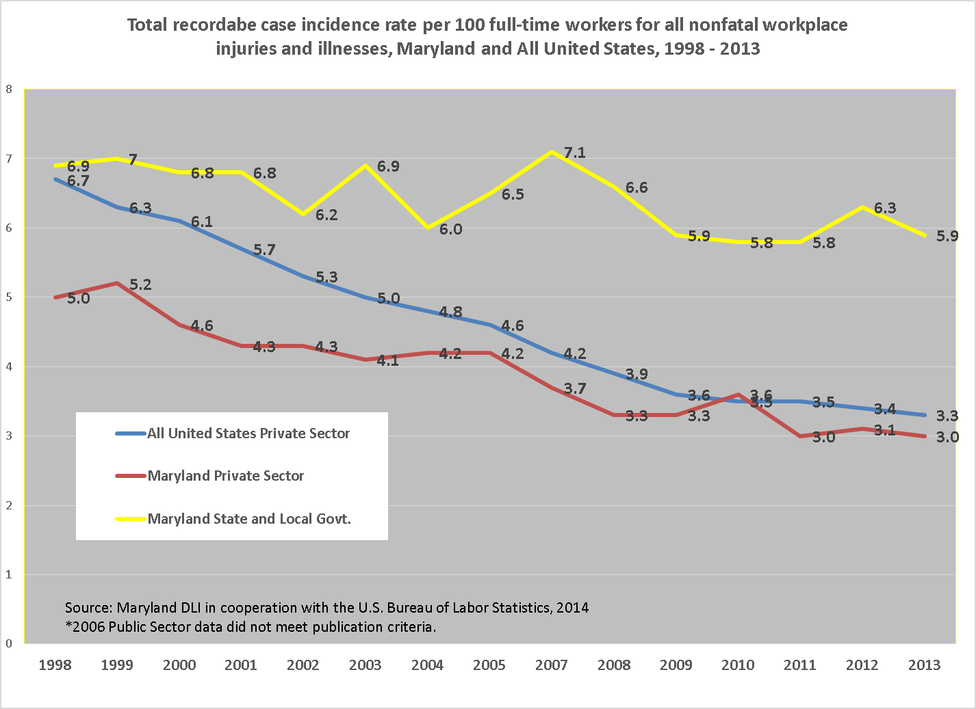

Bureau of Labor Statistics’ Census of Fatal Occupational Injuries (CFOI) Program

The Maryland Census of Fatal Occupational Injuries (CFOI) program collects and publishes statistics on all fatal occupationally related injuries that occur in the State of Maryland. CFOI is conducted within the Maryland Department of Labor, Licensing and Regulation, Division of Labor and Industry in cooperation with the U.S Department of Labor, Bureau of Labor Statistics.

Preliminary results for the CFOI program, Maryland, 2013

Fatal work injuries in Maryland totaled 78, according to the preliminary results. This count represented an 8 percent increase from 2012’s final tally of 72. A number of these fatal events, however, were not under MOSH’s jurisdiction, including cases of workplace homicide, accounting for 12 percent of the total and transportation roadway incidents, accounting for 9 percent. Fatal occupational injuries in Maryland have ranged from a high of 106 cases reported in 2006 to a low of 60 cases reported in 2008. Final fatality numbers for Maryland, as well as the nation, will be released in April 2015.

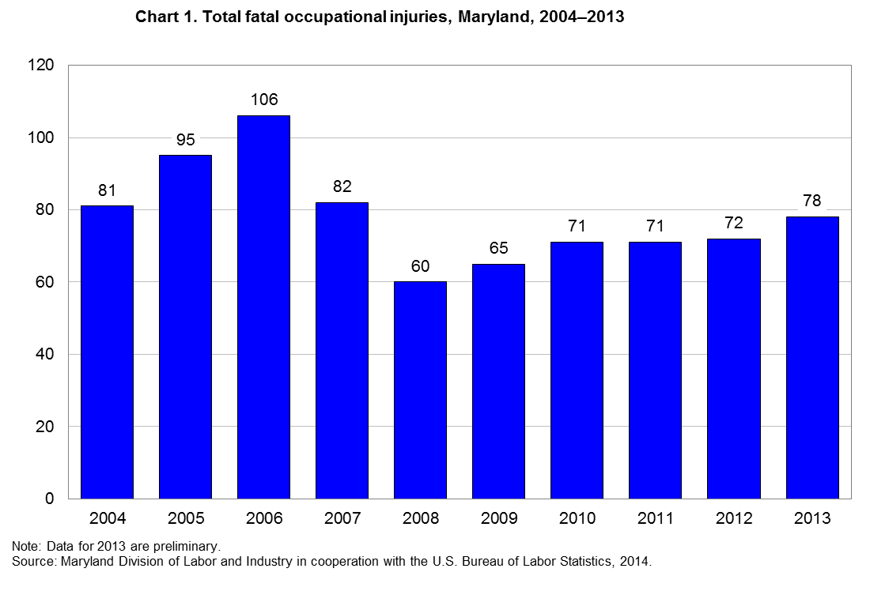

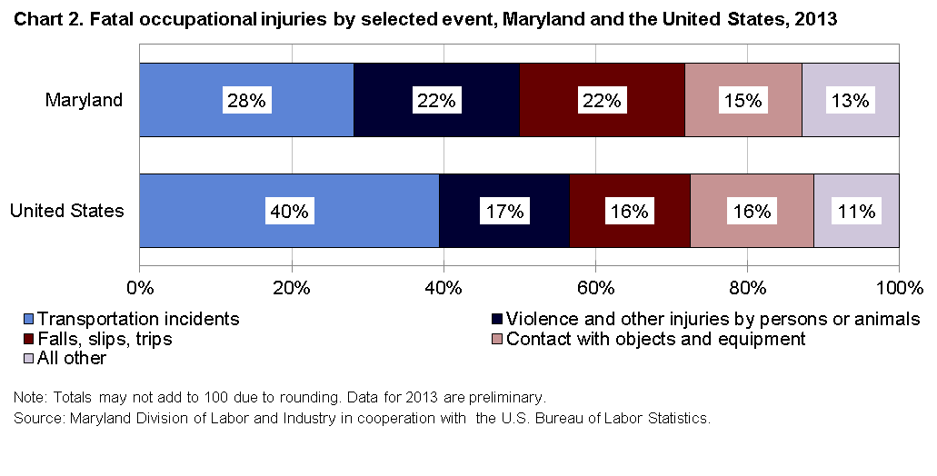

Highlights from the Maryland Census of Fatal Occupational Injuries, 2013

- With 22 workplace fatalities, representing 28 percent of the total count, transportation related incidents were the leading cause of death to workers in the State of Maryland in 2013, as they have been every year since 1996.

- Half of the transportation incidents (11 cases) were pedestrian-vehicular events where the worker was struck by a vehicle either in, or on the side of the roadway. Four of these cases occurred within a construction work zone. Seven of the transportation incidents involved highway crashes between vehicles such as a when a truck driver loses control of his vehicle and crosses the line into oncoming traffic.

- Both falls, slips or trips, and violence and other injuries by persons or animals, were the second most frequently occurring events, each with 17 reported cases. Of the fatal injuries due to falls, 14 of the cases involved falls to a lower level.

- The government sector, which includes federal, state, and local government employment experienced the most fatalities in the State with 19 reported cases. Ten of the cases involved federal workers, while 8 occurred in local government and one in State government.

- Of the 8 local government fatalities, 3 workers were killed after being struck by an object or piece of equipment; two firefighters were killed, one from fire, another in a pedestrian-vehicle accident. Two officers in police protection lost their lives, one from homicide, and one from suicide. The remaining case did not meet publication criteria.

- Slightly over three-quarters of the fatalities, (59 cases) occurred in private industry with service-providing industries accounting for 59 percent (35 cases) and goods-producing industries accounting for 41 percent (24 cases). Based on Maryland DLLR employment data, goods-producing industries accounted for roughly 13 percent of the State’s private sector employment in 2013.

- The construction sector, with 18 reported cases, had the highest fatality count in the private sector. With 146,000 employees, construction represented 7 percent of private sector employment.

- Within the construction sector, specialty trade contractors (NAICS 238) accounted for 10 of the work-related deaths, and of these, 7 occurred with foundation, structure, and building exterior contractors (NAICS 2381).

- Similarly with the 2013 national results, falls, slips and trips was the primary cause of death in the construction sector with 6 reported cases in Maryland; one fewer than the 7 reported in 2012.

- Men accounted for all 18 of Maryland’s construction fatalities and half involved Hispanic or Latino workers.

- Fatalities in the transportation and warehousing sector (NAICS 48-49) declined by more than half from 12 reported cases in 2012 down to 5 fatalities in 2013. General freight trucking, long distance (NAICS 48412) accounted for 3 of the 5 cases. Transportation and warehousing reported 11 deaths in 2011 and 9 in 2010.

- Six workers were killed while employed in the accommodation and food services sector (NAICS 72). Of these, 5 worked in food services and drinking places (NAICS 722).

- White, non-Hispanic workers accounted for 55 percent of the fatalities in Maryland, while nationally this group accounted for 68 percent; black, non-Hispanic workers accounted for just under one-quarter of the deaths in the State, while blacks accounted for 9 percent of the nation’s total. Hispanic or Latino workers accounted for 18 percent of the deaths in Maryland as well as the nation.

- Workers born in the United States accounted for 73 percent (57 cases) of Maryland’s fatality count. Of the 21 workers of foreign-born descent, 43 percent came from El Salvador.

- Men accounted for 95 percent of the State’s fatality count. Their proportion of the total was up from 91 percent in 2012. The primary manner in which the fatal injury occurred for men was a transportation incident with 22 cases, while violence and other injuries by persons or animals and falls, slips or trips accounted for 16 cases each.

- Based on employment status, just under 80 percent of the decedents (62 cases) worked for wages or salaries while the remaining 16 were self-employed. The most frequent manner in which a wage and salary worker was killed was a transportation incident (20 cases) while falls, slips or trips (6 cases) was the most frequent fatal event for the self-employed.

- The construction and extraction occupations had the highest number of fatalities with 17 cases. Over one-third of these fatal events were the result of falls, slips, or trips.

- Transportation and material moving occupations had the next highest count with 14 cases. Eight of these cases involved either vehicle highway crashes or workers struck by vehicles alongside, or in the road. Some of the more detailed occupations in this category were bus drivers, driver/sales workers, tractor-trailer drivers and taxi drivers.

The Baltimore-Towson, Maryland Metropolitan Statistical Area

- Representing 45 percent of the State’s total fatality count, 35 fatalities occurred in the Baltimore-Towson, Maryland Metropolitan Statistical Area which includes Anne Arundel, Baltimore, Carroll, Harford, Howard, and Queen Anne’s Counties, as well as Baltimore City.

- Transportation incidents and violence and other injuries by persons or animals, were the two most frequent events in the Baltimore-Towson Metropolitan Statistical Area in 2013, each with 9 reported cases. Together these two events accounted for 51 percent of the total.

- Of the 9 transportation related events, 5 cases involved pedestrian-vehicle incidents with 2 of the workers killed in construction work-zones.

- Contact with objects and equipment and falls, slips and trips were the next most frequently occurring events, both recording 6 six cases each. Contact with objects and equipment included one worker killed in an excavation or trenching cave-in; another employee caught between a rolling powered vehicle and another object; and one employee caught in running machinery during regular operation.

Chart 3, Total fatal occupational injuries, Baltimore-Towson Metro Statistical Area, 2004-2013
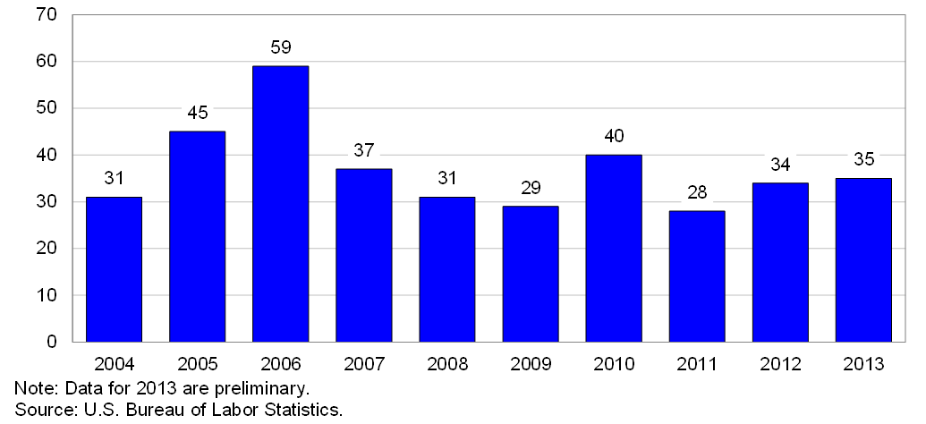

Scope and Program Technical Notes

The Maryland CFOI program compiles a complete accounting of all fatal work injures occurring in Maryland during the calendar year. The program uses diverse data sources from a variety of federal, state and local government administrative records in order to substantiate and then profile fatal work injuries. CFOI includes data for all workplace fatalities regardless of whether the fatality was under the regulatory authority of the Maryland Occupational Safety and Health agency or other federal and state agencies. Therefore, any comparison between the CFOI program’s census counts and those released by other agencies or sources should take into account the different scopes of coverage and definitions being used.

For a fatality to be included in the census, the decedent must have been employed (that is working for pay, compensation, or profit) at the time of the event, engaged in a legal work activity, or present at the site of the incident as a requirement of his or her job. Fatalities to volunteers and unpaid family workers who perform the same duties and functions as paid workers are also included in the count. These criteria are generally broader than those used by State and federal agencies administering specific laws and regulations. (Fatalities that occur during a person’s normal commute to or from work are excluded from the census counts.)
Data presented in this release include deaths occurring in 2013 that resulted from traumatic occupational injuries. An injury is defined as any wound or damage to the body resulting from acute exposure to energy, such as heat, electricity, or impact from a crash or fall, or from the absence of such essentials as heat or oxygen, caused by a specific event or incident within a single workday or shift. Included are open wounds, intracranial and internal injuries, heatstroke, hypothermia, asphyxiation, acute poisonings resulting from short-term exposures limited to the worker’s shift, suicides and homicides, and work injuries listed as underlying or contributory causes of death.

Table 1. Fatal occupational injuries by event or exposure, Maryland, 2012-2013
Event or exposure¹ |  | 2012² |  | 2013p
 |  | Number |  | Number | Percent
Total |  | 72 |  | 78 | 100
Violence and other injuries by persons or animals |  | 15 |  | 17 | 22
Intentional injury by person |  | 12 |  | 16 | 21
Homicides |  | 5 |  | 9 | 12
Shooting by other person--intentional |  | 4 |  | 6 | 8
Stabbing, cutting, slashing, piercing |  | 1 |  | 1 | 1
Bombing, arson |  | - |  | 2 | 3
Suicides |  | 7 |  | 7 | 9
Shooting--intentional self-harm |  | 6 |  | 3 | 4
Transportation incidents |  | 24 |  | 22 | 28
Pedestrian vehicular incident |  | 5 |  | 11 | 14
Pedestrian struck by vehicle in work zone |  | - |  | 4 | 5
Pedestrian struck by forward-moving vehicle in work zone |  | - |  | 4 | 5
Pedestrian struck by vehicle in roadway |  | 3 |  | 4 | 5
Pedestrian struck by forward-moving vehicle in roadway |  | - |  | 4 | 5
Pedestrian struck by vehicle on side of road |  | - |  | 1 | 1
Pedestrian struck by forward-moving vehicle on side of road |  | - |  | 1 | 1
Roadway incidents involving motorized land vehicle |  | 12 |  | 7 | 9
Roadway collision with other vehicle |  | 6 |  | 5 | 6
Roadway collision--moving in same direction |  | - |  | 2 | 3
Roadway collision--moving in opposite directions, oncoming |  | - |  | 2 | 3
Nonroadway incidents involving motorized land vehicle |  | 4 |  | 4 | 5
Nonroadway collision with object other than vehicle |  | - |  | 1 | 1
Part of occupant's body caught between vehicle and other object in  nonroadway transport incident |  | - |  | 1 | 1
Nonroadway noncollision incident |  | 4 |  | 3 | 4
Fires and explosions |  | - |  | 3 | 4
Fires |  | - |  | - | -
Other structural fire without collapse |  | - |  | 1 | 1
Explosions |  | - |  | 1 | 1
Explosion of pressure vessel, piping, or tire |  | - |  | 1 | 1
Falls, slips, trips |  | 14 |  | 17 | 22
Falls on same level |  | - |  | - | -
Fall on same level due to slipping |  | - |  | 1 | 1
Falls to lower level |  | 14 |  | 14 | 18
Fall from collapsing structure or equipment |  | 3 |  | 1 | 1
Fall from collapsing structure or equipment more than 30 feet |  | - |  | 1 | 1
Other fall to lower level |  | 9 |  | 11 | 14
Other fall to lower level less than 6 |  | - |  | 3 | 4
Other fall to lower level 11 to 15 |  | - |  | 1 | 1
Other fall to lower level 16 to 20 feet |  | 2 |  | 4 | 5
Other fall to lower level 21 to 25 feet |  | 1 |  | 1 | 1
Other fall to lower level more than 30 feet |  | 4 |  | 1 | 1
Exposure to harmful substances or environments |  | 8 |  | 7 | 9
Exposure to oxygen deficiency, n.e.c. |  | 2 |  | 2 | 3
Drowning, submersion, n.e.c. |  | 2 |  | 2 | 3
Contact with objects and equipment |  | 11 |  | 12 | 15
Struck by object or equipment |  | 10 |  | 9 | 12
Struck by powered vehicle--nontransport |  | 3 |  | 4 | 5
Struck by falling object or equipment |  | 4 |  | 4 | 5
Caught in or compressed by equipment or objects |  | 1 |  | 1 | 1
Caught in running equipment or machinery |  | - |  | 1 | 1
Caught in running equipment or machinery during regular operation |  | - |  | 1 | 1
Struck, caught, or crushed in collapsing structure, equipment, or material |  | - |  | 2 | 3
Excavation or trenching cave-in |  | - |  | 1 | 1
Struck, caught, or crushed in other collapsing structure or equipment |  | - |  | 1 | 1
1 Based on the BLS Occupational Injury and Illness Classification System (OIICS) 2.01 implemented for 2011 data forward.
2 Data for 2012 are revised and final.
Table 2. Fatal occupational injuries by selected* industry, Maryland, 2012-2013
Industry¹ | 2012² |  | 2013p
Industry¹ | Number |  | Number |  |  | Percent
Total | 72 |  | 78 |  |  | 100
Private industry | 64 |  | 59 |  |  | 76
Natural resources and mining | 5 |  | 5 |  |  | 6
Agriculture, forestry, fishing and hunting | 5 |  | 5 |  |  | 6
Crop production | 1 |  | 3 |  |  | 4
Animal production | - |  | 2 |  |  | 3
Construction | 17 |  | 18 |  |  | 23
Construction | 17 |  | 18 |  |  | 23
Construction of buildings | 5 |  | 5 |  |  | 6
Heavy and civil engineering construction | 4 |  | 2 |  |  | 3
Specialty trade contractors | 8 |  | 10 |  |  | 13
Manufacturing | 5 |  | 1 |  |  | 1
Manufacturing | 5 |  | 1 |  |  | 1
Wood product manufacturing | - |  | 1 |  |  | 1
Trade, transportation, and utilities | 18 |  | 13 |  |  | 17
Wholesale trade | - |  | 4 |  |  | 5
Merchant wholesalers, durable goods | - |  | 3 |  |  | 4
Retail trade | 4 |  | 4 |  |  | 5
Furniture and home furnishings stores | - |  | 2 |  |  | 3
Miscellaneous store retailers | - |  | 1 |  |  | 1
Transportation and warehousing | 12 |  | 5 |  |  | 6
Truck transportation | 7 |  | 3 |  |  | 4
Transit and ground passenger transportation | - |  | 1 |  |  | 1
Professional and business services | 9 |  | 8 |  |  | 10
Administrative and waste services | 8 |  | 7 |  |  | 9
Administrative and support services | 7 |  | 6 |  |  | 8
Leisure and hospitality | 4 |  | 6 |  |  | 8
Accommodation and food services | 3 |  | 6 |  |  | 8
Accommodation | - |  | 1 |  |  | 1
Food services and drinking places | 3 |  | 5 |  |  | 6
Other services, except public administration | 2 |  | 6 |  |  | 8
Other services, except public administration | 2 |  | 6 |  |  | 8
Repair and maintenance | - |  | 4 |  |  | 5
Religious, grantmaking, civic, professional, and similar organizations | 2 |  | 1 |  |  | 1
Government3 | 8 |  | 19 |  |  | 24
Federal government | - |  | 10 |  |  | 13
State government | - |  | 1 |  |  | 1
Local government | 5 |  | 8 |  |  | 10
* For full table detail, see www.bls.gov/ro3/cfoimdtables.htm#industry
1 Industry data are based on the North American Industry Classification System, 2007. Total may include other industries not shown.
2 Data for 2012 are revised and final.
3 Includes fatal injuries to workers employed by governmental organizations regardless of industry.
p Data for 2013 are preliminary. Revised and final 2013 data are scheduled to be released in spring 2015.
NOTE: Totals for major categories may include subcategories not shown separately. Percentages may not add to totals because of rounding. Dashes indicate no data reported or data that do not meet publication criteria. CFOI fatality counts exclude illness-related deaths unless precipitated by an injury event.

Table 3. Fatal occupational injuries by selected* occupation, Maryland, 2012-2013
Occupation¹ |  |  | 2012² |  | 2013p
 |  |  | Number |  | Number | Percent
Total |  |  | 72 |  | 78 | 100
Management occupations |  |  | 6 |  | 10 | 13
Other management occupations |  |  | 6 |  | 10 | 13
Farmers, ranchers, and other agricultural managers |  |  | 2 |  | 5 | 6
Food service managers |  |  | 1 |  | 2 | 3
Community and social services occupations |  |  | 1 |  | 1 | 1
Religious workers |  |  | 1 |  | 1 | 1
Clergy |  |  | 1 |  | 1 | 1
Protective service occupations |  |  | 4 |  | 7 | 9
Supervisors of protective service workers |  |  | - |  | 2 | 3
First-line supervisors of fire fighting and prevention workers |  |  | - |  | 1 | 1
Miscellaneous first-line supervisors, protective service workers |  |  | - |  | 1 | 1
Fire fighting and prevention workers |  |  | - |  | 1 | 1
Firefighters |  |  | - |  | 1 | 1
Law enforcement workers |  |  | 3 |  | 2 | 3
Police officers |  |  | 3 |  | 2 | 3
Other protective service workers |  |  | 1 |  | 2 | 3
Security guards and gaming surveillance officers |  |  | 1 |  | 1 | 1
Miscellaneous protective service workers |  |  | - |  | 1 | 1
Food preparation and serving related occupations |  |  | - |  | 2 | 3
Supervisors of food preparation and serving workers |  |  | - |  | 1 | 1
First-line supervisors of food preparation and serving workers |  |  | - |  | 1 | 1
Cooks |  |  | - |  | 1 | 1
Cooks |  |  | - |  | 1 | 1
Building and grounds cleaning and maintenance occupations |  |  | 10 |  | 4 | 5
Supervisors of building and grounds cleaning and maintenance workers |  |  | 2 |  | 1 | 1
First-line supervisors of building and grounds cleaning and maintenance workers |  |  | 2 |  | 1 | 1
Grounds maintenance workers |  |  | 8 |  | 3 | 4
Grounds maintenance workers |  |  | 8 |  | 3 | 4
Sales and related occupations |  |  | - |  | 4 | 5
Supervisors of sales workers |  |  | - |  | 2 | 3
First-line supervisors of sales workers |  |  | - |  | 2 | 3
Retail sales workers |  |  | - |  | 1 | 1
Cashiers |  |  | - |  | 1 | 1
Office and administrative support occupations |  |  | 4 |  | 2 | 3
Material recording, scheduling, dispatching, and distributing workers |  |  | 3 |  | 2 | 3
Postal service workers |  |  | - |  | 2 | 3
Construction and extraction occupations |  |  | 15 |  | 17 | 22
Supervisors of construction and extraction workers |  |  | 3 |  | 4 | 5
First-line supervisors of construction trades and extraction workers |  |  | 3 |  | 4 | 5
Construction trades workers |  |  | 12 |  | 10 | 13
Carpenters |  |  | - |  | 3 | 4
Construction laborers |  |  | 5 |  | 3 | 4
Structural iron and steel workers |  |  | - |  | 1 | 1
Other construction and related workers |  |  | - |  | 3 | 4
Installation, maintenance, and repair occupations |  |  | 5 |  | 8 | 10
Electrical and electronic equipment mechanics, installers, and repairers |  |  | - |  | 1 | 1
Radio and telecommunications equipment installers and repairers |  |  | - |  | 1 | 1
Vehicle and mobile equipment mechanics, installers, and repairers |  |  | - |  | 3 | 4
Other installation, maintenance, and repair occupations |  |  | 4 |  | 4 | 5
Maintenance and repair workers, general |  |  | - |  | 3 | 4
Miscellaneous installation, maintenance, and repair workers |  |  | - |  | 1 | 1
Transportation and material moving occupations |  |  | 14 |  | 14 | 18
Motor vehicle operators |  |  | 8 |  | 9 | 12
Bus drivers |  |  | - |  | 1 | 1
Driver/sales workers and truck drivers |  |  | 6 |  | 7 | 9
Taxi drivers and chauffeurs |  |  | - |  | 1 | 1
Material moving workers |  |  | 4 |  | 5 | 6
Industrial truck and tractor operators |  |  | - |  | 1 | 1
Laborers and material movers, hand |  |  | 3 |  | 3 | 4
Military occupations3 |  |  | - |  | 4 | 5
* For full table detail, see www.bls.gov/ro3/cfoimdtables.htm#occupation
1 Occupation data are based on the Standard Occupational Classification system, 2010. Total may include occupations not shown.
Table 4. Fatal occupational injuries by worker characteristics, Maryland, 2012-2013
Worker characteristics | 2012¹ | 2013p
Worker characteristics | Number | Number |  | Percent
Total | 72 | 78 |  | 100
Employee status
Wage and salary workers2 | 52 | 62 |  | 79
Self-employed3 | 20 | 16 |  | 21
Gender
Men | 66 | 74 |  | 95
Women | 6 | 4 |  | 5
Age4
18-19 years | 2 | 1 |  | 1
20 to 24 years | 3 | 7 |  | 9
25 to 34 years | 14 | 12 |  | 15
35 to 44 years | 9 | 19 |  | 24
45 to 54 years | 15 | 13 |  | 17
55 to 64 years | 17 | 21 |  | 27
65 and over | 11 | 5 |  | 6
Race or ethnic origin5
White (non-Hispanic) | 37 | 43 |  | 55
Black or African-American (non-Hispanic) | 18 | 18 |  | 23
Hispanic or Latino | 15 | 14 |  | 18
Asian (non-Hispanic) | - | 3 |  | 4
1 Data for 2012 are revised and final.
2 May include volunteers and workers receiving other types of compensation.
3 Includes self-employed workers, owners of unincorporated businesses and farms, paid and unpaid family workers, and may include some owners of incorporated businesses or members of partnerships.
4 Information may not be available for all age groups.
5 Persons identified as Hispanic or Latino may be of any race. The race categories shown exclude Hispanic and Latino workers.
p Data for 2013 are preliminary. Revised and final 2013 data are scheduled to be released in spring 2015.
NOTE: Totals for major categories may include subcategories not shown separately. Percentages may not add to totals because of rounding. Dashes indicate no data reported or data that do not meet publication criteria. CFOI fatality counts exclude illness-related deaths unless precipitated by an injury event.

Employers’ First Report of Injury or Illness Program
Beginning July 1, 2014, Maryland Legislative Departmental Bill (SB13) repealed the requirement that employers submit to the Division of Labor and Industry paper copies of any report they provide to the Maryland Workers’ Compensation Commission or the Chesapeake Employers Insurance Company. In its place, the Workers’ Compensation Commission has provided the Division of Labor and Industry with electronic access to their First Report of Injury or Illness database.
This new query application, allowing on-line access to the workers compensation database, is already providing Maryland Occupational Safety and Health with an important new surveillance tool for monitoring the safety and health of Maryland’s public and private workforce. Specific types or conditions of injury and illness can now be quickly queried with search results that were impossible to match with the archaic paper system of retrieval that had been in place.

All employment data derived from the Maryland Department of Labor, Licensing and Regulation, Office of Workforce Information and Performance, Employment and Payrolls, Industry Series, 2013.
Incidence rates represent the number of injuries and illnesses per 100 full-time workers and are calculated as: (N/EH) x 200,000 where N = number of injuries and illnesses EH = total hours worked by all employees during the calendar year 200,000 = base for 100 equivalent full-time workers.

