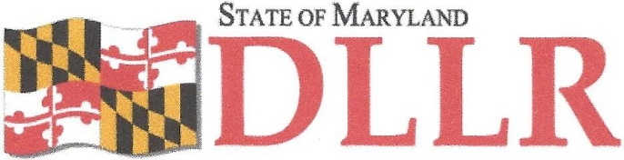
DIVISION OF LABOR AND INDUSTRY MARYLAND OCCUPATIONAL SAFETY AND HEALTH WILLIAM E. DALLAS, ASST. COMMISSIONER
10946 GOLDEN WEST DRIVE, SUITE 160 HUNT VALLEY, MD 21031-8212
DEPARTMENT OF LABOR, LICENSING AND REGULATION _
MOSH INSTRUCTION

INSTRUCTION NUMBER: 19-1 | EFFECTIVE DATE: February 12, 2019
SUBJECT: Local Emphasis Program (LEP) Maryland Hi2h Hazard Industries | ISSUANCE DATE: February 12, 2019
CANCELLATION: MOSH Instruction 16-6 | EXPIRATION: Effective until replaced by a new Instruction

Purpose: This Instruction establishes a Local Emphasis Program for High Hazard Industries in Maryland Scope: MOSH-Wide
Contact: Chief of MOSH Compliance Services
See MOSH Website for Current Information
http://www.dllr.maryland.gov/labor/mosh/

- Purpose. This Instruction establishes a LEP for High Hazard Industries in general industry
- Scope. This Instruction applies to all Regional Offices, Consultation, and Outreach
- References. None
- Expiration. This Instruction expires when replaced by a new Instruction
- Action Information.

a) | Responsible Office: | Office of the Assistant Commissioner
b) | Action Office: | All Regional Offices and Outreach
c) | Information Office: | Office of the Assistant Commissioner

- Action. MOSH compliance personnel shall ensure that the procedures contained in the instruction are followed when conducting this LEP. The Chief of Compliance or designee will randomize establishments of the same NAICS/SIC identified through the High Hazard Industries listed in section 8.b and assign in cycles. These inspections will be scheduled in accordance with MOSH's FOM Chapter 2.

LARRY HOGAN, GOVERNOR • BOYD K. RUTHERFORD, T. GOVERNOR

MOSH Instruction 19-1

February 12, 2019

Page 2

- Background. Industries appearing on this High Hazard List were derived primarily from Maryland specific 2017 Bureau of Labor Statistics' occupational injury and illness annual survey results. The included industries reported incidence rates involving days away from work, job restriction, or job transfer, a.k.a., (DART) rates above Maryland's 2017 private sector DART rate average of 1.5 injuries and illnesses per 100 full-time equivalent workers. In addition, 4 industries were based on 2017 U.S. results, while another 3 were based on the industry's reported rate over a three-year State average. This approach helps ensure hazardous industry identification, regardless of whether or not a particular industry was published during the most recent data collection.

- Procedures. This LEP will be conducted throughout the State.

  - The Chief of Compliance, or designee, will create a randomized establishment inspection list by extracting the industries listed in Paragraph b. of this section from an establishment database. The Supervisor of lndustrial Hygiene may pull a subset of NAICS code and/or establishments based on prior inspection history, industry knowledge, and demographics of injuries/illnesses of the particular industry. This list will then be randomized and distributed in cycles by the Chief of Compliance following a similar pattern as outlined in this instruction. Any comprehensive/programmed planned inspection conducted under this instruction, by either IH or Safety, will result in the company being removed from any inspection list(s) created from this instruction. This does not preclude referrals to/from Safety or Health or joint inspections.

MOSH Instruction 19-1

February 12, 2019

Page 3

  - List ofldentified High Hazard Industries by NAICS Code:

Agriculture, Forestry, Fishing and Hunting | 110000
Food Manufacturing | 311000
Beverage Manufacturing | 312000
Wood Products | 321000
Converted Paper Product Manufacturing | 322200
Printing and related Support Activities | 323000
Plastic and Rubber Products Manufacturing | 326000
Nonmetallic Mineral Product Manufacturing | 327000
Primary Metal Manufacturing | 331000
Fabricated Metal Product Manufacturing | 332000
Machinery Manufacturing | 333000
Transportation Equipment Manufacturing | 336000
Furniture and Related Product Manufacturing | 337000
Merchant Wholesalers Durable Goods | 423000
Grocery & Related Product Wholesalers nondurable | 424000
Motor Vehicle and Parts Dealers | 441000
Furniture and Home furnishings Stores | 442000
Building Material and Garden Equipment and Supplies | 444000
Grocery Stores | 445100
General Merchandise Stores | 452000
Air Transportation | 481000
Truck Transportation | 484000
Transit and Ground Passenger Transportation | 485000
Support Activities for Transportation | 488000
Couriers and Messengers | 492000
Warehousing and Storage | 493000
Telecommunications | 517000
Services to Buildings and Dwellings | 561700
Waste management and Remediation Services | 562000
Hospitals | 622000
Nursing and Residential Care facilities | 623000
Accommodati ons | 721000
Repair and Maintenance | 811000

MOSH Instruction 19-1

February 12, 2019

Page 4

  - Any unprogrammed inspection or investigation such as a complaint, referral, fatality, etc., will be expanded to a comprehensive safety or health inspection for any establishment that is already included within the high hazard list without regard to scheduling order.

  - This list will also serve as a state specific High Hazard list for Consultation coding and targeting efforts for VPP, CCP, SHARP, Alliances, and Training and Education activities.

9) Recording in IMIS. The IMIS identifier code to be used in item 25c on the OSHA-1 will be
"HIGHHAZD".

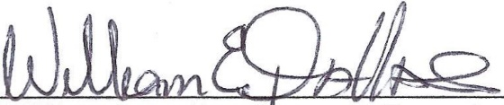
By and Under the Authority of

William E. Dallas, Assistant Commissioner

