MOSH INSTRUCTION

INSTRUCTION NUMBER: 10-4 | EFFECTIVE DATE: May 3, 2010
SUBJECT: Voluntary Protection Programs (VPP) Policies and Procedures Manual | ISSUANCE DATE: May 3, 2010
CANCELLATION: None | EXPIRATION DATE: None

Purpose: This instruction provides guidance concerning the adoption and implementation of OSHA’s Voluntary Protection Programs Policies and Procedures Manual by MOSH.

Scope: This instruction applies MOSH-wide.

References: OSHA Instruction, Directive Number CSP 03-01-003, Voluntary Protection Programs (VPP) Policies and Procedures Manual, Dated April 18, 2008.

Federal Register Volume 74, Number 6, Revisions to the Voluntary Protection Programs to Provide Safe and Healthful Working Conditions, pages 927-952, January 9, 2009.

Contact: William Grabau, Senior Industrial Hygienist
See MOSH Website for Address and Phone Number
http://www.dllr.maryland.gov/labor/mosh.html

Summary

OSHA Instruction, Directive Number CSP 03-01-003 cancels and replaces OSHA Instruction, Directive Number CSP 03-01-002. The Instruction incorporates changes published in Federal Register Notice 68 FR 68475, December 8, 2003, that revised the benchmark injury and illness rates used within VPP. The Instruction modifies procedures for VPP applications, onsite evaluations, and annual participant self-evaluations for applicants/participants subject to OSHA’s Process Safety Management (PSM) standard. The Instruction introduces an alternative onsite reapproval process for Star participants who have demonstrated sustained excellence in safety and health systems management.

MOSH INSTRUCTION 10-4
May 3, 2010
Page 2

The Instruction removes template letters that OSHA periodically modifies and that are more appropriately disseminated through other means. It includes changes in the VPP recognition process. It also removes temporary instructions no longer applicable, and references to specific VPP affiliates. Minor editorial changes improve readability.

Action:

- MOSH is adopting OSHA’s Voluntary Protection Program Polices and Procedures Manual with
the following restrictions:

- MOSH’s participation is limited to fixed general industry sites.

- MOSH’s participation is limited to Star quality sites only. There are no Merit designations.

- MOSH will not forward all the various reports, required of Federal offices, except the usual end-of-month information on newly approved VPP sites. MOSH is adopting all other provisions in OSHA’s VPP

- MOSH is adopting the revisions to the Voluntary Protection Programs To Provide Safe and Healthful Work Conditions, published in the Federal Register Volume 74, Number 6, January 9, 2009.

- The Assistant Commissioner shall ensure that MOSH’s Voluntary Protection Program is implemented in accordance with this Instruction.

By and Under the Authority of

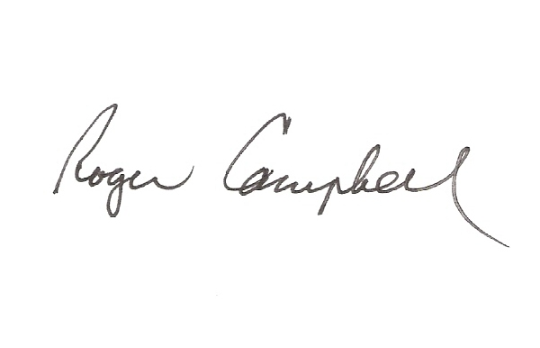
________________________________________ 05/03/2010
Roger Campbell, Assistant Commissioner Date

cc: J. Ronald DeJuliis, Commissioner, Division of Labor and Industry
Craig D. Lowry, Deputy Commissioner, Division of Labor and Industry
Jonathan Krasnoff, Assistant Attorney General
Office of Administrative Hearings

