MOSH INSTRUCTION NUMBER: 10-2 | EFFECTIVE DATE: March 3, 2010
SUBJECT: Facilities that Manufacture Food Flavorings Containing Diacetyl—National Emphasis Program (NEP) | ISSUANCE DATE: May 3, 2010
CANCELLATION: None | EXPIRATION DATE: March 2, 2013

MOSH INSTRUCTION

Purpose: This Instruction describes policies and procedures for a National Emphasis Program (NEP) implemented by OSHA to identify and reduce or eliminate hazards associated with exposures to flavoring chemicals in facilities that manufacture food flavorings containing diacetyl. MOSH will participate in this National Emphasis Program.

Scope: This Instruction applies MOSH - wide

References: OSHA Instruction, Directive Number CPL 03-00-011- National Emphasis Program (NEP) Facilities that Manufacture Food Flavorings Containing Diacetyl

Contact: Chief of MOSH Compliance Services
See MOSH Website for Current Information
http://www.dllr.maryland.gov/labor/mosh.html

____________________________________________________________________________________

Summary

In January 2006, the National Institute for Occupational Safety and Health (NIOSH) released a final Health Hazard Evaluation Report on its investigation at a microwave popcorn production facility. Several employees from this facility were diagnosed with bronchiolitis obliterans, a severe obstructive lung
disease. Following this investigation and evaluation of lung function tests and air sampling results, NIOSH determined that inhalation exposure to butter-flavoring chemicals presents a risk for occupational lung disease. In April 2007, the Centers for Disease Control and Prevention (CDC) reported in its Morbidity and Mortality Weekly Report (MMWP) seven additional cases of bronchiolitis obliterans in
MOSH Instruction 10-2
May 3, 2010
Page 2

employees working in facilities where flavorings were manufactured. OSHA Instruction CPL 03-00-011 establishes an NEP to identify and eliminate hazards associated with employee exposure to flavorings chemicals in facilities that manufacture food flavorings containing diacetyl. Diacetyl is one of the most common compounds found during investigations of microwave popcorn and flavoring manufacturing facilities. OSHA’s NEP provides guidance on targeting, inspection procedures, engineering controls, work practice controls, and compliance assistance.

_____________________________________________________________________________________

Action:

- The Assistant Chief of Health shall ensure that programmed inspections conducted under this NEP are performed in accordance with OSHA Instruction, Directive Number
CPL 03-00-011, 10/30/09.

- All Compliance and Consultation Supervisors shall review this Instruction with their field staff to ensure they are aware of the hazards associated with employee exposure to food flavorings containing diacetyl.

- All inspections conducted under this NEP will be “Health” inspections, and coded as such in Item 21, Inspection Category on the OSHA-1 form.

An inspection conducted under this NEP and in conjunction with an SST inspection will be marked as “programmed planed” in Item 24 on the OSHA-1 form, the “NEP” value of “SSTARG09” will be recorded in Item 25d along with the NEP code “FLAVRING”.
During an SST inspection (or other safety-related inspections) if hazards associated with exposure to flavoring ingredients are observed, the NEP code “FLAVRING” will be recorded.

This new “FLVARING” code applies to the following enforcement forms: OSHA-1, OSHA- 7, OSHA-36, OSHA-90 and OSHA-55.

Consultation/visit forms are to be completed with the NEP code “FLAVRING” in Item 25 on OSHA Form-20, in Item 28 on OSHA Form-30, and in Item 15 on OSHA Form-55.

MOSH INSTRUCTION 10-2
May 3, 2010
Page 3

By and Under the Authority of
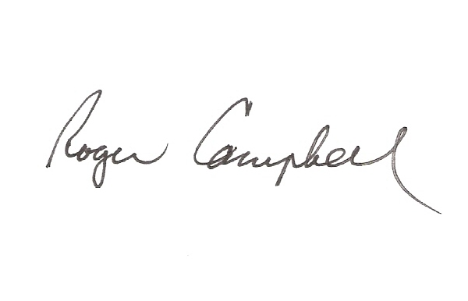

_________________________________ 05/03/2010
Roger Campbell, Assistant Commissioner Date

cc: J. Ronald Dejuliis, Commissioner, Division of Labor and Industry
Craig D. Lowry, Deputy Commissioner, Division of Labor and Industry
Jonathan Krasnoff, Assistant Attorney General
Office of Administrative Hearings

