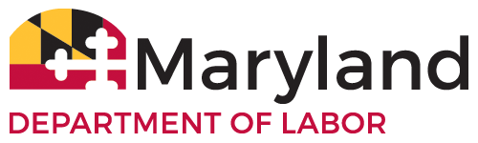
OFFICIAL USE ONLY

 APPROVED  DENIED

By: _________________ Date ____________
BOARD OF INDIVIDUAL TAX PREPARERS

IRS REGISTERED TAX RETURN PREPARER (RTRP) EXAMINATION
CONFIRMATION CERTIFICATE TRANSMITTAL SHEET

Beginning January 1, 2016, tax preparers who prepare tax returns for Marylanders will be required to have passed the Maryland Tax Preparers Examination in order to continue to provide these services. This requirement even applies to those individuals who are currently registered or have renewed their registrations prior to January 1, 2016.

Individuals who are found to have prepared Maryland tax returns this tax season and beyond and who have not passed the examination are subject to disciplinary action which may result in a suspension, revocation and or civil penalties.

____________________________________________ CURRENT MD TAX PREPARERS REG. NO. ___________
LAST NAME FIRST MI

I am eligible for a waiver of the of the requirement to pass the Maryland Tax Preparers Examination because I passed the Tax Return Preparer (RTPR) Examination that was administered by the U.S. Internal Revenue Service (IRS) between November 30, 2011 and January 13, 2015.

I passed the RTRP Examination: _______________________________________________
Indicate the date you passed examination.

 I am attaching the Registered Tax Return Preparers (RTRP) Examination Certificate and results.

 I am also attaching my current IRS PTIN Confirmation Certificate, as required.

CERTIFICATION

I certify, under the penalties of perjury, that the information contained in this application for a waiver of the examinations of the examination requirements of the Maryland Board of Tax Preparers is true and correct to the best of my knowledge, information and belief.

______________________________ _________________________________ __________________ PRINT NAME SIGNATURE DATE

EMAIL OR MAIL EXAMINATION WAIVER APPLICATION TO

MARYLAND BOARD OF INDIVIDUAL TAXPREPARERS
100 S. CHARLES STREET, TOWER 1
BALTIMORE, MD 21201
(410) 230-6257
DLOPLTaxPrep-LABOR@maryland.gov

