Please attach formal report of infraction and any supporting documents.
FOR DLLR USE ONLY
COMPLAINT NO
LICENSE NO.
LICENSE EXP.

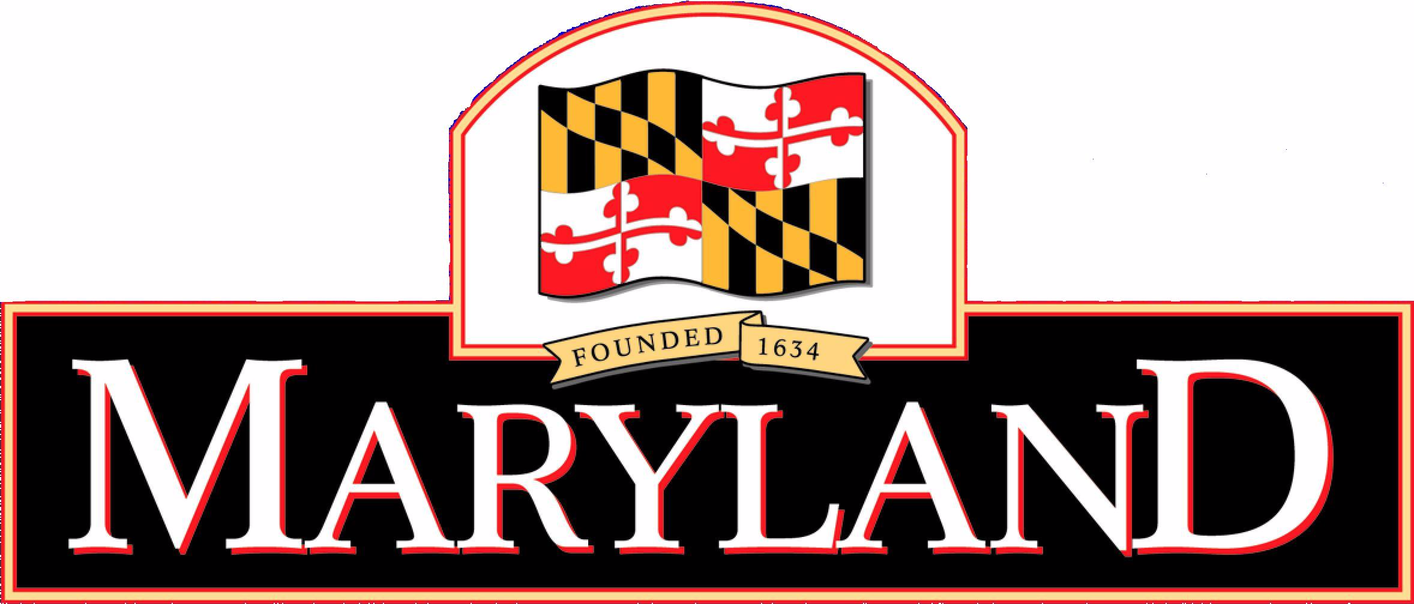

Department of Labor, Licensing and Regulation
Secondhand Precious Metal Object Dealers and Pawnbrokers Program
Law Enforcement Complaint Referral Form

REFERRING LAW ENFORCEMENT AGENCY
JURISDICTION
UNIT
REFERRING OFFICER
STREET
CITY | STATE |  | ZIP CODE
TELEPHONE |  | E-MAIL

DEALER INFORMATION
FIRST NAME | MI |  | LAST NAME
TRADE NAME/DOING BUSINESS AS
STREET 1
STREET 2
CITY |  |  |  | STATE | ZIP CODE
TELEPHONE |  | E-MAIL

TYPE OF VIOLATION (Check all that may apply)
SUBSEQUENT VIIOLATION/COMPLAINT LOCAL ENFORCEMENT CASE NUMBER
DATE OF LAST VIOLATION: |  | JURISDICTION OF VIOLATION:

OTHER (Describe, briefly - 240 characters)

TYPE OF REPORT ATTACHED (IF ANY):
Was dealer warned about/or instructed by your agency in the proper completion of the daily transaction reporting requirements prior to the events cited in this referral to the Department for administrative action? YES NO ((Include detailed history of warnings or instructions in this complaint referral.)
Violation occurred in conjunction with: IN STORE HOME GOLD PARTY HOTEL EVENT ESTATE SALE
I, certify, under penalty of perjury, that the information contained herein is true and correct to the best of my knowledge, information and belief.

SIGNATURE OF REFERRING OFFICIAL | DATE

