
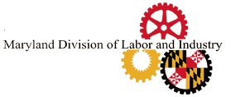


LIE DETECTOR SIGNATURE
FORM

“UNDER MARYLAND LAW, AN EMPLOYER MAY NOT REQUIRE OR DEMAND, AS A CONDITION OF EMPLOYMENT, PROSPECTIVE EMPLOYMENT, OR CONTINUED EMPLOYMENT, THAT AN INDIVIDUAL SUBMIT TO OR TAKE A LIE DETECTOR OR SIMILAR TEST. AN EMPLOYER WHO VIOLATES THIS LAW IS GUILTY OF A MISDEMEANOR AND SUBJECT TO A FINE NOT EXCEEDING $100.”

Signature Date

THIS STATEMENT MUST BE ATTACHED TO ALL EMPLOYMENT APPLICATIONS IN THE STATE OF MARYLAND)

Rev. 9/2015
Department of Labor
Division of Labor and Industry
Employment Standards Service
1100 North Eutaw Street, Room 607
Baltimore, MD 21201
Telephone Number: (410) 767-2357 • Fax Number: (410) 333-7303
E-mail: dldliemploymentstandards-dllr@maryland.gov

