
STATE OF MARYLAND
DEPARTMENT OF LABOR
DIVISION OF OCCUPATIONAL AND PROFESSIONAL LICENSING
STATE BOARD OF HEATING, VENTILATION, AIR CONDITIONING & REFRIGERATION CONTRACTORS
1100 N. EUTAW ST., ROOM 121
BALTIMORE, MD 21201
(410) 230-6231

JOURNEY APPLICATION WITHOUT EXAM – DEPARTMENT OF LABOR CERTIFICATE HOLDERS ONLY

NO FEE REQUIRED WITH THIS APPLICATION
*APPLICATION MUST BE FILLED OUT IN BLUE OR BLACK INK
*APPLICATION MUST BE LEGIBLE.

FULL NAME:_____________________________________________________________________________
Last Name First Name Middle Name

APPRENTICE LICENSE #_______________ (ATTACH A COPY OF YOUR APPRENTICE LICENSE)

ADDRESS: _______________________________________________________________________________
Street

_________________________________________________________________________________________
City State Zip code

Home # ___________________ Business #: ___________________ Email: ______________________

Social Security #: ________________________ Date of Birth: _______________________

Place of Birth: ________________________________________________________________
City State Country

ANSWER ALL THREE QUESTIONS: YES NO

- Are you 18 years of age or older?

- Have you ever been convicted of a felony or misdemeanor in any state or federal court?

- Have you ever had this type of license, certificate, registration or permit denied,

suspended, or revoked by Maryland or any other jurisdiction?

If you answer “YES” to question #2 and/or #3 above, please submit the additional information requested below:
Question #2 - In cases of a conviction of a felony or misdemeanor that is directly related to the fitness and qualification of the applicant to provide the services for which he or she is applying, you must include:
(1) A “true test copy” of the court docket where the action was heard;
(2) A letter in your own words outlining what actually happened, the current status as it relates to the case, and what you have done since the occurrence to turn things around;
(3) A letter from your parole/probation officer outlining your current status and probable date of completion, if you are still on parole or probation; and,
(4) Letters of reference are encouraged from current employers, ministers, and other persons who may be able to speak to your character and changes in lifestyle since the conviction.

Question #3 - In cases where you had this type of license, certificate, registration, or permit denied, suspended or revoked by Maryland or any other jurisdiction, you must include:
(1) A copy of the final order of action in cases of a license denial, suspension or revocation, from the jurisdiction where the action occurred;
(2) A letter in your own words outlining what actually happened; and,
(3) Letters of reference are encouraged to show your present employment activities and character.

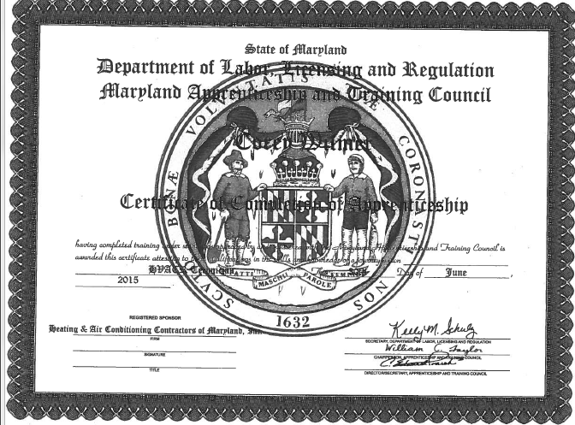
*Attach a copy of your State of Maryland Department of Labor Certificate.*

PLEASE NOTE THAT YOU HAVE TWO YEARS FROM THE DATE ON YOUR CERTIFICATE TO OBTAIN A JOURNEY LICENSE WITHOUT EXAM.

Email your signed application, copy of your apprentice license, copy of your Department of Labor Certificate and any other required documentation to the following address:

DLOPLHVACR-LABOR@MARYLAND.GOV

IT IS THE RESPONSIBILITY OF EACH APPLICANT (NOT THE EMPLOYER) TO MAKE SURE THAT AN INDIVIDUAL WHO PROVIDES OR ASSISTS IN PROVIDING HVACR SERVICES HOLDS A STATE HVACR LICENSE AND THAT IT IS KEPT CURRENT.

-CERTIFICATION-

In accordance with Executive Order .01.01.1983-18, the Department of Labor is required to advise you as follows regarding the collection of personal information. Personal information requested by the licensing agency of this Department is necessary in determining you eligibility for licensure. Such personal information is also intended for use as an additional means of verifying the licensee’s identity or to enable the agency to communicate, in a timely manner, with the licensee should the need arise. The licensee has the right to inspect his/her personal record and to amend or correct the personal data if necessary. Personal information is generally available for inspection by the public only in accordance with the Public Information Act. Personal information is not routinely shared with State, Federal or Governmental agencies.

Affidavit/Signature - I hereby certify that the information provided on both sides of this application is true
and correct and the Maryland Department of Labor may rely on its truthfulness considering this application.

Sign Here _____________________________________ _________________________________
Signature of Applicant Date

If you have any questions or require additional assistance, please call (410) 230-6231 or email the Board staff at DLOPLHVACR_DLLR@maryland.gov or fax your questions ATTN: HVACR BOARD STAFF at (410) 244-0977.

