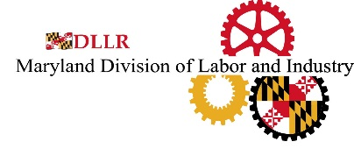

CREDIT REPORT COMPLAINT
(Job Applicant Fairness, Labor and Employment Article, Section 3-711, Annotated Code of Maryland)

The Job Applicant Fairness Act generally prohibits employers in Maryland from using a job applicant or employee’s credit report to determine:

(1) whether to hire a job applicant;

(2) whether to terminate an employee; or

(3) the rate of pay or other conditions of employment for an employee.

If you feel that your rights may have been violated under this law, complete this form, provide any supporting documentation, and mail the complaint form to the address below. Upon receipt, the Commissioner will conduct an investigation and notify you of its determination.

For more information, click here to visit the Job Applicant Fairness Act FAQs (link to current page)

Name:

Address:
City State Zip

Daytime Phone Number(s):

Email Address:

Employer Name:

Employer Address:
City State Zip

Supervisor and/or Business Owner Name:

Describe in detail the nature of the complaint (also, please provide any supporting documentation):

Department of Labor
Division of Labor and Industry
Employment Standards Service
10946 Golden West Drive – Suite 160
Hunt Valley, MD 21031
Telephone Number: (410) 767-2357 • Fax Number: (410) 333-7303
E-mail: DLDLIMdLaborComplaint-dllr@Maryland.gov
Rev: 8/23

