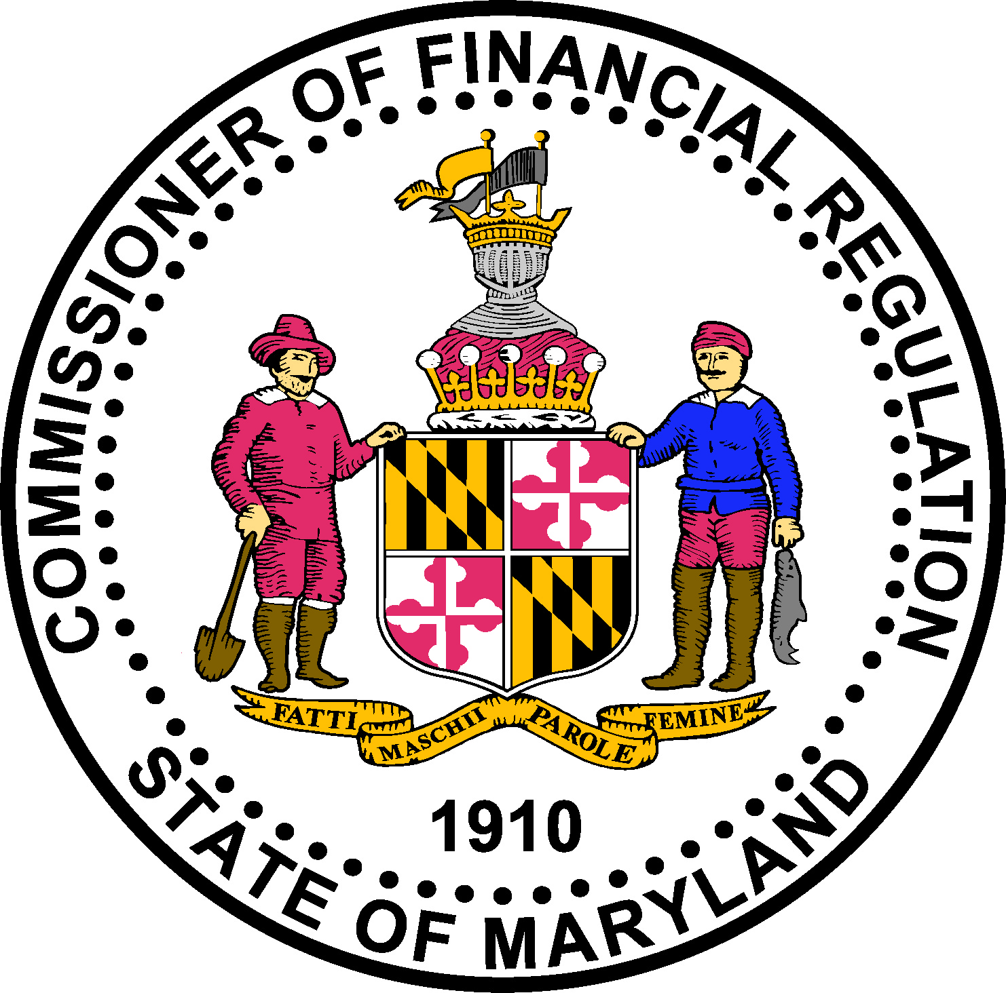

Maryland DEBT SETTLEMENT SERVICES

COMPANY renewal REGISTRATION CHECKLIST

LEGAL REQUIREMENTS:

Maryland Code Annotated, Financial Institutions § 12-1001 et seq. (Maryland Debt Settlement Services Act)
Maryland Code Annotated, Commercial Law § 13-301 et seq. (Unfair or Deceptive Trade Practice)

APPLICATION PROCESS:

This document includes instructions for a Debt Settlement Services registration renewal with the Office of the Commissioner of Financial Regulation (“Commissioner”) website at:
http://www.dllr.state.md.us/finance/industry/debtsettlement.shtml

Please note that the Commissioner must receive (at the address below) this checklist and information marked “Attached” on the checklist within five (5) business days of the electronic submission of your application:

For U.S. Postal Service or Overnight Delivery

Maryland Commissioner of Financial Regulation
Attn: Licensing Unit
500 N Calvert Street, Suite 402
Baltimore, Maryland 21202

INCOMPLETE REGISTRATION:

If your registration renewal package is incomplete (including explanations and/or required documentation submitted in an incorrect format) sixty (60) days after the filing, the Commissioner may terminate the processing of the registration and will deem the incomplete package withdrawn by the applicant.

REGISTRATION FEE

Renewal Registration Fee: $400.00

Registration Number: ________________

Applicant Legal Name: _____________________________________

Attached | Not applicable | MARYLAND DEBT SETTLEMENT SERVICES  COMPANY REGISTRATION CHECKLIST
□ | □ | non-refundable REGISTRATION fee: Registration fee of $1,000 in the form of a check or money order was mailed with invoice on _____________ [Date] to:  Maryland Commissioner of Financial Regulation  P.O. Box 17409  Baltimore, Maryland 21297-1409
Debt Settlement Services Provider Registration Form. Attach completed registration form. The affidavit on that form must be signed by a control person, as defined in the form, of the registrant.
Debt Settlement Services Provider Registration New & Renewal Form
http://www.dllr.state.md.us/finance/industry/debtsettlement.shtml
□ | □ | STATE OF FORMATION CERTIFICATE OF GOOD STANDING: As applicable, if applicant is an entity formed in a state other than Maryland, attach a certificate of good standing issued by applicant’s state of formation not more than sixty (60) days prior to the date of this application.
□ | □ | Good Standing STATUS: Applicants must be registered and in good standing with the Maryland Department of Assessments and Taxation (SDAT) to be licensed. The current good standing status may be verified on the SDAT website: http://dat.maryland.gov.
□ | □ | SURETY BOND ($50,000 per Debt Settlement Services Provider): The company may provide a Bond Continuation or Verification Certificate for the bond on file instead of providing a new bond. If a new bond is submitted, then the following requirements apply:  - This bond must be completed on the form posted on the Commissioner’s website:  http://www.dllr.state.md.us/finance/industry/debtsettlement.shtml  - The insured’s name and address must match exactly the applicant’s full legal name and address: and  - The surety bond company must be licensed to conduct business in Maryland.  Note: Confirm the bond company is licensed by doing a quick search on the Maryland Insurance Administration Website:  http://insurance.maryland.gov/Consumer/Pages/CompanySearchInstructions.aspx  - The original surety bond must be submitted to the Office of the Commissioner of Financial Regulation and it will be maintained in the file.

WHOM TO CONTACT – Contact the Commissioner of Financial Regulation licensing staff by phone at 410-230-6155 or 888-784-0136 for further assistance regarding Maryland specific requirements.
THE APPLICANT/REGISTRANT IS FULLY RESPONSIBLE FOR ALL OF THE REQUIREMENTS OF THE REGISTRATION FOR WHICH APPLICANT/ REGISTRANT IS APPLYING. THE SPECIFIC REQUIREMENTS CONTAINED HEREIN ARE FOR GUIDANCE ONLY. SHOULD YOU HAVE QUESTIONS, PLEASE CONSULT LEGAL COUNSEL.

