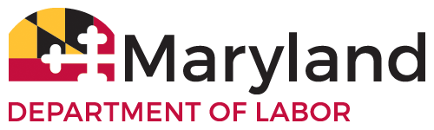
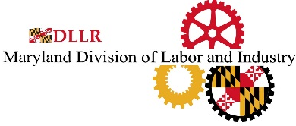
Free On-Site Consultation Request for Assistance Form

Company Name:

Mailing Address:

Site Address:

Telephone Number: E-Mail:

Contact Person (Name/Title):

Describe type of business, products manufactured, operations and/or services at this worksite:

North American
Industry Classification System (NAICS Code) if known:

Number of employees (at location): (corporate-wide):

Is there a recognized labor organization (or organizations) at this workplace? Yes No

Please check type of survey(s) requested. Separate visits will normally be made for each box checked (refer to footnotes for a description of surveys):

Safety Industrial Hygiene

Scope of Survey (please check one): Entire workplace survey Partial workplace survey

Describe scope of survey if you checked the partial workplace survey box. Also use this space to describe any specific issues you wish to have addressed:

Normally, a consultation visit cannot be conducted while a MOSH Compliance action is open. Please check any of the following statements that are true:
A MOSH Compliance inspection is in progress
There has been a MOSH Compliance inspection with in the past six months
There is a contested MOSH Compliance activity
There is an unresolved denial of entry

Please read the following. Contact the Consultation Project Manager if you have any questions.

- The consultation service is provided at no cost to employers with federal and state funds. Priority in scheduling is given to requests received from small businesses that are in high-hazard industries or have the most hazardous conditions at issue in the request.

- The Consultation Program is dedicated to assisting small, high-hazard employers reduce occupational injuries and illnesses through the identification and correction of hazards. While the identification of hazards by a consultant will not mandate the issuance of citations or penalties, the employer is required to take necessary action to eliminate employee exposure to a hazard which in the judgment of the consultant represents an imminent danger to employees, and to take action to correct within a reasonable time any serious hazards that are identified. The discovery of such a hazard will not initiate any enforcement activity unless the employer fails to eliminate the identified hazard within the established time frame or extension period.

- While utilizing this service, employers remain under a statutory obligation to provide safe and healthful work and working conditions for employees.

- Employee involvement is an element of an effective safety and health program. The consultant will confer with a reasonable number of employees concerning matters of workplace safety and health.

- The employer must agree to post a list of all serious hazards found by the consultant and the correction due dates, and to notify affected employees when hazards are corrected. MOSH Enforcement cannot schedule a compliance inspection in response to a complaint based upon a posted List of Hazards unless the employer fails to meet his obligations to correct hazards, or fails to provide interim protection for exposed employees.

- The employer must agree to make information on the corrective actions proposed by the consultant, as well as other-than-serious hazards identified, available at the worksite for review by affected employees.

- Certain employers who receive both safety and industrial hygiene workplace surveys, correct all hazards identified by the consultants, and develop and operate an effective safety and health program may be eligible to participate in a Recognition and Exemption Program. Participants are granted an exemption from MOSH programmed enforcement inspections. Contact the Project Manager for details.

I acknowledge that I have the authority to make a request for consultation assistance on behalf of my employer.

Signature Date

Printed Name Title

Please sign and return this form by e-mail, mail or fax to the address/fax number below.

Learn more about Consultation Services by visiting OSHA’s Consultation Page at www.osha.gov.

Maryland Department of Labor
Division of Labor and Industry
Maryland Occupational Safety and Health, Consultation Services
10946 Golden West Drive, Suite 190
Hunt Valley, Maryland 21031
Telephone Number: (410) 527-4472 • Fax Number: (410) 527-5678
E-mail: mosh.consultation@maryland.gov

Rev. 9/2019
Department of Labor, Licensing and Regulation
Employment Standards Service
1100 North Eutaw Street, Room 607
Baltimore, MD 21201
Telephone Number: (410) 767-2357 • Fax Number: (410) 333-7303
E-mail: dldliemploymentstandards-dllr@maryland.gov

A safety survey will focus on fire, mechanical, electrical, material handling and working surface hazards.
An industrial hygiene survey will focus on chemical safety, personal protective equipment, bloodborne pathogens, and exposures to noise, radiation, heat, and air contaminants.

