MARTIN O’MALLEY, Governor
ANTHONY G. BROWN, Lt. Governor
THOMAS E. PEREZ, Secretary

Andrew Moser, Assistant Secretary

Division of Workforce Development
DLLR Home Page • http://www.dllr.state.md.us
E-mail • amoser@dllr.state.md.us

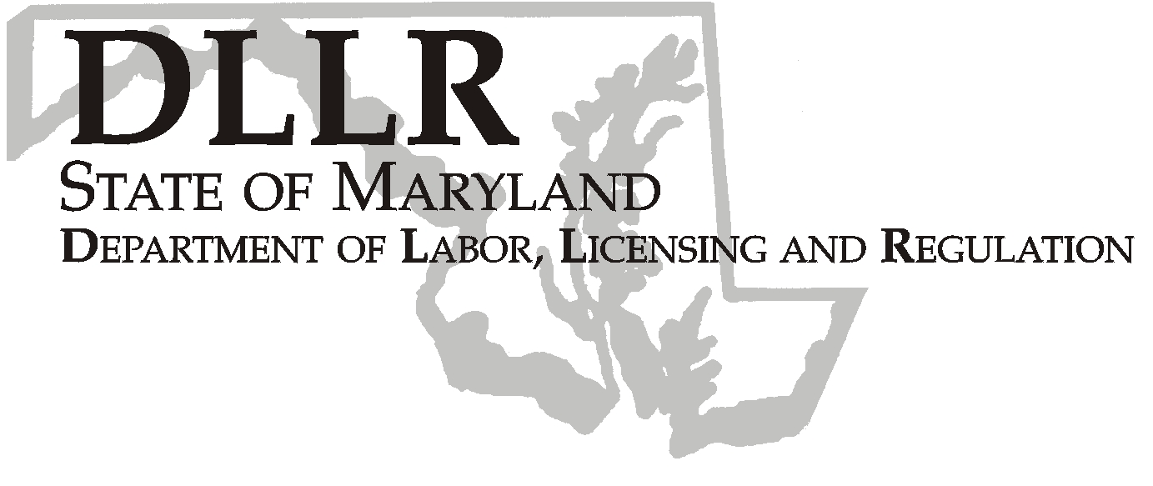

WORKFORCE INVESTMENT FIELD INSTRUCTION (WIFI) No. 09-08

DATE: May 15, 2009

TO: Maryland Workforce Investment Area Grant Recipients

SUBJECT: Recertification of Local Workforce Investment Boards (LWIBs)

REFERENCES: Public law 105-220 ~ Workforce Investment Act of 1998 (WIA)
20 CFR 652 Workforce Investment Act: Final Rule
WIFI 10-99: Local Comprehensive Workforce Investment Act Five Year Plan
WIFI 04-04: Recertification of Local Workforce Investment Boards (LWIBs)

BACKGROUND INFORMATION:

Section 117 (c) (2) {Certification} WIA provides that:

“(A) IN GENERAL – The Governor shall, once every two (2) years, certify one local board for each local area in the State.”

“(B) CRITERIA – Such certification shall be based on criteria established under subsection (b) {Membership} and, for a second or subsequent certification, the extent to which the local board has ensured that workforce investment activities carried out in the local areas have enabled the local area to meet the local performance measures.”

WIA mandates that the Governor recertify Local Workforce Investment Boards biannually. To fulfill this requirement, policy and local Board certification processes were developed in 2005.

Policy

- Recertify LWIBs effective July 1, 2009, for a period of two (2) years provided that:

1100 NORTH EUTAW STREET, ROOM 616
BALTIMORE, MD 21201

Keeping Maryland Working and Safe
PHONE: 410-767-2997 FAX: 410-333-5355
TTY USERS, CALL VIA THE MD RELAY SERVICE

- The LWIB meets the membership criteria of WIA Section 117 (b);
- The LWIB has satisfactorily performed the board functions outlined in WIA Section 117 (d);
- The LWIB has established a Youth Council or an alternative entity, as specified in WIA Section 117 (h), that carries out required duties;
- The LWIB has maintained fiscal integrity, defined as having no major unresolved questioned costs, or other major outstanding audit issues and having no findings of fraud or abuse; and,
- Beginning in PY 2006 – 2008, Maryland implemented WIA common performance measures, an action which eliminated the use of the original WIA performance measures as a basis for assessing performance for the purpose of recertification. As a result of the transition to common performance measures, for this recertification period only, LWIBs will be assessed on their ability to achieve 80 percent or higher on at least nine (9) of the twelve (12) locally negotiated performance measures:

- Adult Entered Employment Rate;
- Dislocated Workers Entered Employment Rate;
- Entered Employment Rate (Labor Exchange);
- Adult Employment Retention Rate;
- Dislocated Workers Employment Retention Rate;
- Employment Retention Rate (Labor Exchange);
- Adult Average Earnings Rate;
- Dislocated Workers Earnings Rate;
- Average Earnings Rate (Labor Exchange);
- Youth Placement in Employment or Education;
- Youth Attainment of a Degree or Certificate; and
- Youth Literacy and Numeracy Gains.

Please note that this assessment will be based on PY2007 data.

- There shall be the following two levels of recertification:

Level I Recertification

If the LWIB meets all of the requirements in # 1 above, it will be recertified for a period of two (2) years.

Level II Recertification

If the LWIB fails to meet the standards outlined in # 1 above, it will receive a one-year Provisional Certification designation, provided it establishes an improvement plan and agrees to technical assistance provided by the Department of Labor, Licensing and Regulation (DLLR). At the conclusion of the one-year period, the LWIB may be certified for one additional year, provided that it meets the requirements set forth in # 1 above. At the conclusion of the one-year provisional period, the LWIB may be certified for one additional year, provided that it meets the requirements set forth in # 1. In the event the LWIB remains in non-compliance, the Governor’s Workforce Investment Board (GWIB) may recommend significant action, included decertification and the appointment of a new board as provided in WIA Section 136 (h).

ACTION REQUIRED:

As a part of this communication, we have provided the following electronic forms that must be completed regarding your local board to ensure we have the correct information needed to recertify your board:

- LWIB Certification Form;
- Local Workforce Investment Board Questionnaire; and
- LWIB Certification Matrix

For your convenience, you are able to type directly into the fields on each of the forms; saving you time from handwriting your responses. Additionally, where signatures are requested, please feel free to provide your electronic signature.

Please complete and return your package via email to Lynn Reed at lreed@gwib.state.md.us by close of business by Monday, June 1, 2009, so that we will ample time to review your package in preparation for the June 17, 2009 Quarterly GWIB Board Meeting.

Next Steps

GWIB staff will review LWIB membership and composition, while staff from the DLLR Division of Workforce Development (DWD) will monitor WIA performance, financial/audit reports and Board activities. All results and related reports will be made available to the LWIB upon completion of the monitoring process.

If a local area is not performing at the standard outlined in the proposed policy, the local area will be required to prepare an improvement plan and DLLR will provide technical assistance to help in achieving the standard. Any decisions to recommend recertification or decertification of a local board must be preceded by the opportunity for a review of the data by DLLR and the local area.

CONTACTS: Eric Seleznow at eselznow@gwib.state.md.us
Lynn Reed (410) 767-2131 or lreed@gwib.state.md.us

EFFECTIVE
DATE: May 15, 2009

Andrew Moser
Assistant Secretary
Division of Workforce Development

