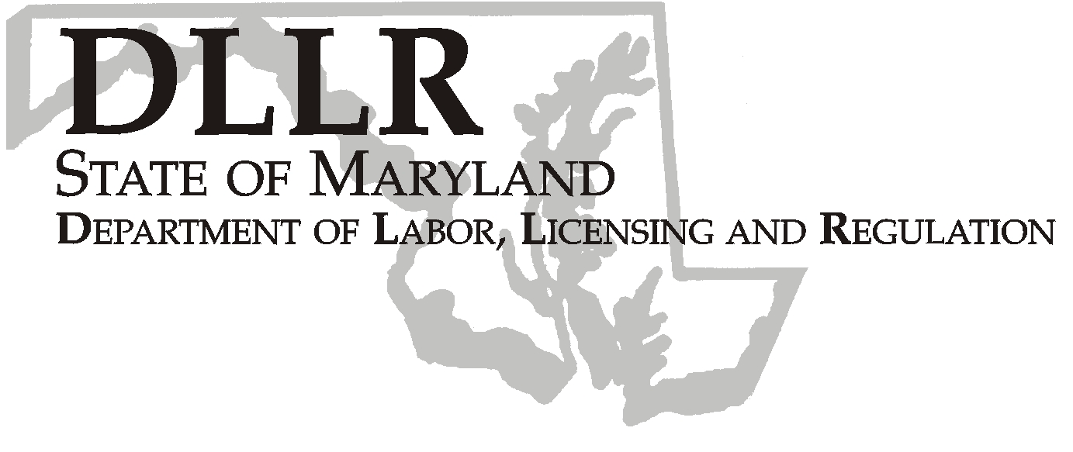
MARTIN O’MALLEY, Governor
ANTHONY G. BROWN, Lt. Governor
THOMAS E. PEREZ, Secretary

Andrew Moser, Assistant Secretary

Division of Workforce Development
DLLR Home Page • http://www.dllr.state.md.us
E-mail • amoser@dllr.state.md.us

WORKFORCE INVESTMENT FIELD INSTRUCTION (WIFI), NO. 8-08

DATE: April 8, 2009

TO: Maryland Workforce Investment Act (WIA) Grant Recipients

SUBJECT: Revised Federal Poverty Level Guidelines and Lower Living Standard Income Levels (LLSIL)

REFERENCES: Public Law 105-220 – Workforce Investment Act
20 CFR 652 – Workforce Investment Act: Final Rule
Federal Register/Vol. 74, No. 14
Federal Register/Vol. 74, No. 57

BACKGROUND INFORMATION:

Under Title I of the Workforce Investment Act, the Secretary of Labor annually determines the Lower Living Standard Income Level (LLSIL) for uses that are defined in the law. WIA defines the term “low income individual” as one who qualifies under various criteria, including an individual who received income that does not exceed the higher of the poverty line or 70 percent of the lower living standard income level. In accordance with the Act, Health and Human Services/Office of the Secretary has released the revised 2009 figures for poverty levels, and the Department of Labor has released the revised 2009 LLSIL.

ACTION TO BE TAKEN:

All Maryland WIA grant recipients should use one of the attached charts, either the 2009 Poverty Income Guidelines or the 2009 70 percent LLSIL (whichever is higher), to determine if applicants are low income for those programs that require it. These new poverty income guidelines are now available in MWE. All intake personnel are to be advised of the changes and refer to the revised guidelines.

CONTACT PERSON: Valerie Myers (410-767-2825)

EFFECTIVE DATE: March 26, 2009

Attachment

Andrew Moser
Assistant Secretary

Division of Workforce Development
2009 Lower Living Standard Income Level (LLSIL)- 70%
and
Poverty Income Guidelines for The State of Maryland
2009 HHS Poverty Guidelines
Size of Family |  |  |  |  |  |  |  |  |  |  |  | Poverty Guideline
1………………….......…………………………………………………………………..…… |  |  |  |  |  |  |  |  |  |  |  | $10,830
2………………….......…………………………………………………………………..…… |  |  |  |  |  |  |  |  |  |  |  | $14,570
3………………….......…………………………………………………………………..…… |  |  |  |  |  |  |  |  |  |  |  | $18,310
4………………….......…………………………………………………………………..…… |  |  |  |  |  |  |  |  |  |  |  | $22,050
5………………….......…………………………………………………………………..…… |  |  |  |  |  |  |  |  |  |  |  | $25,790
6………………….......…………………………………………………………………..…… |  |  |  |  |  |  |  |  |  |  |  | $29,530
7………………….......…………………………………………………………………..…… |  |  |  |  |  |  |  |  |  |  |  | $33,270
8………………….......…………………………………………………………………..…… |  |  |  |  |  |  |  |  |  |  |  | $37,010
*For family units with more than 8 members, add $3,740 for each additional person.
70% LLSIL
Area | 1 |  | 2 |  | 3 |  | 4 |  | 5 |  | 6 |  | Over 6 Add
Anne Arundel County WIA | 10,340 * |  | 16,945 |  | 23,258 |  | 28,709 |  | 33,884 |  | 39,626 |  | 5,742
Baltimore City WIA | 10,340 * |  | 16,945 |  | 23,258 |  | 28,709 |  | 33,884 |  | 39,626 |  | 5,742
Baltimore County WIA | 10,340* |  | 16,945 |  | 23,258 |  | 28,709 |  | 33,884 |  | 39,626 |  | 5,742
Frederick County WIA | 10,340* |  | 16,945 |  | 23,258 |  | 28,709 |  | 33,884 |  | 39,626 |  | 5,742
Lower Shore WIA | 7,815* |  | 12,802* |  | 17,571* |  | 21,690* |  | 25,597* |  | 29,935 |  | 4,338
Mid Maryland WIA
Carroll County | 10,340* |  | 16,945 |  | 23,258 |  | 28,709 |  | 33,884 |  | 39,626 |  | 5,742
Howard County | 10,340* |  | 16,945 |  | 23,258 |  | 28,709 |  | 33,884 |  | 39,626 |  | 5,742
Montgomery County WIA | 10,340* |  | 16,945 |  | 23,258 |  | 28,709 |  | 33,884 |  | 39,626 |  | 5,742
Prince George's County WIA | 10,340* |  | 16,945 |  | 23,258 |  | 28,709 |  | 33,884 |  | 39,626 |  | 5,742
Southern Maryland WIA
Calvert County | 10,340* |  | 16,945 |  | 23,258 |  | 28,709 |  | 33,884 |  | 39,626 |  | 5,742
Charles County | 10,340* |  | 16,945 |  | 23,258 |  | 28,709 |  | 33,884 |  | 39,626 |  | 5,742
St. Mary's County | 7,815* |  | 12,802* |  | 17,571* |  | 21,690* |  | 25,597* |  | 29,935 |  | 4,338
Susquehanna Region WIA
Cecil County | 9157* |  | 15,002 |  | 20,595 |  | 25,422 |  | 30,004 |  | 35,085 |  | 5,081
Harford County | 10,340* |  | 16,945 |  | 23,258 |  | 28,709 |  | 33,884 |  | 39,626 |  | 5,742
Upper Shore WIA | 7,815* |  | 12,802* |  | 17,571* |  | 21,690* |  | 25,597* |  | 29,935 |  | 4,338
Queen Anne's County | 10,340* |  | 16,945 |  | 23,258 |  | 28,709 |  | 33,884 |  | 39,626 |  | 5,742
Western Maryland WIA
Allegany County | 8,104* |  | 13,278* |  | 18,225* |  | 22,500 |  | 26,556 |  | 31,058 |  | 4,502
Washington County | 8,104* |  | 13,278* |  | 18,225* |  | 22,500 |  | 26,556 |  | 31,058 |  | 4,502
Garrett County | 7,815* |  | 12,802* |  | 17,571* |  | 21,690* |  | 25,597* |  | 29,935 |  | 4,338
* Poverty level is greater than the LLSIL figures
Effective 03/26/2009

