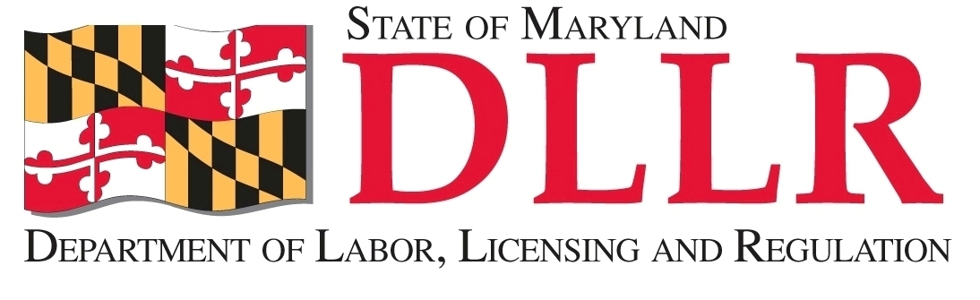

www.dllr.maryland.gov

Maryland Department of Labor, Licensing and Regulation Division of Workforce Development and Adult Learning

Office of Workforce Development

One-Stop Career Center and Programmatic MONITORING GUIDE local area
DWDAL – Office of Workforce Development
One Stop Career Center and Programmatic Monitoring Guide

Purpose and Process:

The purpose of the Workforce Investment Act (WIA) monitoring is to ensure the integrity of the WIA system and WIA funds in the State of Maryland, assess compliance with applicable laws and regulation, and to identify successful methods and best practices that serve to enhance the system as a whole.

The monitoring process is accomplished through a combination of desk and on-site reviews. Desk reviews include analyzing information to support the on-site monitoring. Documents gathered for the desk review include prior audit and monitoring reports, current Local Workforce Investment Area (LWIA) Plan, written policies and procedures or other guidance governing the LWIA. The on-site review is a fundamental component of monitoring and employs data collection techniques using a formal monitoring tool. On-site reviews are conducted through a monitoring schedule on an annual basis. The monitor should be prepared to provide on-site technical assistance during the on-site review.

To minimize disruption to LWIA operations, other monitoring functions such as financial and performance should be scheduled at the same time where appropriate.

Procedures:

Contact is made via email with the director of each LWIA and the Labor Exchange Administrator (LEA) to schedule a monitoring date and advise them of the scope of the monitoring review. Copies of the monitoring tools are included in the email to the LWIA Director and LEA.

The date is confirmed during the initial scheduling period.

One day prior to the start date of the visit, a telephone call is made or email is sent as a reminder.

Entrance Conference:

Arrange for an entrance conference. However, a formal entrance conference is not always necessary. The decision to have an entrance conference should be a mutual one between the local area and monitor. Instances where an entrance conference would be necessary are:

1. This is the initial monitoring visit to the local area;
2. There are major problems with the local area’s program systems;
3. The local area requests an entrance conference.
When an entrance conference is held, the LWIA Director, LEA, and other appropriate staff (at the discretion of the director) should attend. The monitor can request specific staff be in attendance if there are programmatic reasons.

The entrance conference may include, but should not be limited to the following subjects:

1. The purpose of the visit;
2. The procedures to be used by the monitor;
3. Problems disclosed during prior review visits.

The monitor should create a record of the entrance conference meeting in the monitoring report.

One Stop Career Center and Programmatic Monitoring Questionnaire

In addition to the programmatic on-site review, the monitor also conducts the One Stop Career Center monitoring review at each comprehensive one-stop center in each local area. The One Stop Career Center and Programmatic questionnaire is emailed to the LWIA Director and LEA when the visit is scheduled. The LWIA Director and LEA completes the questionnaire prior to the monitor’s visit. All questions are discussed during the review and the monitor obtains supporting documents.

The One Stop Career Center and Programmatic Questionnaire include several attachments that may be used for monitoring additional components of the workforce development system. The attachments allow flexibility in use and follow the same monitoring process as the One Stop Career Center and Programmatic Questionnaire. Examples of monitoring tools that may be used are:

#1 – National Emergency Grant (NEG) Questionnaire
#2 – State On-the-Job Training (OJT) Monitoring Guide
#3 – Equal Opportunity and Nondiscrimination Monitoring Review Instrument

Sampling Procedures

Since it is rarely cost effective to examine all active participant files, monitors should consider examining a representative sample of each local area’s WIA formula funded programs (Adult Dislocated Worker, Youth). The number of active participant files in the sample is based on the amount of funding each local area receives.

Two methods are used to create a sample of active participant files for the review. Prior to the scheduled visit, a random sample of active participants is selected from the Maryland Workforce Exchange for each formula funded program. Another method takes place in the local WIA office where a random sample of active participant files is selected on-site.

The monitor will use the Eligibility Determination Questionnaire for each formula funded program (Adult, Dislocated Worker, and Youth) for the participant file review.

Monitor’s Work Papers

Monitoring work papers (i.e., Eligibility Determination Questionnaire) record the activities that took place during the monitoring visit and form the rationale for the monitoring report. Extensive notes may be necessary as part of the review process and may serve to validate the information collection process. Monitoring work papers should:

1. Detail the source of the information acquired and conclusions reached;
2. Document the weaknesses and deficiencies disclosed by the review;
3. Be complete, timely and fully reflect the review steps taken by the monitor;
4. Be retained for review by DOL for auditing purposes.

Technical Assistance

There are no set procedures to follow for providing technical assistance. Each situation is unique. The monitor must determine what is appropriate in the given circumstances. However, it should be kept in mind that the act of identifying an issue without accompanying technical assistance in the creation and implementation of corrective action results in little improvement. All technical assistance given should be documented in the work papers, and should be noted in summary in the monitoring report following the on-site visit. Any necessary follow-up assistance should also be detailed in the work papers and noted in the monitoring report as well.

Exit Conference

1. An exit conference is to be held at the end of every on-site review.
2. In arranging the time for the exit conference, the monitor should ensure that the LWIA Director, LEA, and appropriate staff are available to attend.
3. Subjects discussed at the exit conference may include, but are not limited to:
a. Findings disclosed during the review;
b. Action taken to resolve prior findings;
c. Required corrective action and timeframes;
d. Technical assistance provided or to be provided by monitor;
e. Timeframes for issuance of the written monitoring report.
4. Open discussions should be encouraged at the meetings.
5. The monitor will create a record of the meeting in the work papers and in the monitoring report.

Monitoring Report

When the on-site monitoring review has been completed and the work papers have been fully prepared, a report must be written reflecting the purpose and scope of the review. The report should clearly identify all findings and required corrective action, and should set a timeline by which the LWIA is expected complete each required corrective action. Written monitoring reports should be structured to assist the LWIA in reaching their goals by providing feedback regarding program compliance issues.

The findings identified in the written monitoring report should reflect a concise statement of fact and should include the following information:

1. The basis of the requirement in law, regulations, state policy or guidance, or LWIB policy;
2. Background information;
3. Problem analysis;
4. A synopsis of what was reviewed;
5. Size of the sample taken (if applicable);
6. Conclusions reached; and
7. Recommendations for corrective action including timeframes.

Preparation of the draft report and supervisory review should ideally be completed within two weeks of the exit meeting. The draft report is emailed to the LWIA Director and LEA immediately upon supervisory approval with copies to the DWDAL Assistant Secretary/Deputy Assistant Secretary of the Division of Workforce Development, Office of Workforce Development Director, One Stop Statewide Operations Manager, and the monitor. The LWIA must acknowledge receipt of the draft monitoring report within two weeks, and if there are no findings a final report will be sent. Timeframe for corrective action is 30 days from the date of the draft report at which time a final report is prepared by the monitor. The final report is sent to the LWIA director and LEA with copies to the DWDAL Assistant Secretary/Deputy Assistant Secretary of the Division of Workforce Development, Office of Workforce Development Director, One Stop Statewide Operations Manager, and the monitor.

Copies of the draft monitoring report and final monitoring report are stored electronically on DWDAL’s server in the identified program year Monitoring Report folder.

