
Division of Workforce Development
and Adult Learning
1100 N. Eutaw Street
Room 209
Baltimore, MD 21201

WORKFORCE INVESTMENT FIELD INSTRUCTION (WIFI) No. 07-10

DATE: March 25, 2011

TO: Maryland Workforce Investment Act (WIA) Grant Recipients

SUBJECT: Revised Federal Poverty Level Guidelines and Lower Living Standard Income Levels (LLSIL)

REFERENCES: Public Law 105-220 – Workforce Investment Act
20 CFR 652 – Workforce Investment Act: Final Rule
Federal Register/Vol. 76, No. 13
Federal Register/Vol. 76, No. 54

BACKGROUND
INFORMATION: Under Title I of the Workforce Investment Act, the Secretary of Labor annually determines the Lower Living Standard Income Level (LLSIL) for uses defined in the law. WIA defines the term “low income individual” as one who qualifies under various criteria, including an individual who received income that does not exceed the higher of the poverty line or 70 percent of the lower living standard income level. In accordance with the Act, Health and Human Services/Office of the Secretary has released the revised 2011 figures for poverty levels and the Department of Labor has released the revised 2011 LLSIL.

ACTION TO

BE TAKEN: All Maryland WIA grant recipients should use one of the attached charts, either the 2011 Poverty Income Guidelines or the 2011 70 percent LLSIL (whichever is higher), to determine if applicants are low income for those programs that require it. These new poverty income guidelines are now available in MWE. All intake personnel are to be advised of the changes and refer to the revised guidelines

CONTACT PERSON: Valerie Myers (410) 767-2825 or vmyers@dllr.state.md.us

EFFECTIVE DATE: March 21, 2011

Attachment
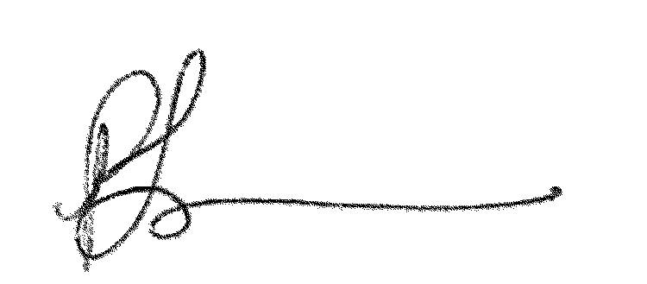

Paulette Francois
Assistant Secretary
Division of Workforce Development and Adult Learning

Phone: 410-767-2173 • FAX: 410-333-5162 • INTERNET: www.dllr.maryland.gov
2011 Lower Living Standard Income Level (LLSIL)- 70%
and
Poverty Income Guidelines for The State of Maryland
2011 HHS Poverty Guidelines
Size of Family |  |  |  |  |  |  |  |  |  |  |  | Poverty Guideline
1………………….......…………………………………………………………………..…… |  |  |  |  |  |  |  |  |  |  |  | $10,890
2………………….......…………………………………………………………………..…… |  |  |  |  |  |  |  |  |  |  |  | $14,710
3………………….......…………………………………………………………………..…… |  |  |  |  |  |  |  |  |  |  |  | $18,530
4………………….......…………………………………………………………………..…… |  |  |  |  |  |  |  |  |  |  |  | $22,350
5………………….......…………………………………………………………………..…… |  |  |  |  |  |  |  |  |  |  |  | $26,170
6………………….......…………………………………………………………………..…… |  |  |  |  |  |  |  |  |  |  |  | $29,990
7………………….......…………………………………………………………………..…… |  |  |  |  |  |  |  |  |  |  |  | $33,810
8………………….......…………………………………………………………………..…… |  |  |  |  |  |  |  |  |  |  |  | $37,630
*For family units with more than 8 members, add $3,820 for each additional person.
70% LLSIL
Area | 1 |  | 2 |  | 3 |  | 4 |  | 5 |  | 6 |  | Over 6 Add
Anne Arundel County WIA | 10,673 * |  | 17,491 |  | 24,008 |  | 29,635 |  | 34,976 |  | 40,904 |  | 5,928
Baltimore City WIA | 10,673* |  | 17,491 |  | 24,008 |  | 29,635 |  | 34,976 |  | 40,904 |  | 5,928
Baltimore County WIA | 10,673* |  | 17,491 |  | 24,008 |  | 29,635 |  | 34,976 |  | 40,904 |  | 5,928
Frederick County WIA | 10,673* |  | 17,491 |  | 24,008 |  | 29,635 |  | 34,976 |  | 40,904 |  | 5,928
Lower Shore WIA | 8,265* |  | 13,540* |  | 18,583 |  | 22,940 |  | 27,071 |  | 31,659 |  | 4,588
Mid Maryland WIA
Carroll County | 10,673* |  | 17,491 |  | 24,008 |  | 29,635 |  | 34,976 |  | 40,904 |  | 5,928
Howard County | 10,673* |  | 17,491 |  | 24,008 |  | 29,635 |  | 34,976 |  | 40,904 |  | 5,928
Montgomery County WIA | 10,673* |  | 17,491 |  | 24,008 |  | 29,635 |  | 34,976 |  | 40,904 |  | 5,928
Prince George's County WIA | 10,673* |  | 17,491 |  | 24,008 |  | 29,635 |  | 34,976 |  | 40,904 |  | 5,928
Southern Maryland WIA
Calvert County | 10,673* |  | 17,491 |  | 24,008 |  | 29,635 |  | 34,976 |  | 40,904 |  | 5,928
Charles County | 10,673* |  | 17,491 |  | 24,008 |  | 29,635 |  | 34,976 |  | 40,904 |  | 5,928
St. Mary's County | 8,265* |  | 13,540* |  | 18,583 |  | 22,940 |  | 27,071 |  | 31,659 |  | 4,588
Susquehanna Region WIA
Cecil County | 9,563* |  | 15,669 |  | 21,510 |  | 26,551 |  | 31,337 |  | 36,643 |  | 5,306
Harford County | 10,673* |  | 17,491 |  | 24,008 |  | 29,635 |  | 34,976 |  | 40,904 |  | 5,928
Upper Shore WIA | 8,265* |  | 13,540* |  | 18,583 |  | 22,940 |  | 27,071 |  | 31,659 |  | 4,588
Queen Anne's County | 10,673* |  | 17,491 |  | 24,008 |  | 29,635 |  | 34,976 |  | 40,904 |  | 5,928
Western Maryland WIA
Allegany County | 8,447* |  | 13,841* |  | 18,998 |  | 23,454 |  | 27,682 |  | 32,375 |  | 4,693
Washington County | 8,447* |  | 13,841* |  | 18,998 |  | 23,454 |  | 27,682 |  | 32,375 |  | 4,693
Garrett County | 8,265* |  | 13,540* |  | 18,583 |  | 22,940 |  | 27,071 |  | 31,659 |  | 4,588
* Poverty level is greater than the LLSIL figures
Effective 03/21/2011

