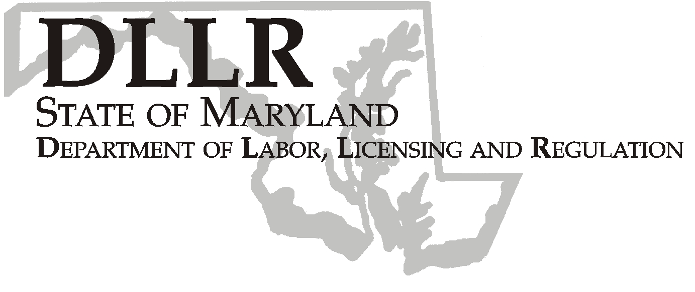
MARTIN O’MALLEY, Governor
ANTHONY G. BROWN, Lt. Governor
ALEXANDER M. SANCHEZ, Secretary

Andrew Moser, Assistant Secretary

Division of Workforce Development and Adult Learning
DLLR Home Page • http://www.dllr.state.md.us
E-mail • amoser@dllr.state.md.us

WORKFORCE INVESTMENT FIELD INSTRUCTION (WIFI) No. 07-09

DATE: March 11, 2010

TO: Maryland Workforce Investment Act (WIA) Grant Recipients

SUBJECT: PY 2009 Local WIA Performance Incentive Funds – For PY 2008 Performance

REFERENCES: Workforce Investment Act (WIA) of 1998 – (PL105-220),
Section 136
Workforce Investment Act, Final Rule, 20 CFR Part 652
Training and Employment Guidance Letter No 8-99
Maryland’s Strategic State Five Year Workforce Investment Act Plan
Maryland’s Two Year Extension of the State Five Year Workforce Investment Act Plan
Workforce Investment Act Field Instruction No 2-00, No 4-02

BACKGROUND
INFORMATION: The Workforce Investment Act (WIA) contains performance provisions intended to hold States and localities accountable for the results obtained by activities within the local Workforce Investment Areas. Performance accountability revolves around the rewarding and sanctioning of local Workforce Investment Areas based upon their performance as measured by negotiated standards for the federally required performance indicators under Title I of the Workforce Investment Act of 1998.

As agreed, the State of Maryland purchased fifteen (15) Employ-On licenses for the local Workforce Investment Areas with a portion of the PY 09 statewide incentive funds. The cost of these licenses was deducted from each area’s individual incentive award.

Keeping Maryland Working and Safe

1100 NORTH EUTAW STREET, ROOM 616
BALTIMORE, MD 21201

PHONE: 410-767-2997 FAX: 410-333-5355
TTY USERS, CALL VIA THE MD RELAY SERVICE

ACTION TO

BE TAKEN: Each Local Workforce Investment Area shall prepare and submit a grant request in accordance with the funding levels in Attachment A. The funds are available for expenditure from July 1, 2009 to June 30, 2010. Up to 10 % of the funds may be used for actual administrative costs. The grant request must contain two (2) signed WIA Grant Request and Approval Signature Sheets and a Grant Narrative.

The requests must be submitted no later than March 31, 2010, and sent to the attention of:

Doreen Shahan
DLLR, DWDAL, Office of Administration
1100 N. Eutaw Street, Room 209
Baltimore, Maryland 21201

CONTACT
PERSON: Dorothee Norton
DWDAL Budget and Fiscal Manager
410-767-2283

EFFECTIVE: Immediately

Andrew Moser
Assistant Secretary

Division of Workforce Development and Adult Learning

ATTACHMENT A

PY 2009 INCENTIVE AWARDS for PY 2008 PERFORMANCE
Anne Arundel | $14,160
Baltimore City | $18,150
Baltimore County | $1,055
Frederick | $4,267
Lower Shore | $9,179
Mid Maryland | $17,655
Montgomery | $12,897
Prince George | $11,056
Southern Maryland | $7,870
Susquehanna | $36,484
Upper Shore | $21,442
Western Maryland | $43,035

dn

