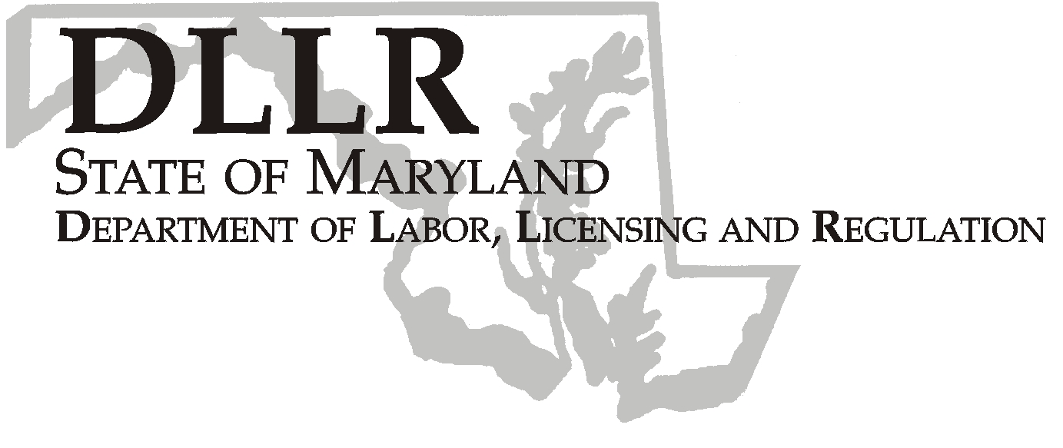
MARTIN O’MALLEY, Governor
ANTHONY G. BROWN, Lt. Governor
THOMAS E. PEREZ, Secretary

DLLR Home Page • http://www.dllr.state.md.us
E-mail • amoser@dllr.state.md.us

Andrew Moser, Assistant Secretary

Division of Workforce Development

Workforce Investment Field Instruction (WIFI), No. 07-07

DATE: June 11, 2008

TO: Maryland Workforce Investment Act (WIA) Grant Recipients

SUBJECT: Transfer Waiver for Adult and Dislocated Worker Funds

REFERENCES: WIA Section 189(i)(4)(B), 20 CFR 661.420(c) and 20 CFR 667.140 (a),
WIA Section 133 (b)(4) (A) and (B)

BACKGROUND INFORMATION:

Under current law, Local Workforce Investment Areas may use up to thirty percent (30%) of local WIA Adult and Dislocated Worker allocations for expenditures from the other funding stream. The State of Maryland recently requested a waiver to allow additional flexibility in transferring expenditures between the two funding streams. This request is consistent with one of the improvements that the Administration is seeking through WIA Reauthorization. Accordingly, DOL approved this waiver request to be effective July 1, 2007 through June 30, 2009. This waiver applies to PY 07 and PY 08 WIA Adult and Dislocated Worker funds.

Under the Waiver, local Workforce Investment Areas may transfer up to one hundred percent (100%) of expenditures between WIA Adult and WIA Dislocated Worker programs, pending state approval.

ACTION TO BE TAKEN:

Expenditures transfers may only be made between funding streams from the same program year. Requests for the transfer of expenditures under the waiver must be submitted in writing to DLLR, within the following timelines: Requests to transfer PY 07 expenditures must be submitted by

03-31-09. Requests to transfer PY 08 expenditures must be submitted by 05-31-09. A justification for the transfer of expenditures is required. If the transfer exceeds fifty percent (50%), you must provide an explanation

showing how services will be provided to the targeted population and what funding sources will be used.

The local Workforce Investment Area must submit a written request including a justification to request the transfer.

The request must be sent to:

Dorothee Norton
DWD Budget and Fiscal Manager
Office of Administration
1100 N. Eutaw Street, Room 209
Baltimore, Maryland 21201

CONTACT
PERSON: Laura Ferguson, 410-767-2038

EFFECTIVE
DATE: June 11, 2008

Andrew Moser
Assistant Secretary
Division of Workforce Development

