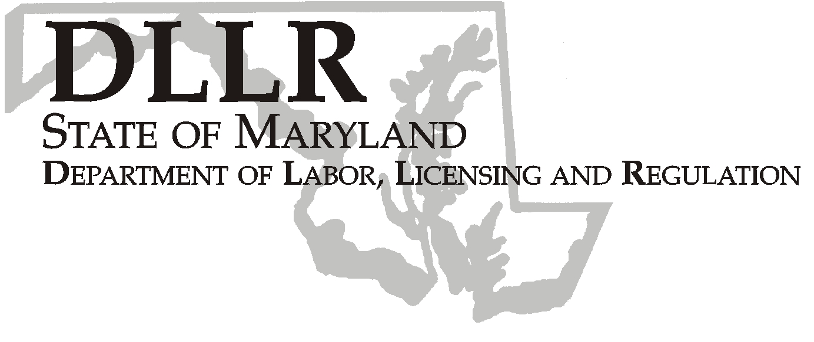

Andrew Moser, Assistant Secretary

Division of Workforce Development
MARTIN O’MALLEY, Governor
ANTHONY G. BROWN, Lt. Governor
THOMAS E. PEREZ, Secretary

DLLR Home Page • http://www.dllr.state.md.us
E-mail • amoser@dllr.state.md.us

Workforce Investment Field Instruction (WIFI) No. 06-08

DATE: March 20, 2009

TO: Maryland Workforce Investment Grant Recipients

SUBJECT: Local WIA Allocations for American Recovery and Reinvestment Act Funds

REFERENCES: American Recovery and Reinvestment Act of 2009, Division A Title VIII, P.L.
111-5;
Public Law 105-220 – Workforce Investment Act
20 CFR 652 – Workforce Investment Act; Interim Final Rule
Training and Employment Notice No. 30-08
Training and Employment Guidance Letter No. 13-08

BACKGROUND
INFORMATION: The American Recovery and Reinvestment Act of 2009 (The Recovery Act) was signed into law by President Obama on February 17, 2009. It is intended to preserve and create jobs, promote the nation’s economic recovery, and assist those most impacted by the recession. The Recovery Act provides the public workforce system with unprecedented levels of funding for a number of training programs to help Americans acquire new skills and get back to work.

Key Features of Recovery Act Implementation.

*Transparency and Accountability;
*Expedited and effective use of funds, with expenditures made concurrently with
regular formula funds;
*Emphasis on training and innovative and invigorated service delivery strategies;
*Emphasis on services for hard-to-serve populations and needs-related payments;
*Substantial increase in numbers of customers served and receiving training;
*Investments connected to economic growth objectives through regional sector
strategies aligned with economic development and education, including community
colleges, business and labor organizations, as well as other partners for high-growth industries such as green jobs, healthcare, and advanced manufacturing.
*Dual customer focus: supply-side workers and demand-side business needs for
skills and talent; and
*Approaches to reach low income and low skills customers so they may share in
economic prosperity, including engaging with community-based organizations.

ACTION TO BE Although these funds are coming as PY08 funds, they are to be tracked separately
TAKEN: fiscally and programmatically. It is the intent of Congress and the Administration that the majority of these funds will be utilized within the first year of availability.

Additionally, the Recovery Act expressly identifies summer employment for youth as a use of the WIA Youth formula funds and the legislative history clearly provides that “the conferees are particularly interested in these funds being used to create summer employment opportunities for youth.”

Submit three original WIA signature sheets along with a program narrative immediately. The allocations are available effective February 17, 2009.

Additional guidance on implementation will follow this Workforce Investment Field Instruction upon review of guidance (TEGL 14-08) released by the Department of Labor on March 18, 2009.

CONTACT: Laura Ferguson

EFFECTIVE DATE: Immediately

Andrew Moser
Assistant Secretary

Attachments: PY 2008 WIA Allocations under the American Recovery and Reinvestment Act of 2009

WORKFORCE INVESTMENT ACT
PY 2008 ARRA Allocations
 | ADULT | YOUTH | DISLOCATED | Total
 |  |  | WORKER
ANNE ARUNDEL | $106,669 | $232,654 | $379,804 | $719,127
BALTIMORE CITY | $1,545,216 | $3,558,951 | $1,040,769 | $6,144,936
BALTIMORE CO | $586,818 | $1,460,105 | $1,168,805 | $3,215,729
FREDERICK | $47,701 | $122,309 | $257,841 | $427,851
LOWER SHORE | $289,234 | $718,293 | $431,591 | $1,439,117
MID-MARYLAND | $52,635 | $109,273 | $1,014,736 | $1,176,644
MONTGOMERY | $184,793 | $343,884 | $773,315 | $1,301,993
PRINCE GEORGE | $716,810 | $1,870,449 | $720,453 | $3,307,712
SOUTHERN MD | $46,383 | $110,344 | $192,140 | $348,867
SUSQUEHANNA | $175,684 | $386,367 | $337,202 | $899,253
UPPR SHORE | $120,156 | $273,607 | $694,680 | $1,088,443
WESTERN MD | $301,194 | $661,533 | $585,887 | $1,548,614

