WORKFORCE INVESTMENT FIELD INSTRUCTION (WIFI) No. 05-12, Change 1

DATE: July 30, 2026

TO: Maryland Workforce Investment Act (WIA) Grant Recipients

SUBJECT: Modification of the State of Maryland’s Program Year (PY) 2012 Performance Goals for the WIA Title 1B Programs and Wagner-Peyser Act Funded Activities

REFERENCES:
- Workforce Investment Act of 1998 - (Public Law 105-220), 136(b) and 136(c)
- Workforce Investment Act, Final Rule, 20 CFR Part 652, published at Federal Register Vol. 65, No. 156 (August 11, 2000) , Wagner-Peyser Act
- Department of Labor (DOL) Training and Employment Guidance Letter (TEGL) 17-05, Common Measures Policy for the Employment and Training Administration’s (ETA) Performance Accountability System and Related Performance Issues (February 17, 2006), and DOL TEGL 17-05 Change 2 (May 20, 2009)
- DOL (7/7/2006) Waiver Request to Implement Common Measures in PY 2006
- DOL TEGL 8-99, Negotiating Performance Goals; and Incentives and Sanctions Process under Title I of WIA (March 3, 2000)
- DOL TEGL 11-01, Guidance on Revising WIA state Negotiated Levels of Performance (February 12, 2002
- Workforce Investment Field Instruction (WIFI) No. 05-12, WIA Title 1B and Wagner-Peyser Performance Goals for Program Year (PY) 2012

PURPOSE: To inform Maryland Workforce Investment Act (WIA) Grant Recipients of the final negotiated Workforce Investment Act (WIA) performance goals and performance levels for the Wagner-Peyser Act funded activities for Program Year (PY) 2012. These performance goals have been agreed upon between the state and the Employment and Training Administration (ETA), and will be incorporated into the State’s Strategic Plan for the WIA and Wagner-Peyser Act.

ACTION TO
BE TAKEN: Local Workforce Investment Areas and DLLR staff should refer to the attached Performance Goals Charts for their PY2012 Wagner-Peyser and WIA Title IB performance levels and develop and administer programs to meet or exceed the performance measures established in this issuance.

CONTACT
PERSON: Carolyn J. Mitchell, OWIP Director
410 767- 2953 or pmhelp@dllr.state.md.us

EFFECTIVE
DATE: July 1, 2012

Ellen Flowers-Fields
Deputy Assistant Secretary
Division of Workforce Development and Adult Learning

Attachments:

- PY2012 WIA and Wagner Peyser Performance Targets
- PY2012 Wagner - Peyser Average Earnings Locally Adjusted
- PY2012 Adult and Dislocated Worker Average Earnings Locally Adjusted

Attachment A - PY2012 WIA and Wagner Peyser Performance Targets

MARYLAND PROGRAM YEAR 2012 PERFORMANCE STANDARDS
WIA ADULT | US DOL Agreed Upon PY12 Levels | 8o% of PY12 Goals
Entered Employment Rate | 82% | 65.6%
Retention Rate | 84% | 67.2%
Average Earnings * State standards | $15,800* | $12,640*
WIA DISLOCATED WORKER
Entered Employment Rate | 87% | 69.6%
Retention Rate | 91% | 72.8%
Average Earnings * State standards | $18,346* | $14,677*
WIA YOUTH
Literacy/Numeracy | 67% | 53.6%
Attainment of Degree or Certificate | 68% | 54.4%
Placement in Employment or Education | 65% | 52.0%
WAGNER PEYSER/ LABOR EXCHANGE
Entered Employment Rate | 55% | 44.0%
Retention Rate | 81% | 64.8%
Average Earnings | $15,000* | $12,000*

* See attachments B and C for the Local Adjusted Average Earnings Statement.

Attachment B- PY 2012 Wagner Peyser Average Earnings Locally Adjusted

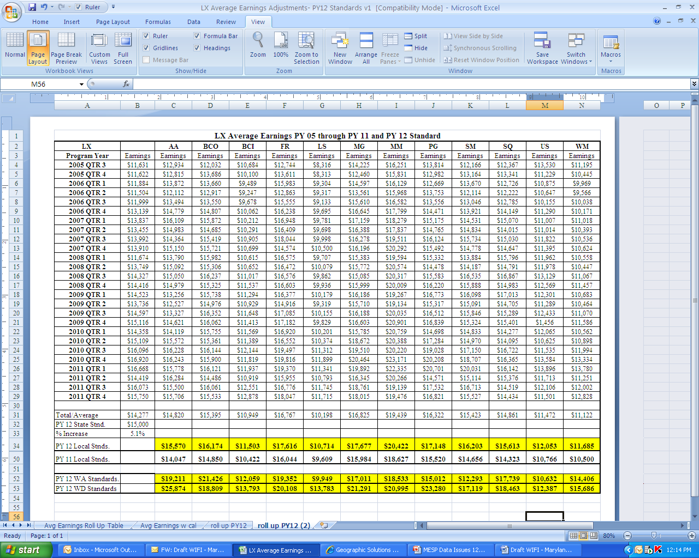

Attachment C- PY2012 Adult and Dislocated Worker Average Earnings Locally Adjusted

