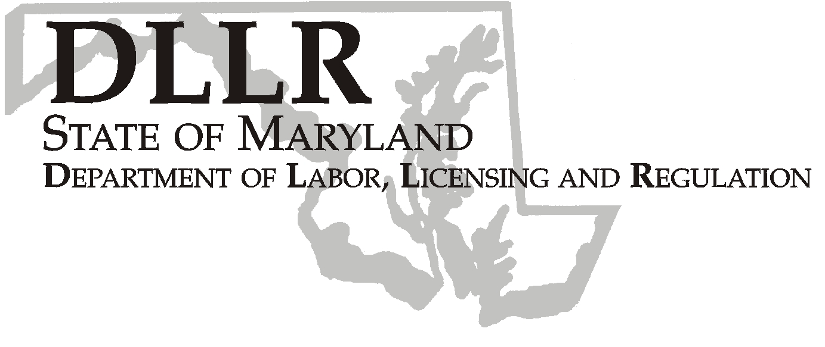
MARTIN O’MALLEY, Governor
ANTHONY G. BROWN, Lt. Governor

Bernard L. Antkowiak, Assistant Secretary

Division of Workforce Development

DLLR Home Page • http://www.dllr.state.md.us
E-mail • bantkowiak@dllr.state.md.us

PHONE: 410-767-2997 . FAX: 410-333-5355
TTY USERS, CALL VIA THE MD RELAY SERVICE

1100 NORTH EUTAW STREET . ROOM 616
BALTIMORE, MD, 21201

Workforce Investment Field Instruction (WIFI), No. 05-05 Change 1

DATE: January 18, 2007

TO: Maryland Workforce Investment Act (WIA) Grant Recipients

SUBJECT: Transfer Waiver for Adult and Dislocated Worker Funds

REFERENCES: WIA Section 189(i)(4)(B), 20 CFR 661.420(c) and 20 CFR661.420(e)
WIA Section 133 (b)(4)

BACKGROUND INFORMATION:

WIFI number 05-05 provided information regarding a waiver request that would allow up to 100% transfer authority between WIA Adult and Dislocated Worker funds. The Department of Labor (DOL) approved Maryland’s waiver request to be effective between July 1, 2005 and June 30, 2007. WIFI number 5-05 indicated that the transfer authority applied only to PY 05 WIA funds.

DLLR is extending the transfer authority to include PY 06 funds. The authority to transfer funds remains effective from July 1, 2005 through June 30, 2007.

ACTION TO BE TAKEN:

Transfers may only be made between Adult and Dislocated Worker funding streams from the same program year. Requests for the transfer of funds under the waiver must be submitted in writing to DLLR, within the following timelines: Requests to transfer PY 05 and PY 06 funds must be submitted by 03-31-07. A justification for the transfer of funds is required. If the transfer exceeds fifty percent (50%), you must provide an explanation showing how services will be provided to the targeted population and what funding sources will be used.

Keeping Maryland Working and Safe

