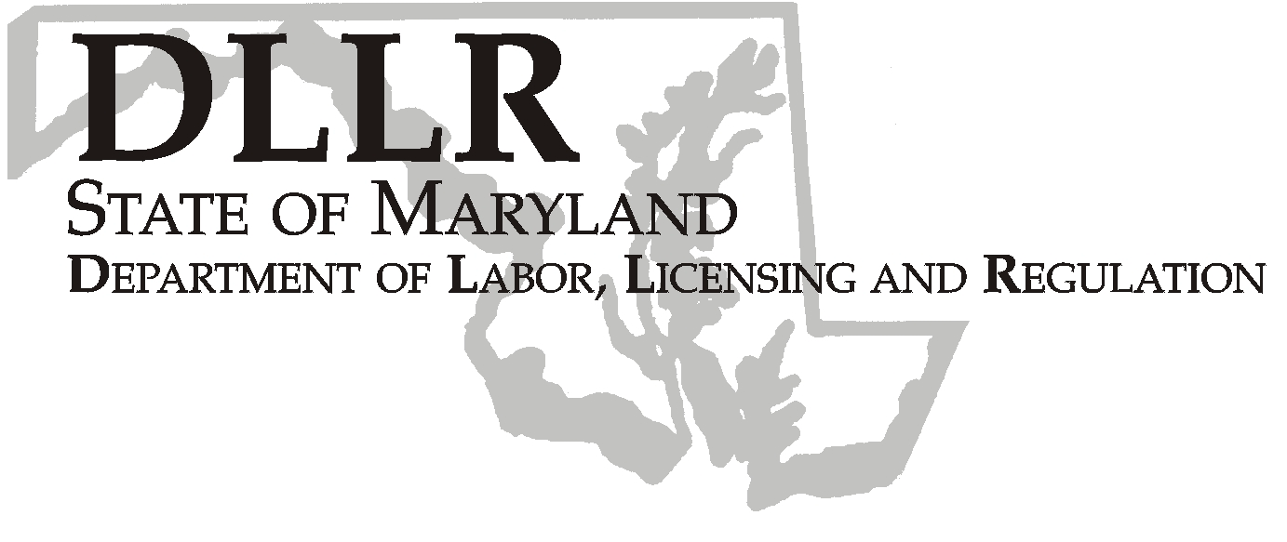
Workforce Investment Field Instruction (WIFI) No. 04-09
MARTIN O’MALLEY, Governor
ANTHONY G. BROWN, Lt. Governor
ALEXANDER SANCHEZ, Secretary

Andrew Moser, Assistant Secretary

Division of Workforce Development
DLLR Home Page • http://www.dllr.state.md.us
E-mail • amoser@dllr.state.md.us

DATE: October 14, 2009

TO: Maryland Workforce Investment Grant Recipients
Labor Exchange Administrators

SUBJECT: PELL Grants and the Payment of Unemployment Benefits to Individuals in Approved Training

REFERENCES: Training and Employment Guidance Letter (TEGL) No.21-08
(TEGL) No.21-08, Change #1
Code of Maryland Regulations (09.33.01.06), Determinations of Eligibility for Unemployment Insurance, Approved Training
Maryland Unemployment Insurance Law Section 8-903

BACKGROUND: President Obama recently announced that the Administration seeks to enable more workers to obtain job training while receiving unemployment benefits so they can develop their skills while the economy recovers. Attached TEGL 21-08 and TEGL 21-08 Change #1 strongly encourages states to widen the types of training and the conditions under which education or training are considered “approved training” for purposes of the state’s UI law during economic downturns. States are strongly encouraged to notify UI beneficiaries of their potential eligibility for PELL Grants and other financial aid and to assist with applications. The Office of Unemployment Insurance has sent the attached letter to UI recipients encouraging claimants to apply for a PELL grant. The claimants must follow the instructions in the letter. Claimants should be referred to the training institution for enrollment and assistance with the Federal Student Aid (FASA) application for PELL approval. Once they are notified of a PELL Grant award they are instructed to visit the one-Stop Centers to obtain a work search waiver for the training.

ACTION TO
BE TAKEN: WIA staff in consultation with DLLR staff must complete the attached Job Search waiver for the PELL Grant Recipient. The
WIA and DLLR staff shall jointly develop local policies that will incorporate the PELL Work Search Waiver process and continue the seamless integration of One-Stop Services.

Refer to WIFI 11-99, 5-00, 5-00 Change 1 for the training provider requirements. The list of approved training schools is available at: http://www/mhec.state.md.us/career/WIA/searchfor.asp. Claimants are strongly encouraged to enroll in the WIA program, but it is not a requirement to receive the job search waiver. Any individual enrolled in the WIA Program should receive services within your normal training approval process.

In accordance with the COMAR Regulation cited above, DLLR staff will be responsible for forwarding the completed attached Work Search Waiver online document to: pellgrantwaivers@dllr.state.md.us. Again, the completion of this Work Search Waiver form will be through joint consultation of WIA and DLLR Staff in adherence to State COMAR.

This form must be completed using the following criteria established by State COMAR regulations:

Approved Training
(1) Job Service shall determine whether an employment-related training program is approved for the purposes of granting a work search waiver to unemployment insurance claimants.
(2) Job Service shall consider the following factors in determining whether to approve a training program:
(a) Whether the prospects for the claimant's employment in the occupation for which the claimant has existing training and experience are minimal;
(b) Whether the training program will prepare the claimant for employment in a career in which there are job opportunities;
(c) Whether participating in the training program will effectively prevent the claimant from conducting work search or employment activities during the claimant's normal work hours;
(d) Whether the claimant could reasonably be required to attend a similar training program at times that would not conflict with the claimant's normal work hours;
(e) Whether the claimant has been accepted into the training program; and
(f) Any other factors that the Secretary determines are relevant.
(3) A work search exemption may not be granted for:
(a) A self-study program that does not require on-premises attendance;
(b) A program not accredited by or approved by the appropriate authority, unless the program lasts 13 weeks or less and the training is in a field for which there are jobs in the local labor market; or
(c) Education leading to a college or post-college degree, unless the claimant will attain the degree in 26 weeks or less and the training is in a field for which there are jobs in the local labor market.
(4) A claimant who is granted a work search waiver due to participation in approved training shall submit each week attendance and progress reports on Department forms.
(5) A claimant who fails to attend training or to submit the required forms shall have the work search exemption withdrawn.
To ensure that PELL Work Search Waiver recipients continue to receive their UI Benefits, it is imperative that this process and the PELL Work Search Waiver Form is completed in a timely fashion.

Please ensure that this policy is disseminated to the appropriate staff in the one-stop centers.

CONTACT: Valerie Myers, Manager, One-Stop Services
410 767-2825

EFFECTIVE
DATE: Immediately



Andrew Moser
Assistant Secretary
Division of Workforce Development and Adult Learning

Attachments

