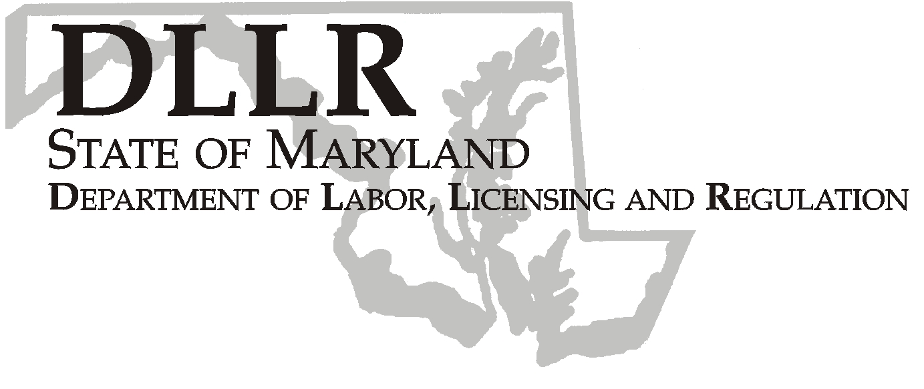
MARTIN O’MALLEY, Governor
ANTHONY G. BROWN, Lt. Governor
THOMAS E. PEREZ, Secretary

Andrew Moser, Assistant Secretary

Division of Workforce Development

DLLR Home Page • http://www.dllr.state.md.us
E-mail • amoser@dllr.state.md.us

PHONE: 410-767-2997 FAX: 410-333-5355
TTY USERS, CALL VIA THE MD RELAY SERVICE

1100 NORTH EUTAW STREET . ROOM 616
BALTIMORE, MD, 21201

Keeping Maryland Working and Safe

WORKFORCE INVESTMENT FIELD INSTRUCTION (WIFI) 3-08

DATE: February 23, 2009

TO: WIA Directors, Labor Exchange Administrators, Supervisors

SUBJECT: Providing Labor Exchange Services to Employers Filing Foreign Labor Certification Applications and Job Seekers Requesting Referral to Job Orders Associated with Foreign Labor Certification Applications

REFERENCES: 20 CFR 655 & 656; 29 CFR 501, 780 & 788; Temporary Agricultural Employment of H2A Aliens in the United States; Modernizing the Labor Certification Process and Enforcement; Final Rule; Labor Certification and Enforcement for Temporary Employment in Occupations other than Agriculture or Registered Nursing in the United States (H2B Workers), And Other Technical Changes; Final Rule; 8 CFR 274a Control of Employment of Aliens

BACKGROUND INFORMATION:

Services to employers filing job orders associated with applications for foreign labor certification and job seekers requesting referral to job orders associated with applications for foreign labor certification are changed under the final rules for both H2A and H2B Foreign Labor Certification processes as published in the Federal Register on December 18, 2008 (H2A) and December 19, 2008 (H2B) respectively.

ACTION TO BE TAKEN:

All job orders submitted to the state Labor Exchange System (Maryland Workforce Exchange) by employers who are submitting an application to the U.S. Department of Labor for foreign labor certification must indicate that the job order is associated with an application for Foreign Labor Certification. Present Central Office Workforce Development staff will advise employers who are known to customarily place their job orders into MWE without staff assistance of the requirement. (The majority of non-agricultural employers who file applications for temporary foreign labor certification customarily place their own job orders and do not require staff assistance.) All One-Stop staff who assist employers with placing job orders will have to determine whether or not a job order is associated with an application for foreign labor certification. Then, when staff place the order into MWE, they must properly indicate that the job order is associated with a foreign labor certification application. The indicator that a job order is associated with an application for foreign labor certification may be seen by employers and staff only. Staff may also search for job orders associated with applications for foreign labor certification. However, this indicator is not available to job seekers.

Non-agricultural job orders associated with applications for foreign labor certification may be submitted no more than 120 calendar days before the employer’s date of need and must remain open for a period of not less than 10 calendar days. Agricultural job orders associated with applications for foreign labor certification may be submitted no more than 75 calendar days and no less than 60 calendar days before the employer’s date of need and must remain open until 30 calendar days past the employer’s date of need.

Referrals to non-agricultural foreign labor certification job orders may be either self-referrals or staff-assisted referrals. Usually, the employer will make this determination when placing the job order. When a job seeker comes to a One-Stop with an advertisement from any newspaper or other public venue, or information gleaned from such an advertisement, and the job seeker requests referral to the advertised MWE job order, when that job is associated with an application for foreign labor certification, that referral must be staff-assisted. All referrals to agricultural foreign labor certification job orders must be staff-assisted. (This policy represents no change to present policy.)

When a referral is completed by staff to any job order associated with an application for foreign labor certification, staff must complete the Employment Eligibility Verification process (I-9). Immigration and Naturalization Services regulations require that only state agency (DLLR) staff complete the Employment Eligibility Verification process. When the Employment Eligibility Verification process is completed, it must be recorded as a job seeker service in MWE. When the Employment Eligibility

Verification service is successfully recorded in MWE, staff will have access to an Employment Eligibility Verification document which must be completed and mailed via U.S. mail to the employer or the employer’s representative that has hiring authority for the job. Staff may not give Employment Eligibility Verification documents to job seekers. Completion of the Employment Eligibility Verification process requires completion of the I-9, copying original documents only (no photocopies or receipts for applications for duplicate documents) provided by the job seeker to complete the I-9, recording the service in MWE, mailing the Employment Eligibility Verification document to the employer or the authorized employer’s representative.

Labor Exchange Administrators should develop record retention systems for Employment Eligibility Verification records for their local areas or offices. Employment Eligibility Verification records must be retained for three (3) years from the date of service.

All staff should note MWE Alert 2009-068 related to this WIFI. Local staff training may be arranged with Carl Reavis.

CONTACT PERSON: Carl Reavis 410-767-2093

EFFECTIVE DATE: January 20, 2009

Andrew Moser
Assistant Secretary
Division of Workforce Development

