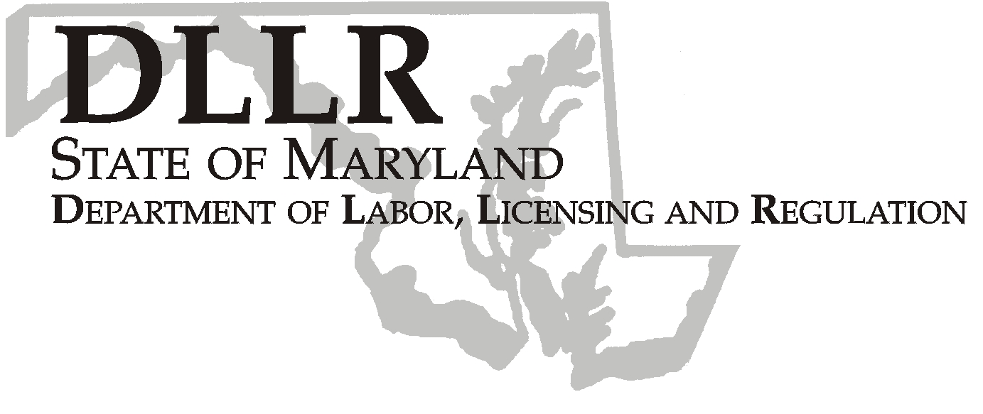
MARTIN O’MALLEY, Governor
ANTHONY G. BROWN, Lt. Governor
THOMAS E. PEREZ, Secretary

Andrew Moser, Assistant Secretary

Division of Workforce Development

DLLR Home Page • http://www.dllr.state.md.us
E-mail • amoser@dllr.state.md.us

notes, but a printed copy must be maintained in the files. Each local are must but In addition, you must ensure that the appropriate documentation to

Keeping Maryland Working and Safe

Workforce Investment Field Instruction (WIFI) No. 17- 05 Change 1

DATE: December 11, 2007

TO: WIA Directors, Labor Exchange Administrators

SUBJECT: Providing Early Intervention Workshops for Limited English Proficient (LEP) customers

REFERENCES: DLLR policy for LEP and Translation Interpreter Services; Civil Rights Act of 1964, Titles VI and VII;
Presidential Executive Order 13166 – Improving Access to Services for Persons with Limited English Proficiency, August 11, 2000;
Workforce Investment Act of 1998, Section 188;
Annotated Code of Maryland, Article – State government, Section 10-1101 through 10-1103
WIFI 9-03
WIFI 17-05

BACKGROUND INFORMATION:

WIFI 17-05 outlined DLLR’s policy for providing early intervention workshops for LEP customers. This WIFI explains the policy changes for scheduling requests for Spanish EI workshops.

ACTION TO BE TAKEN:

The EI Call-In Letter is available in Spanish through our Maryland Workforce Exchange system for facilitators to use when claimant lists are downloaded from the UI system. This list identifies the claimant who spoke Spanish when calling in a UI claim. In order to provide equitable service to the state LEP population and to avoid possible non-compliance with federal and state laws, the English Call-In Letter contains a notice in Spanish, immediately after the salutation, which advises claimants to contact Ms. Bertha Gonzalez at the Montgomery Works One-Stop in Wheaton. Her phone number is (301) 929-6880 ext. 1507.

Bilingual staff at the reception area of the Montgomery Works One-Stop in Wheaton will use a script to speak with claimants who call to inquire about EI workshops. If the claimant is a resident of Montgomery County, the reception staff will refer the caller to the local EI staff in Wheaton to address the request. If the claimant resides outside of Montgomery County, the reception staff will record the claimant’s demographic information and forward an e-mail to Carl Reavis in the DLLR Office of Field Operations. His e-mail address is creavis@dllr.state.ms.us. Mr. Reavis will determine the appropriate bilingual EI facilitator who can best provide the service in the customer’s local area. The request will be forwarded to local bilingual EI facilitator staff around the state who will then contact the claimant to follow up on the EI request.

Limited English Proficient customers may continue to request a workshop in another language other than Spanish or English. For these customers other arrangements might be possible. Approval of such requests will depend on the demand and the agency resources, or the claimant could be excused from participation in a workshop. Consultation for such a decision may be made with Carl Reavis or Valerie Myers. Local EI facilitators should keep a record of requests for workshops in languages other than English or Spanish.

CONTACT PERSON: Carl Reavis 410-767-2093

EFFECTIVE DATE: Immediately

Andy Moser
Assistant Secretary
Division of Workforce Development

