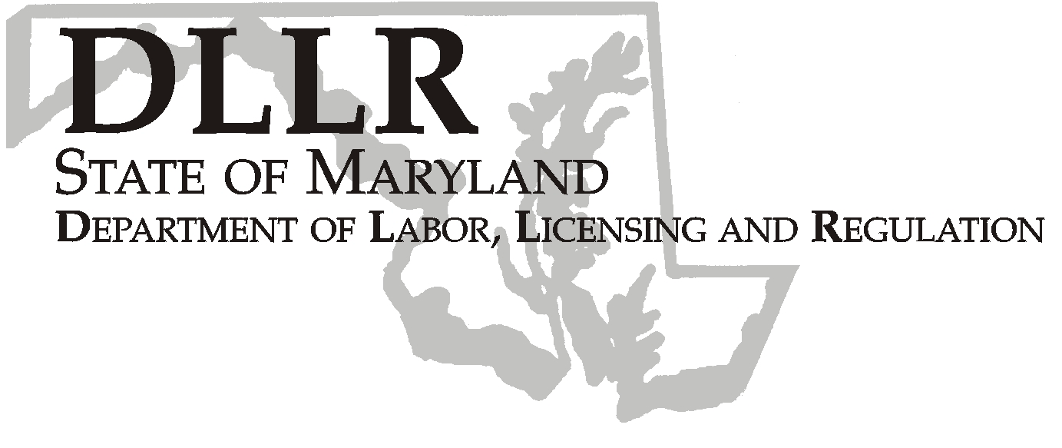
MARTIN O’MALLEY, Governor
ANTHONY G. BROWN, Lt. Governor
THOMAS E. PEREZ, Secretary

Andrew Moser, Assistant Secretary

Division of Workforce Development

DLLR Home Page • http://www.dllr.state.md.us
E-mail • amoser@dllr.state.md.us

WORKFORCE INVESTMENT FIELD INSTRUCTION (WIFI) No. 13-08

DATE: June 26, 2009

TO: Maryland Workforce Investment Act (WIA) Grant Recipients

SUBJECT: Maryland Summer Youth Connection PY 09/FY 10

REFERENCES: None

BACKGROUND
INFORMATION: Governor Martin O’Malley included $120,350 in the State Fiscal Year budget for the Department of Labor, Licensing and Regulation (DLLR) to operate a Fiscal Year 2010 Summer Youth Program. These State General funds will be awarded to local Workforce Investment Areas (LWIAs) effective July 1, 2009, using the federal WIA formula allocation methodology. LWIAs will be responsible for providing summer employment opportunities for youth within the parameters outlined by DLLR.

ACTION TO BE
TAKEN: Local Workforce Investment Areas must follow the attached guidelines and procedures for requesting these funds, and incorporate the attached funding amount in their grant requests.

CONTACT: Laura Ferguson (410) 767-2038 or lferguson@dllr.state.md.us

EFFECTIVE: June 26, 2009

Andrew Moser
Assistant Secretary

Division of Workforce Development

Keeping Maryland Working and Safe

1100 NORTH EUTAW STREET. ROOM 616
BALTIMORE, MD, 21201

PHONE: 410-767-2997 FAX: 410-333-5355
TTY USERS, CALL VIA THE MD RELAY SERVICE

PY 09 MARYLAND SUMMER YOUTH CONNECTION PROGRAM GUIDELINES

The Maryland Summer Youth Connection Program will primarily serve youth who are 14 and 15 years old and who are low-income, have a disability, or a special need. The funds may be used to develop, match, monitor, and evaluate job placement of eligible youth. Additionally, these funds may be used as an incentive or match to encourage the private sector to hire eligible youth during the summer months.

A local area’s allowable program costs include wages paid to participants, supervision and training, materials and supplies related to the work provided, reasonable transportation costs and other administrative costs. Participating youth must not be paid less than the state minimum wage of $6.55 per hour through 07/23/09, and $7.25 per hour starting 07-24-09.

Requirements

The local workforce investment areas must:

- Develop meaningful and well-supervised work experiences for youth in the program,
- Provide activities to enhance job skills and career-exposure,
- Submit a narrative to DLLR detailing the local area’s plan for summer activities, including a Statement of Planned Outcomes for the program. This statement will include targeted outcomes such as: number of job placements, number of program completers, and number of enhancement activities (resume development, interview techniques, career exposure, etc.), and
- Complete an end-of-summer report by October 15, 2009, that includes the number of youth served, age group of youth served, activities provided, and an accounting of expenditures.

These funds must be expended between July 1, 2009, and September 30, 2009, for authorized activities only. If you are unable to accept your allocation, (see attached chart), please contact Ms. Dorothee Norton no later than July 15, 2009.

In order to receive these funds, you must submit the following to Ms. Dorothee Norton by July 15, 2009:

- Three signed original WIA Signature Sheets
- Program Narrative which includes the above requirements

Summer Youth Connection

PY 09 Allocations

ANNE ARUNDEL | $2,843
BALTO CITY | $43,494
BALTIMORE | $17,844
FREDERICK | $1,495
LOWER SHORE | $8,778
MID-MARYLAND | $1,335
MONTGOMERY | $4,203
PRINCE GEORGE'S | $22,859
SOUTHERN MD | $1,348
SUSQUEHANNA | $4,722
UPPER SHORE | $3,344
WESTERN MD | $8,085
TOTALS | 120,350

