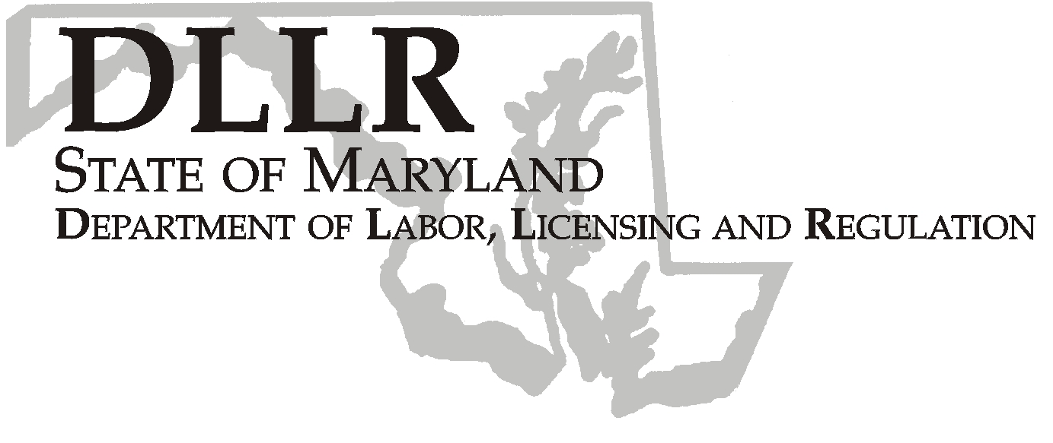
MARTIN O’MALLEY, Governor
ANTHONY G. BROWN, Lt. Governor
THOMAS E. PEREZ, Secretary

Andrew Moser, Assistant Secretary

Division of Workforce Development

DLLR Home Page • http://www.dllr.state.md.us
E-mail • amoser@dllr.state.md.us

notes, but a printed copy must be maintained in the files. Each local are must but In addition, you must ensure that the appropriate documentation to

Keeping Maryland Working and Safe

WORKFORCE INVESTMENT FIELD INSTRUCTION (WIFI) No.10-04 Change 2

DATE: December 4, 2007

TO: Maryland Workforce Investment Act (WIA) Grant Recipients

SUBJECT: Documentation of U.S. Citizenship/Alien Status

REFERENCES: WIA Participant Case Record Management
WIFI #10-04
WIFI #10-04 Change 1
WIFI #12-04 Change 1
Public Law 105-220 – Workforce Investment Act (WIA)
Sec. 188(a)(5)
Federal Register/Vol.72, No.226 (Department of Homeland Security, U.S. Citizenship and Immigration Services, Introduction of the Amended Form I-9 and the New Handbook for Employers)

BACKGROUND INFORMATION:

The U.S. Citizenship and Immigration Services issued a notice effective November 26, 2007 regarding the amended Form I-9, “Employment Eligibility Verification.” Employers are required to use the Form I-9 to verify the identity and employment authorization of newly hired employees. The amended Form I-9 contains an updated list of acceptable identity and employment authorization documents that reflect the current regulations.

This update affects the appropriate documentation that supports WIA participant eligibility criteria on the chart attached to WIFI #12-04 Change 1. Under the Eligibility Criteria for Citizenship/Alien Status, the Alien Registration Card I-151 has been removed from the list of acceptable documentation because it lacked sufficient features to help deter counterfeiting, tampering and fraud. Although Form I-151 is no longer issued, an unexpired Form I-151 is still an acceptable document. Additionally, unexpired Employment Authorization Documents

that contain a photograph, Forms I-766, I-688, and I-688B, must be added to the list of acceptable documentation.

ACTION TO BE TAKEN:

All local WIA areas must update the acceptable documentation sources for Citizenship/Alien Status eligibility criteria in WIFI #12-04 Change 1 to reflect the revised identity and employment authorization documents issued by the U.S. Citizenship and Immigration Services.

CONTACT: Valerie Myers (410) 767-2825 or vmyers@dllr.state.md.us

EFFECTIVE: November 26, 2007

Andrew Moser
Assistant Secretary
Division of Workforce Development

