WORKFORCE INVESTMENT FIELD INSTRUCTION (WIFI) No. 01-13

DATE: September 24, 2013

TO: Maryland Workforce Investment Act (WIA) Grant Recipients

SUBJECT: Maryland’s Program Year (PY) 2013 Performance Goals for the WIA
Title 1B Programs and Wagner-Peyser Act Funded Activities

REFERENCES: Workforce Investment Act of 1998 - (Public Law 105-220), 136(b) and 136(c); Workforce Investment Act, Final Rule, 20 CFR Part 652, published at Federal Register Vol. 65, No. 156 (August 11, 2000) , Wagner-Peyser Act; DOL TEGL 8-99, Negotiating Performance Goals; and Incentives and Sanctions Process under Title I of WIA (March 3, 2000); DOL TEGL 11-01, Guidance on Revising WIA state Negotiated Levels of Performance (February 12, 2002); DOL (7/7/2006) Waiver Request to Implement Common Measures in PY 2006; Department of Labor (DOL) Training and Employment Guidance Letter (TEGL) 17-05, Common Measures Policy for the Employment and Training Administration’s (ETA) Performance Accountability System and Related Performance Issues (February 17, 2006), and DOL TEGL 17-05 Change 2 (May 20, 2009); DOL TEGL 26-12, Negotiating Performance Goals for the Workforce Investment Act (WIA) Title 1B Programs and Wagner-Peyser Act Funded Activities for Program Year (PY) 2013 (May 6, 2013)

PURPOSE: To inform Maryland Workforce Investment Act (WIA) Grant Recipients of the final negotiated Workforce Investment Act (WIA) performance goals and performance levels for the Wagner-Peyser Act funded activities for Program Year (PY) 2013. These performance goals have been agreed upon between the state and the Employment and Training Administration (ETA), will be incorporated into the State’s Strategic Plan for the WIA and Wagner-Peyser Act.
ACTION TO
BE TAKEN: Local Workforce Investment Areas and DLLR staff should refer to the attached Performance Goals Charts for their PY2013 Wagner-Peyser and WIA Title IB performance levels and develop and administer programs to meet or exceed the performance measures established in this issuance.

CONTACT
PERSON: Carolyn J. Mitchell, OWIP Director
410 767- 2953 or pmhelp@dllr.state.md.us

EFFECTIVE: July 1, 2013

Julie Ellen Squire
Assistant Secretary
Division of Workforce Development and Adult Learning

Attachments (3):

- PY2013 WIA and Wagner Peyser Performance Targets
- Wagner - Peyser PY 2013 Average Earnings Locally Adjusted
- Adult and Dislocated Worker PY2013 Average Earnings Locally Adjusted

Attachment A: PY2013 WIA and Wagner Peyser Performance Goals

MARYLAND
ADULT | DOL Negotiated PY2013 Performance Goals
Entered Employment Rate | 82%
Retention Rate | 87%
Average Earnings * state standard | $15,800
DISLOCATED WORKER
Entered Employment Rate | 87%
Retention Rate | 91%
Average Earnings * state standard | $18,500
YOUTH
Literacy/Numeracy | 69%
Attainment of Degree or Certificate | 70%
Placement in Employment or Education | 67%
WAGNER PEYSER
Entered Employment Rate | 55%
Retention Rate | 81%
Average Earnings * State standard | $15,000

* Average Earnings listed above are the State standards. The PY2013 locally adjusted Average Earnings are contained in attachments B & C

Attachment B: Wagner Peyser PY 2013 Average Earnings Locally Adjusted

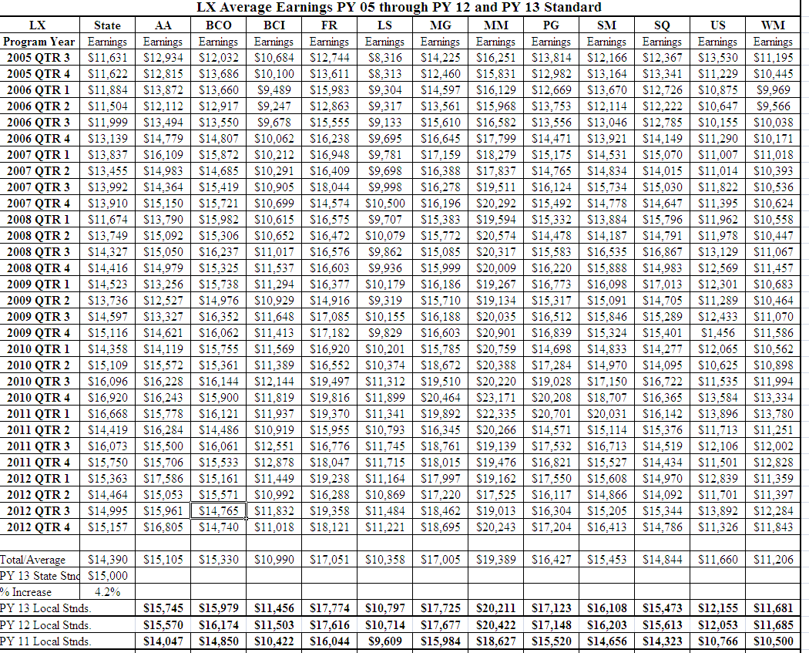

Attachment C: Adult and Dislocated Worker PY2013 Average Earnings Locally Adjusted

