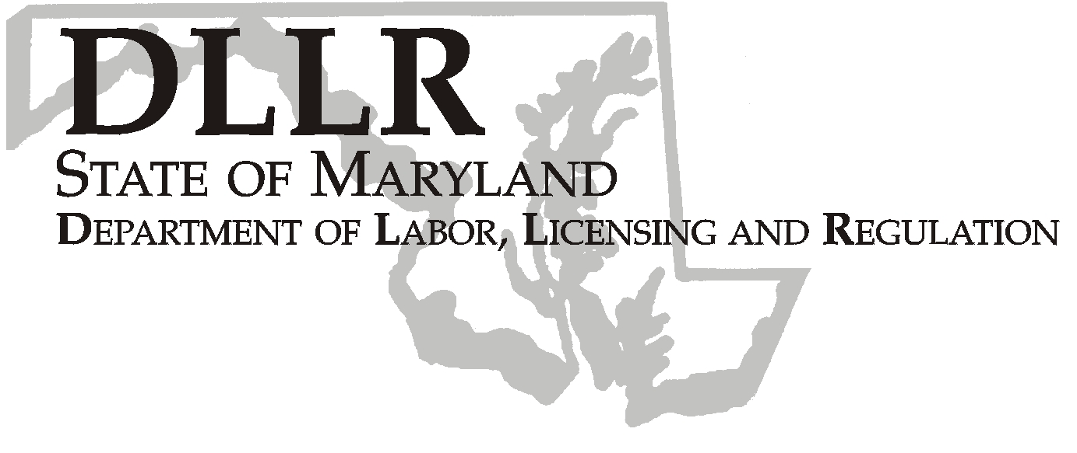
MARTIN O’MALLEY, Governor
ANTHONY G. BROWN, Lt. Governor
THOMAS E. PEREZ, Secretary

Andrew Moser, Assistant Secretary

Division of Workforce Development

DLLR Home Page • http://www.dllr.state.md.us
E-mail • amoser@dllr.state.md.us

PHONE: 410-767-2997 FAX: 410-333-5355
TTY USERS, CALL VIA THE MD RELAY SERVICE

1100 NORTH EUTAW STREET . ROOM 616
BALTIMORE, MD, 21201

Keeping Maryland Working and Safe

WORKFORCE INVESTMENT FIELD INSTRUCTION (WIFI) No. 01-08

DATE: August 13, 2008

TO: WIA Directors, Labor Exchange Administrators

SUBJECT: Labor Law Posters

REFERENCES: Federal and State Laws

BACKGROUND INFORMATION:

Historically, federal and state governments have passed laws and issued policies to benefit workers employed by US employers. Some of these laws and policies were promulgated with requirements that employers and government agencies display posters that convey specific information to employees and potential employees. DLLR, as the state agency charged with administration of state labor laws, and as the primary agency charged with operating United States Department of Labor programs, has always been a model for employers and other state agencies for proper and current display of required federal and state labor law posters.

ACTION TO BE TAKEN:

All One-Stop Centers within the Maryland Workforce Investment system must prominently display current required federal and state labor law posters so that the information is easily accessible to customers, usually in reception or resource areas. It is recommended that local areas purchase posters from reputable vendors who sell labor law posters and provide update notification when changes are made in applicable laws. Certain vendors may include compliance guarantees with poster purchases. Compliance with display requirements and timeliness of posters is subject to review at any time by state or federal officials.

Federal regulations and state law governing access accommodation by Limited English Proficient customers apply to display of labor law posters in One-Stop Centers. Therefore, metropolitan area One-Stop Centers and Eastern Shore One-Stop Centers (due to their farm worker populations), should display labor law posters in both English and Spanish. Under current regulatory guidelines, only Southern Maryland and Western Maryland One-Stop Centers may be considered exempt from the bilingual poster display requirements.

CONTACT: Carl Reavis (410) 767-2093 or creavis@dllr.state.md.us

EFFECTIVE: August 13, 2008

Andrew Moser
Assistant Secretary

Division of Workforce Development

