
Attachment A
U.S. Department of Labor
Employment & Training Administration

WIRED principles present a basic process for transforming regional economies. This process is NOT linear - the steps may occur and reoccur depending on regional circumstances.
WIRED 6 Step Method

- Identify the Regional Economy - Ignore political boundaries and identify surrounding areas that share the same economic structure. Form one regional economy around the assets of several contiguous communities.
- Form Core Leadership Group - Form a senior executive team responsible for implementing growth strategies and guiding the transformation effort.
- SWOT Analysis - Conduct a comprehensive analysis of the Strengths, Weaknesses, Opportunities, and Threats in a region that feeds directly into strategy development.

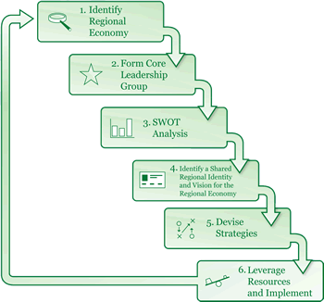

- Create a Shared Regional Identity and Vision for the Regional Economy - Develop a regional identity and vision for regional economic growth.
- Devise Strategies - Create "SMART" strategies (Specific, Measurable, Achievable, Realistic, and with a timeline).

6. Leverage Resources and Implement - Leverage regional resources from

private, non-profit, and government sources to implement a transformational

strategy.

<!--
.SidebarBox {
font-family: Verdana, Arial, Helvetica, sans-serif;
list-style-type: none;
width: 150px;
font-size: 10px;
float: left;
}
.SidebarBox a {
background-image: url(../images/top_link.png);
background-repeat: no-repeat;
background-position: 130px;
width: 150px;
display: block;
color: #9c1019;
text-decoration: none;
font-size: 10px;
}
.SidebarBox { float: left; width: 160px; }
.SidebarBox a:hover {
background-image: url(../images/top_link_hover.png);
background-repeat: no-repeat;
background-position: 130px;
color: #3b54a6;
text-decoration: none;
}
#SidebarBoxContent {
border: none;
background: #fff;
position: relative;
left: -2px; top: -2px;
}
#SidebarBoxContainer {
position: relative;
background: #666;
margin: 4px;
}
-->

