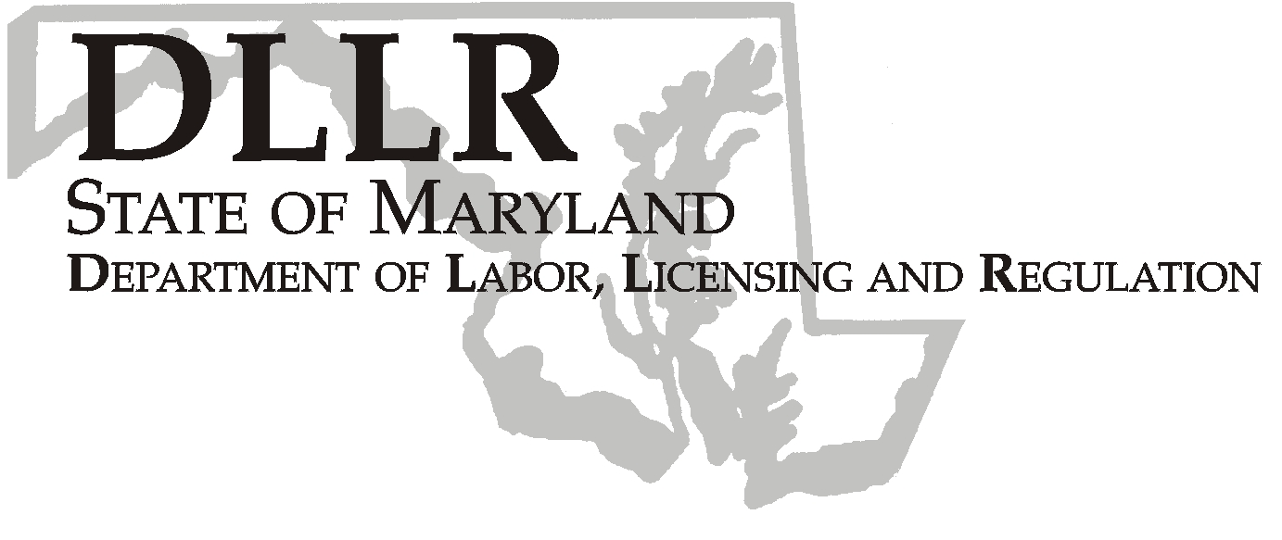
MARTIN O’MALLEY, Governor
ANTHONY G. BROWN, Lt. Governor
THOMAS E. PEREZ, Secretary

Andrew Moser, Assistant Secretary

Division of Workforce Development

DLLR Home Page • http://www.dllr.state.md.us
E-mail • amoser@dllr.state.md.us

notes, but a printed copy must be maintained in the files. Each local are must but In addition, you must ensure that the appropriate documentation to

Keeping Maryland Working and Safe
Workforce Investment Field Instruction (WIFI) No. 01-07

DATE: October 10, 2007

TO: Local WIA Grant Recipients

SUBJECT: Workforce ONE Maryland Project:
Regional Base Realignment and Closure (BRAC) Project Coordinators

REFERENCES: Workforce Investment Act (WIA) Title I Section 173; Training and Employment Guidance Letter (TEGL) No. 16-03, 16-03 change 1, 16-03 change 2, 16-03 change 4, WIRED Tools- WIRED 6 Step Method

BACKGROUND
INFORMATION: In response to the 2005 Base Realignment and Closure (BRAC), the U.S. Department of Labor (USDOL) made Workforce Investment Act National Emergency Grant (NEG) funding available to assist several states with the planning and implementation of workforce development initiatives related to BRAC. USDOL expects that funded states will adopt the WIRED 6 Step Method (see Attachment A) to approaching BRAC-related workforce development challenges. The purpose of WIRED is to create a regional approach by ignoring political boundaries and creating regional shared visions based on regional assets, strengths, and resources.

Maryland’s Department of Labor, Licensing and Regulation’s (DLLR) Division of Workforce Development (DWD) was awarded a $4 million grant to assist in the State’s planning and implementation of projects that address the workforce challenges created by the 2005 BRAC process.

Maryland’s project, Workforce ONE Maryland, will address the coordination of workforce development activities, initiatives and projects across all regions in and around Maryland utilizing the WIRED approach.

To facilitate the operation of this project, Regional BRAC Project Coordinators will be funded to various WIAs throughout Maryland to facilitate regional projects, collaboration and cooperation and assist with the coordination of BRAC-related workforce development activities centered on Maryland’s military installations affected by BRAC. Initially, five Coordinators will be funded to cover the regions around these military installations. In addition, Coordinators will be hired and managed by a Workforce Investment Area (WIA). Upon hire, in accordance with the Workforce ONE Maryland project, Coordinators must utilize a regional approach. Listed below are the BRAC regions, counties in the region and the WIA that will receive the Coordinator funding:

- Aberdeen Proving Ground Region (Caroline, Cecil, Dorchester, Harford, Kent, Queen Anne’s, Somerset, Talbot, Wicomico, and Worcester Counties)- Susquehanna WIA
- Baltimore Region (Baltimore City and Baltimore County)- Baltimore City WIA
- Bethesda Naval Hospital Region (Calvert, Charles, Montgomery, Prince George’s, St. Mary’s Counties)- Montgomery County WIA
- Fort Detrick Region (Allegany, Frederick, Garrett, and Washington Counties)- Frederick County WIA
- Fort Meade Region (Anne Arundel, Carroll and Howard Counties)- Mid-Maryland WIA

The Coordinator’s primary function is to assist workforce investment areas and other vendors with the development, submission, and monitoring of regional project applications (project funding will be made available as soon as the Regional BRAC Project Coordinators are hired). In addition, Coordinators will be responsible for assessing workforce challenges, sharing and coordinating regional workforce development initiatives and resources, and attending all BRAC-related meetings and events.

In adherence with USDOL’s expectation of integrating the WIRED principles into NEG BRAC Grants, all WIAs are expected to collaborate and participate in BRAC-related workforce development activities. With the Regional BRAC Project Coordinators creating regional collaboration and opportunities, Maryland will be able to create smart solutions that will efficiently serve the employer and job seeker communities.

ACTION TO
BE TAKEN: Local WIA Grant Recipients have been advised under separate correspondence regarding their Program Year 2007 Regional BRAC Coordinator grant award amounts. These grant awards will include funding for salary, fringe benefits, travel, supplies, equipment, and administration. Grant recipients will need to submit three signed signature sheets, a brief narrative (see Attachment B), and budget (see Attachment C) as soon as possible for a transfer of funds. The funding period is 7/1/2007 through 6/30/2008 with possible continued funding depending upon performance.

Each Regional BRAC Project Coordinator will be required to work closely with the Workforce ONE Maryland Project Director (Sara Muempfer) and respond to requests and directives as necessary. Coordinators will attend regular state and federal training sessions and meetings. In addition, the Regional BRAC Project Coordinator position description (see Attachment D) must be reviewed and become a part of the state and local funding agreement.

Local WIA Grant Recipients should proceed with the Regional BRAC Project Coordinator hiring process as soon as possible. Ideally, Local WIA Grant Recipients should interview and hire their Coordinators within thirty (30) days. Local WIA Grant Recipients may hire new staff, utilize/promote current staff or contract with a consultant to fill their Coordinator position. In addition, Local WIA Grant Recipients are encouraged to utilize and include the Workforce ONE Maryland Project Director, Sara Muempfer, in the recruitment, hiring and interviewing process.

Each WIA that receives Regional BRAC Project Coordinator funding is
required to submit a monthly Status Report for the Administrative and
Program costs. In addition, Regional BRAC Project Coordinators will submit monthly reports regarding local program operations and activities. Additional instructions on federal reporting and program evaluation will be received and distributed at a later time.

CONTACT
PERSON: Sara Muempfer- 443-248-3583, smuempfer@dllr.state.md.us

EFFECTIVE
DATE: Immediately

Andrew Moser
Assistant Secretary
Division of Workforce Development

.

