Solicitation for Grant Proposals

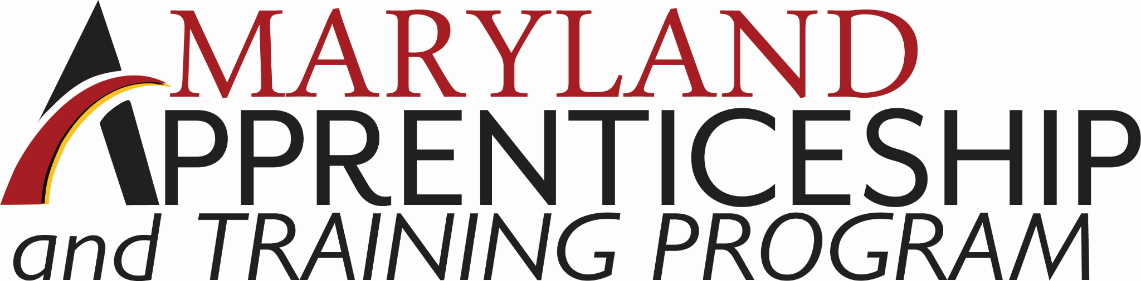

Issue Date: November 16, 2023

This application is for organizations seeking funding from the Maryland Department of Labor under the Public Sector Apprenticeship Innovation Fund (PSAIF). This grant is being funded on a rolling, competitive basis until all funds are exhausted.

Please complete all fields of this application and submit it with the program budget. Prior to submission, review the required and optional documents table below to ensure a complete application. Incomplete applications will not be considered.

Applicants should carefully review the Public Sector Apprenticeship Innovation Fund Policy (which can be found here: https://labor.maryland.gov/employment/mpi/) prior to completing this application. The Policy provides details on required program components and key terminology associated with this project.

Public Sector Apprenticeship Innovation Fund Initial Application Submission Checklist

REQUIRED DOCUMENTS | OPTIONAL DOCUMENTS
- PSAIF Application | - Letters of Support
- PSAIF Program Budget (.xlxs) | - Supportive Service Policy

Submission Instructions

Completed applications should be submitted via email to Wayne Salter at wayne.salter@maryland.gov. Submissions must include all required documents listed above and should be submitted as a file transfer or as attachments to a single email.

SECTION 1: APPLICANT INFORMATION
1 | Organization Name
2 | Employer Identification Number (FEIN)
3 | Point of Contact Name
4 | Point of Contact Title
5 | Point of Contact Email Address
6 | Point of Contact Phone Number
7 | Organization Street Address

SECTION 2:ASSURANCES PRIOR TO APPLICATION SUBMISSION
1 | I have read and understand the rules and requirements written in the Public Sector Apprenticeship Innovation Fund policy. | - Yes  - No
2 | I have worked with an MD Labor Apprenticeship Navigator to develop my application. | - Yes  - No
3 | I have worked with the Maryland Department of Budget and Management to develop my application (applicable only to State of Maryland executive agency applicants). | - Yes  - No  - N/A

SECTION 3: PROGRAM AND PROJECT INFORMATION
4 | Provide a brief overview of the organization and the organization's experience with Registered Apprenticeship.
5 | State the proposed occupation(s) to be supported through this project, including the relevant O’NET code. O’NET Codes can be found here: https://www.onetcodeconnector.org/.
6 | Provide an overview of the staff composition of the organization within the proposed occupation(s), including:  - Current number of active staff in the proposed occupation(s);  - Current number of vacancies in the proposed occupation(s);
7 | Check which of the following program elements are incorporated in the scope of the organization’s project. Please note that preference will be given to projects that are Group-Joint and/or utilize School-to-Apprenticeship. Definitions can be found in the Public Sector Apprenticeship Innovation Fund policy.
Is the proposed project:
- Creating a new Registered Apprenticeship pathway; or,
- Expanding an existing Registered Apprenticeship pathway

Is the proposed project:
- Multi-employer (group); or,
- Single-employer (non-group)

Does the proposed project involve:
- Union occupations (joint); or,
- Non-union occupations (non-joint)

Will the proposed project utilize School-to-Apprenticeship:
- Yes
- No

8 | Provide an overview of the proposed project, including:  - Which allowable activities the project intends to provide (see policy for details);  - If providing supportive services, is the applicant using MD Labor’s supportive service policy or attaching their own?;  - Will the applicant subaward funds to any partners? If so, identify any partners.
9 | Describe the outreach activities that will be used to recruit potential Apprentices.
10 | Would the proposed project be possible without the support of the Public Sector Apprenticeship Innovation Fund? If not, why?
11 | Provide a sustainability plan for how the project will continue beyond the completion of the grant period.

SECTION 4: PROGRAM EVALUATION AND REPORTING TARGETS
12 | Complete the chart below to identify the program’s targeted key performance outcomes.
A | Number of Registered Apprentices enrolled
B | Number of Registered Apprentices that complete their Apprenticeship
C | Average Earnings for Registered Apprentices
13 | Describe how the applicant will track and evaluate each of the performance outcomes identified above. Additionally, how will the applicant track any required demographic data?

Instructions for Section 5: Program Financial Information

Complete this section and provide financial information for the PSAIF grant requested. Information in this section must be consistent with an itemized PSAIF Program Budget. The Program Budget should be completed and submitted as an Excel document (.xlsx) along with this application. Please reconcile Section 5 of this application with the associated Program Budget prior to submission.

Cost per participant (Question 23B) should be calculated as total amount requested (23A) divided by total number of participants served from Question 18C.

SECTION 5: PROGRAM FINANCIAL INFORMATION
14 | Provide the following financial information about the funding requested.
A | Total grant amount requested | $
B | Cost per participant | $

Prior to signing below, review all sections of this application for completion and accuracy. Review the Public Sector Apprenticeship Innovation Fund Policy for any additional requirements associated with this program. Ensure that all required attachments and any desired optional attachments are included in the final submission.

AFFIRMED
The undersigned affirms that the applicant organization and any prospective subawardees are in good standing with the Comptroller of Maryland and the Maryland Department of Labor.
The undersigned affirms that the contents of this application are true and verifiable.

The undersigned agrees to all the requirements put forth in the program policy.

Applicant Full Name
Applicant Title
Applicant Email
Applicant Phone Number

Applicant Signature | Date

Completed Applications should be submitted via email to:
Wayne Salter at wayne.salter@maryland.gov.

All MD Labor Apprenticeship Navigators and their contact information can be found here: https://www.labor.maryland.gov/employment/appr/apprnavigators.shtml.

