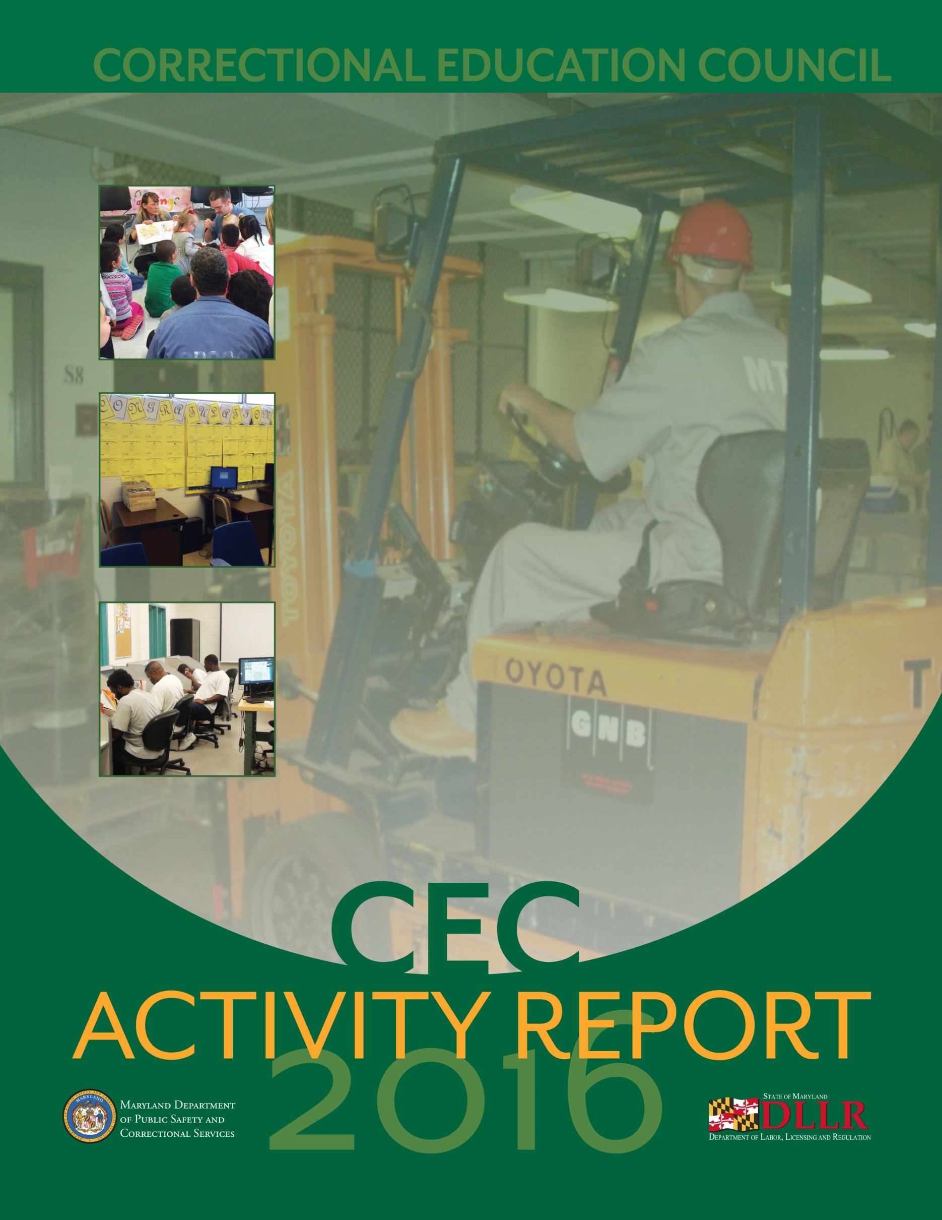

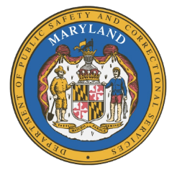
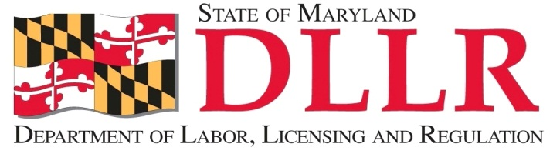
Maryland Department of
Public Safety and
Correctional Services

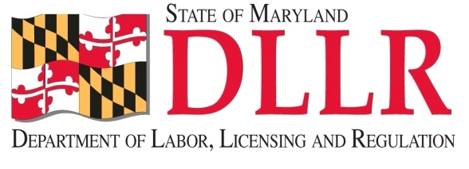
IN
PARTNERSHIP
WITH

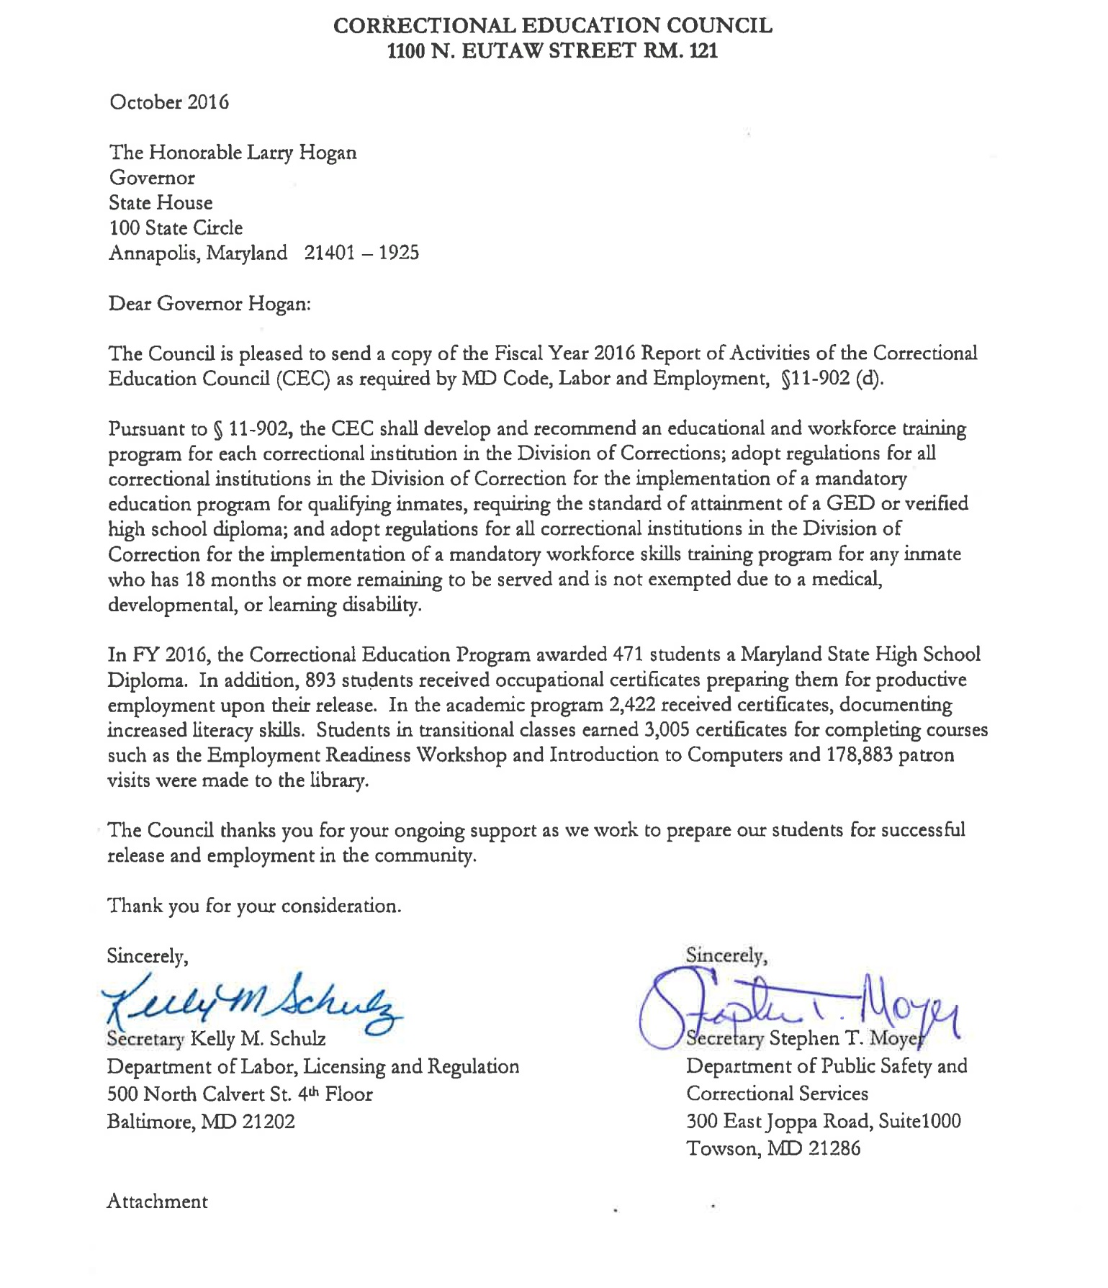
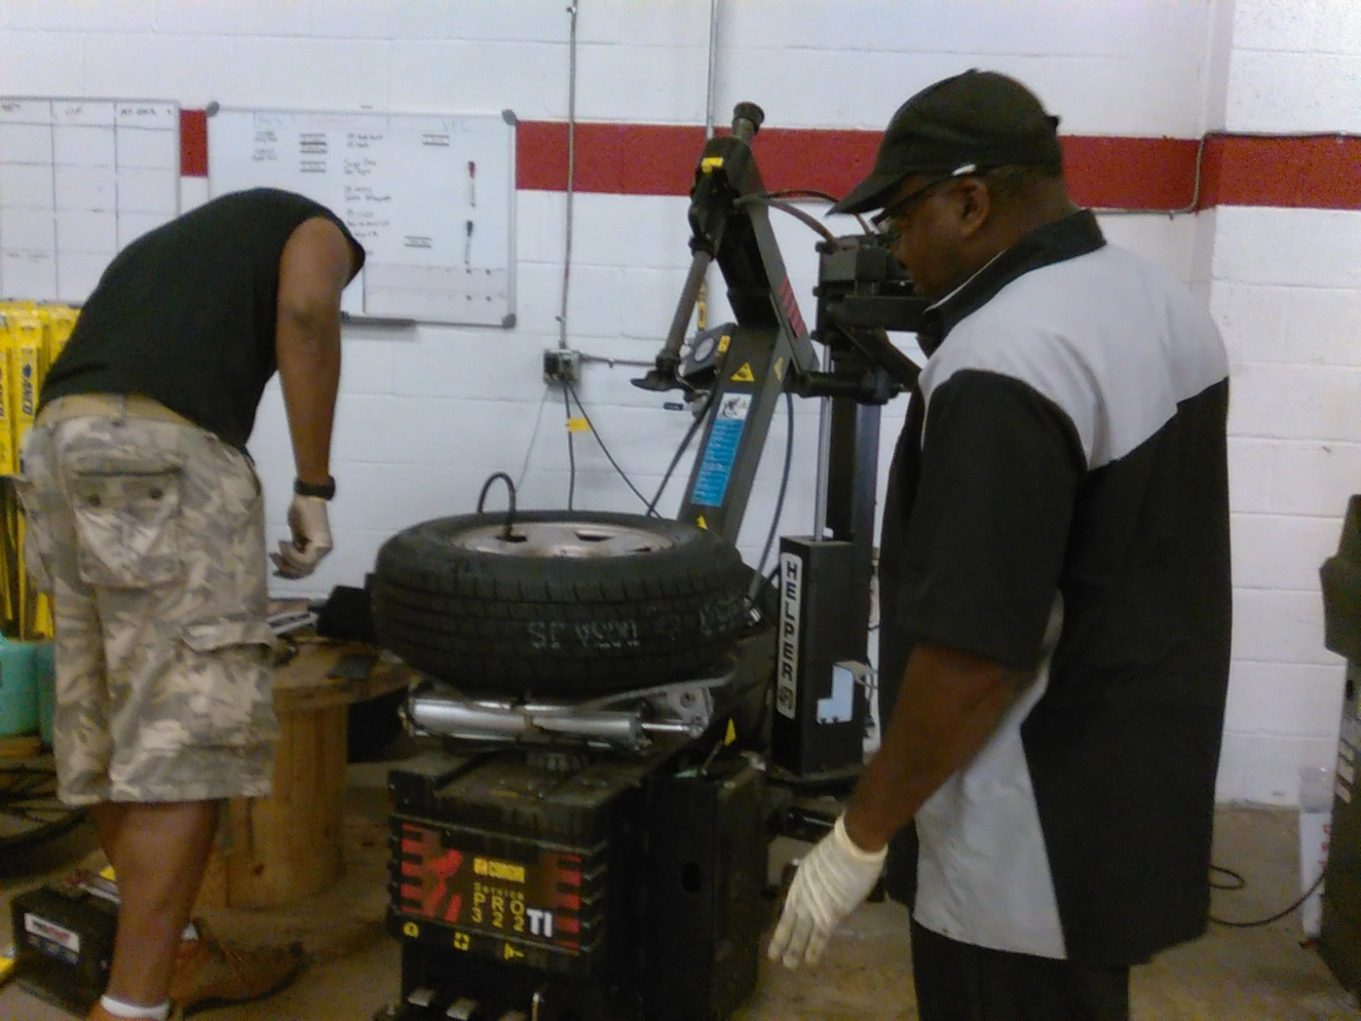

ANNUAL ACTIVITY REPORT TO THE GOVERNOR FY2016
CORRECTIONAL EDUCATION COUNCIL (CEC)

Table of Contents
- About the CEC 1
  - CEC Members 2
  - CEC Responsibilities 2
  - CEC Council and Agencies 3
  - CEC Council and Committees 4
- Department of Public Safety and Correctional Services Highlights 7
- Correctional Education Overview 8
  - Correctional Education Mission Statement 8
  - FY2016 Programs / Overview 8
  - Programs at a Glance 10
  - Mandatory Education 10
  - Community College Partnerships 10
- FY2016 Program Outcomes 11
  - Academic Programs 12
  - Revision of Curriculum Scope and Sequence 12
  - Postsecondary Education Programs 13
  - Occupational Programs 14
  - Transition Services 16
  - Special Education 18
  - Library Services 18
  - Implementing Computer Based GED® Testing 20
- Success Stories 20
- Academic Programs 23
- Correctional Education and Workforce Development Services 23
- Unique Programs 25
Reading Unites Families 25
Governor’s Office of Crime Control and Prevention 25
- Summary 27

1 ABOUT THE CEC
CEC • ACTIVITY REPORT 2016

Recognizing the importance of Adult and Correctional Education’s role in furthering employment opportunities for offenders, and pursuant to Labor and Employment §11-901-902, MD Code Ann., the Correctional Education Council (CEC) was established by Chapter 134 of the Acts of the 2008 Session of the Maryland General Assembly to oversee the implementation of DLLR’s Correctional Education (CE) Program. Council meetings were held in September and December of 2015 and March and June of 2016.

At each Council meeting, DLLR’s CE Program presented an overview of changes to the curriculum, resources, and services available to inmates at the various locations. Topics of discussion included classroom instruction, occupational programs, special education, implementation of the more rigorous 2014 GED® Test, library resources, transition services, and postsecondary education.

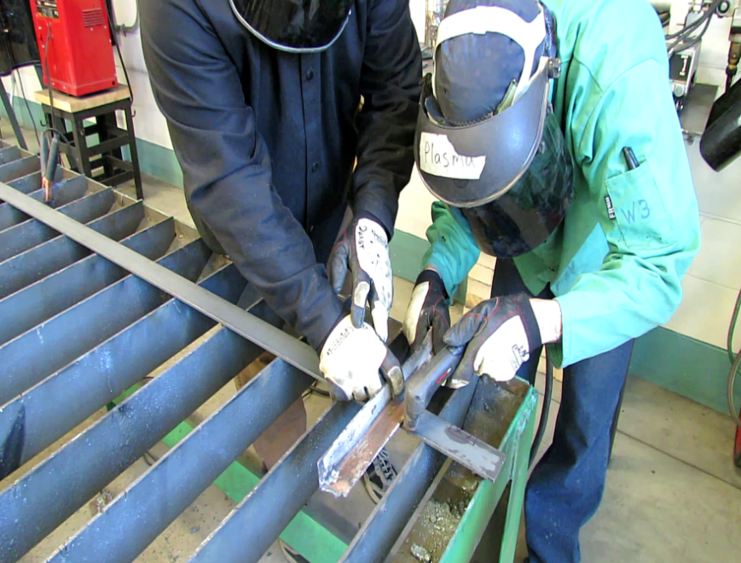
In 2016, the CEC worked with DLLR’s CE Program to foster progress of a comprehensive program with an emphasis on linking education and training of inmates to productive re-entry and employment opportunities in the community. DLLR’s CE Program strives to ensure that all Correctional Education students are provided educational opportunities, enabling them to become independent and productive workers, citizens, and parents.
(1)
CEC • ACTIVITY REPORT 2016

Correctional Education Council Members
The Council consists of fourteen members. Four members are appointed by the Governor, and ten Ex-Officio members are identified in COMAR.

Member Name | Professional Affiliation | Type of Member
Stephen Moyer | Secretary, Department of Public Safety and  Correctional Services, Co-Chair | Ex Officio
Kelly M. Schulz | Secretary, Department of Labor, Licensing and  Regulation, Co-Chair | Ex Officio
Jack Weber | Uptown Printing | Business Community
Yariela Kerr-Donovan | Johns Hopkins Hospital | Business Community
John Danko | Danko Arlington, Inc. | General Public
Thomas Lane | Maryland Correctional Enterprises | Former Offender
Karen B. Salmon | State Superintendent of Schools | Ex Officio
R. Michael Gill | Secretary of the Department of Business and Economic  Development | Ex Officio
Dawn Lindsay/Faith  Harland-White, designee | President, Anne Arundel Community College | Ex Officio
Francis “Hall” Chaney/Michael DiGiacomo, designee | Chair, Governor’s Workforce Development Board | Ex Officio
Jack Kavanagh | Superintendent of Howard County Detention Center | Ex Officio
James Fielder | Acting Secretary of Higher Education | Ex Officio
Alice Wirth | Director of Correctional Education | Ex Officio
VACANT | Local Representative, County Superintendent of Schools | Ex Officio

Correctional Education Council Responsibilities
The Council is charged with the following responsibilities:
    - Develop and recommend an educational and workforce training program for each correctional institution to meet the needs of the inmate population;
    - Adopt regulations for all correctional institutions for the implementation of mandatory education and workforce skills training programs;
    - Actively advocate and promote interests of education and workforce skills training opportunities in correctional institutions;
    - Ensure quality education and workforce skills training are available to inmates;
    - Review educational and workforce skills training programs at correctional institutions, including curriculum, resource materials, supplies, and instruction;
    - Recommend and advocate improvements to the educational and workforce skills training programs;
    - Meet quarterly; and
    - Submit an annual activities report to the Governor on or before October 30.
(2)
CEC • ACTIVITY REPORT 2016

Correctional Education Council and the Agencies
The major focus of the Council’s quarterly meetings was on the many changes occurring within DPSCS and Correctional Education.

CHANGES IN REVIEW

- Correctional Education partnered with the Maryland Transit Administration to develop a diesel mechanic program.
- Legislation was passed in Baltimore City to “Ban the Box” by stipulating that employers cannot ask about convictions on the initial employment application but may inquire if a previous conviction is relevant to the position.
- The Maryland General Assembly passed the Maryland Second Chance Act of 2015 (Chapter 313, 2015). The Act authorizes a person to petition a court to shield court and police records relating to one or more shieldable convictions no earlier than three years after the person satisfies the sentence, or sentences, imposed for all convictions for which shielding is requested. Under the Act, “shield” renders a court and police record relating to a conviction of a crime inaccessible by members of the public. The Act allows continued access to shielded information by certain individuals and entities.
- HB 304 (2015) – The bill expands eligibility for expungement by repealing the existing statutory prohibition on expungement of a police, court, or other record if (1) the petition for expungement is based on a nolle prosequi, a nolle prosequi with the requirement of drug and alcohol treatment, or a conviction of one of a list of specified crimes; and (2) the person to whom the petition applies has subsequently been convicted of a crime (other than a minor traffic violation) or is a defendant in a criminal processing.
- SB 651 (2015) – This bill expands eligibility for expungement to a person convicted of a crime that is no longer a crime.
- HB 908 (2015) – This bill limits the disqualification of a person convicted of a felony from registering to vote. A person can be disqualified only during the period in which the individual is serving a court-ordered sentence of imprisonment for the conviction (eliminating the inclusion of any term of parole or probation).
- SB1005 (2016) – The Justice Reinvestment Act (Chapter 515 of 2016) is said to be the largest and most comprehensive criminal justice reform to pass in Maryland in a generation. The Act, which was signed into law by Governor Hogan on May 19, 2016, will enable Maryland to better help families, restore communities, keep our streets safe, and move Maryland’s economy forward.

The greatest change for Correctional Education continues to be the implementation of the computerized 2014 GED® Test. Not only is testing done by computer for the first time in the history of the GED® Test, but the rigor of the test has increased. Correctional Education is adapting well. The pass rate for this year was 88 percent.

(3)
CEC • ACTIVITY REPORT 2016

COUNCIL ACTIVITIES

The Council had an active, productive year and met regularly to discuss ideas and programs important to the field of Correctional Education. Among the topics of discussion were:
- Computerized GED® Testing – In January 2014, all tests were solely computer-based and only delivered only in official Pearson VUE computer testing centers. The CEC continues to examine how the new test can be administered effectively.
- Important Changes to GED® Testing Scores – Effective March 1, 2016, GED® Testing Service changed its performance levels and lowered its passing score. The Council was briefed on how the new changes will affect inmates who previously took the exam and received a score between 145 and 150.
- EARN Program – The Council heard reports from the Employment Advancement Right Now (EARN) Maryland Strategic Industry Partnerships. Specifically, representatives from Vehicles for Change and the Jane Addams Resource Corporation (JARC) gave presentations to the members of the Council highlighting their innovative training programs that promote opportunities for returning citizens.
- Diesel Training – The Council continued to examine opportunities to expand its current occupations offerings behind the fence through the incorporation of a diesel mechanic certification. Automotive mechanics certifications, which include the nationally recognized Automotive Service Excellence (ASE) certification, are offered to inmates in certain institutions.
- College Behind the Fence – The Council continued to monitor state and federal initiatives that would provide opportunities for inmates to obtain Pell Grant funding for college classes. In October 2015, DLLR representatives joined U.S. Secretary of Education Arne Duncan and U.S. Attorney General Loretta Lynch at the Maryland Correctional Institute – Jessup to unveil a pilot program that will allow a group of inmates to use federal Pell Grant to fund their college education

  - Correctional Education Council and Committees
During FY2016, the committees supported the mission and work of the CEC. Each committee member serves for two years. All CEC members or their designee are encouraged to serve on a committee. Non-council members may serve on committees to allow for a greater range of expertise and staff to assist with the endeavors of each group. Participants on the committees include the following individuals:

(4)
CEC • ACTIVITY REPORT 2016

Employer Engagement and Occupational/Apprenticeship/Academic Committee

Jack Weber (Chair) | Thomas Lane
Ed Schwabeland  (Acting Occupational Coordinator) | John Danko
Alice Wirth | Charlene Templeton
Brandon Butler  Deborah Monroe  Yariela Kerr-Donovan  Chris Hadfield | Kathryn Holmes Lamon Harris  Ryan Huether  Michael Thomas  Kathleen White
Workforce Transition/Community Integration Committee
Thomas Martin
Yariela Kerr-Donovan
Erica N. DuBose (Co-Chair)
Constance Parker (Co-Chair)
Scot Pullen

(5)
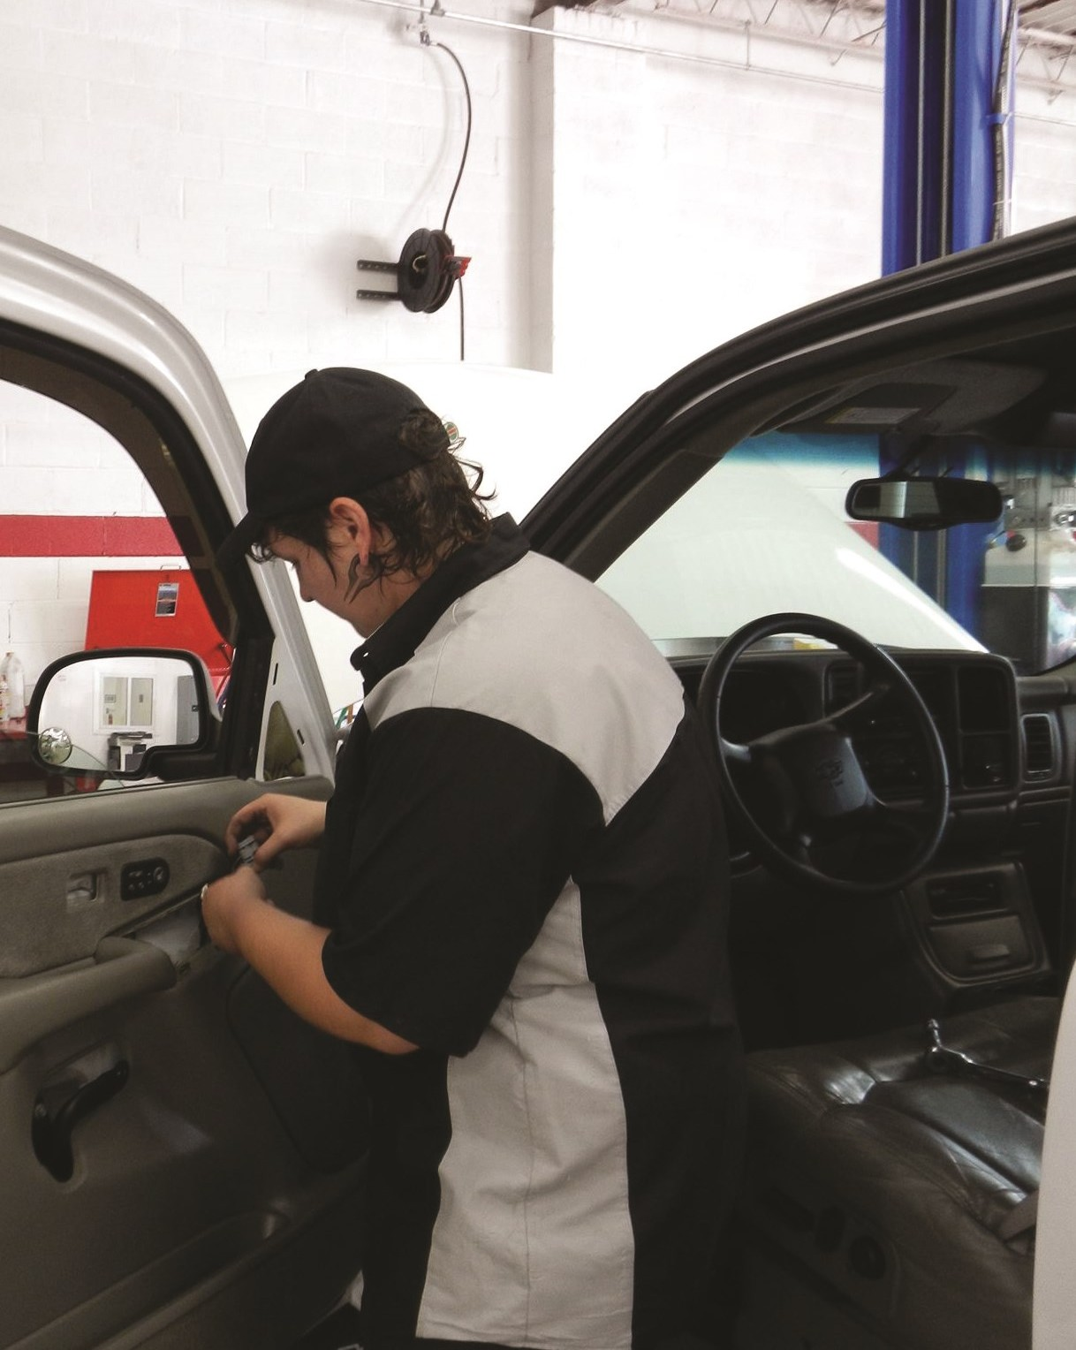
CEC • ACTIVITY REPORT 2016

Each committee has worked to establish priorities and actions to support the mission and mandates of the CEC and Correctional Education. A brief summary of each committee’s priorities is listed below.

EMPLOYER ENGAGEMENT AND OCCUPATIONAL/APPRENTICESHIP/ACADEMIC COMMITTEE
  - Evaluate current occupational programs.
  - Evaluate teachers’ score cards.
  - Review of occupational programs by employers.
  - Expand employer advisory committees as required by federal funding.
  - Develop an occupational skills assessment for students prior to entering occupational training programs.

WORKFORCE TRANSITION/COMMUNITY INTEGRATION COMMITTEE
  - A video to support the transition of inmates from the correctional system to the community statewide has been completed. A link can be viewed on the DLLR website at http://www.dllr.maryland.gov/ce/ or directly at the following link:
http://www.your4state.com/news/news/growing-demand-for-welders-prisons-offer-training
  - Support regional re-entry coordination and regional re-entry activities.
The America’s VetDogs Program was instituted in December of 2012 when Eastern Correctional Institution (ECI) received its first group of puppies. Based out of Smithtown, New York, America’s VetDogs is a non-profit organization that trains service dogs for wounded and disabled veterans. Inmates at ECI are raising and training service dogs who will one day work as service dogs for wounded veterans. This picture was created by an inmate at ECI.

(6)

DEPARTMENT OF PUBLIC SAFETY AND CORRECTIONAL SERVICES (DPSCS)
CEC • ACTIVITY REPORT 2016

The work of the CEC is integral to the Department of Public Safety and Correctional Services’ (DPSCS) overall effort to help offenders under its supervision successfully re-enter the community. As part of its overall re-entry efforts, the DPSCS has made Public Safety Works (PSW) a key priority to help inmates learn valuable skills and give back to the community. In FY 2016, PSW gave back over 550,000 hours of work to communities throughout the State. Key projects included assisting with the following efforts:

- Farming for Hunger with farming and harvesting 4,784,186 lbs. of food for non-profit organizations;
- Tuckahoe Habitat for Humanity with building affordable housing for Caroline and Queen Anne County residents;
- Recreation and Parks Departments with grounds maintenance services for several areas – Baltimore City, Queen Anne’s, Washington, and Wicomico counties); and
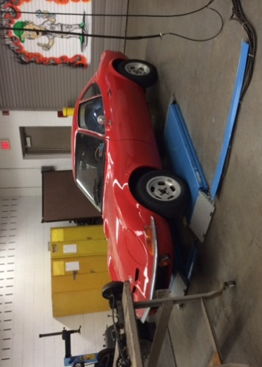
- Helping the Maryland Department of Natural Resources’ Marylanders Grow Oysters program – citizens grow oysters in cages (many of which are made by Eastern Pre-Release Unit) by hanging them from their personal docks, delivering them to a set location whereby an inmate crew collects the oysters for a sanctuary at Glebe Bay.

In addition, through a partnership with the Department of Health and Mental Hygiene, DPSCS and PSW expanded the sharing of mental health data with Core Service Agencies for individuals released from a departmental facility. The agreement now includes 12 local jurisdictions, with more expected to be approved this coming year. This agreement allows DPSCS to better understand the mental health treatment needs of assessed individuals, while also allowing community providers to better adjust the treatment needs of individuals recently released from incarceration.

DPSCS entered into an agreement with Community Mediation Maryland to deliver mediation services to inmates and their families for the purpose of mending relationships that may have been damaged due to incarceration. A total of 535 mediation sessions were completed in FY 2016. DPSCS renewed the relationship with CMM for the coming year. Through the Department’s continued agreement with the Motor Vehicle Administration (MVA), a total of 2,054 MVA ID’s were processed for individuals prior to their release or within 60 days of their release from incarceration. This effort represented a crucial step in the ability of individuals to access much-needed services and employment upon returning to the community.
(7)

CEC • ACTIVITY REPORT 2016

CORRECTIONAL EDUCATION OVERVIEW

The Council works collaboratively with the Correctional Education (CE) program at DLLR to promote and advocate for education and workforce skills training opportunities in correctional institutions.

Correctional Education Mission Statement
The CE program provides incarcerated individuals with high quality services that facilitate successful transition into Maryland’s workforce and communities.

FY2016 Programs Overview

Correctional Education provides academic, library, occupational, and transitional services to incarcerated students in State correctional institutions. The academic program includes Adult Basic Education, GED® Preparation, Special Education, English for Speakers of Other Languages, and a Postsecondary Education Program.

The Library Services Program provides informational, research, and recreational reading services. The Occupational Program offers a variety of vocational programs with twelve nationally-recognized certifications. Transitional classes include life skills, financial literacy, introduction to computers, employment readiness and workforce development, and career exploration.

Specific attention is given to academic, transitional and occupational students who are under 21 years of age to address their unique needs. Correctional Education prepares incarcerated students to become responsible members of their communities.

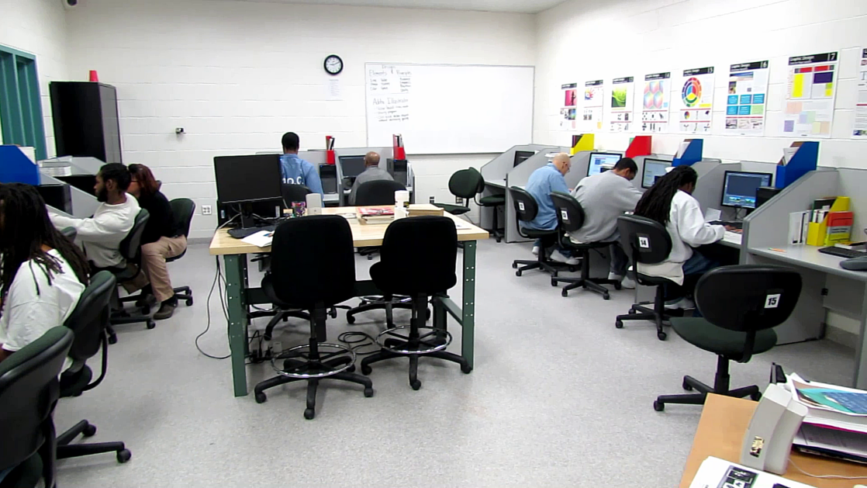
Example of an Occupational Program class
(8)
OCCUPATIONAL SUCCESS

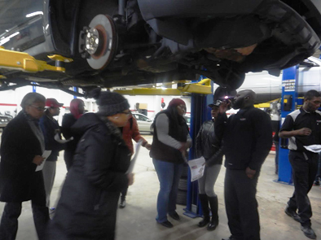
Antoine went to prison at the age of 17. He was released at the age of 38, having spent more than half of his life behind prison walls.

The father of a young man in his early twenties, Antoine knew that he wanted to make a change and hit the ground running upon release. His game plan? He would learn to repair automobiles.

While in prison, Antoine took classes at the Occupational Skills Training Center (OSTC). His teacher was duly impressed with Antoine and highly recommended him for the new prison re-entry automotive internship at Full Circle Service Center, Vehicles for Change’s (VFC) new auto repair shop. Antoine was accepted into the new training program in September of 2015, making the journey from Baltimore Pre-Release Unit (BPRU) to Halethorpe, Maryland, each day. One of the lead mechanics at VFC quickly saw the potential that Antoine possessed and enlisted him to take on jobs with increasing complexity.

Recognizing the potential for advancement as an intern, Antoine took his work seriously and became a leader at Full Circle Service Center. His transition within the program was no less compelling than that of a caterpillar going through the stages of becoming a butterfly under the tutelage of the lead instructor at Vehicles for Change’s lead automotive instructor. Antoine went from BPRU to home detention, picking up four ASE certifications along the way. In early February 2016, Antoine was released on parole and was later offered a full-time job as a mechanic at MileOne in Catonsville, MD. Antoine has the special honor of being the first former inmate to be hired at a MileOne dealership.

CEC • ACTIVITY REPORT 2016

Program at a Glance
Educational programming for offenders has been found to be one of the most effective tools in reducing recidivism rates. A study by The Rand Corporation found that inmates who earn their GED® were more likely to find a job and less likely to return to prison once released. The CE program has 237 positions dedicated to offender instruction and educational support; the educational program offers more than fifty academic, occupational, and workforce skills classes.
The need for correctional education in Maryland is well documented. The average reading level of the 21,300 inmates currently in the Maryland prison system is between 5th and 8th grade. Less than half of these inmates have high school diplomas when they enter the correctional system. Correctional education provides a comprehensive education program designed to meet the needs of students at all educational levels.

Average number of students served per day | 3,200
Approximate number of students served per year | 13,000
Number of full-time state CE employees | 155.5
Number of part-time contractual employees | 81
Number of schools | 21

Mandatory Education
Pursuant to the Labor and Employment Article of the Maryland Annotated Code, §11-09.37.02, education for certain inmates is a requirement. The law mandates that inmates must enroll in educational or workforce skills classes if individuals do not have a high school diploma, have at least 18 months remaining on their sentence, and are not exempt due to medical, developmental, or learning disabilities. Inmates must participate for a minimum of 120 days.

Community College Partnerships
As part of its mission to serve incarcerated students, CE has established Memoranda of Understanding with Anne Arundel Community College, Hagerstown Community College, and Wor-Wic Community College to enhance the educational program statewide. Using funds from grants and other reimbursable sources, this partnership enables CE to provide additional continuing education, workforce skills training, and transition classes in facilities across Maryland. As a result, CE was able to expand the number of classes for students.
(10)

4 FY2016 PROGRAM OUTCOMES
CEC • ACTIVITY REPORT 2016

In 2015, the Council reviewed the program outcomes for all sectors of CE. As a result of these evaluations and the ongoing work of the Council, the following goals were established for FY 2016:
Leadership and Accountability Highlights

The following CEC legislative mandates are evidenced by FY 2016 outcomes:
- Develop and recommend an educational and workforce training program for each correctional institution to meet the needs of the inmate population
- Ensure quality education and workforce skills training are available to inmates
- Review educational and workforce skills training programs at correctional institutions, including curriculum, resource materials, supplies and instruction
- Recommend and advocate for instructional changes based on the 2014 GED® Test
- The Council Chairs and members will work with Community College presidents to identify ways to expand current partnerships and strengthen CE programs within the prison system and allow postsecondary education opportunities for inmates.
The Council will investigate potential funding sources to assist in the
upgrade of occupational training equipment and support for national
certifications to improve employment possibilities.
- The Council will explore ways to educate the private sector regarding hiring ex-offenders.
- The Council will encourage and support the development of a mentoring/volunteer network to assist ex-offenders as they transition back into the community.
During FY 2016, the Council worked on several initiatives to strengthen and improve the mission and efforts of the Correctional Education program. Those initiatives included the continuation of the working committees whose scope of work is outlined in Section 1.3 of this report. The Council supported the development and work of Employer Advisory Boards, expansion of the limited internet computer labs, the development of several new occupational training programs, and the establishment of a regional re-entry demonstration project funded through Governor’s Office of Crime Control and Prevention (GOCCP). Finally, CEC initiated the development of a partnership with community colleges to strengthen and expand the capability of the academic, postsecondary, occupational, and transitional service programs. All of these efforts worked in concert to support the mission of CE.

(11)

4.1 Academic Programs
CEC • ACTIVITY REPORT 2016

0.0 - 3.9 | 727 | Completions
4.0 - 5.9 | 812 | Completions
6.0 - 8.9 | 883 | Completions
9.0 - 12.9 | 471 | GED® Completions
Comprehensive Academic Programs were delivered at 21 institutions through the dedicated work of 69 Position Identification Numbers (PIN) and 26 contractual instructors.
    - Academic grade level completions (see chart).
    - ESOL (English for Speakers of Other Languages) – approximately 158 students served in nine institutions.
    - Services to the under 21 population led to 34 high school diplomas earned by this population group and 75 percent of the lowest level readers showing a gain in reading skills.

Revision of Curriculum Scope and Sequence
The implementation of the 2014 GED® Test and passage of the Workforce Innovation and Opportunities Act established the need for a revised CE Curriculum Scope and Sequence and set of skills. The two national actions required increased rigor to be added to the curriculum. The new GED® Test series; new definitions in the Common Core State Standards; and the Office of Career, Technical and Adult Education’s (OCTAE) College and Career Readiness Standards for Adult Education became the base documents for the review.

The curriculum revision process to update the Correctional Education Curriculum Scope and Sequence was designed to involve all academic teachers at each school. The process began in February 2016 with a review by teachers at the school level. Principals met with academic teachers at their school, made recommendations, and submitted the changes to the Academic Program Coordinator in March 2016. Feedback was reviewed by a Steering Committee of principal designees. The final draft of the Curriculum Scope and Sequence was distributed at the July 2016 Correctional Education Systems’ Meeting. The final curriculum was completed in September 2016.

The 2014 GED® Test Performance Level descriptors, OCTAE’s College and Career Readiness Standards for Adult Education, the Maryland Common Core State Curriculum, and the Juvenile Services Education GED® Curriculum. CEC has insured the educational services delivered to the State’s inmate population were up-to-date. Webb’s Depth of Knowledge was also added to each skill within the Curriculum Scope and Sequence. As a result, each skill has an expected level of performance. The Depth of Knowledge level gives guidance to teachers about the intensity and complexity of instruction needed for student achievement.

Performance levels are:
- Level 1, which includes basic recall of facts, concepts, information, or procedures.
- Level 2, which involves skills and concepts, such as the use of information (graphs) and requires at least two steps with decision points along the way.
(12)
CEC • ACTIVITY REPORT 2016

- Level 3, which requires strategic thinking; students must analyze and evaluate complex problems/situations with predictable outcomes.
- Level 4, which requires extended thinking into an investigation or application to solve complex problems with unpredictable outcomes.

The new curriculum will be rolled out in October of 2016.

Postsecondary Education Programs
The postsecondary education self-pay programs continued to be held at three prisons, Marylad Correctional Training Center (MCTC), Jessup correctional Institution (JCI) and Eastern Correctional Institution East ( ECI-E) in conjunction with Hagerstown Community College (HCC), Anne Arundel Community College (AACC), and Wor-Wic Community College (WWCC) respectively. Goucher College, through a private grant, continued to offer courses at two institutions, MCI-J and MCI-W that may be applied to a bachelor of science degree.

ANNE ARUNDEL COLLEGE SELF-PAY PROGRAM

The Anne Arundel Community College Program at JCI experienced success and growth in FY16. In April 2016, six JCI students earned certificates in Business Office Management. They also earned Microsoft Office Specialist certifications in Word and Excel. Their new skills and certifications have equipped them to work in virtually any business setting upon release and have proven to be a strong foundation for the Entrepreneurship program in which they are now enrolled. The college held a formal graduation ceremony attended by the AACC president, Dr. Dawn Lindsay, a college vice president, and several deans. These students and their families continue to pay for the books and classes themselves. A second cohort was formed in late November 2015, and seven students earned the Microsoft Office Specialist certification in Word. Cohort 2 students have three classes remaining and are expected to complete their program of study and graduate in May 2017.

GOUCHER COLLEGE PROGRAM

The Goucher Prison Education Partnership (GPEP), a division of Goucher College, offers an excellent college education to students at the Maryland Correctional Institution for Women (MCI-W) and Maryland Correctional Institution - Jessup (MCI-J). GPEP has enrolled incarcerated men and women in Maryland state prisons as Goucher students since 2012 and has offered 74 courses to date. Last academic year, 70 students studied with Goucher through GPEP – approximately 40 at MCI-W and 30 at MCI-J. The partnership’s goal is to offer students the opportunity to earn a college education; therefore, in addition to college classes, GPEP offers college preparatory courses for students needing additional support to be ready for rigorous college work. The college also offers academic advising and twice-weekly academic tutoring to all GPEP students.

This summer, Goucher College was one of four colleges in Maryland, and 67 colleges and universities nationwide, named by the United States Department of Education as Second Chance Pell Grant pilot sites. While Pell grant funding will not be available to all students, will not cover all expenses for students who are eligible, and may be available for
(13)
only a limited term, this public support together with the generosity of private funders will allow Goucher to deepen and expand its work with students in Maryland State Prisons. GPEP expects to serve approximately 100 students in the coming year.
CEC • ACTIVITY REPORT 2016

In addition, classes are available for staff members at the prison to access higher education. GPEP has offered up to two spots in each GPEP cohort to men and women who work at MCI-W and MCI-J and who do not yet have an undergraduate degree.

4.4 Occupational Programs

OVERVIEW
During the 2015-2016 school year, CE enrolled 2191, students in 41 occupational classes in 10 institutions. In terms of completions, 893 students received Occupational Certificates in the career programs offered below:
(14)
- Architectural CADD (1) * | - Pre-Apprenticeship Electrical (1)
- Auto Body Repair (1) | - Pre-Apprenticeship Facilities Maint. (1)
- Automotive Maintenance and Inspection (5) | - Pre-Apprenticeship HVAC/R (2)
- Building Maintenance (1) | - Pre-Apprenticeship Masonry (3)
- Fabric and Upholstery Cleaning (1) | - Pre-Apprenticeship Plumbing (2)
- Furniture Upholstery (1) | - Pre-Apprenticeship Sheet Metal (1)
- Graphic Arts and Design (3) | - Pre-Apprenticeship Welding (1)
- Introduction to Word and Excel (2) | - Print Communication (2)
- Office Practice and Management (1) | - Roofing (1)
- Office Technology (5) | - Small Engine Repair (1)
- Pre-Apprenticeship Carpentry (3) | - Warehouse/Distribution (1)
*Indicates the number of schools offering this program | - Woodworking/Finish Carpentry (1)
CEC • ACTIVITY REPORT 2016

NATIONAL CERTIFICATES

In addition, 697 students were awarded 881 national certificates, offered by five national certification organizations.
OCCUPATIONAL PROGRAM | NATIONAL CERTIFICATE | NUMBER AWARDED
Automotive Maintenance and Inspection | Automotive Service Excellence (ASE) (Refrigerant Test) | 7  55
Construction Programs: CORE, and  Pre-Apprenticeship courses listed above | National Center for Construction Education and Research (NCCER) | CORE: 403  Trades: 284
Fabric Cleaning | Pro Clean College | 24
HVAC | Environmental Protection Agency | 108
 | Total | 881
*Online testing not permitted

OCCUPATIONAL PRIORITIES
For 2015-2016 school year priorities, CE focused on hiring staff for vacant positions, increasing the number of national certifications offered, certifying staff to issue national certifications in their specialty, and developing a partnership with Vehicles for Change (VFC) to train automotive mechanics for possible employment as paid VFC interns and eventually employment in the private sector.

Hiring Staff for Vacant Positions
Over the course of the 2015-2016 school year, CE hired instructors for the following positions:
- Office Technology at OSTC
- Office Technology at MCI-W
- Office Technology at RCI
- Masonry at MCTC
- Joint Skills Training Program (JSTP) assistant for Hagerstown and the Jessup region

Training and Certifying Staff to Issue National Certifications

In FY 2016, the occupational coordinator provided five automotive instructors training regarding how to register students for ASE testing. The coordinator also provided the same training for two additional individuals as well as explained how to conduct ASE testing and how to receive and record student scores in the national registry.
(15)

Lastly, CORE (the basic NCCER construction course) was added to the Roofing Program and that instructor was likewise trained and certified.
CEC • ACTIVITY REPORT 2016

Providing Online Student Testing for National Certifications
A major goal of CE’s occupational programs is to offer third-party, online national certification testing for all programs. The five Automotive Maintenance and Inspection Training Programs achieved this goal. Each site established testing procedures, and third-party online testing was established for students throughout the school year. Similar third-party online testing was not implemented for the Microsoft Office, CADD, or Adobe-based programs.

Expanding the “Joint Skills Training Partnership” (JSTP) to the Jessup Facilities
CE expanded its JSTP program to the Jessup facilities—Maryland Correctional Institution-Jessup (MCI-J); Brockbridge Correctional Facility (BCF); Maryland Correctional Institution for Women (MCI-W); and Central Maryland Correctional Facility (CMCF)—during this past school year 2015-2016. The program’s purpose is to document the skills that inmates, working in various prison jobs, master “on the job.” Normally, inmates work in these various jobs without realizing that they are learning some very significant job skills as well as gaining employability skills that will translate to employment once they are released. In the Hagerstown facilities—MCTC, MCI-H, RCI and WCI— 298 inmate workers received Certificates of Completion documenting skills attained in over 25 jobs. At the Jessup facilities, 77 inmate workers received Certificates of Completion in more than 12 jobs.

Expanding the Partnership (JSTP) with Vehicles for Change (VFC)
CE and VFC have established an efficient well run partnership providing paid internships and possible private sector employment for motivated inmate students who complete the Automotive Maintenance and Inspection Program and are then released back to the Baltimore area. They are interviewed and, if hired by VFC’s Full Circle automotive repair business, expand their knowledge and skills in repairing automobiles. VFC has developed partnerships with many private sector employers who hire these interns as needed. During the 2015-2016 school year, VFC hired 31 interns; 22 of whom were employed. Six are current interns and three dropped out or were incarcerated. Of those employed in the private sector, three have been employed for at least a year, and six have been employed for at least six months. In addition, Correctional Education began the process of evaluating the feasibility of adding a diesel component to the automotive shops.

4.5 Transition Services
The Council’s Workforce Transition and Community Engagement sub-committee is continuing its efforts to evaluate and make recommendations regarding the curriculum and instruction provided to inmates in preparation for employment and re-entry into the community. Transition Program curriculum is offered at 20 sites by 25 instructors with 3,005 participants successfully completing courses during FY2016.
(16)
Courses of Instruction in the Transition Program
CEC • ACTIVITY REPORT 2016

  - Personal Assessment and Career Exploration
  - Employment Readiness Workshop
  - Financial Literacy
  - Health and Nutrition
  - Parenting
  - Introduction to Computers
  - Basic Keyboarding
  - Success at Work
  - Life Skills for Re-entry
  - Internet Job Search
  - Re-entry and Employment Resource Skills Training

Institution-Level Employment and Re-entry Efforts
  - Supported DPSCS Re-entry Conference at Brockbridge Correctional Facility.
  - Supported Re-entry Resource Fairs for Community Supervision.
  - Provided updated DWDAL publications regarding American Job Centers and employment to the DPSCS Transition Team, Correctional Education Libraries, and Correctional Education Transition Instructors.
  - Participated in the Re-entry Council Symposium to support professionals in re-entry.

Transition Program Initiatives and Partnerships
  - Limited Internet Lab for Job Search continued operations at facilities throughout the State.
  - Worked closely with Maryland Community Services Locator staff to ensure proper usage behind the fence.

Delivered professional development workshops to Correctional Education Transitions Instructors on the topics of

Governor’s Office of Crime Control and Prevention of Maryland (GOCCP) Re-entry Program Initiatives,

Second Chance Act Grant Best Practices,

Maryland DHR Benefits Overview, and

Social Media for Job Seekers with a Criminal Background.
  - Continued the partnership with the Maryland Re-entry Initiative; provided technical assistance and staff training on offender employment issues.
  - Participated in the National Institute of Corrections/Maryland Offender Workforce Development Specialist Partnership’s Offender Workforce Development Specialist certificate course. This 160-hour training program leads to national certification in OWDS and Global Career Development Facilitator (GCDF). Twenty-five staff members, including DLLR Veterans Employment Services Program staff, participated and achieved their certifications.
  - Participated in the Re-entry Center Partnership Network, which developed and initiated the First Annual Re-entry Practitioners Symposium; over 170 re-entry professionals attended the event.
(17)

4.6 Special Education Services
CEC • ACTIVITY REPORT 2016

The Correctional Education Council works collaboratively with partners to implement Part B of the Individuals with Disabilities Education Act (IDEA), 34 CFR 300 and the Education Article, Title 8, Subtitles 3 and 4 of the Annotated Code of Maryland. Part B assures a Free Appropriate Public Education (FAPE) for all students with disabilities, birth through the end of the school year in which the student turns 21 years old, in accordance with the student’s Individualized Education Program (IEP). These academic and related services are provided within the parameters of security and public safety within DPSCS.

Outcomes of the Special Education Program included
- Continuous collaboration among public school system personnel, Department of Public Safety and Correctional Services, Department of Juvenile Services, and Maryland State Department of Education to provide adequate special education services to students through the age of 21.
- Adult institutions which are fully-staffed with special education teachers and related service providers.
- Availability of Woodcock-Johnson IV Tests.
- Availability of services in 11 state institutions including Maryland Metropolitan Transition Center (formerly Baltimore City Detention Center).
- Opportunity for students with special needs to obtain Transition and Occupational certificates.
- Access to special education teachers conducting IEP meetings year-round and identifying and serving a monthly average of over 100 students.
- Integrated classroom technology enhancing teaching and learning by equipping each special teacher with a new laptop computer.
- In collaboration with DPSCS, incorporating interpreters in the education setting for hearing-impaired students.

Professional Development Opportunities included
- Maryland Common Core Standards curriculum with the general education instructors.
- Special Education Wrightslaw Conference.
- Maryland On-Line IEP training through Johns Hopkins University.
- Reading Horizons - Elevate Training.
- Procedural Safeguards - Child Find, Parent Rights, and Woodcock Johnson IV assessments.

Library Services

Libraries continued to serve as information centers for the entire incarcerated community living in prisons across the state. The library is used for book circulations, legal information and research, employment exploration and readiness, health information, book discussions and other reading and writing centered programs. The main libraries provide additional services to satellite libraries (minimum and pre-release). All libraries maintain reading materials for inmates across all reading levels.
(18)
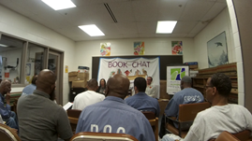
CEC • ACTIVITY REPORT 2016

Library patrons had the opportunity to

- Seek, locate, and retrieve library resources in various print and electronic formats to meet their information needs;
- Receive instruction regarding the use of technology and other resources to find general and specific information;
- Choose from a collection of materials that meet their recreational reading needs and lifelong learning and transitional aspirations;
- Research information related to careers and transitional services using up-to-date materials;
- Study and practice foreign languages using recorded and computer program formats;
- Participate in a variety of book discussion groups, poetry slams, creative writing workshops, Touchstone and Toastmasters, and attend guest speaker programs; several libraries also provide puzzle solving and logic problem solving groups;
- View educational and career videos; and
- Access to Limited Internet Career websites in the library Career Center.

Special project highlights this year included

  - The Library of Congress’ Veterans History Project at MCI-H library and a prison-wide poetry slam at JCI; several libraries provided support and assistance to Goucher College inmate students;
  - Grant awarded to MCTC from Lisa Libraries for Children;
  - A book/topic discussion series at ECI-W library in partnership with Salisbury University since 2000; this library recently received the Lights of Literacy Award from the Wicomico County Library System for its contributions to literacy and sustaining lifelong learning;
  - Poster presentation by librarian at the 2016 Maryland Library Association Conference in Ocean City, MD; and
  - Participation by five libraries in the Maryland Humanities 2016 One Maryland, One Book reading project.

LIBRARY SERVICES OUTCOMES FOR FY2016
Patron visits | 178,883
Book circulations | 156,388
General reference questions answered | 27,281
Legal reference questions answered | 62,092
Inter/Intra Library Loans | 152
Magazine circulation | 43,086
Media circulation | 2,928
Educational Programs | 129
Internet Job Searches | 677
(19)

Computer Based GED® Testing
CEC • ACTIVITY REPORT 2016

The GED® Testing Service continues to utilize computerized assessment to allow adults to earn a high school credential. Each CE school has become an official Pearson VUE Testing Center with four to eight individual testing stations offering privacy and security. Students take the GED® Ready test prior to taking the GED® Test to determine whether they are likely to pass the GED® Test.

To date, students testing in the CE testing centers are passing the 2014 GED® Test at a significantly higher rate than the national average. The pass rate for Correctional Education on the GED® Test is 88 percent. Teachers have adjusted their classroom instruction to address the new skills assessed by the 2014 GED® Test. Students who pass the GED® Test earn a Maryland High School Diploma.
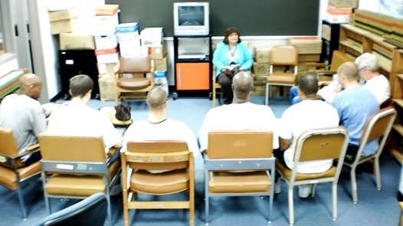

SUCCESS STORIES

After serving four years for committing a theft that triggered a violation on a former assault and battery conviction, Jasmine exited prison with the desire to work and improve her life. Jasmine entered the American Job Center and was determined to change her life. AJC staff assisted her with upgrading her résumé and also referred her to the Women Behind the Community (WO-BE-CO) for clothing assistance—both for interviewing purposes and for her eventual job.

While Jasmine worked with the center’s Business Service Representative and attended the job club, her CDF, identified and referred Jasmine to the Next Course Food Service Training offered by St. Vincent de Paul. Next Course offers a 17 week program and an opportunity to obtain ServSafe Food Handlers Certification and the ServSafe Manager’s Certification. She was accepted into the program and gained hands-on experience with the St. Vincent’s KidzTable, a production kitchen providing over 11,000 quality meals to head start programs, daycares, shelters, and after-school programs throughout Baltimore. Jasmine was accepted into the training program. She also attended the AJC’s recruitment for Hospitality Staff and secured a part-time position in food service for 20 hours per week at $8.75 per hour. Her training prepared her for her job. WO-BE-CO gave Jasmine appropriate clothes for the interview and two uniforms for work. Jasmine has achieved her goal of “securing stability with employment and adding plenty of certifications under my belt to make me more employable.”
(20)
CEC • ACTIVITY REPORT 2016

J. B. was a natural leader. He was also a drug dealer. He eventually landed in the Maryland Criminal Justice System. While in prison, he learned financial literacy, including banking and credit. As a result of his academic diligence, he was selected to attend Alleghany Community College where he obtained a certification in fiber optic communication.

He now works with a non-profit organization that mentors and helps at-risk youth to deter them from making the same poor decisions that led him to prison. J.B. has a “strong desire to help our communities reshape and restructure.” He credits the staff at ECI-E for encouraging him to “be a better man” and for “moving him in the right direction of changing his mind, heart and spirit.” He entered prison as a convicted drug dealer and exited to become a successful and productive member of society.

Aston was almost eighteen when he arrived at ECI-East Education. He knew he had a long path to the day that he would be released from prison. As required for students age 21 and under, he was given priority to enter school. His first placement was in the Basic Literacy class, Level 1 of 5. He was also interviewed for Child Find and found to be an active Special Education student.

Immediately, he was assigned to a general education class in the morning and a special education class in the afternoon. After a brief period, he earned his first Adult Skills Certificate. As Aston advanced to Beginning Basic and Intermediate Low, he had no obvious problems in school. He was able to receive an Adult Skills Certificate 2 and 3 within a three-month time period. He was progressing very well; however, at the Intermediate High level, learning became very difficult for him and his confidence waned. He found himself saying, “I can’t do this,” and he did not want to attend school. Aston wanted Ms. Miller, his Special Education teacher, to take him out of class, but she would not. She had confidence in him and his ability. As it was Aston’s choice whether to stay or quit, Ms. Miller started having talks with him about positive thinking and gave learning strategies he could apply during lessons. These were especially helpful when he was most frustrated.

Once Aston got the Adult Skills Certificate 4, Intermediate High, he started to believe in himself again and in his ability to learn. He came to class in the afternoon and stayed longer than was required. He practiced, practiced, practiced! About this time, Aston met with his attorney to ask the judge to agree to reduce his prison sentence if he earned a high school diploma. The judge agreed.

(21)
Even though the work was getting much more difficult, Aston persisted; he took every opportunity to be in school. When he received an Adult Skills Certificate 5, Adult Secondary Low, he knew he was ready to take the GED® Test. He was incredibly pleased and proud of his accomplishments!!! On the day he received the Adult Skills Certificate 5, he announced, “I’m ready to take the GED® Test.” At that point, Ms. Miller knew nothing would stop him. His confidence was boosted even more when he took the GED® Ready test and it showed he was “likely to pass” the GED® Test. He realized that he had never been able to do any of this level work before. Aston took the GED® Test and passed it to earn the long-awaited high school diploma. Aston was rewarded by the judge in his case who reduced his prison time.
CEC • ACTIVITY REPORT 2016

Today, Aston is at the Occupational Skills Training Center, Correctional Education Program. He works with a demolition crew that tore down the Old Jail in Baltimore. One day while working on site, the boss of the demolition company walks up to him, holds out his hand to shake his, and says, “I like the way you work!” He hands Aston a company card and tells him to come see him when is released, which is very soon.

Getting his high school diploma by passing the GED® Test was Aston’s first major accomplishment in his life. The next achievement will be a great job to add to that list! Now at age 22, Aston has learned more than the skills to earn a high school diploma. He has learned to believe in himself and to work hard for what he wants to achieve.

Letter from Richard to Jack Weber
Occupational Skills Training Center (OSTC)
9/4/2016

“I am working in the Litho Department in Belcamp, MD, and am printing on metal. I've been there since May 27th. There is A LOT to learn and I'm still in training, but I am well on my way to becoming a pressmen. Mr. Benjamin's [OSTC] class definitely helped me get my foot-in-the-door. The knowledge I gained from OSTC gave me an advantage, even with guys that have been working at this company for years. Printing on metal involves a couple more make-ready processes and we also print containers for food products, so some of the coatings and inks we use require special wash-up procedures. All I can say is that everything in the metal plant is A LOT bigger. We use ovens and UV lights to cure inks and coatings, so it's very hot in some areas of the plant. I'm glad summer is just about over. Thank you for following up on my employment. I think I lucked out with finding the right company. By the time I get this little black box off my leg (sometime in May 2017) I should be making a decent wage that I can live on and be comfortable. And, my benefits package is finally active. Monday (Labor Day) is my first paid holiday. By the way, last week I worked 20 hours of overtime. At the next OSTC Printing & Graphics Industry Day let the students know it can be done. Their records don't matter. Companies are going to hire you based on your knowledge and motivation to learn and help the company make money. I'm living proof that the program works.

~ Richard

(22)
CEC • ACTIVITY REPORT 2016

Services for Youth Under 21
Maryland adult prisons house between 300 and 600 youth under the age of 21. These students receive priority of services by CE. All inmates who are under the age of 21 who do not have a high school diploma are placed in classes within 30 days of arrival in the prison system so they may develop academic and social skills.

Students also receive transitional planning services from a transition specialist. Transitional planning is designed to help the under 21 population return to the community and continue their education. Many students complete their high school education while incarcerated. Postsecondary options are discussed with those who receive a high school diploma and will be released in 18 months or less. A path to return to their high school or adult education program is outlined for those who are released from the institution prior to completing their high school education.
Students receive career planning in the institution. O*Net assessments are administered at intake. Employment Readiness Workshops address the unique needs of this population group. Transition specialists link students to the American Job Centers and assist them to find employment before being released.

While incarcerated, these students are encouraged to participate in other programs offered in the prison. The additional opportunities help them with cognitive decision making, anger management, parenting, spiritual growth, gang reduction, and drug abuse avoidance.

Several of the under 21 population are also eligible for and receive services under the Individuals with Disabilities Education Act. Students receiving these services are explained in another section of this report.

CORRECTIONAL EDUCATION AND WORKFORCE DEVELOPMENT SERVICES

CE continues to work with local AJCs to share employment information regarding how incarcerated individuals can access employment services. CE supports the continuation and expansion of this partnership to aid in the successful re-entry of inmates following release. While the transition starts behind the fence, an indicator of the success of CE’s Transition Program occurs once individuals are connected to employment opportunities in their communities.

This practice encourages individuals to benefit from the vast number of services provided through our Maryland AJC system. The Maryland Re-entry Initiative, under DLLR’s Division of Workforce Development and Adult Learning, works collaboratively with CE to bring workforce development resources and services to CEC’s programs behind the fence and to connect released individuals to these resources/services.
(23)
CEC • ACTIVITY REPORT 2016

Part of these efforts to support the linkages to the workforce development system include information on employability skills and workforce development programs presented at annual resource fairs and Employment Readiness Workshop (ERW) classes inside the prisons by AJC staff. In addition, The Re-entry Center located at the Northwest American Job Center in Baltimore maintains a unique partnership with Correctional Education that began while CE was located at Maryland State Department of Education and continues at DLLR.

WORKFORCE DEVELOPMENT INITIATIVES:

CORRECTIONAL EDUCATION/RE-ENTRY CENTER PARTNERSHIP
In its eighth year of operation, the Northwest American Job Center provided outreach services to inmates in the Maryland prison system. As a result of these services:
- 856 inmates received services, exceeding the goal of 750;
- 120 inmates received assessment services;
- 51 received barrier removal services; and
- 80 were placed in subsidized employment.
The average wage for the individuals in receipt of these services was $10.69 per hour.

Within DLLR’s Division of Workforce Development and Adult Learning, The Maryland Re-entry Initiative (MRI) and Correctional Education Transition Services successfully collaborated to bring evidence based best practices in Statewide re-entry to corrections, workforce development, and community/faith-based staff throughout the State. As part of the collaboration, these partners have designed and implemented workforce development programs to serve individuals with criminal histories. The AJCs serve incarcerated individuals and individuals living in the community who have criminal backgrounds in varying capacities. Services to ex-offenders in American Job Centers include the same programs and services as any individual who seeks employment help:

Job Referral

Job Placement

Management

Documents for Employment

Workforce Training

Follow-up Services

Orientation

Job Development

Job Search

Educational Programs

Workforce Training

Case Management and Referral to Support Services

(24)
DLLR also supports the delivery of services that are of particular relevance to the offender population entering the workforce. These services include the following:
CEC • ACTIVITY REPORT 2016

  - Federal bonding,
  - Documents for employment,
  - Staff training,
  - Outreach to prisons,
  - Outreach to local detention centers, and
  - Mobile Career Center site visits to Eastern Pre-Release Unit and Poplar Hill Pre-Release Unit.
- UNIQUE PROGRAMS

Reading Unites Families
“Reading Unites Families”, is a jointly-sponsored Program of Correctional Education and Department of public safety and correctional services

Commencing in 1998, the Reading Unites Families (RUF) program brings together inmate parents and their children. The value of this program can be best explained by participants, such as a child who participated in the program for three years, and mothers/wives who brought their children to the program.

Ex-offender, A.N., spoke eloquently about his experience and involvement in RUF. He discovered that his granddaughter at age 6 was unable to spell her name. Through this program, his support, and their collective motivation, his granddaughter is now on grade level in her academic achievement. He went on to say that after being incarcerated for 14.5 years, he wanted to give back to society and was willing to help others establish a similar program.

Many of the MCI-J teachers who attended the presentation showed their support for A.N., his granddaughter, and the program. Many of the men who participate in RUF become model inmates who earn these visits and look forward to the time with their children.

UNIQUE PROGRAM: GOVERNOR’S OFFICE OF CRIME CONTROL PREVENTION (GOCCP)

DLLR’s Office of Workforce Development originally received a GOCCP Safe Streets grant in 2013 in order to undertake a multi-county re-entry project including Washington County (Hagerstown), Wicomico County (Salisbury), and partial funding of the Howard County Re-entry Coordinator at the Howard County Detention Center. The Re-entry Project is currently funded through the Byrne Justice Assistance Grant (BJAG) and is managed under the direction of DWDAL’s
(25)
MRI Program. The project was designed to demonstrate the impact of providing coordinated wrap-around services to Maryland citizens with criminal backgrounds through interagency collaboration. The participants would include both those released and those soon-to-be-released.
CEC • ACTIVITY REPORT 2016

UNIQUE PROGRAMS
The GOCCP grant is one example of the many re-entry successes. Offenders reentering the community are referred to the GOCCP Re-entry Project where they receive employment coordinated with the local AJC and other services to ensure a positive transition.

Collaboration continues to be the key in successfully assisting individuals with criminal records and minimizing and/or ameliorating the negative effects of the collateral consequences of their past choices. The partnerships established in each jurisdiction participating in this project continue to assure that project participants receive services and resources to assist them in becoming positive, tax paying citizens within their local communities. It cannot be emphasized enough: public safety improves when individuals remain in the community and do not re-engage in criminal activities. Gainful employment—providing livable wages—continues to be a significant measure for reducing the probability that an individual will recidivate. The crucial point is that having the opportunity for gainful employment providing a livable wage is the key. During the last two quarters of FY 2016, 119 individuals were employed, bringing the total number employed since the project’s inception to 404 individuals.

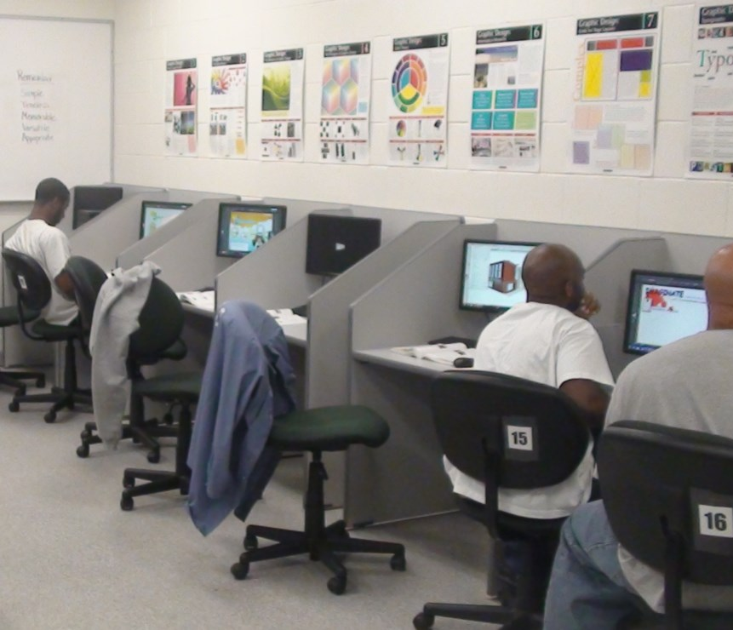
Howard County continues to provide crucial assistance to its soon-to-be released population, connecting them to multiple services provided by the members of its 128 agency/community member referral network. Through strong partnerships with addictions treatment centers, two returning citizens with lengthy criminal histories and addiction issues advanced the last quarter of FY2016to the second phases of their respective programs. Job Club participating individuals in Washington county are provided continued assistance through the network of providers and the Re-entry Coordinator until they are employed. After employment, they will receive follow up services. For the last quarter of FY 2016, 30 new Job Club participants enjoyed the benefits of this program. Keeping individuals engaged in services and activities geared directly toward their goal of becoming employed also reduces the likelihood that they will become re-engaged in criminal activity. Part of the Job Club’s program includes mentoring/coaching. Re-entry Coordinators and the Re-entry Collaborative Coalition continue to participate in the monthly “Call-Ins” or the Governor’s Office of Crime Control and Prevention’s Maryland Violence Prevention Initiative (VPI) offering those attending the opportunity to engage in the services offered through the Job Clubs and the project etwork partners. Those who become a part of the project are at “less risk” for re-offending.
(26)

SUMMARY
CEC met regularly with the staff of Correctional Education to ensure that quality education and workforce skills training were available to inmate students in the Correctional Education program. The Council recommended several actions to strengthen and improve program service delivery and employment opportunities for inmates upon their release. Highlights are as follows:
- Ten schools will establish advisory committees to review current programs for inmate students,
- Computer systems will be upgraded, and
- Additional funding for occupational equipment will be sought.
Both DPSCS and DLLR noted these concerns and indicated that they would provide additional support.
- Is uniquely positioned to promote Correctional Education programs and employment opportunities for the inmate student population,
- Will continue its commitment to the vision and mission of Correctional Education,
- Will strengthen its partnerships in the prison system and throughout the state to further enhance employment opportunities for inmate students, and
- Will continue to support the efforts of the Governor to ensure that quality education and training programs are available to inmates across the Maryland Correctional System.
###

(27)

