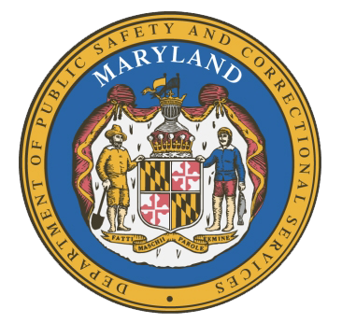
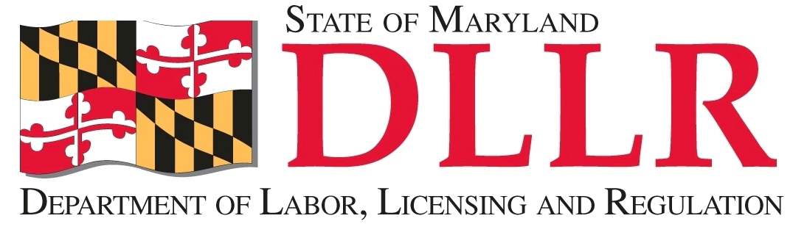
MARYLAND
Department of Public Safety and Correctional ServiceS
In
Partnership
With

Correctional Education Council
September 20, 2017
9:15 a.m. – 9:30 a.m.

Conference Call – Phone Number 866-247-6034, Code 5812736994

Council Meeting Agenda

Welcome Secretary Kelly Schulz
Secretary Stephen Moyer

Council Discussion Follow-up and Vote
on the CEC Activity Report ALL

Concluding Remarks Secretary Stephen Moyer
Secretary Kelly Schulz

