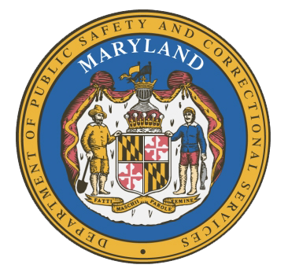

MARYLAND
Department of Public Safety and Correctional Services
In
Partnership
With

Correctional Education Council
Conference Call – Phone Number 1-484-854-4639, Code 113136656#

September 16, 2019
10:00 a.m. – 12:00 p.m.
Department of Labor, Licensing and Regulation
1100 North Eutaw Street, Room 108
Baltimore, MD 21201

Council Meeting Agenda

Welcome Secretary Tiffany Robinson
Review/Vote on June 17th, 2019 Minutes

DPSCS Updates Secretary Robert Green

Labor Updates Secretary Tiffany Robinson

Correctional Education Updates
- Staff Vacancies Jack Cunning
- Academic Deron Crawford/Fran Mumford
- Occupational Tamara Barron
- Transitional Erica DuBose

Tablet Expansion Update Danielle Cox

Regional Principal Updates
- Western Region Lonnie Lewis
- Central Region Tricia Hopkins
- Eastern Region Melissa Murphy

Navigator Updates James Grossman
Ellen Bredt
Anthony Onyango

Community Partner Nicole Hanson-Out for Justice

Employer Engagement Committee Updates Jack Weber

Concluding Remarks Secretary Tiffany Robinson
Secretary Robert Green

