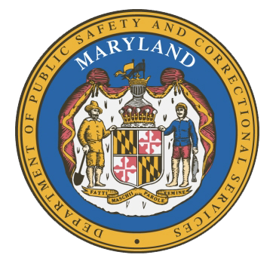
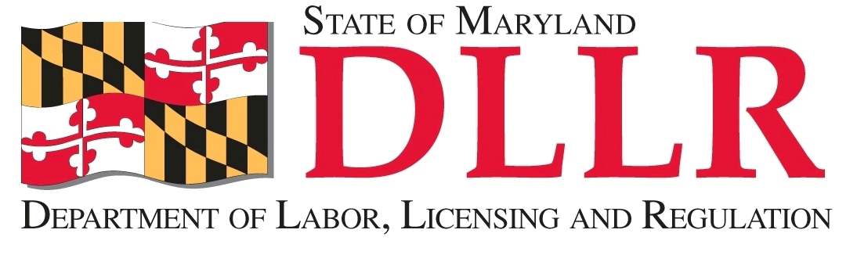
MARYLAND
Department of Public Safety and Correctional ServiceS
In
Partnership
With

Correctional Education Council
Conference Call – Phone Number 866-247-6034, Code 5812736994

September 24, 2018
10:00 am – 12:00 pm
Department of Labor, Licensing and Regulation
1100 North Eutaw Street, Room 108
Baltimore, MD 21201

Council Meeting Agenda

Welcome/Review of the June18th Minutes Secretary Stephen Moyer
Deputy Secretary David McGlone

DPSCS Updates Secretary Stephen Moyer

DLLR Updates Deputy Secretary David McGlone

Discussion/Approval of the FY 18 CEC Activity Report Secretary Stephen Moyer
Deputy Secretary David McGlone

Correctional Education Updates Alice Wirth and Staff
- Staff Vacancies Jack Cunning
- Correctional Education GED Numbers Danielle Cox
- Occupational Updates Tamara Barron
- Transitional Updates Erica DuBose

Employer Engagement Committee Updates Jack Weber

Concluding Remarks Secretary Stephen Moyer
Deputy Secretary David McGlone

For those who wish to attend in person, we will be meeting in Room 108.

