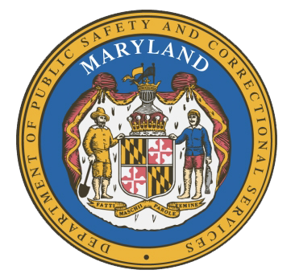
MARYLAND
Department of Public Safety and Correctional Services
In
Partnership
With



Correctional Education Council-Hybrid Meeting

March 13, 2023
10:00 a.m. – 12:00 p.m.
For those that wish to join us in person, please meet in:
LABOR-DWD-OAS Conference Room
Video call link: https://meet.google.com/ixr-dfhs-zwf
Or dial: ‪(US) +1 218-460-2175‬ PIN: ‪869 739 587‬#

Council Meeting Agenda

Welcome Secretary Portia Wu
Review/Vote on December 13, 2022 Minutes

Opening Remarks Secretary Carolyn Scruggs
Secretary Portia Wu

Correctional Education Updates
- Staff Vacancies Dr. Jack Cunning
- Academic Patrick Hruz
- Special Education Katharine Lander
- Occupational Dr. Tamara Barron
- Transition Dr. Erica DuBose

Regional Principal Updates
- Western Region Deron Crawford
- Central Region Edward Schwabeland
- Eastern Region and Library Updates June Brittingham

American Job Center and Reentry Navigator Updates Lloyd Day

Community Partner Updates Janay Harris
Vehicles for Change

Concluding Remarks Secretary Portia Wu
Secretary Carolyn Scruggs

