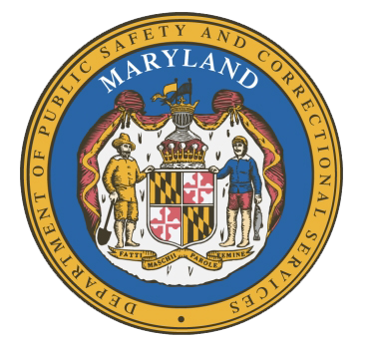

MARYLAND
Department of Public Safety and Correctional Services
In
Partnership
With

Correctional Education Council
Conference Call – Phone Number 252-397-0135, Code 201137563#

March 16, 2020
10:00 a.m. – 12:00 p.m.
State of Maryland Department of Labor
1100 North Eutaw Street, Room 108
Baltimore, MD 21201

Council Meeting Agenda

Welcome Secretary Tiffany Robinson
Review/Vote on December 16th, 2019 Minutes

DPSCS Updates Secretary Robert Green

Labor Updates Secretary Tiffany Robinson

Correctional Education Updates
- Staff Vacancies Jack Cunning
- Academic Pat Hruz
- Occupational Tamara Barron
- Transitional Erica DuBose

Tablet Expansion Update Danielle Cox

Regional Principal Updates
- Western Region Peggy Stanford
- Central Region Edward Schwabeland
- Eastern Region June Brittingham

Navigator Updates Marshel Lawrence
James Grossman
Ellen Bredt
Sandy Graham

Community Partner Pass it On Community Technical
Training and IT Solutions

Employer Engagement Committee Updates Jack Weber

Concluding Remarks Secretary Tiffany Robinson
Secretary Robert Green

