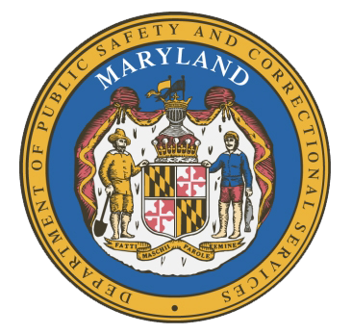
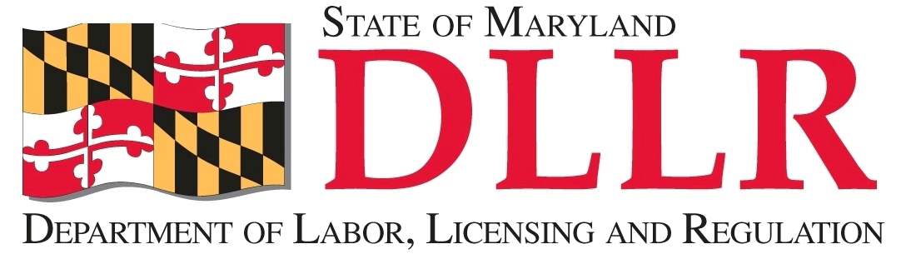
MARYLAND
Department of Public Safety and Correctional ServiceS
In
Partnership
With

Correctional Education Council
Conference Call – Phone Number 866-247-6034, Code 5812736994

March 19, 2018
10:00 am – 12:00 pm
Department of Labor, Licensing and Regulation
1100 North Eutaw Street, Room 108
Baltimore, MD 21201

Council Meeting Agenda

Welcome and Review of the September 20th (Approval of Secretary Stephen Moyer
FY 17 Activity Report) Minutes and December 2017 Minutes Deputy Secretary David McGlone

DPSCS Updates Secretary Stephen Moyer

DLLR Updates Deputy Secretary David McGlone

Senate Roundtable – Technology to Improve Education and
Reentry in Prisons Erica DuBose

Update on Internet Based National Certification Exams Tamara Barron

Correctional Education Updates Jack Cunning and Staff
- Staff Vacancies Jack Cunning
- Correctional Education GED Numbers Danielle Cox
- Occupational Updates Tamara Barron
- Transitional Updates Erica DuBose

Employer Engagement Committee Updates Jack Weber

Concluding Remarks Secretary Stephen Moyer
Deputy Secretary David McGlone

For those who wish to attend in person, we will be meeting in Room 108.

